1. Prepare a U disk（USB driver） with a storage capacity of at least 16 GB
2. Right click and select format... Format U disk to FAT32 format,and change the
Volume label to WINPE ,click start to finish formatting
- Copy your BIOS files to U disk, and it must be in the root directory of U disk.

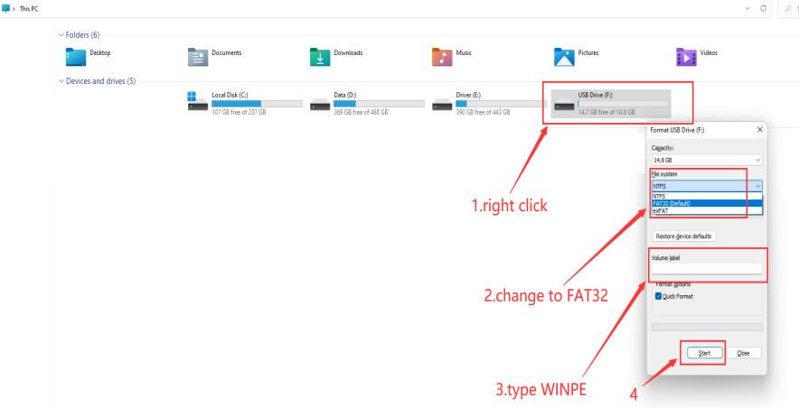

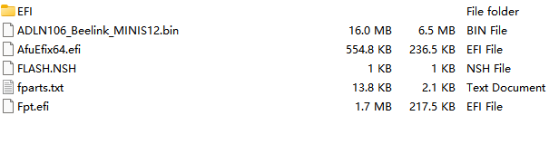

4. Restart the computer, press F7 repeatedly on the boot logo interface, and select
USB boot in the boot options
5.Start flashing.After it completes the processing, please type exit,press enter.
