Here is the tutorial on how to reinstall window 11 PRO on Mini s13

- Please insert your Bootable USB flash drive with the system file into the USB port of MINI S13

- Turn on the PC. Please open the file <Scripts>
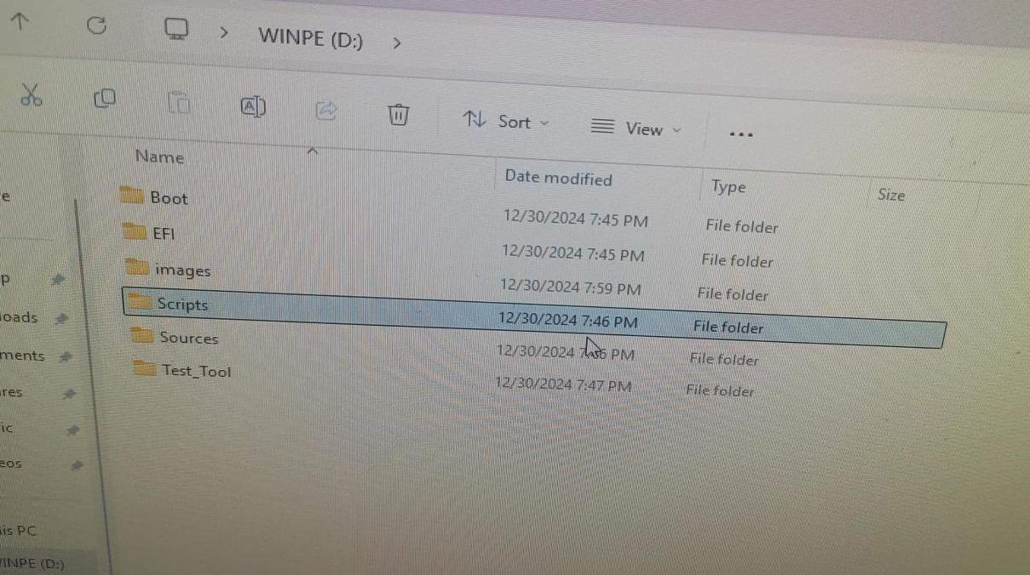

- Please double click Winpe.exe
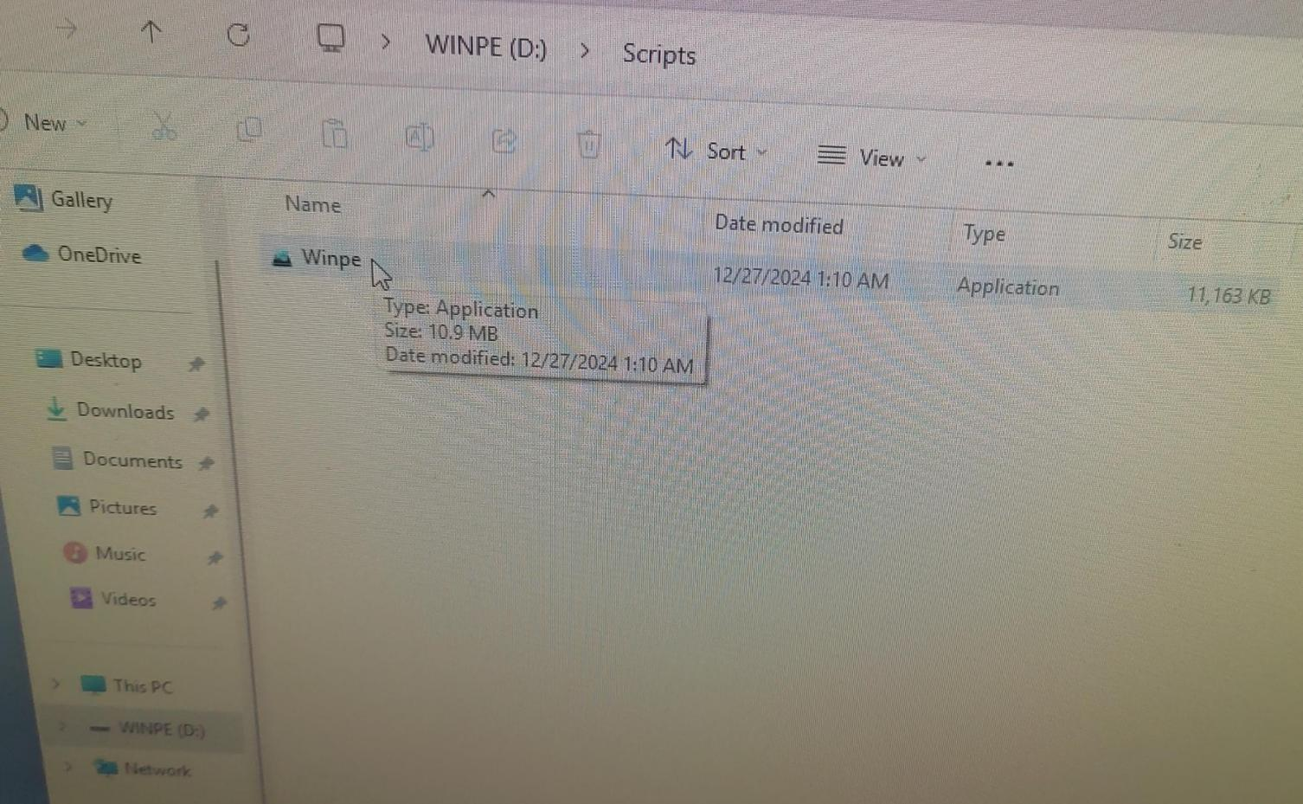
- Please choose SATA SSD as the disk, and click save.
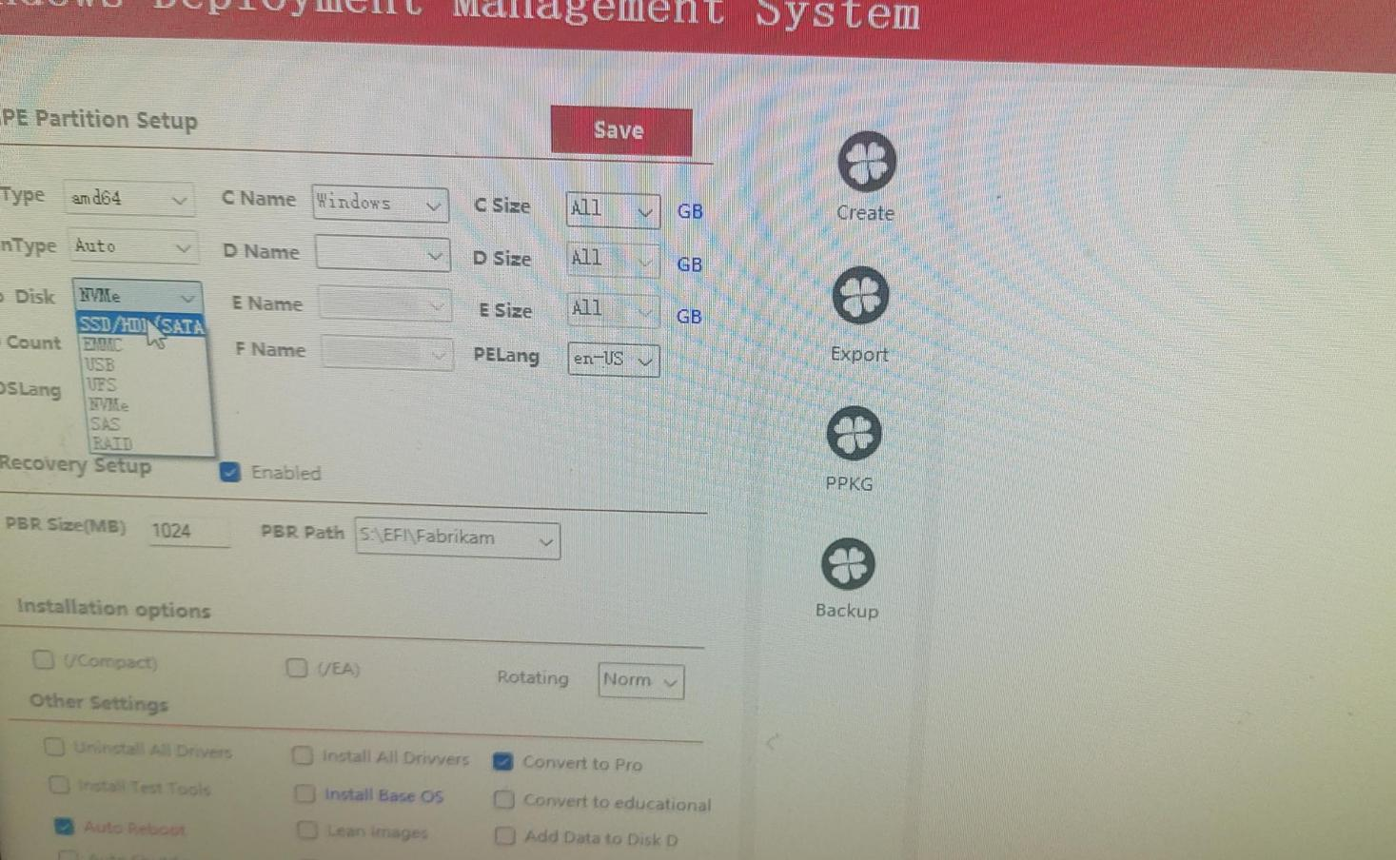

- Please restart the PC, and press F7 repeatedly. Choose USB flash drive partition, press enter.

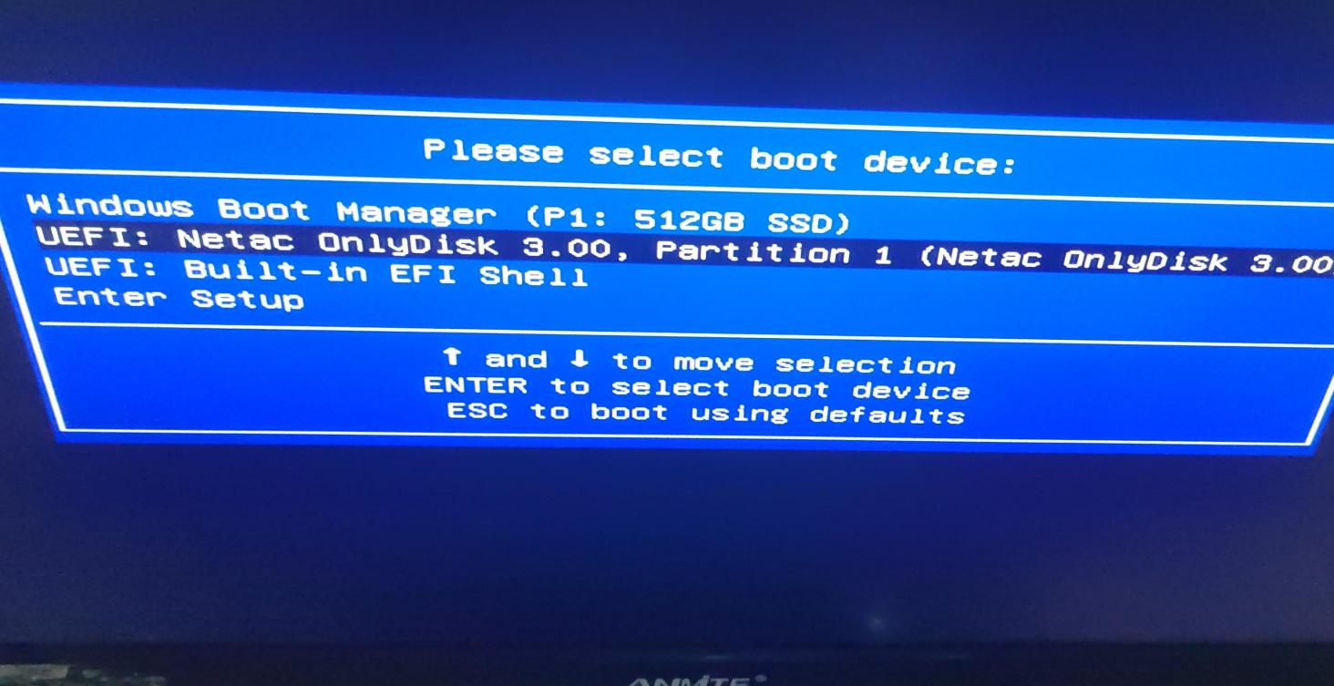
- The re-installation will start, wait until it is finished.
