1. Prepare a USB disk（USB drive） with a storage capacity of at least 4 GB
2. Right click and select format... Format U disk to FAT32 format,and change the
Volume label to WINPE ,click start to finish formatting
- Copy your system files to USB disk, and it must be in the root directory of USB disk.

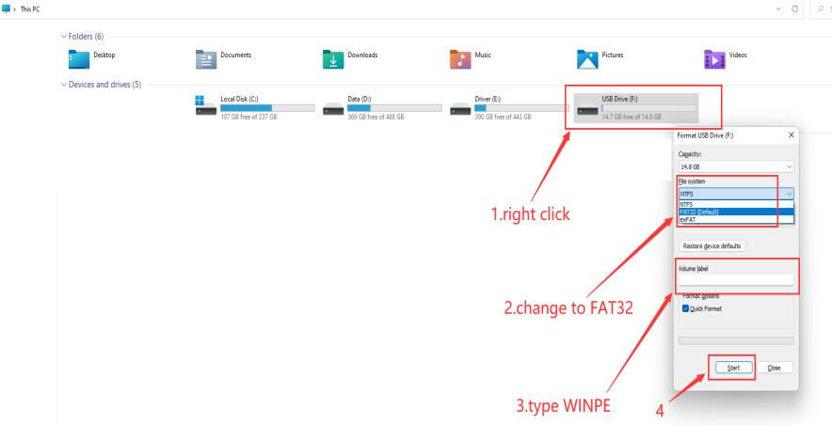

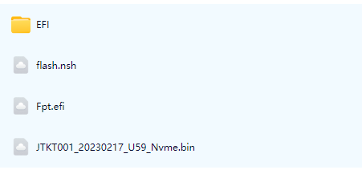

4. Restart the computer, press F7 repeatedly on the boot logo interface, and select
USB boot in the boot options
5.Type fs3:(you may type fs1：-fs6:,depends on where the USB drive is ，do not foget colon) , then press enter
6.Type dir or ls , press enter so that you can locate the files
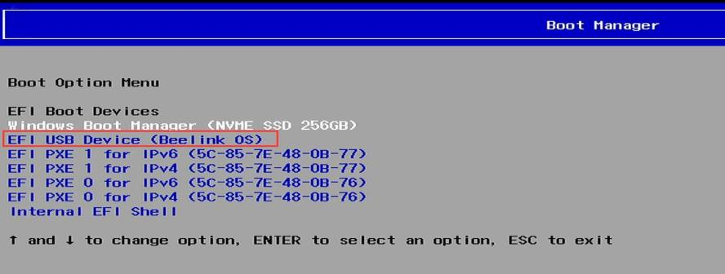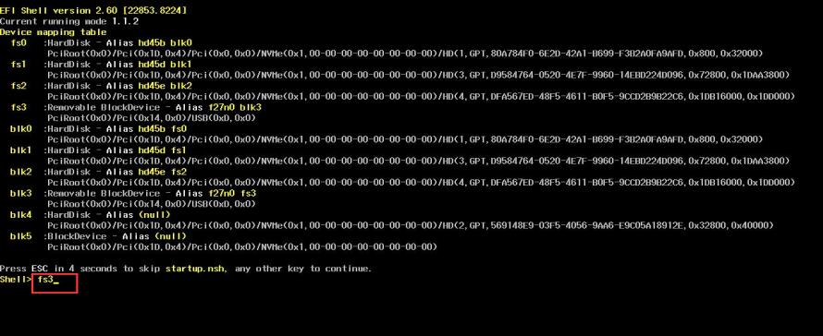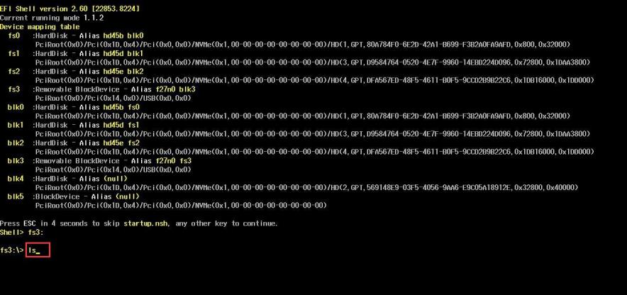
7.Type flash, press tab,then press enter.
8.Start flashing, if there is a similar reminder, enter exit.
