1. Prepare a U disk（USB driver） with a storage capacity of at least 16 GB
2. Right click and select format... Format U disk to FAT32 format,and change the
Volume label to WINPE ,click start to finish formatting
- Copy the BIOS files to U disk, and it must be in the root directory of U disk.

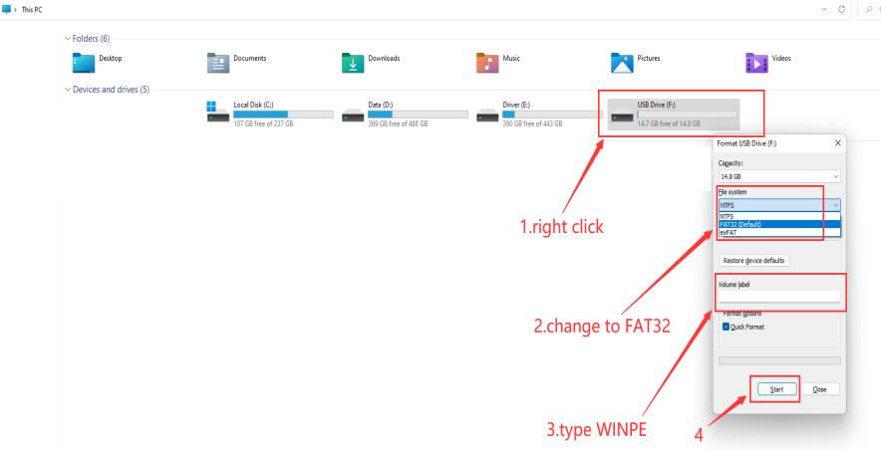

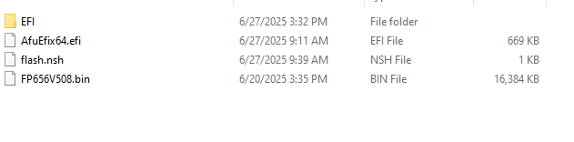
4. Restart the computer, press F7 repeatedly on the boot logo interface, and select
USB boot in the boot options
5.Type fs3:(you may type fs1:-fs4:,depends on where the USB drive is ,do not forget the colon) , then press enter
6.Type dir or ls , press enter so that you can locate the files
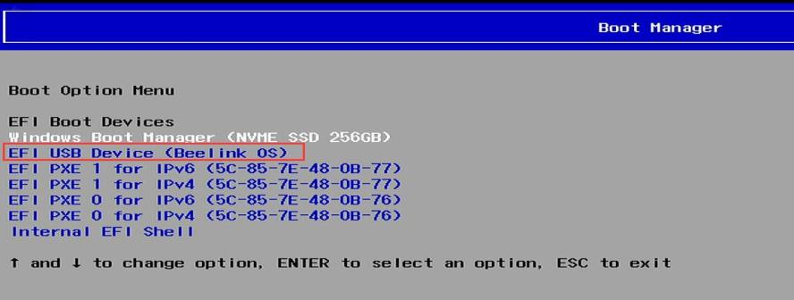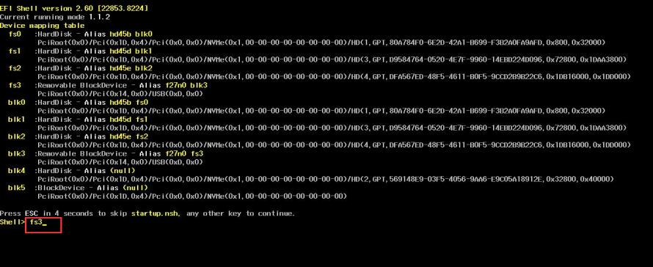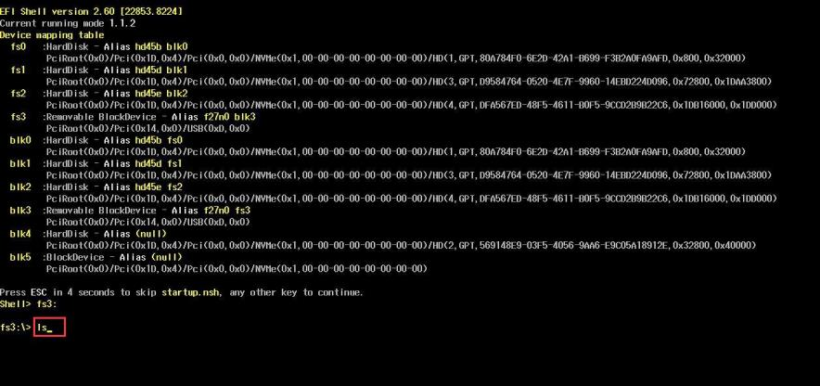

7.Type flash, press tab,then press enter. Change AfuEfix64.efi FP656V508.bin /p /b /n /k /x /l /r /capsule to AfuEfix64.efi FP656V508.bin /p /b /n /k /x /l /r ，press enter. Press F.

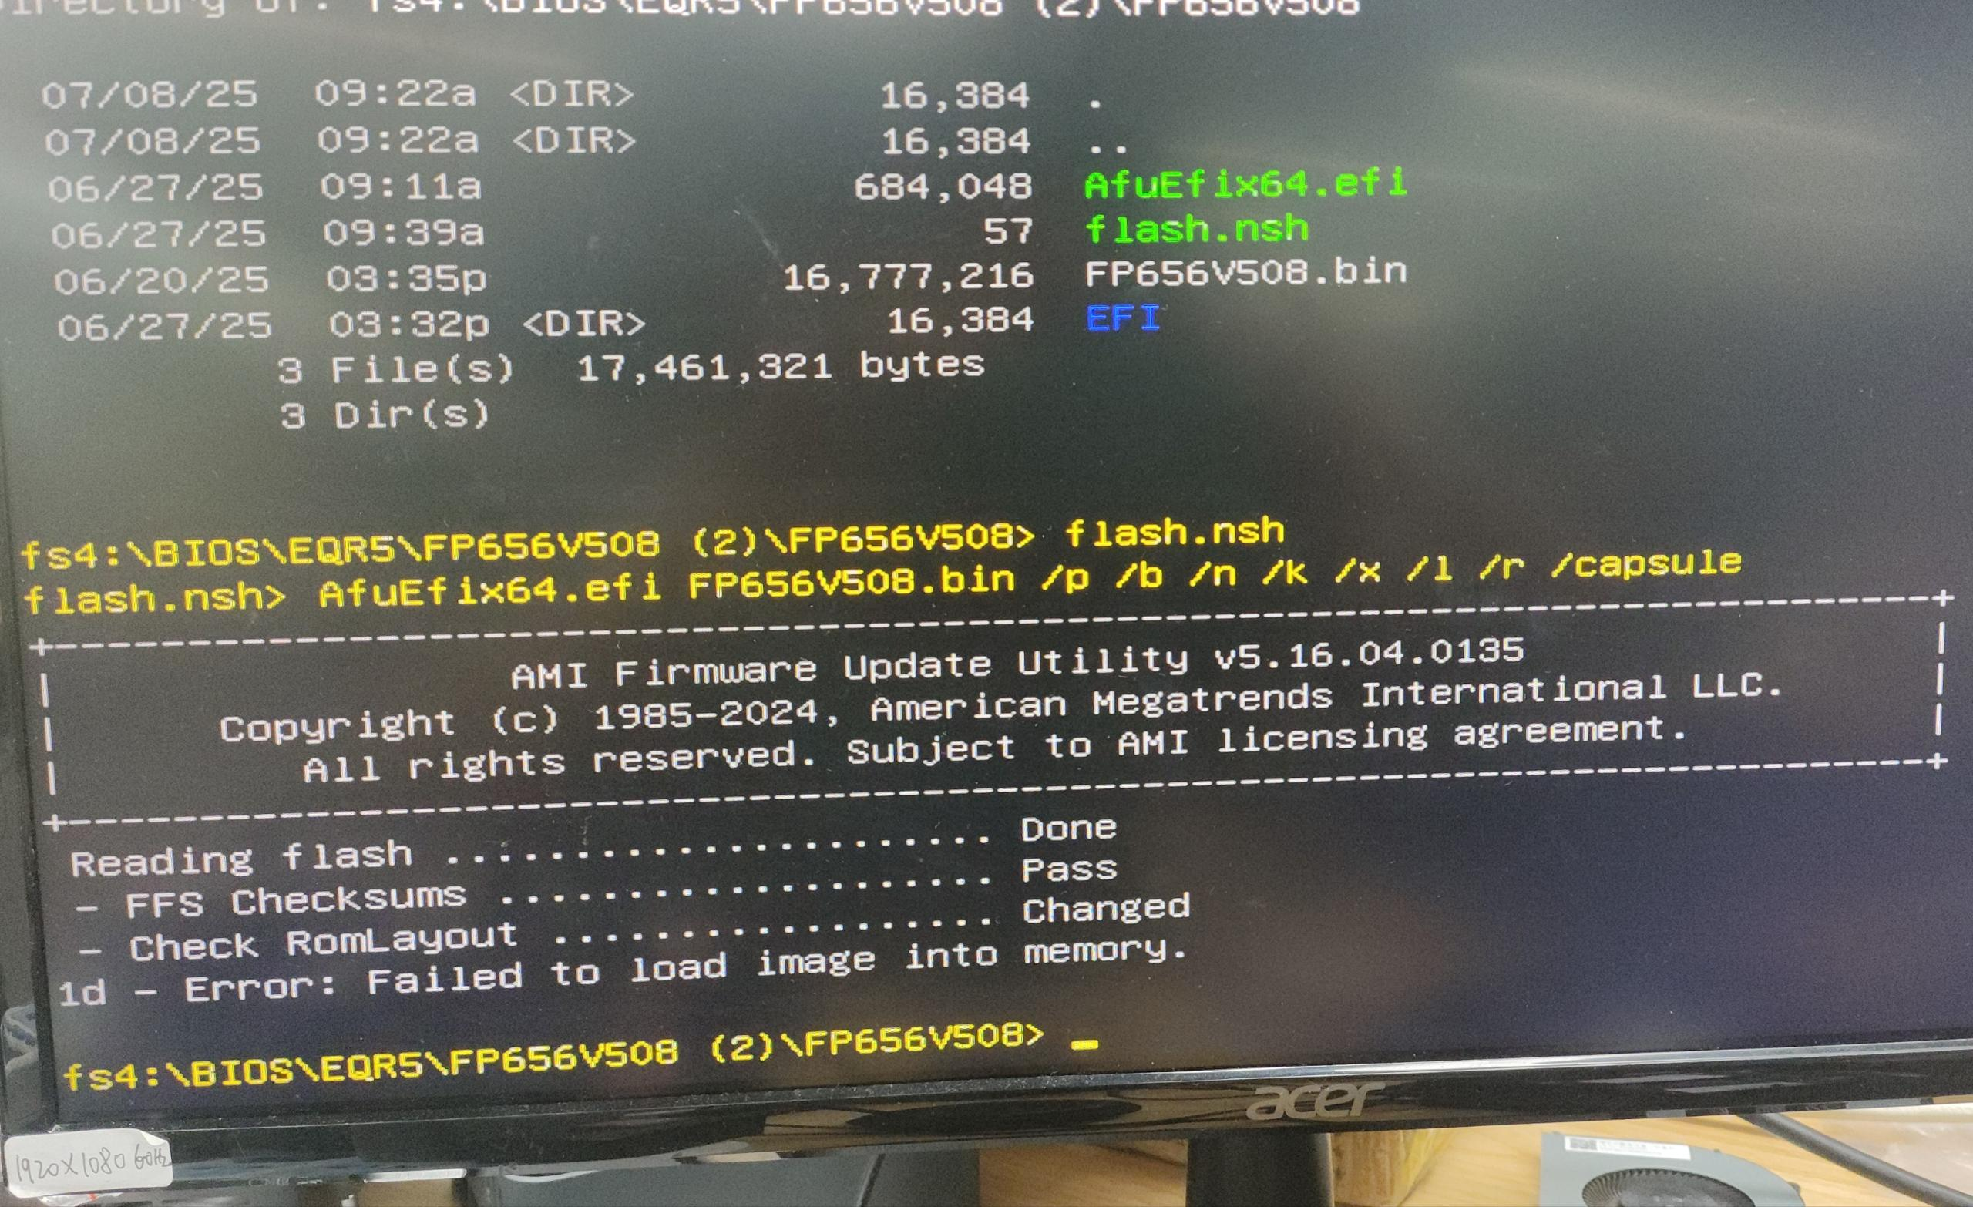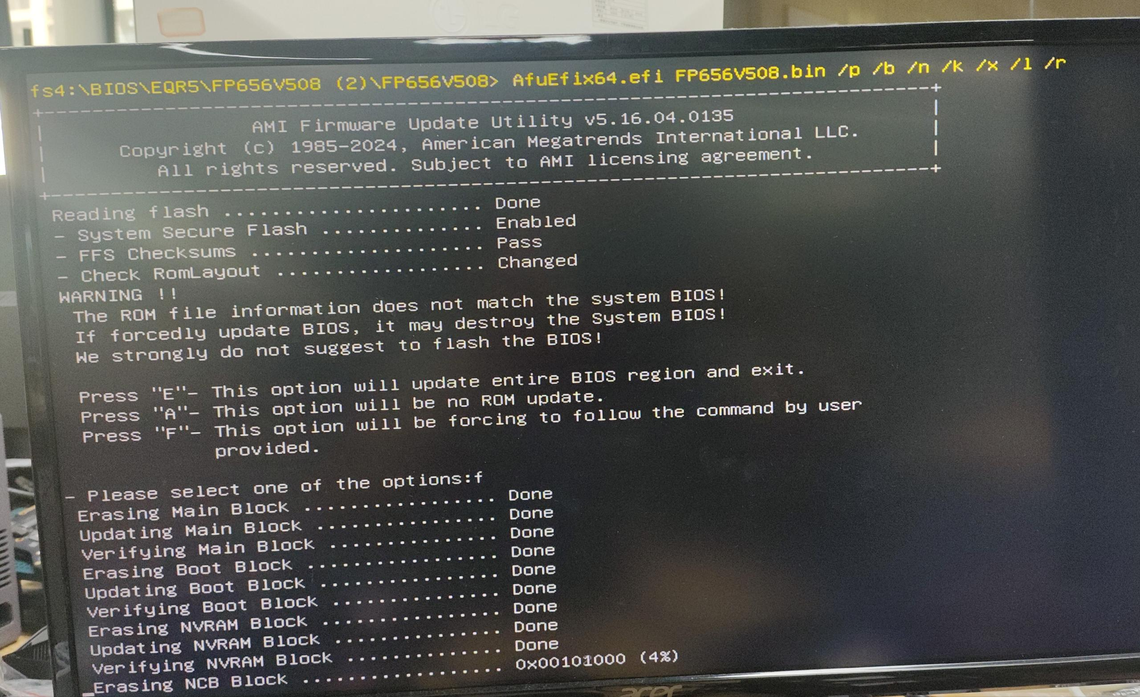

8.Start flash, If there is a similar reminder, enter exit.

