2. Right click and select format... Format U disk to FAT32 format,and change the
Volume label to WINPE ,click start to finish formatting
- Copy your system files to U disk, and it must be in the root directory of U disk.

1. Prepare a U disk（USB drive） with a storage capacity of at least 16 GB
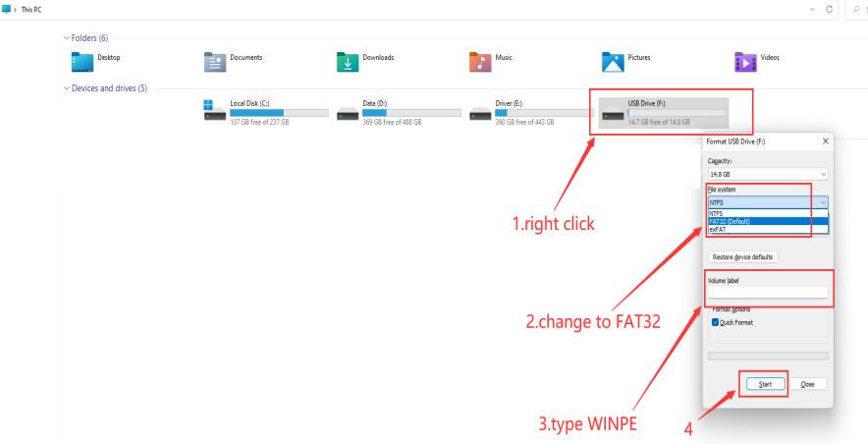

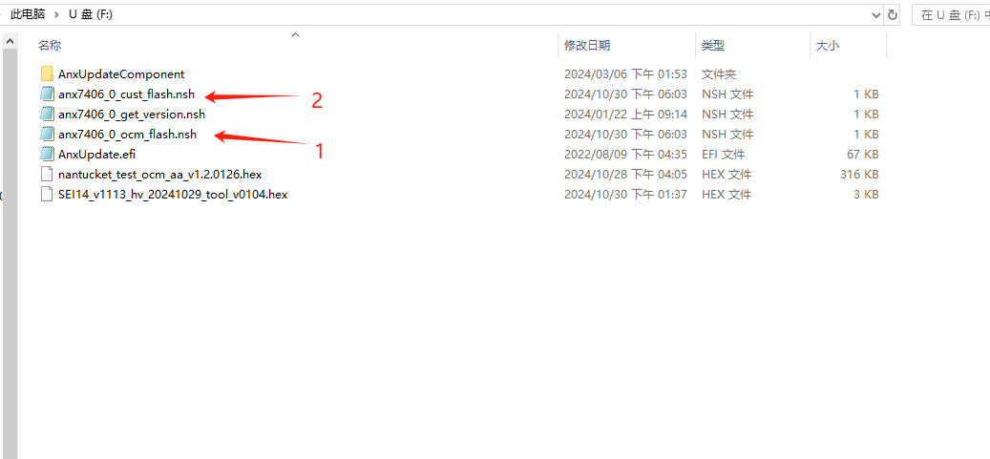

4. Restart the computer, press F7 repeatedly on the boot logo interface, and select
USB boot in the boot options

5.Type fs3:(depends on where your USB flash drive is) , then press enter
6.Type dir or ls , press enter so that you can locate the files

6.Type dir or ls , press enter so that you can locate the files

8.Start flash, If there is a similar reminder, enter exit.
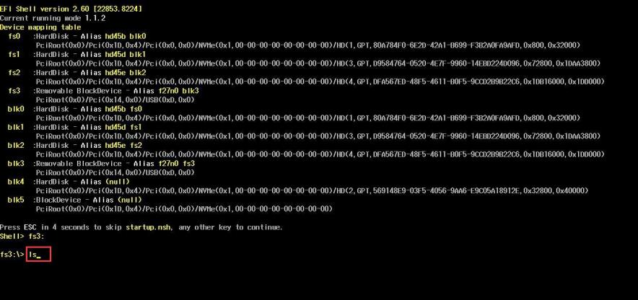
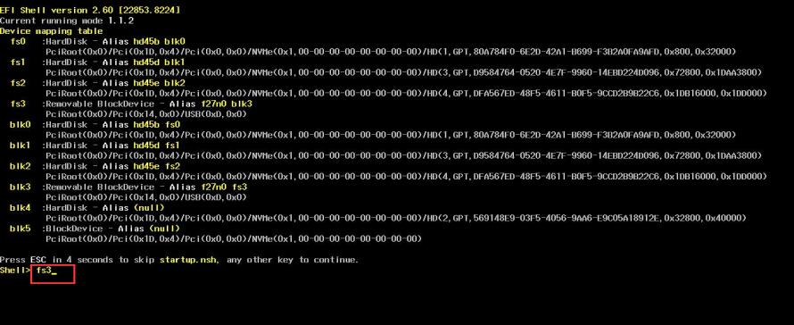
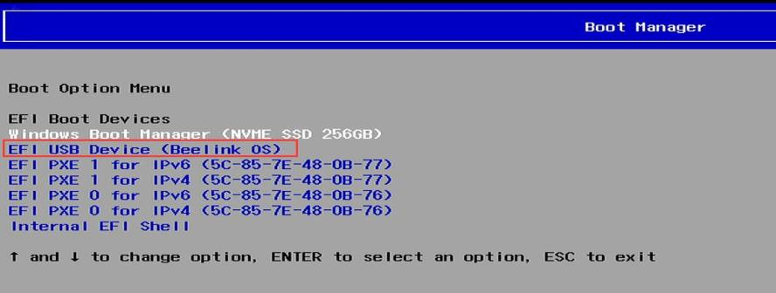

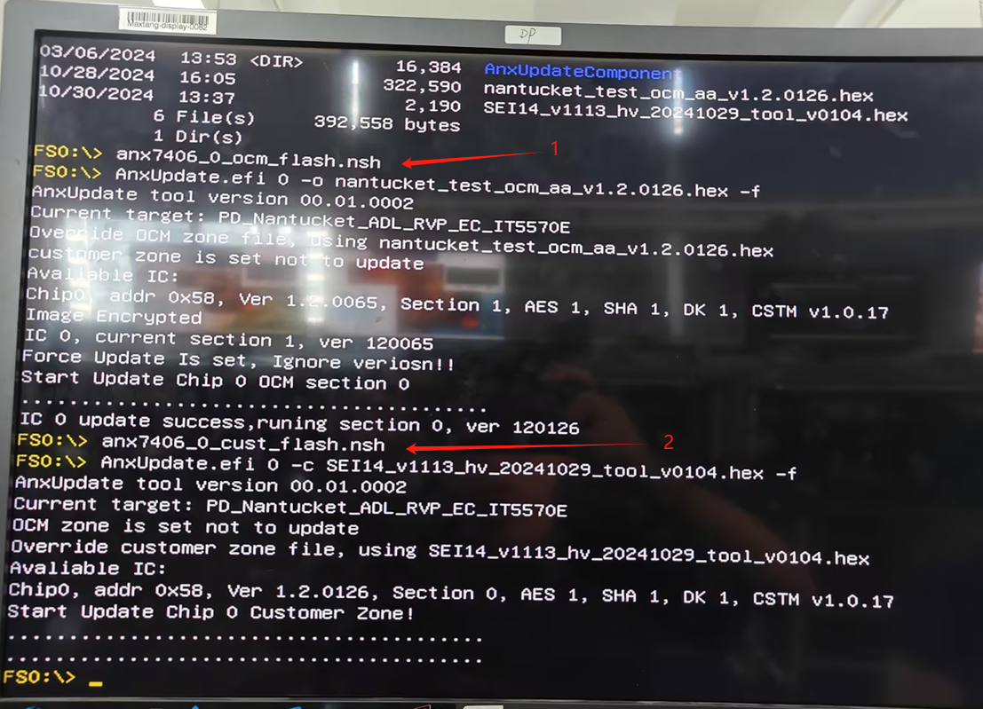
7.Type anx7406_0_ocm_flash.nsh，press enter, then type anx7406_0_cust_flash.nsh，press enter, after the flashing is done, please turn off the PC and then turn it on.

