1. Prepare a U disk（USB driver） with a storage capacity of at least 16 GB
2. Right click and select format... Format U disk to FAT32 format,and change the
Volume label to WINPE ,click start to finish formatting
- Copy the BIOS file to U disk, and it must be in the root directory of U disk.

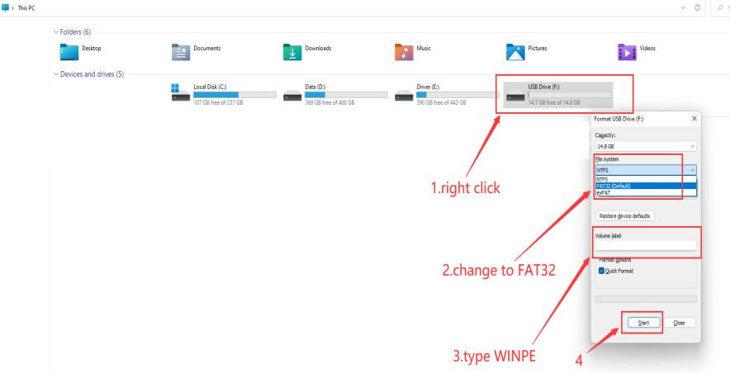

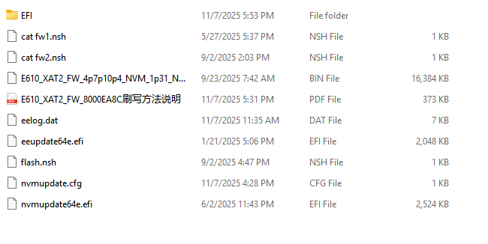

4. Restart the computer, press F7 repeatedly on the boot logo interface, and select
USB boot in the boot options
5.Type fs3:(you may type fs0:-fs4:,depends on where the USB drive is ) , then press enter
6.Type dir or ls , press enter so that you can locate the files
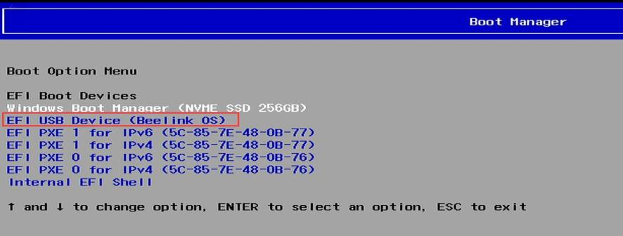
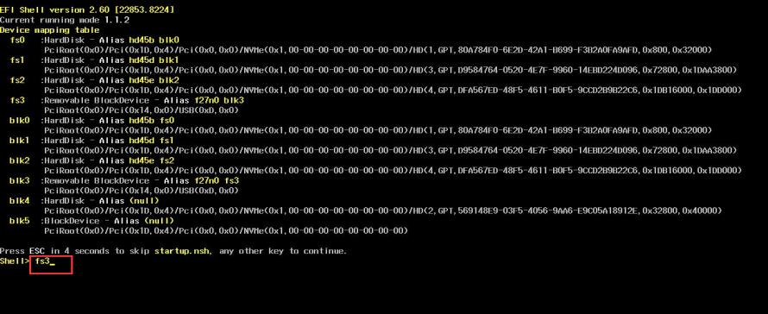
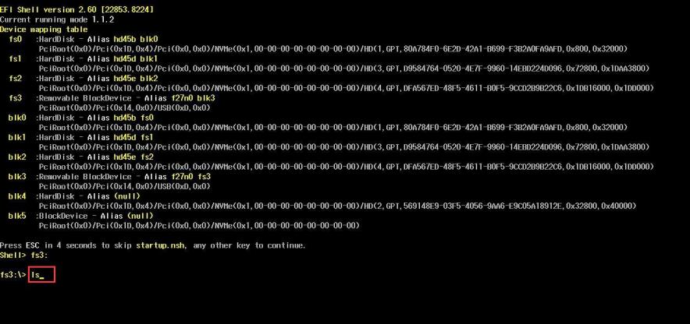
7.Type flash, press tab,then press enter.
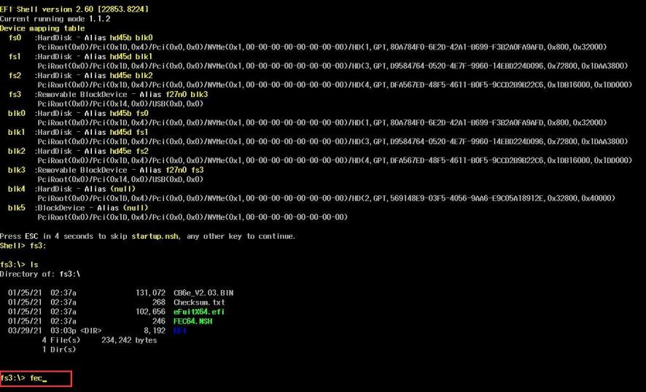

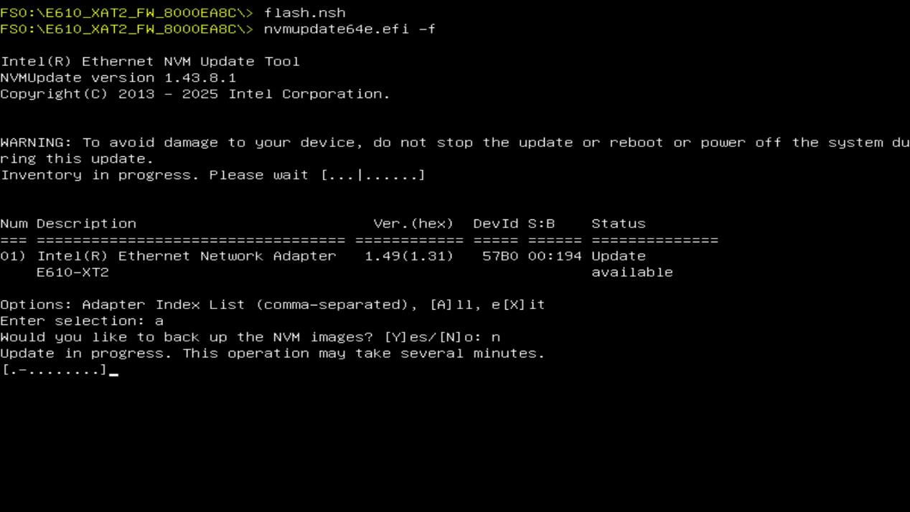

8.When the first prompt appears, enter "a". When the second prompt appears, enter "n" and press Enter to wait for the flashing/writing process to complete.

9.A restart prompt indicates that the flashing/writing process is complete. Disconnect the power, then turn the device back on to finish.

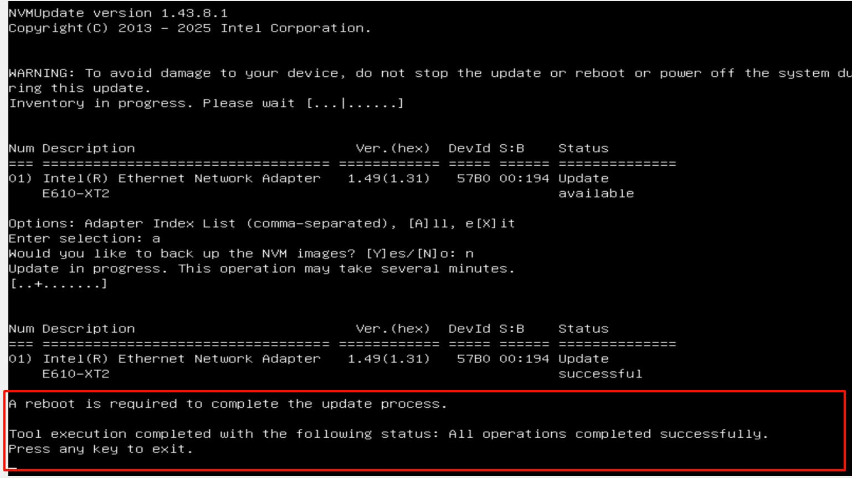

10.After turning on the device, repeat steps 1 to 6 above. Then enter cat fw1.nsh or cat fw2.nsh to check the firmware version. If the input results in an error, manually enter the command eeupdate64e.efi /nic=1 /adapterinfo or eeupdate64e.efi /nic=2 /adapterinfo to view the firmware version. If the displayed version number matches the target one below, the flashing/writing process is successful.

