1. Prepare a U disk（USB driver） with a storage capacity of at least 16 GB
2. Right click and select format... Format U disk to FAT32 format,and change the
Volume label to WINPE ,click start to finish formatting
- Copy the BIOS file to U disk, and it must be in the root directory of U disk.

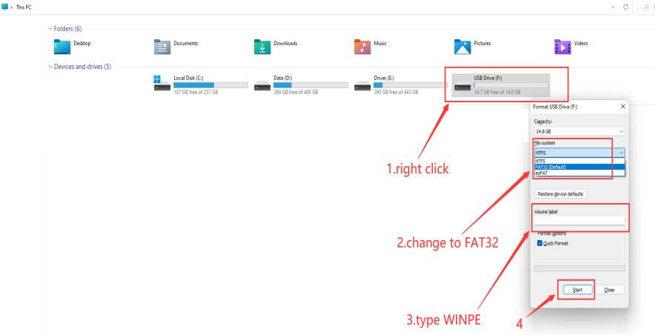

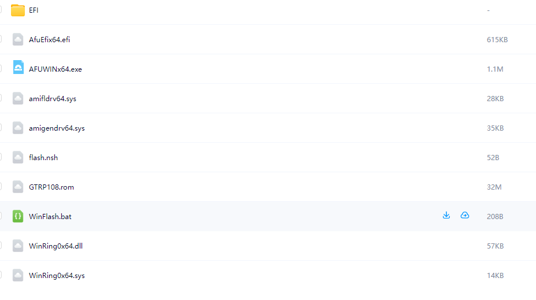

4. Restart the computer, press F7 repeatedly on the boot logo interface, and select
USB boot in the boot options
5.Type fs3:(you may type fs0:-fs4:,depends on where the USB drive is ) , then press enter
6.Type dir or ls , press enter so that you can locate the files
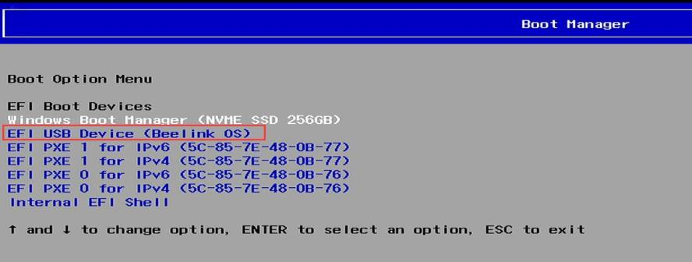
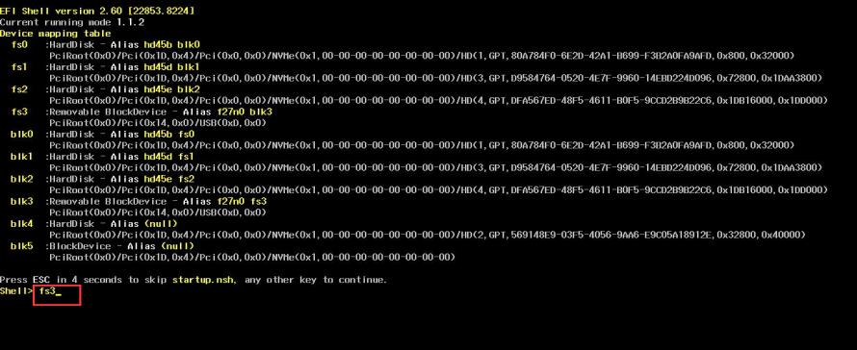
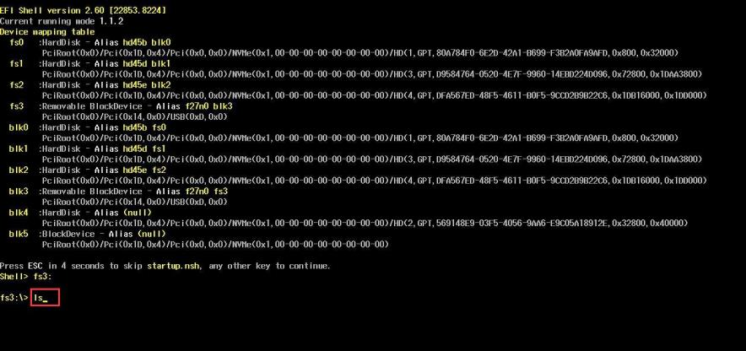
7.Type flash, press tab,then press enter.
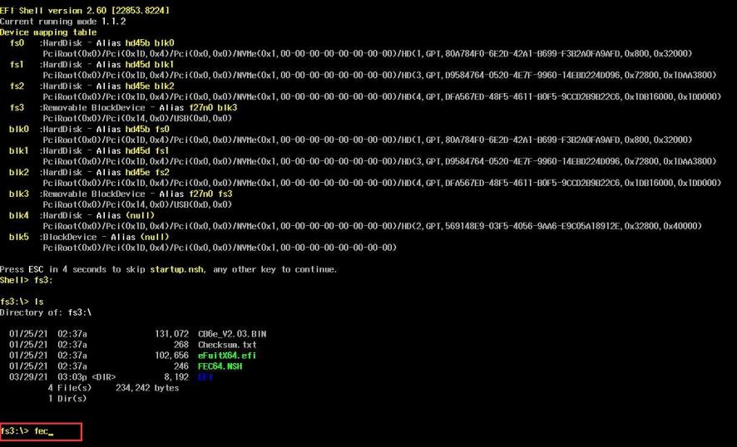
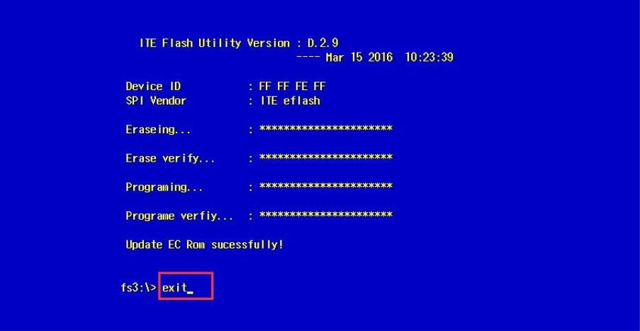

8.APTl0 SETUP.AMl screen pop up,please select PROCEED WITH FASH UPDATE.
Start flashing, if there is a similar reminder, enter exit.

