Here are the tutorial on how to select the SSD and the Windows version to install.

- Please open the system file <Scripts> in your USB flash drive :
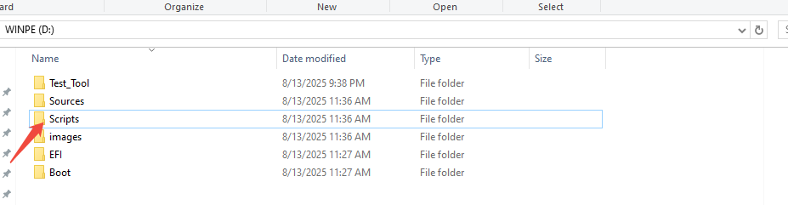

- Double click the file Winpe to run

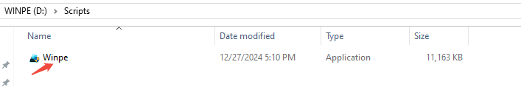

- If it pops up the message the system prompt , please choose No.
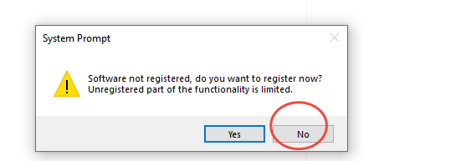
④Please choose the SSD you want to install the image , and choose the Windows version, click save.

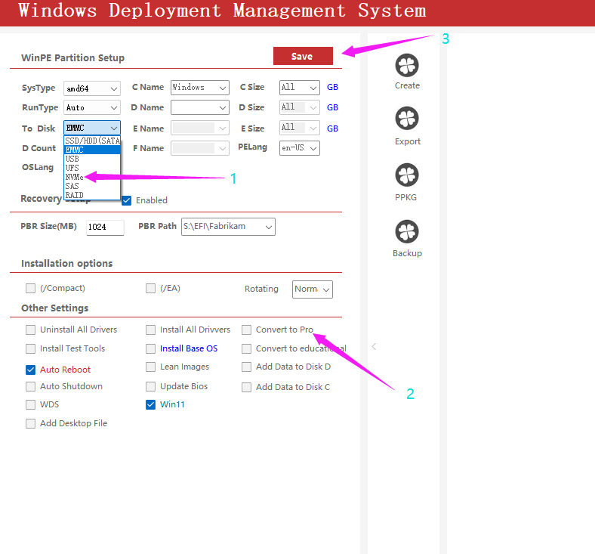
⑤After the setting is done, please insert the USB flash drive to ME mini, restart the PC, press F7 , then choose USB flash drive to start installing the image.

