- Please download the BIOS file :
https://beelink.oss-cn-hongkong.aliyuncs.com/MINI%20PC/SEI/BIOS%E5%92%8CEC/SEI11320/AfuWin64_TL55T201_Beelink20231215.zip

- Unzip the file :


- Copy and paste the whole file to the users folder of C drive :
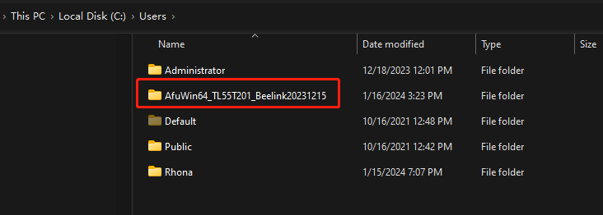

④Double click the file of AfuWin64_TL55T201_Beelink20231215, then copy the path of the file :

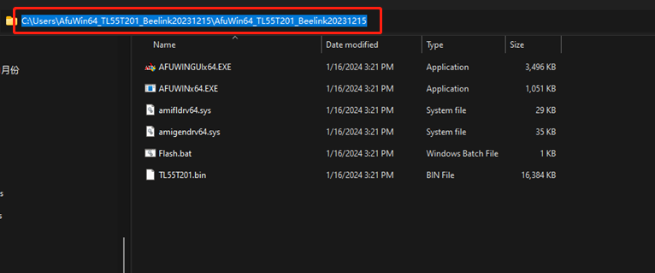
- Right click windows,then click windows terminal(Admin)

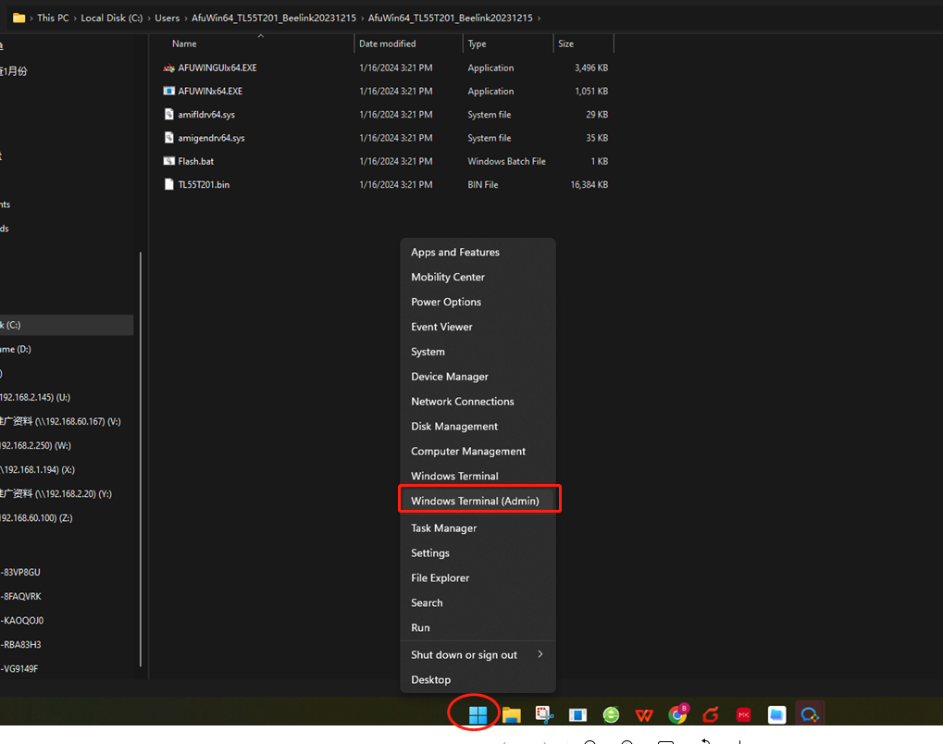
⑤On the command, type in :CD ,then Paste the path on the command
C:\Users\AfuWin64_TL55T201_Beelink20231215\AfuWin64_TL55T201_Beelink20231215 (My Path might be different from yours.), press enter.
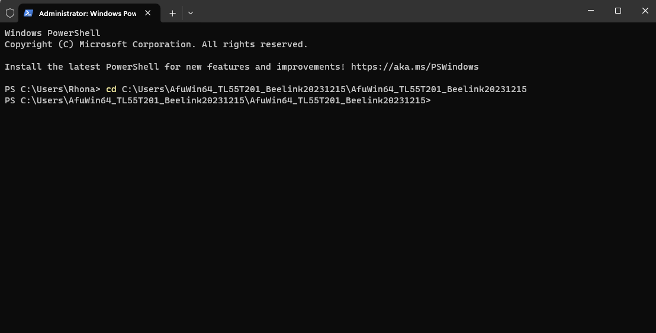
⑥Type in : LS , then press enter key
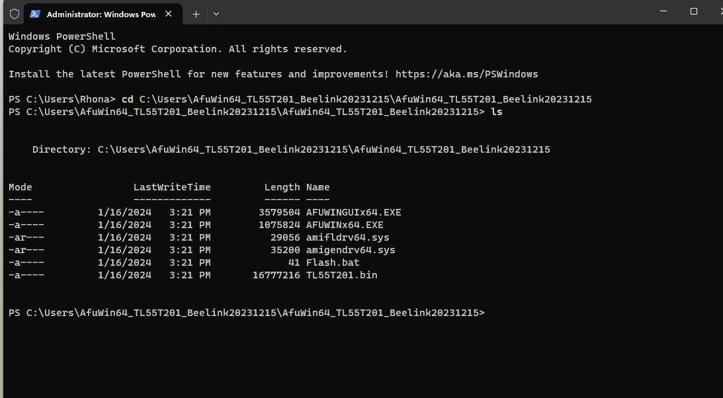
⑦ Type in: flash，press the key Tab on the keyboard to complete the whole command,then you will get .\Flash.bat

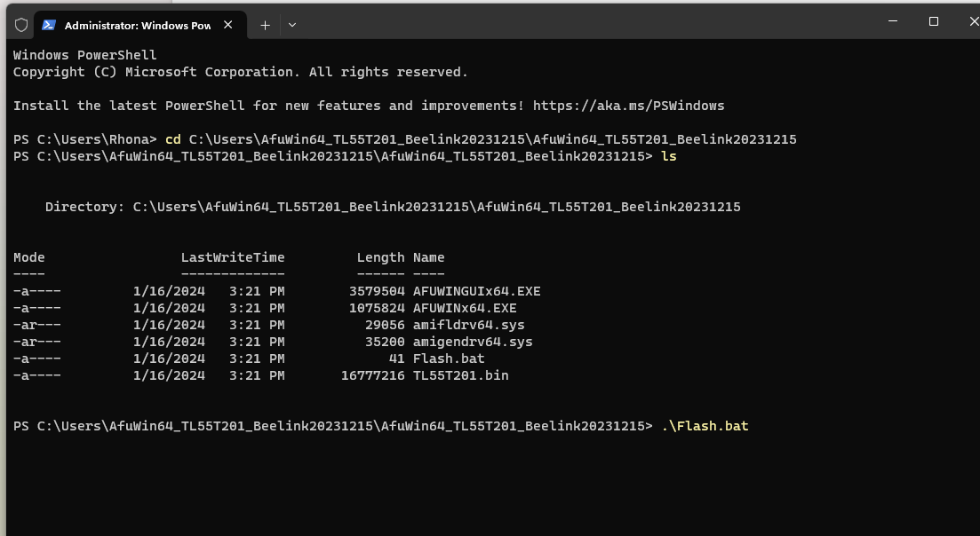
⑧Then press enter key to start flashing the BIOS. After the BIOS update is finished, type in :exit,press enter.

