Tutorial on Setting up RAID Disk Array for SEi14

The SEi14 has two built-in NVme hard disk slots and supports the hard disk RAID function. Currently, the following RAID modes are supported:

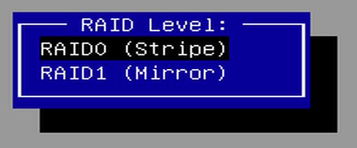
Volume: Combines multiple hard disks into one large hard disk, also known as JBOD (Just a Bunch Of Disks). It doesn't require the hard disk capacities to be the same, and the final available capacity is the sum of the capacities of each hard disk. RAIDable: Reserves the hard disk as a potential ability for future RAID. This means that the hard disk is designed to be combined with other hard disks to form a RAID array to provide higher performance, fault tolerance, or storage capacity. RAID 0: Distributes data evenly across multiple hard disks in a striped manner, thereby increasing the read and write speeds. The capacity of RAID 0 is the minimum hard disk capacity multiplied by the number of hard disks. RAID 1: Writes data to two hard disks simultaneously in a mirrored manner to ensure data integrity. Each hard disk contains a complete copy of the data, so when one of the hard disks fails, the other hard disk can still provide complete data.

If you need to set up the RAID mode, please follow the steps below:

Preparatory Work:

- Prepare an SEI14 mini PC.
- Prepare two M.2 2280 solid-state drives (select hard disks with the same or different capacities according to the required RAID mode).
- Use the official Microsoft tool to create a Windows 11 system USB flash drive. The system USB flash drive provided as a gift cannot be used for installation via DOS. For the creation method, please refer to the [Windows 11 Official System Installation Tutorial].
- Download the RAID driver, decompress it, and then place it in the root directory of the Windows 11 system installation USB flash drive. Download address: https://url.bee-link.cn/t9d0

Note that creating a new RAID mode will delete all the current hard disk space and data. Please back up your data in advance and operate with caution.

Starting the Setup:

- Press the "delete" key after the boot-up and the Beelink logo appears to enter the BIOS setup page.
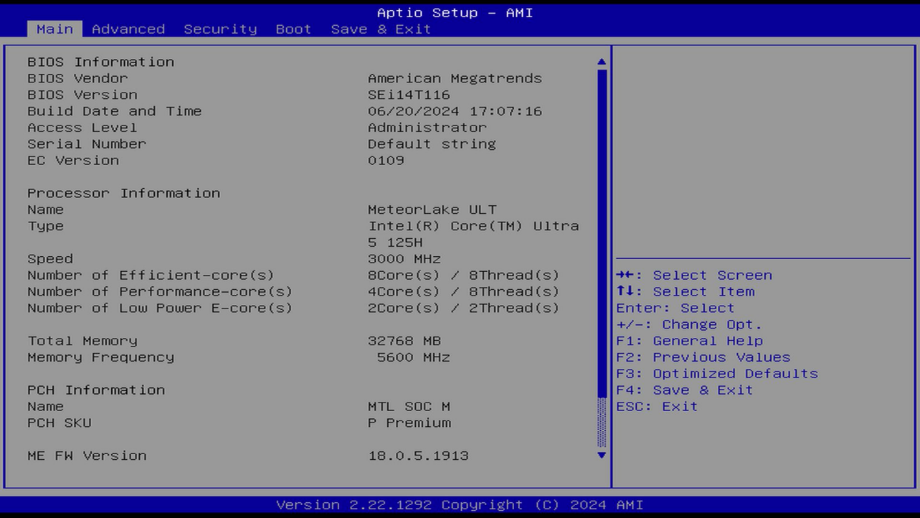
2.Select the second item "Advanced" in the menu bar, find the sub-menu "System Agent (SA) Configuration", and press "Enter" to enter it.
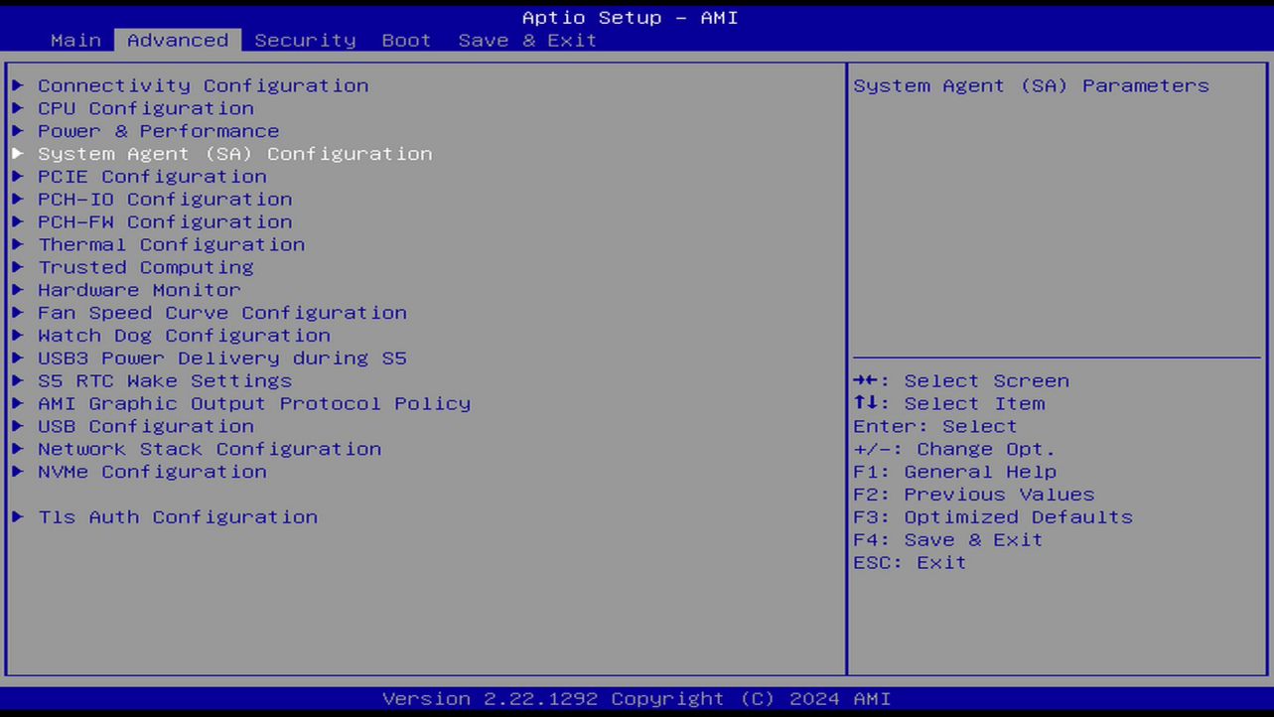
3.Enter the ["VMD setup menu"] menu.
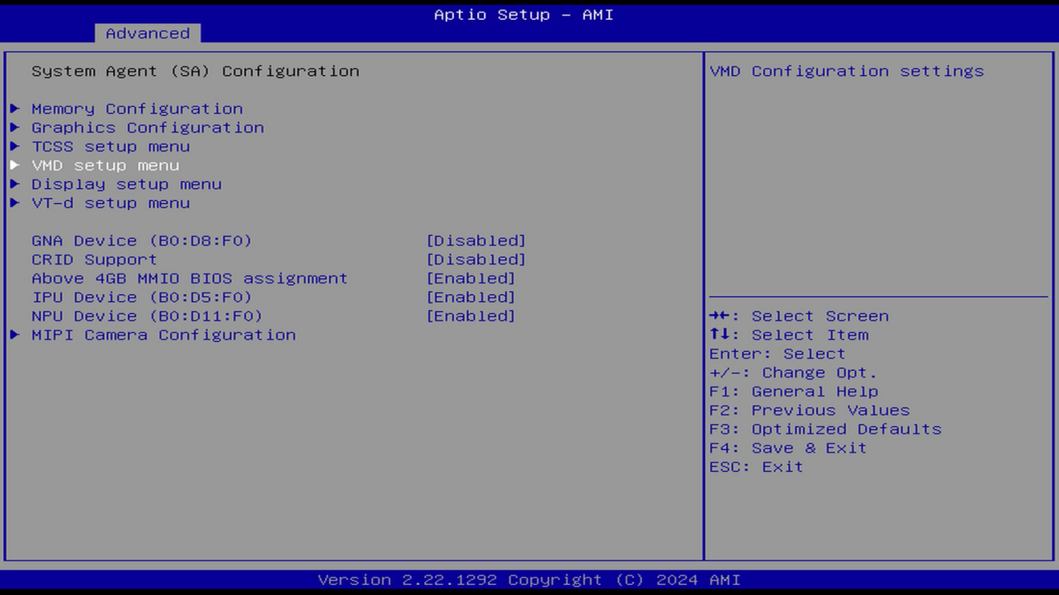
4.Set the ["Enable VMD controller"] option to ["Enabled"] to enable the Raid function.
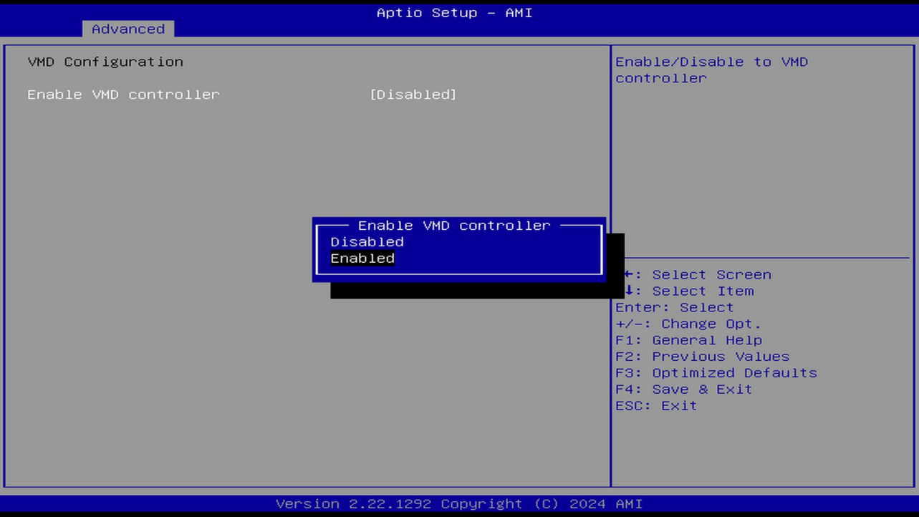
5.After the setting is completed, press ["F4"] to save and exit.
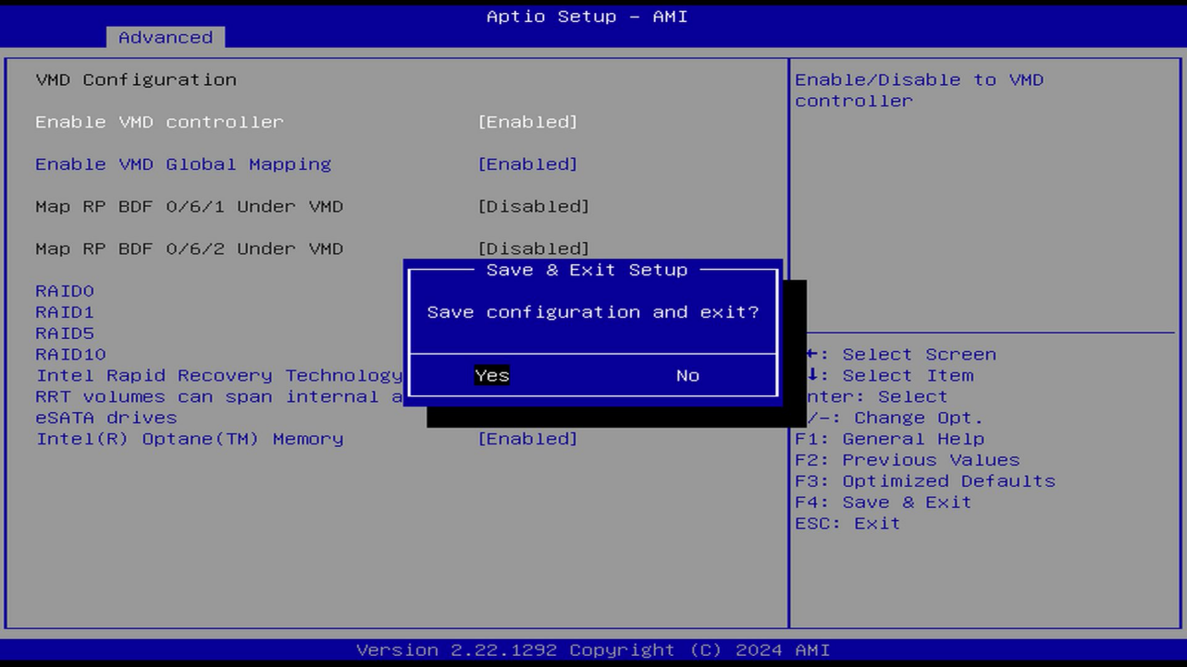
6.Re-enter the BIOS menu, switch to the ["Advanced"] option, and you will see an additional ["Intel(R) Rapid Storage Technology"] menu. Press "Enter" to enter the setting.

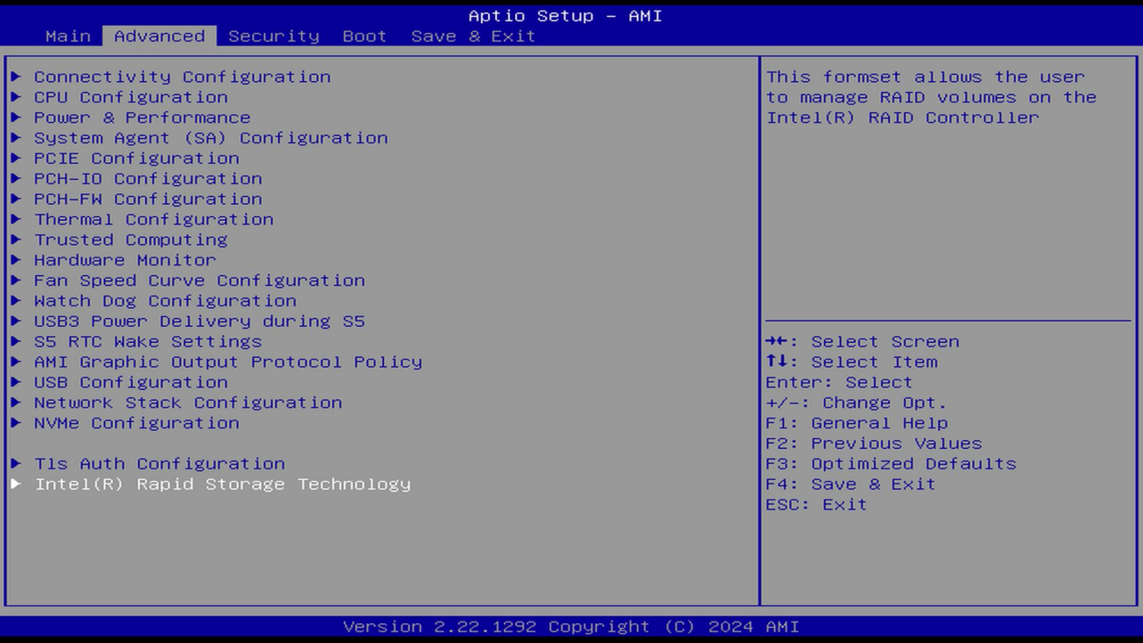
7.Continue to enter the ["Create RAID Volume"] menu.
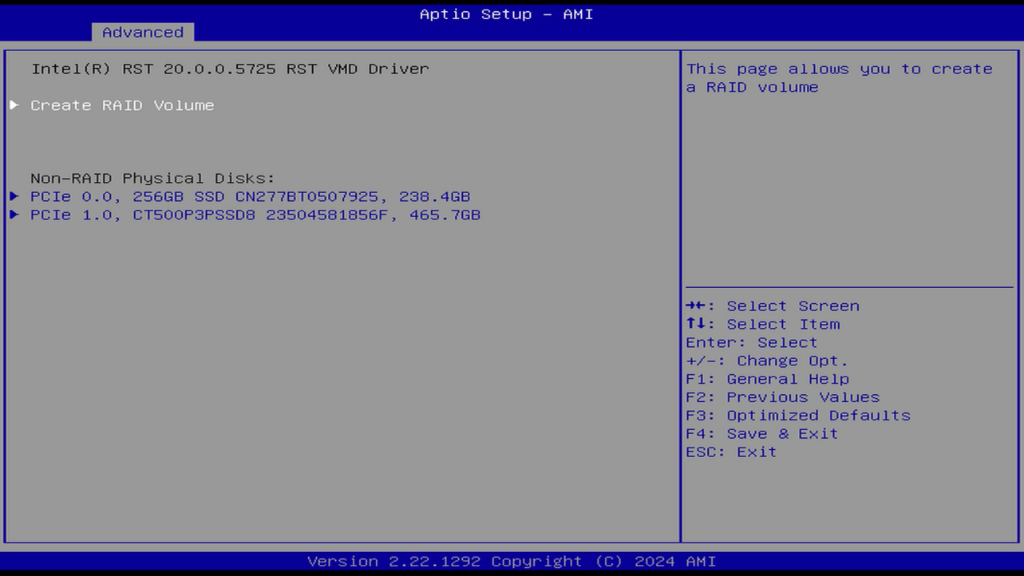
8.In the ["RAID Level"] option, you can set the RAID mode. In RAID 0 mode, the actual hard disk capacity becomes twice the capacity of the smallest SSD, the read and write speeds increase. If you remove any one of the SSDs, you won't be able to enter the system. The BIOS will display (fail). After reconnecting the SSD, you still won't be able to enter the system, and the boot menu won't be able to read the disk. You need to restart it to restore normal operation. In RAID 1 mode, the actual hard disk capacity becomes the capacity of the smallest SSD, the write speed decreases, and you can still enter the system after removing any one of the SSDs. The BIOS will display "RAID function degraded" (Degraded).

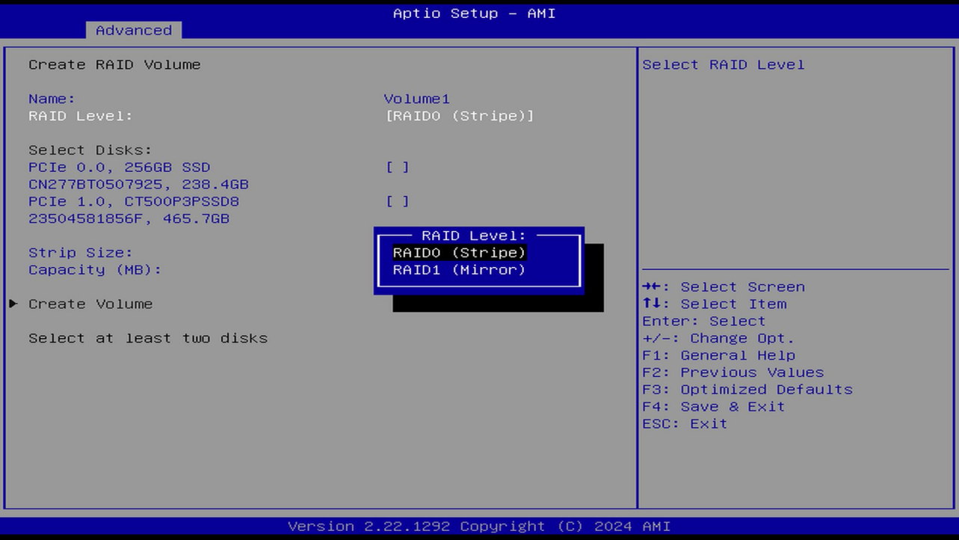
9.Here, take RAID 0 as an example, and select the hard disks that need to form the RAID.

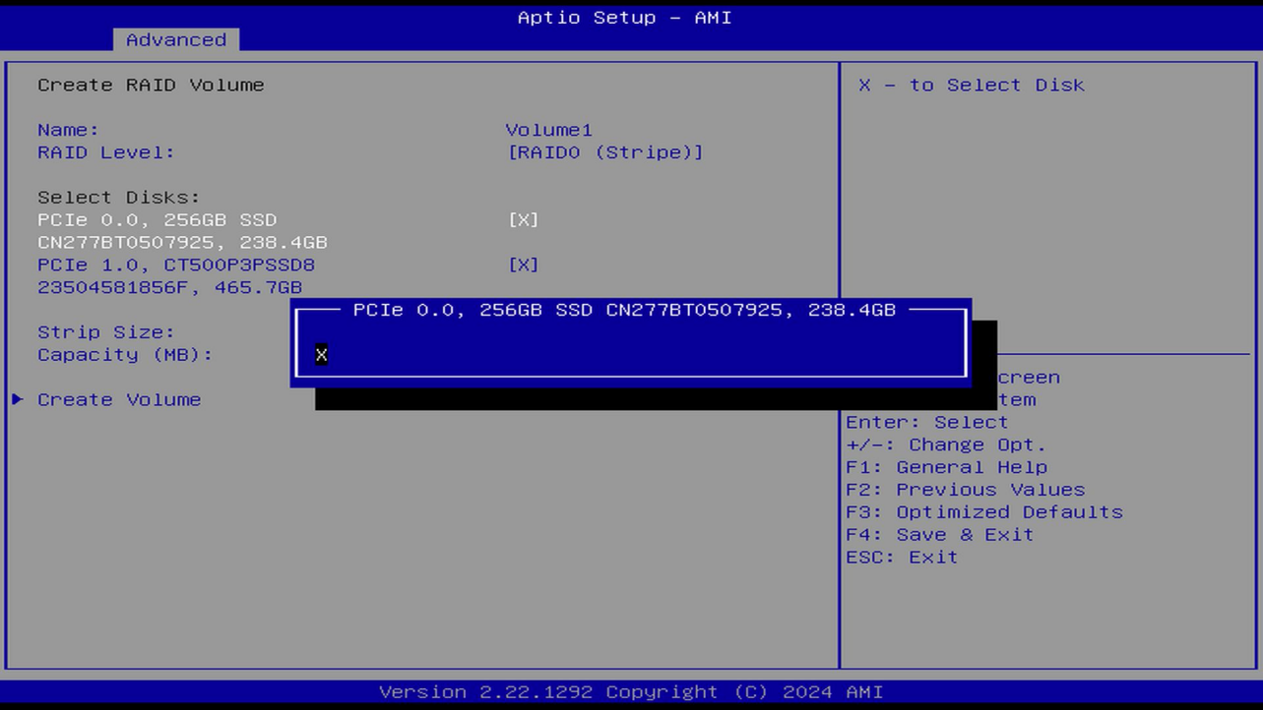
10.After checking the hard disks, click ["Create Volume"] to create the disk array.
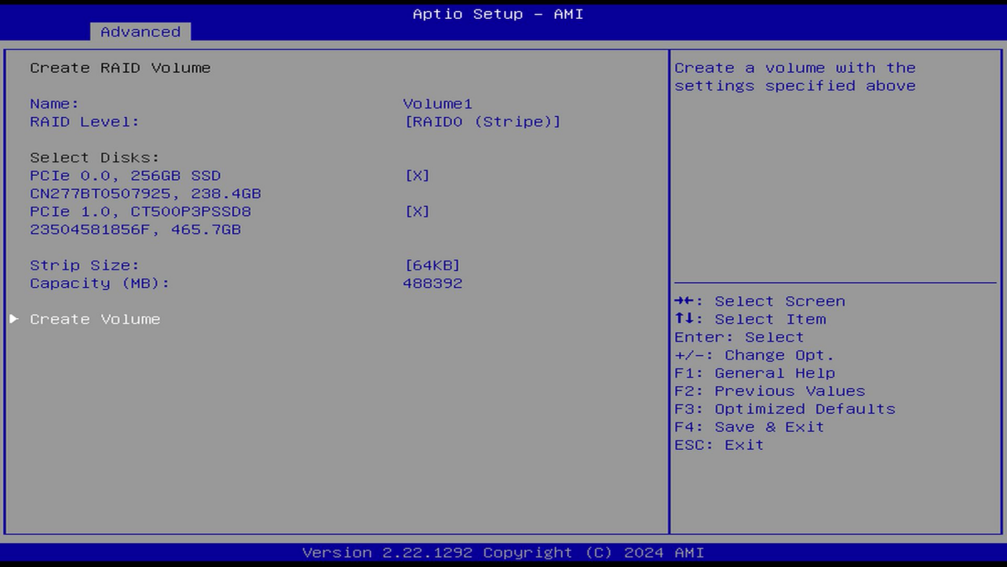
11.By now, the RAID disk array has been created, and it will display ["Normal"] indicating that it is in normal condition.
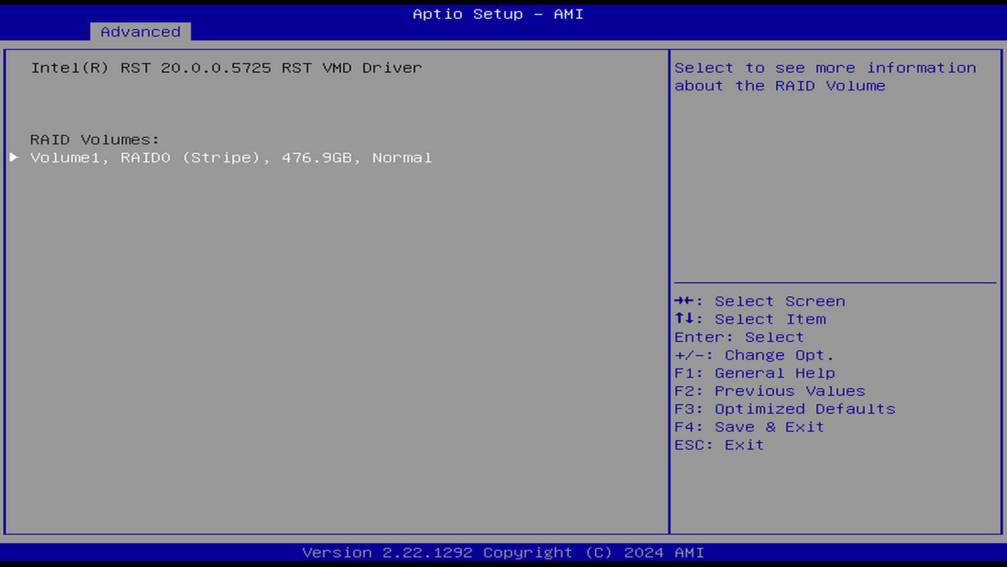
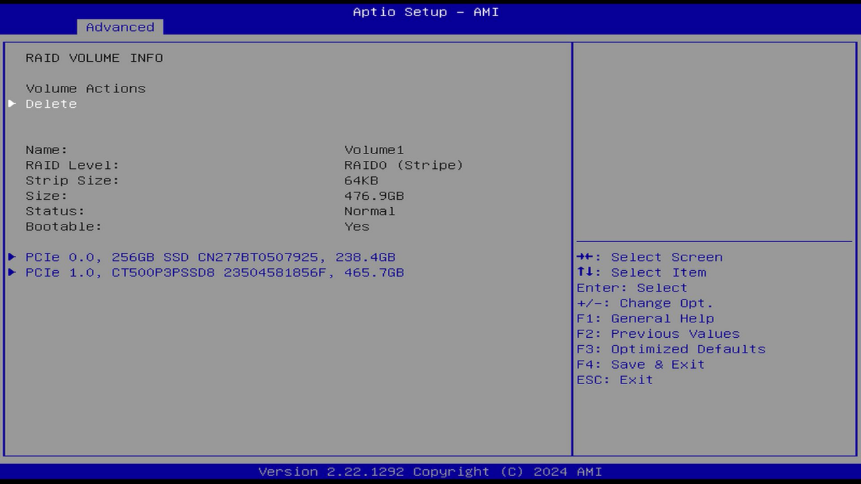
12.Return to the previous level, insert the prepared Windows 11 system installation USB flash drive, press "F4" to save the settings and restart.
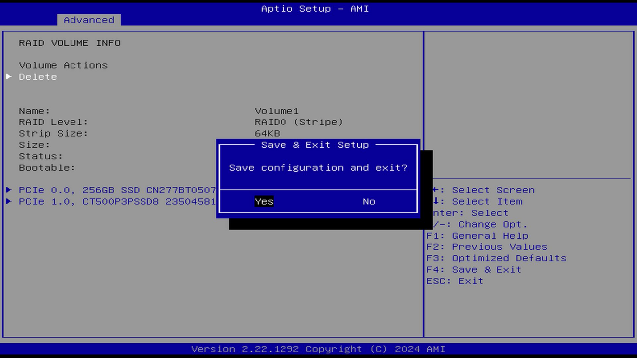
13.Since the hard disk has been formatted, the system installation page will automatically appear when you turn on the computer. Click "Next" to start the system installation process.
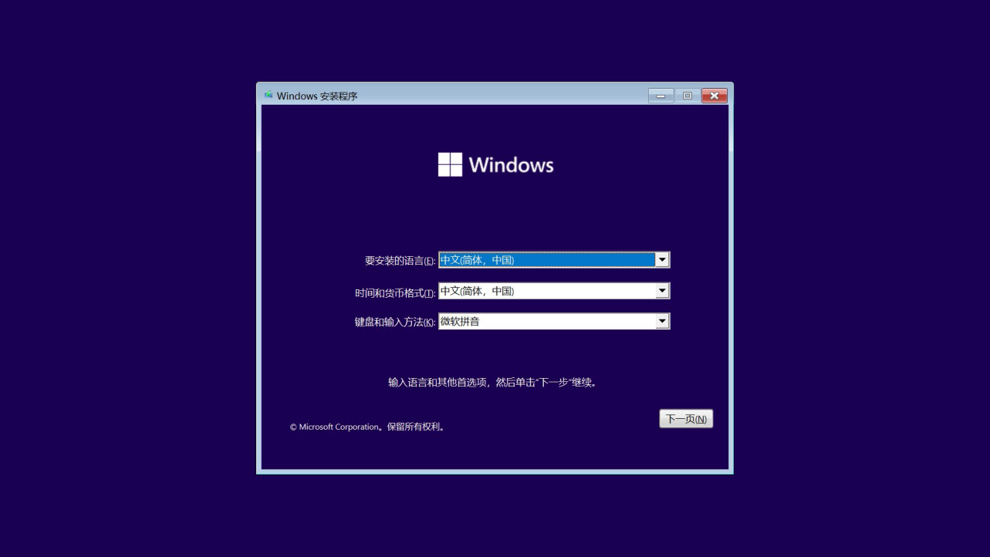
14.Enter your Windows activation code. If you don't have an activation code, you can choose "I don't have a product key" to skip this option first and activate it after entering the system.
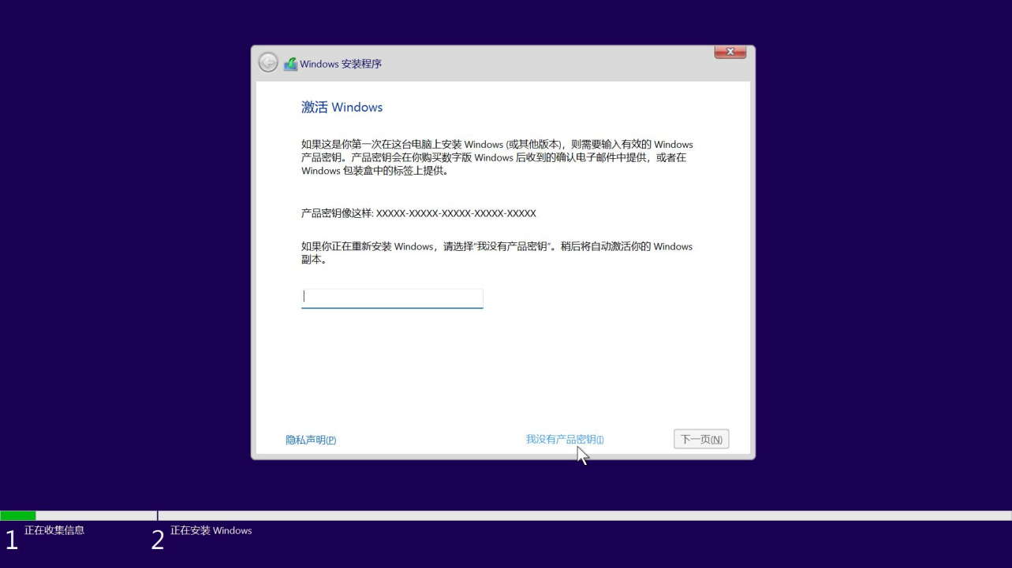
15.Select the system version you want to install. Here, it is recommended that you install Windows 11 Professional Edition, which has more available functions.
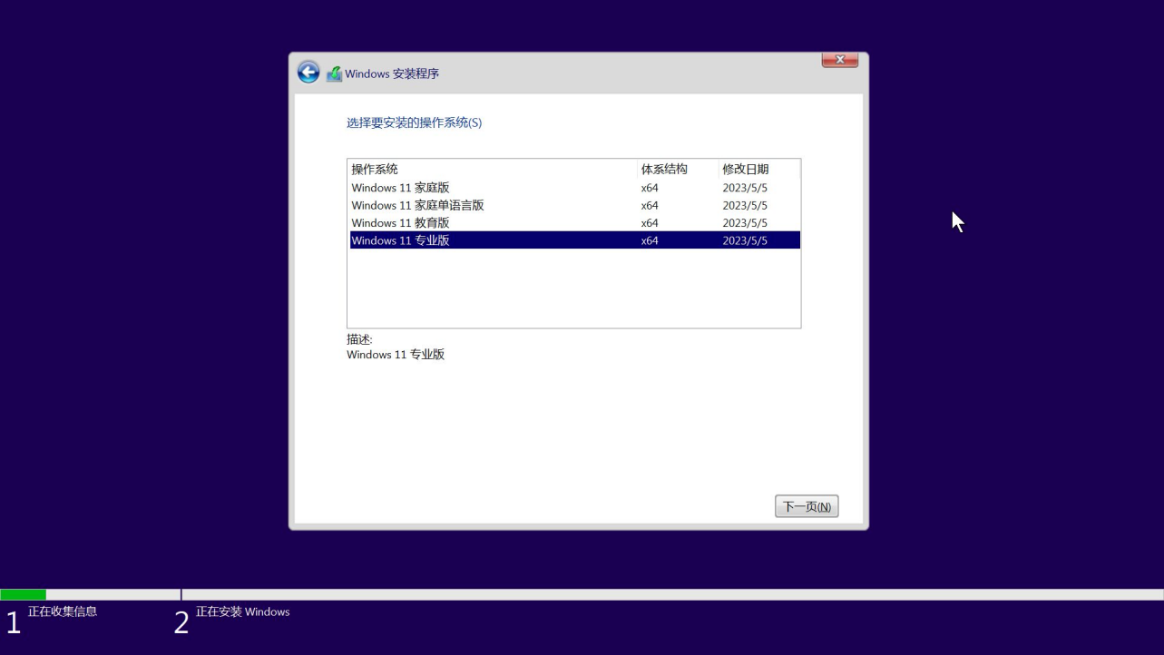
16.Select "Custom: Install Windows only" to install a brand-new Windows system.

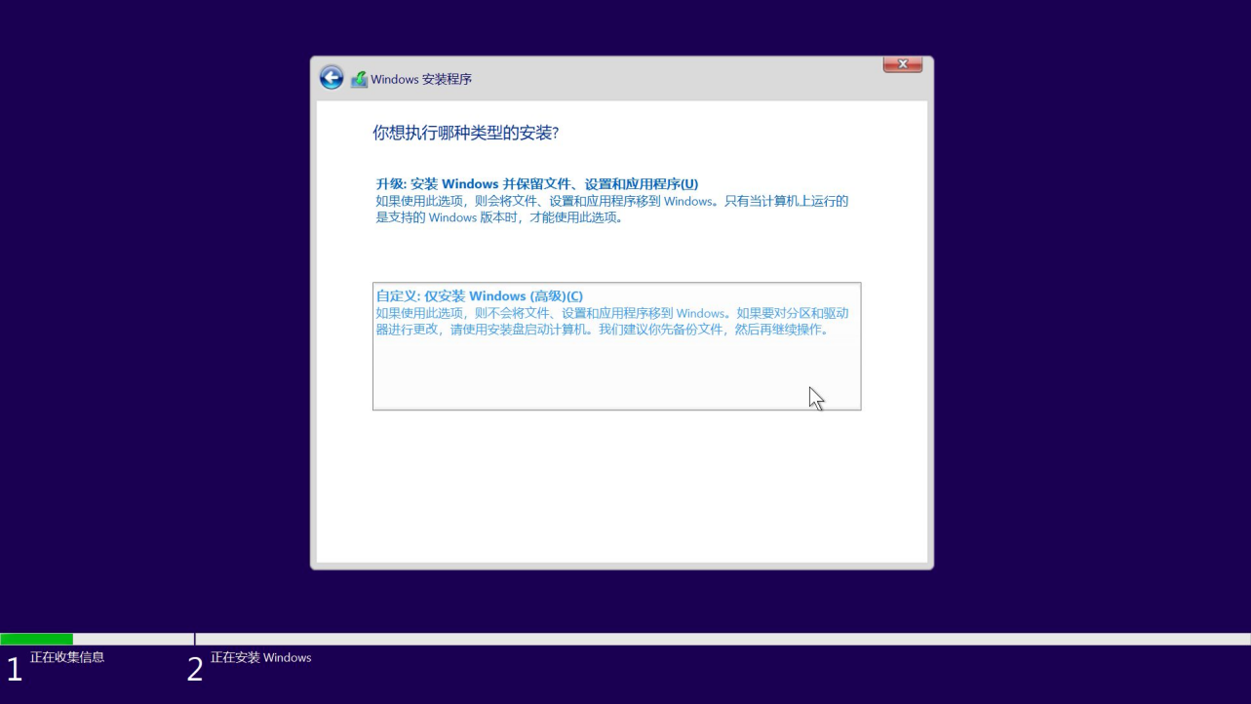
17.You will see that the disk list is blank. Click "Load Driver".

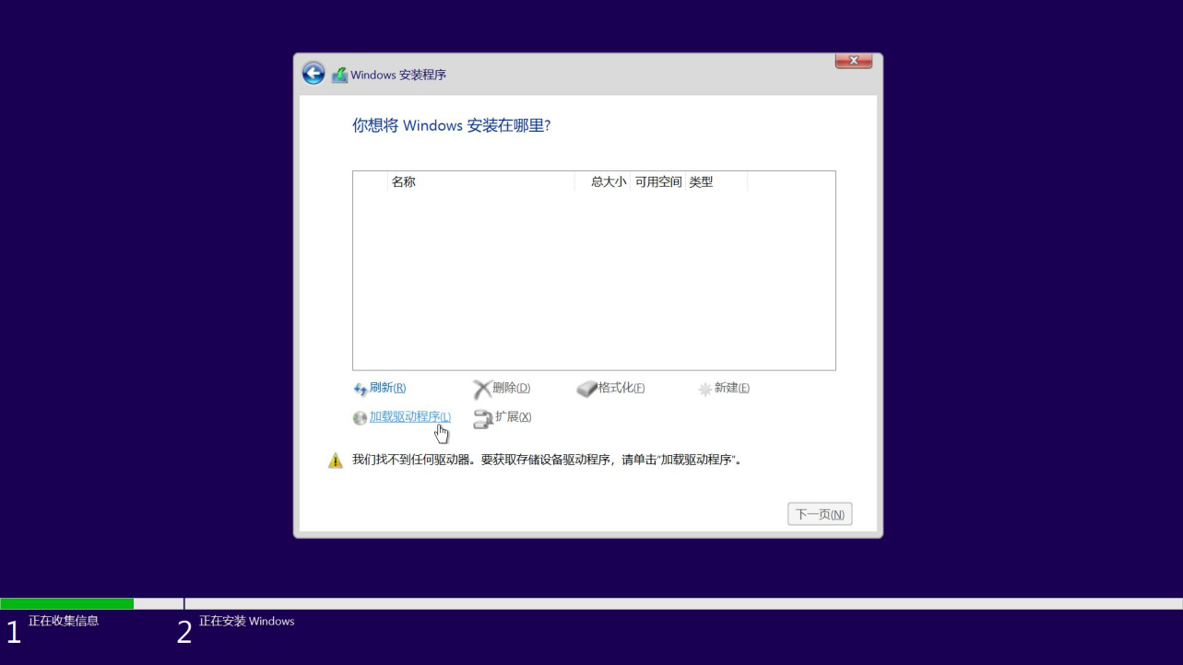
18.Click "Browse".
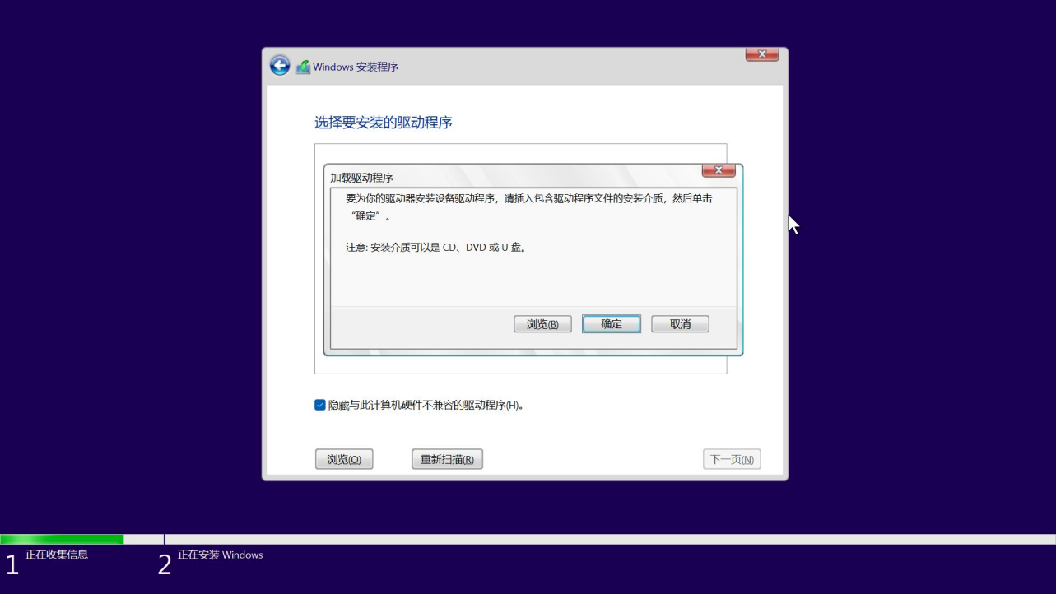
19.Select the path where the Windows RAID driver files are stored, find the "VMD" directory, and click "OK".
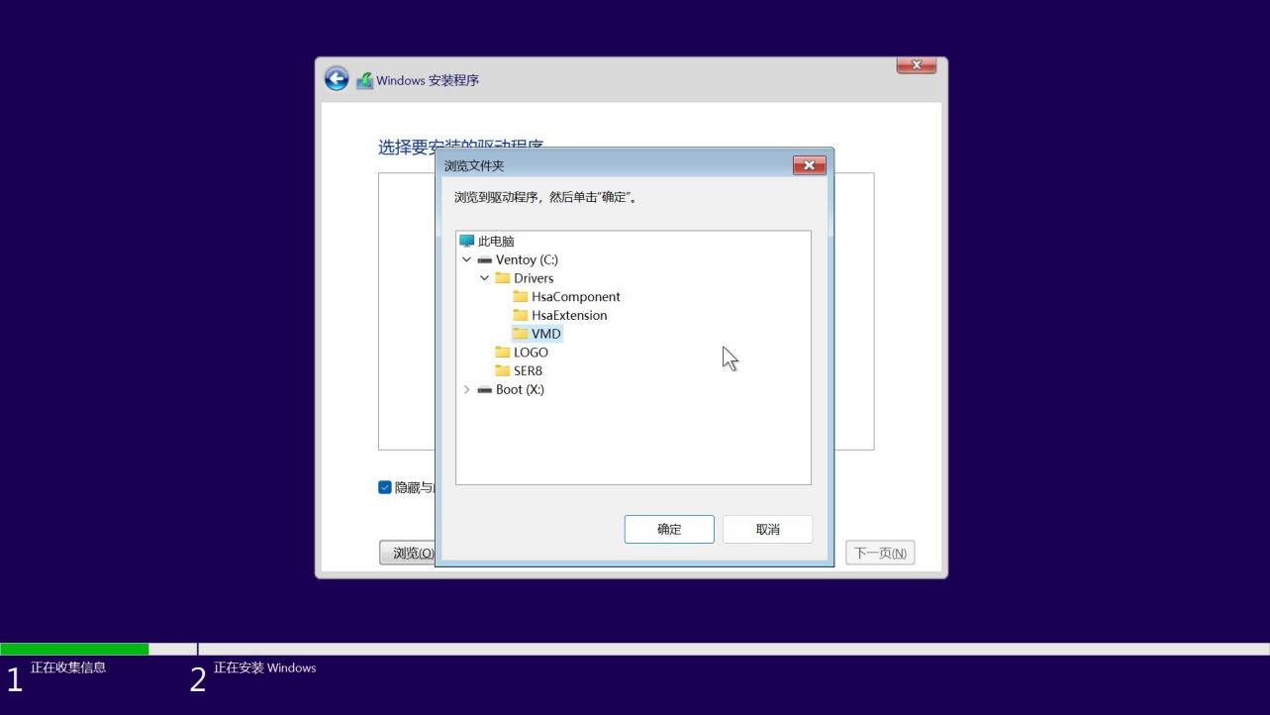
- Uncheck "Hide drivers that are incompatible with this computer". Multiple drivers will appear in the list. Click "Next" to automatically install them.
After the driver installation is completed, the hard disk will be displayed normally. Click "Next" to start the normal process of installing the system.

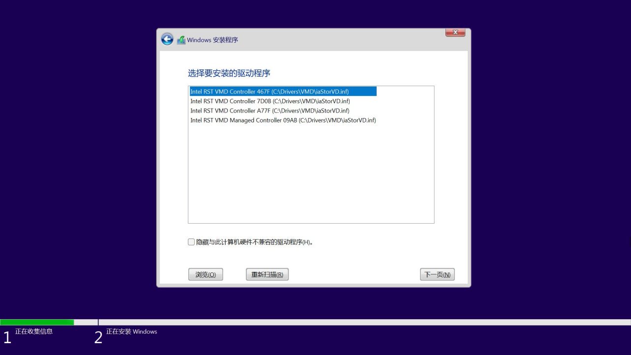
21.Wait patiently for the system installation to be completed.

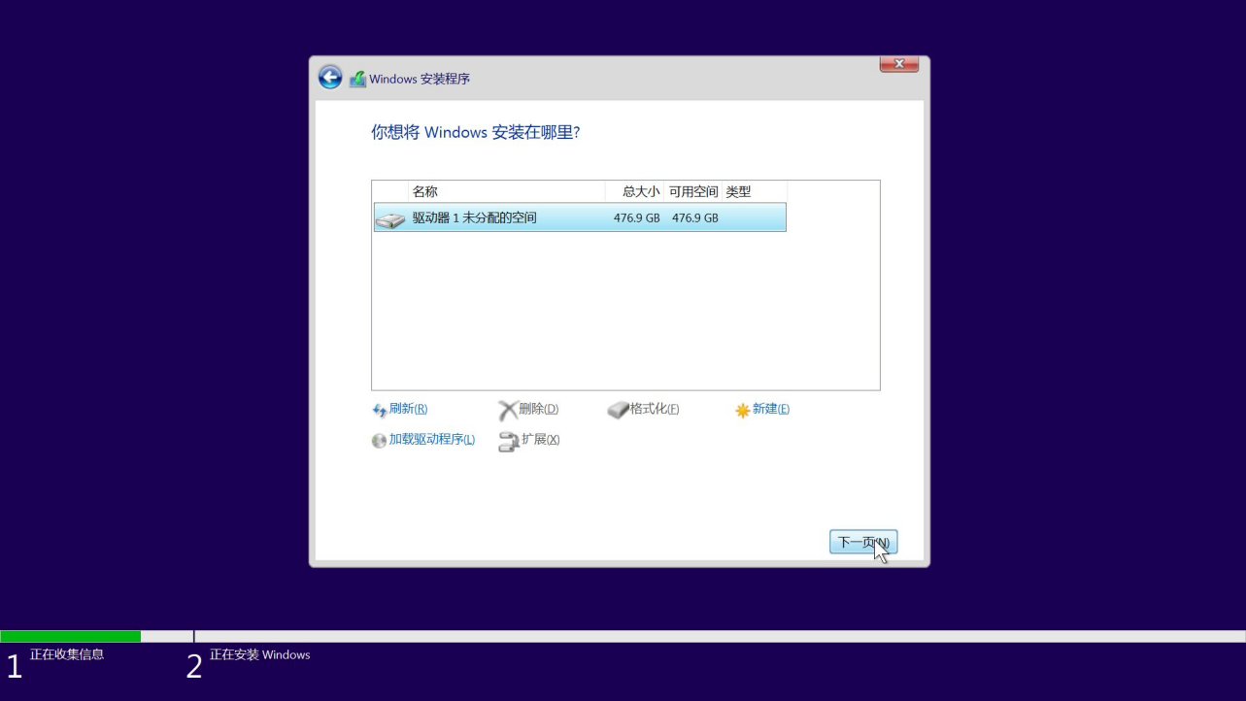
22.Wait patiently for the system installation to be completed.

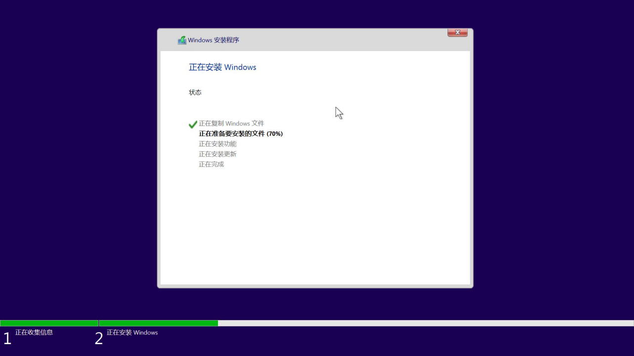
23.After the system installation is completed, it will automatically restart and enter the system initialization page. After simple configuration, you can enter the desktop.
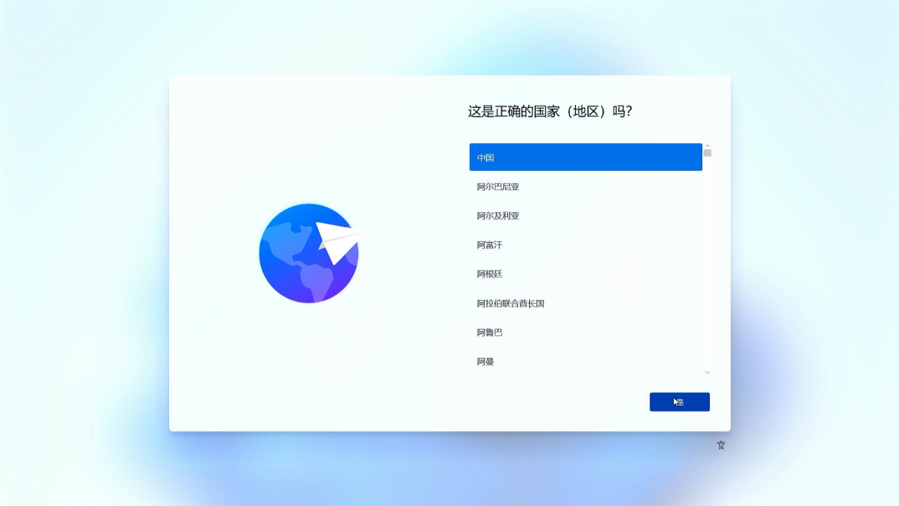
If you need to log in to your Microsoft account online, you can press "Shift + F10" to bring up the CMD manager, enter "oobe.cmd" to run it. After automatic restart, the option to skip online connection will appear. Skip the online connection, enter the system, and then log in to your Microsoft account.

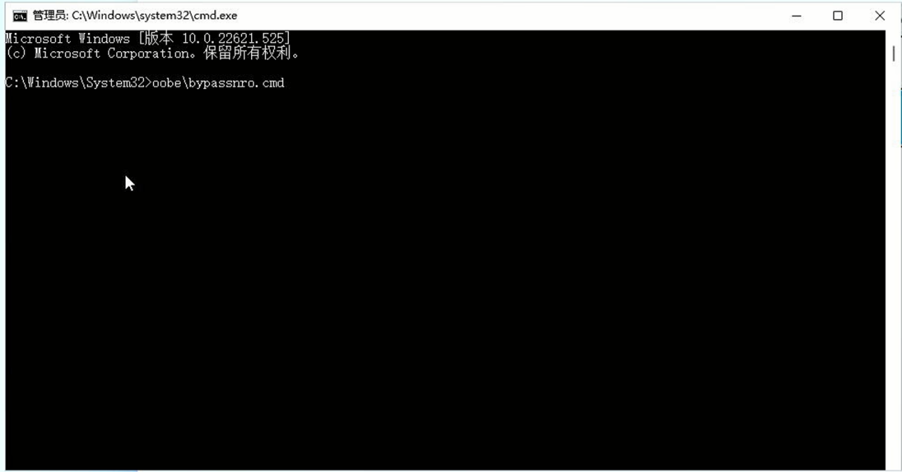
24.Check the local disk space, and you can see that the two hard disks have been combined into one disk, and the speed has been greatly improved.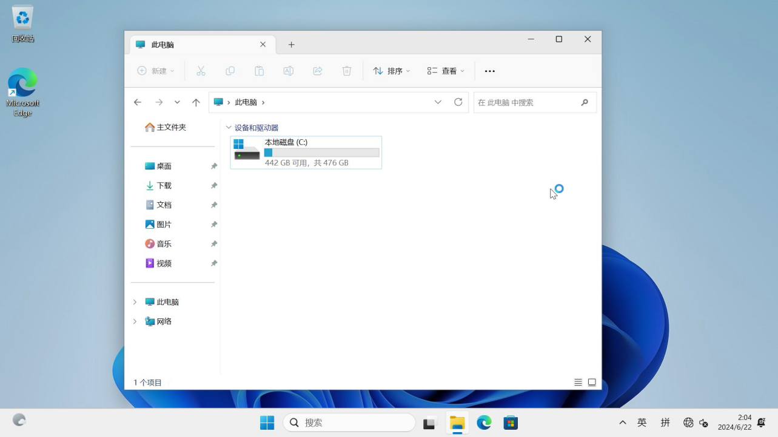
Precautions: After the RAID array is set up, try not to update the BIOS or clear the COMS. If you have carried out these operations, you need to set the "Advanced - System Agent (SA) Configuration - VMD setu menu - Enable VMD controller" in the BIOS to "Enabled" again.

