1. Prepare a USB disk（USB drive） with a storage capacity of at least 16 GB
2. Right click and select format... Format U disk to FAT32 format,and change the
Volume label to WINPE ,click start to finish formatting
- Copy the files to USB disk as below, and it must be in the root directory of USB disk.

(The specific file is subject to the file you open,and the following just a sample)

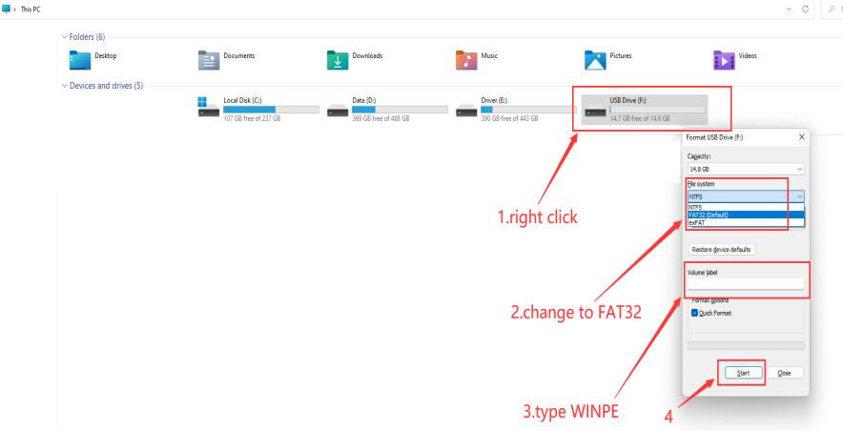

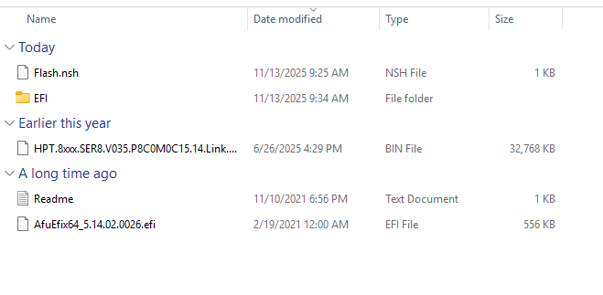

4. Restart the computer, press F7 repeatedly on the boot logo interface, and select
USB boot/partition in the boot options,press enter

5.BIOS will automatically start flashing. PC will restart after the update is completed.
