1. Prepare a USB disk（USB drive） with a storage capacity of at least 4 GB
2. Right click and select format... Format USB disk to FAT32 format,and change the
Volume label to WINPE ,click start to finish formatting
- Copy the BIOS file to USB disk, and it must be in the root directory of USB disk.

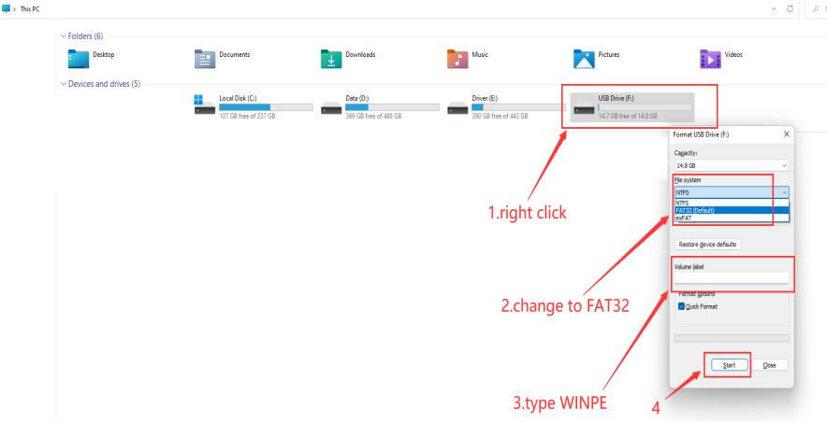

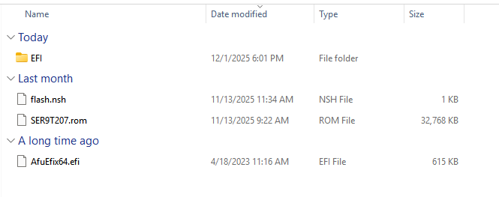

4. Restart the computer, press F7 repeatedly on the boot logo interface, and select
USB boot in the boot options
5.Type fs3:(you may type fs0:-fs4:,depends on where the USB drive is ,do not forget the colon) , then press enter. If the BIOS is updated automatically, you can ignore the the step and the next ones.
6.Type dir or ls , press enter so that you can locate the files
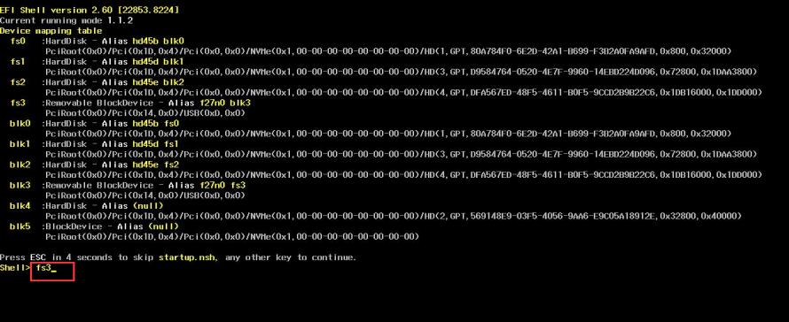
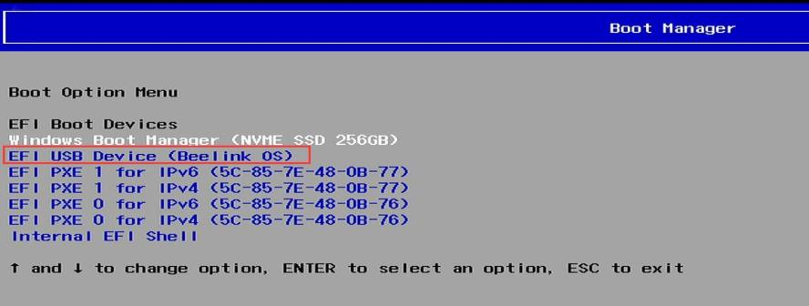
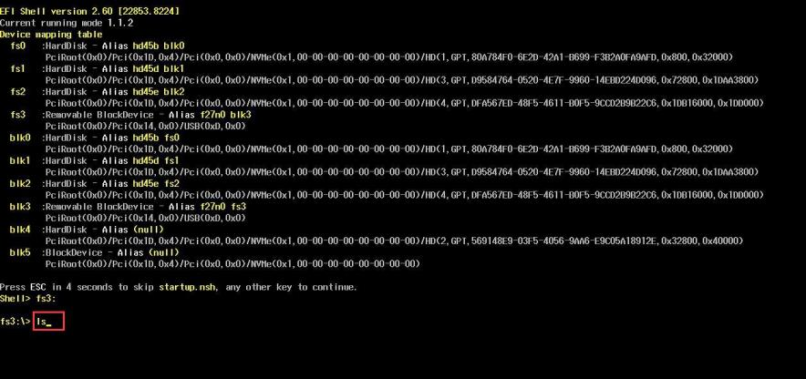
7.Type flash, press tab,then press enter.
8.Start flash, If there is a similar reminder, enter exit.
