1. Prepare a USB disk（USB drive）
2. Right click and select format... Format USB disk to FAT32 format,and change the
Volume label to WINPE ,click start to finish formatting
- Unzip the file and Copy the UEFI_Update_BIOS_07 file to USB disk, and it must be in the root directory of USB disk.

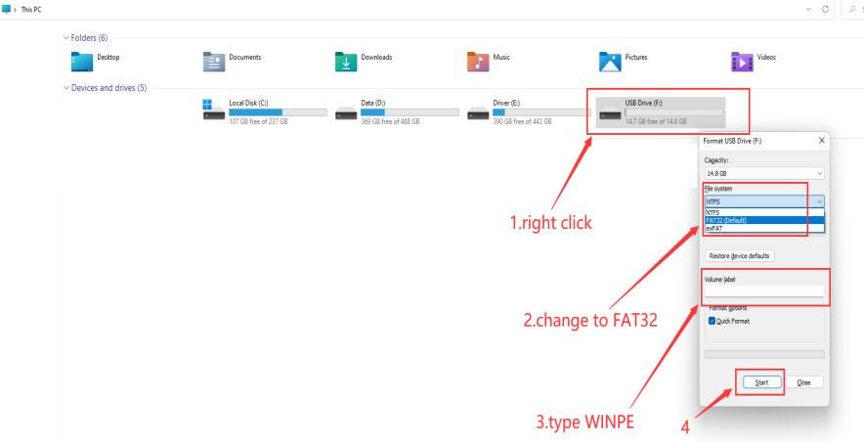

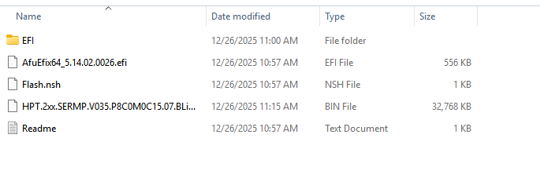

4. Restart the computer, press F7 repeatedly on the boot logo interface, and select
USB boot in the boot options
5.If the BIOS flashes automatically, wait till it finishes. If not, type fs3:(you may type fs1:-fs4:,depends on where the USB drive is ,do not forget the colon) , then press enter
6.Type dir or ls , press enter so that you can locate the files
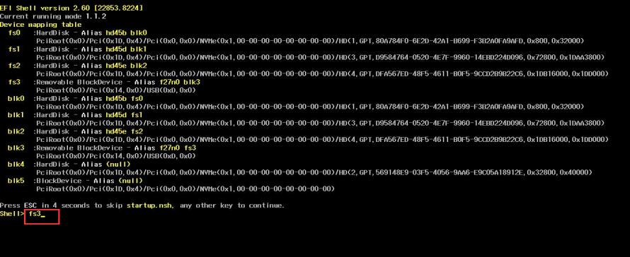
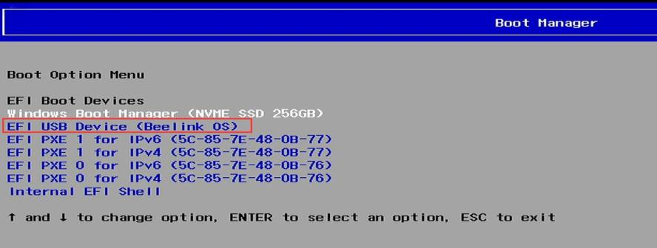
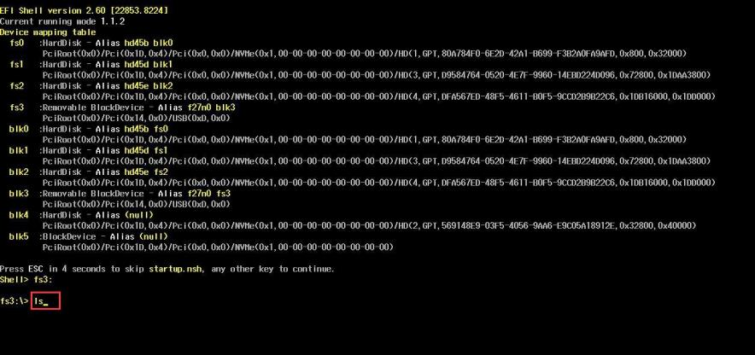
7.Type flash, press tab,then press enter.
8.Start flash, If there is a similar reminder, enter exit.
