GTi14 Setting Up RAID Tutorial
GTi14has two internal NVme slots，supporting RAID function. Currently, the following RAID modes are supported.
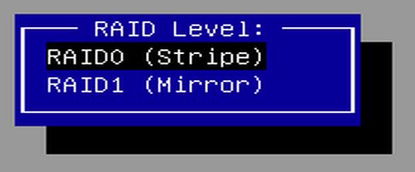
Volume : Combine multiple hard drives into one large hard drive, also known as JBOD (Just a Bunch Of Disks). It does not require the hard drives to have the same capacity. The final available capacity is the sum of the capacities of each hard drive.
RAIDable: Reserve the hard drive as a potential for future RAID. This means that the hard drive is designed to be combined with other hard drives into a RAID array to provide higher performance, fault tolerance, or storage capacity.
RAID 0: Use striping to evenly distribute data on multiple hard drives to improve read and write speeds. The capacity of RAID 0 is the capacity of the smallest hard drive multiplied by the number of hard drives.
RAID 1: Use mirroring to write data to two hard drives simultaneously to ensure data integrity. Each hard drive contains a complete copy of the data. Therefore, when one hard drive fails, the other hard drive can still provide complete data.

If you need to set up the RAID mode, please follow these steps: **Preparation work**:
- Prepare an GTi14 mini PC.
- Prepare two M.2 2280 SSD (select drives with the same or different capacities according to the required RAID mode).
- Use the official Microsoft tool to create a USB flash drive for the Windows 11 system. The provided system USB flash drive cannot be used for DOS installation. For the creation method, please refer to [Windows 11 official system installation tutorial].
- Download the RAID driver and unzip it, then place it in the root directory of the Windows 11 system installation USB flash drive. Download address:
https://dr.bee-link.cn/download/dXBsb2Fkcy9HVEkvR1RpMTQvRHJpdmVyL0dUaTE0LVJBSUQtRHJpdmVyXzIwMjQtMTAtMDlfMy01MS0xNy56aXA=/h/d78f641b2d1ef71f34aaf345b657abd3
- g. Note that creating a new RAID mode will delete all current hard drive space and data. Please back up your data in advance and operate with caution.

Setup details：

1.Please repeatedly press delete key as soon as you turn on the PC, go to BIOS.
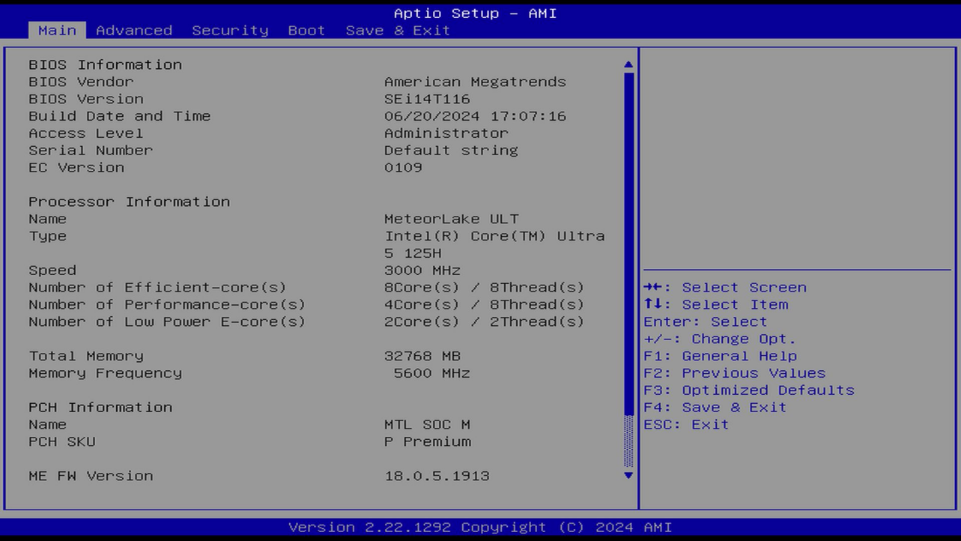

2.Please choose the second menu Advanced,and click the sub-menu System Agent (SA) Configuration ,press enter
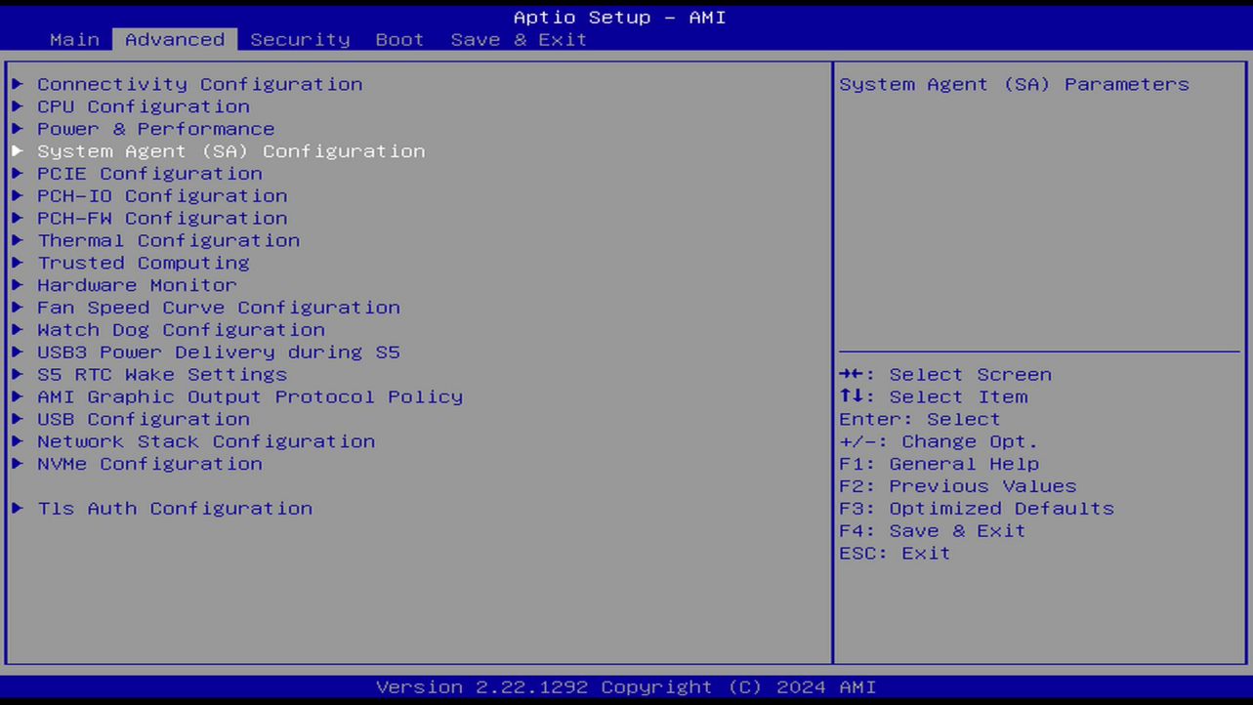

3.Go to【VMD setu menu】,press enter
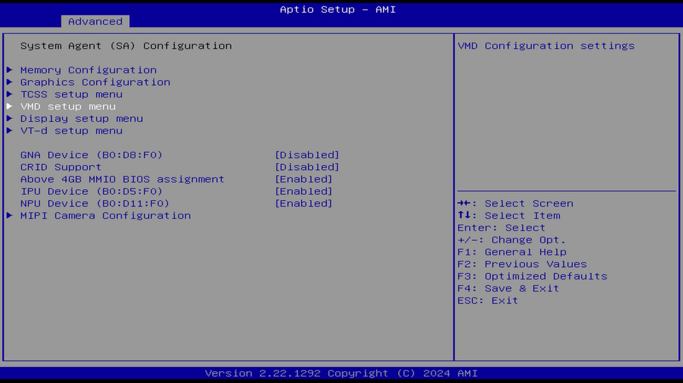

4.Please set【Enable VMD controller】to 【Enabled】, it will enable RAID.
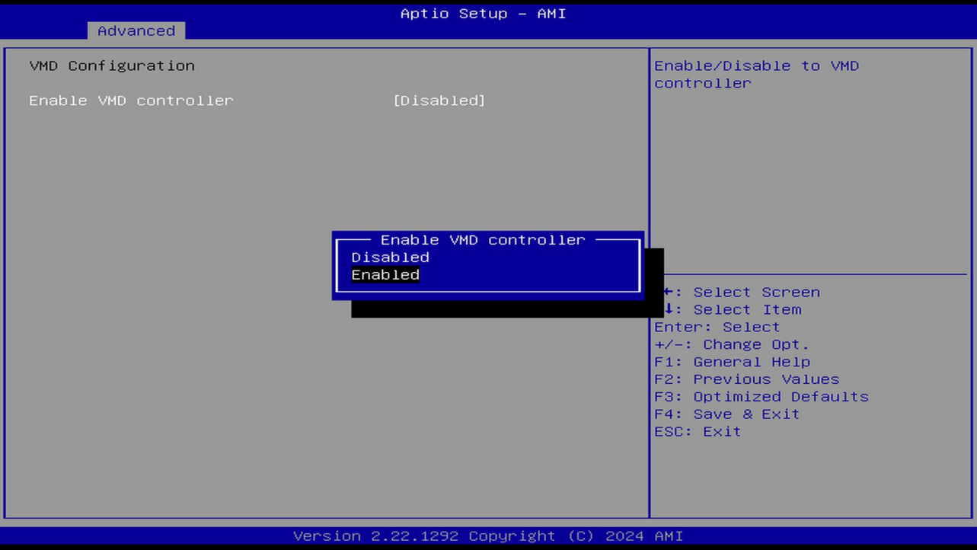

5.After the setting is finished, press F4 to save and exit.
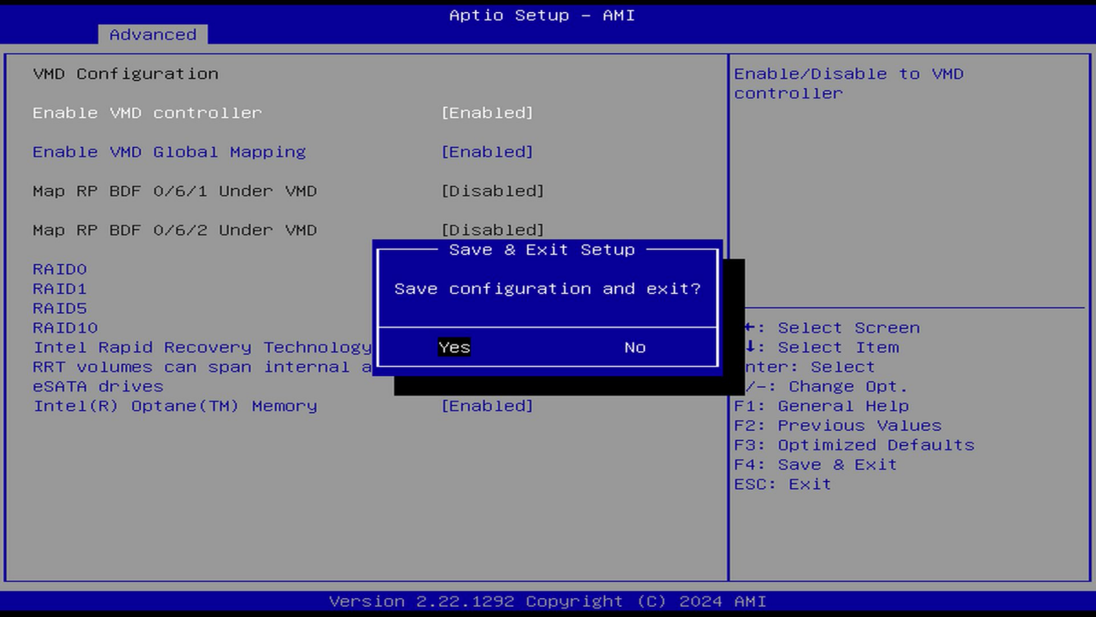

Go to BIOS again, navigate to Advanced menu, you will see the new menu【Intel(R) Rapid Storage Technology】,choose it and press enter.
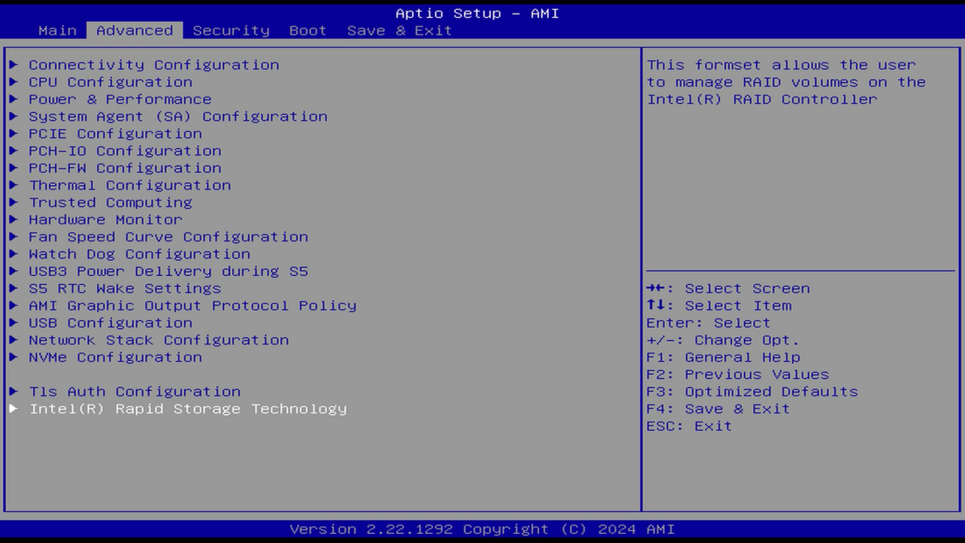

7.Choose【Create RAID Volume】menu
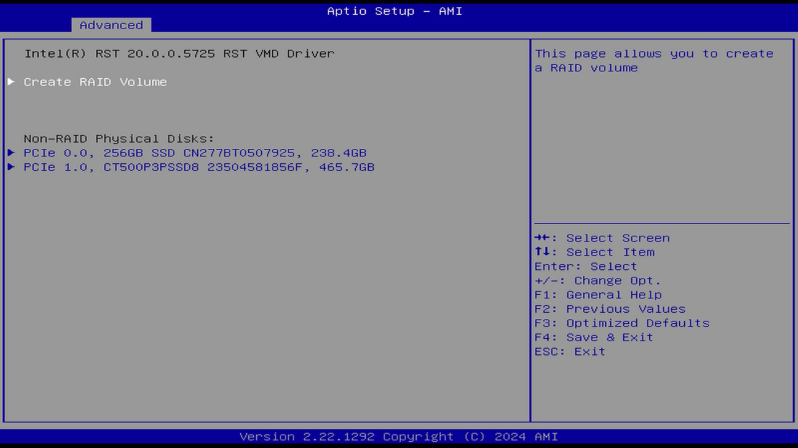

In the “RAID Level” option, you can set the RAID mode. In RAID0 mode, the actual capacity of the hard drive becomes twice the capacity of the smallest SSD. The read and write speed becomes faster. After removing any one SSD, you cannot enter the system. The BIOS shows (fail). After reconnecting the SSD, you still cannot enter the system. The boot menu cannot read the disk. You need to restart the PC to return to normal. In RAID1 mode, the actual capacity of the hard drive becomes the capacity of the smallest SSD. The write speed decreases. After removing any one SSD, you can still enter the system. The BIOS shows that the RAID function is degraded (Degraded).
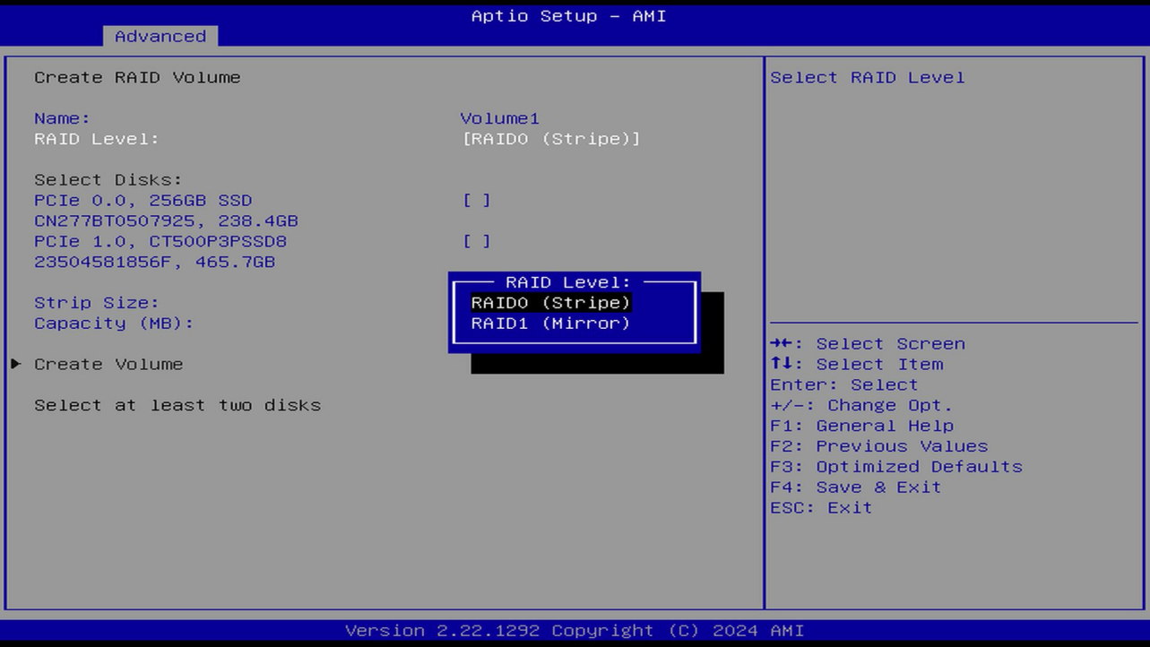

9.We take RAID0 as an example here, choose the disk that need to be grouped into RAID.
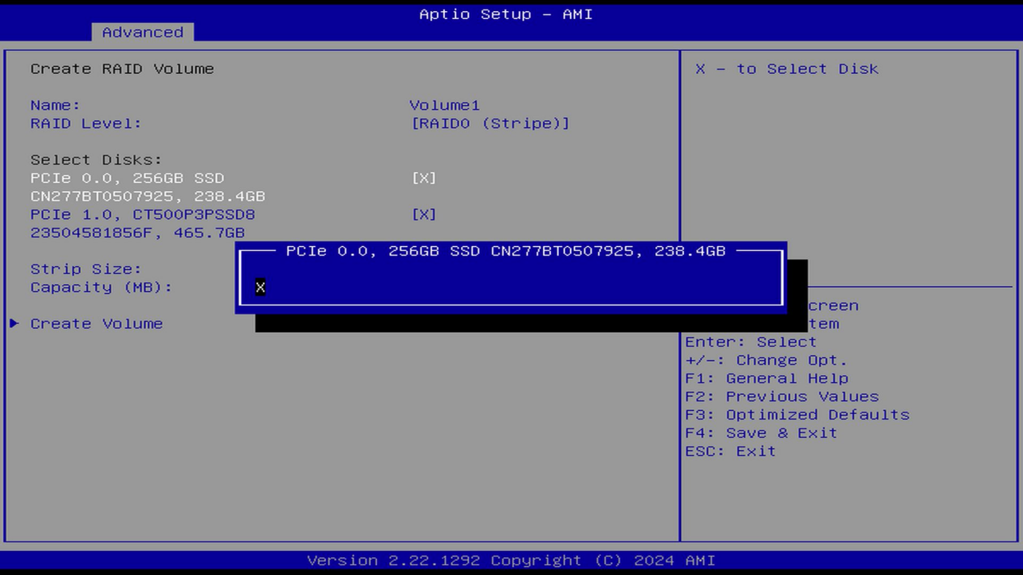

10.After select the disk, click 【Create Volume】to create the disk array.
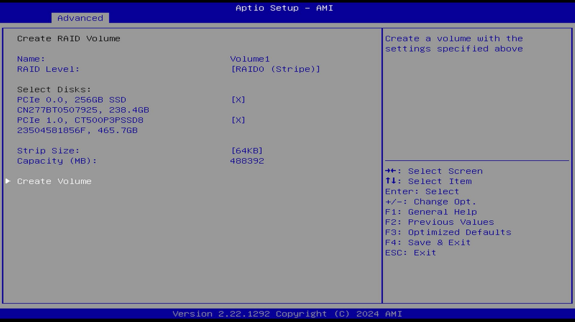

11.At this point, the RAID disk array has been created. It shows that the array is [Normal]
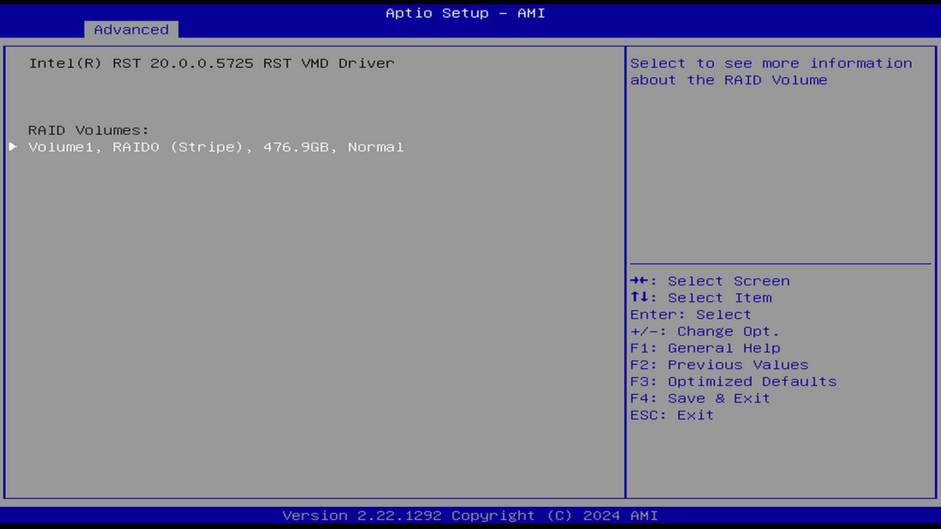
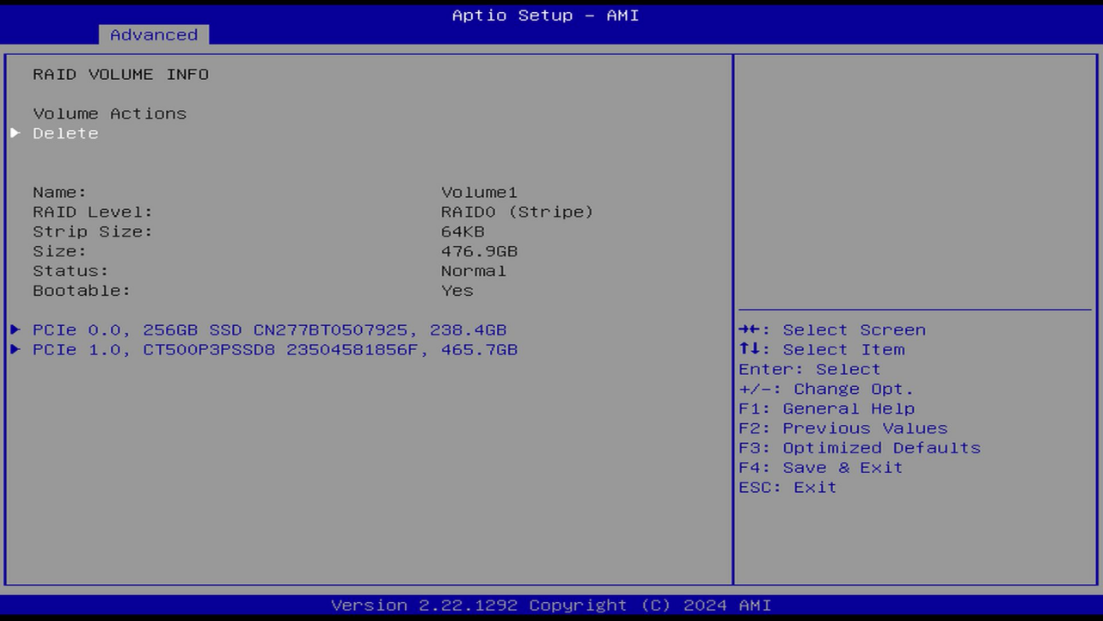

12.After returning to the previous level, plug in the prepared Windows 11 system installation USB flash drive, press F4 to save the settings and restart.
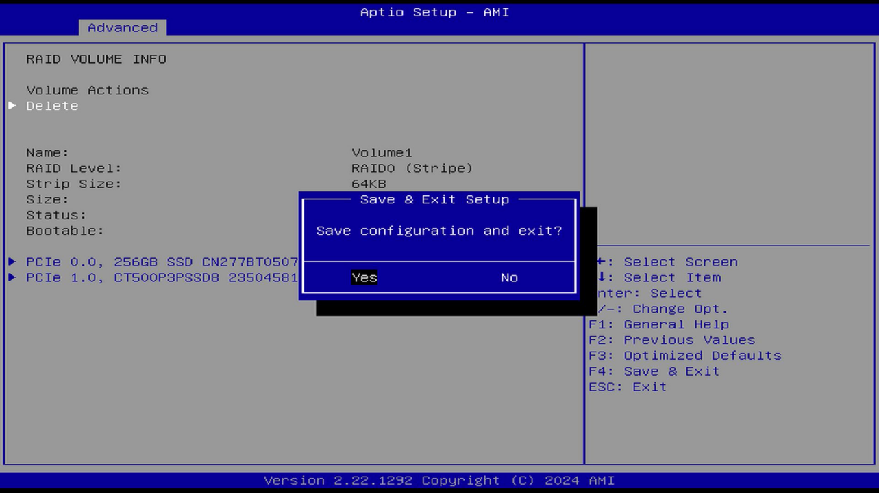

13.Since the hard drive is formatted, the system will automatically enter the installation system page when it is turned on. Click Next to start the system installation process.
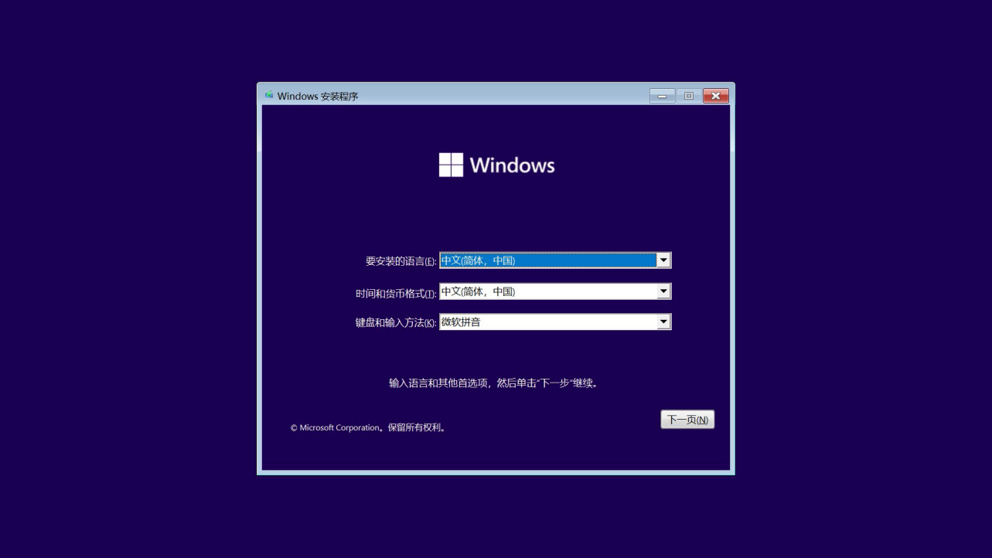

14.Enter your Windows activation key. If you don't have an activation key, you can select “I don't have a product key” to skip this option first and activate it after entering the system.
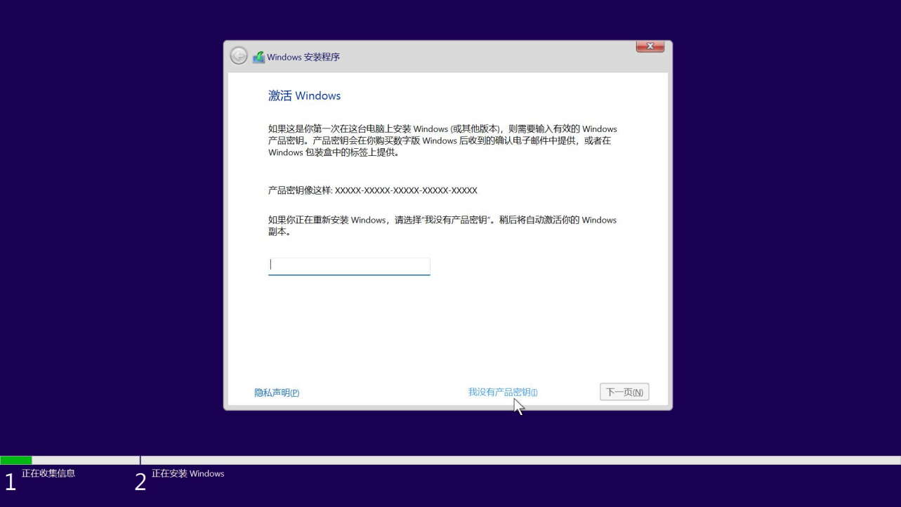

15.Select the system version you want to install. Here it is recommended that you install Windows 11 Professional Edition, which has more available functions.
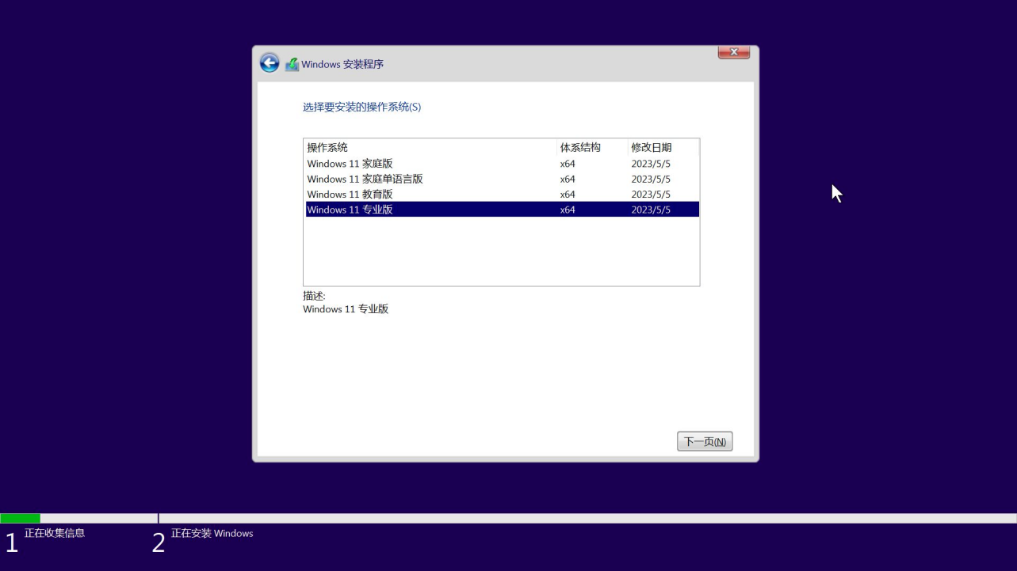

16.Select Custom: Install Windows only to install a brand new Windows system.
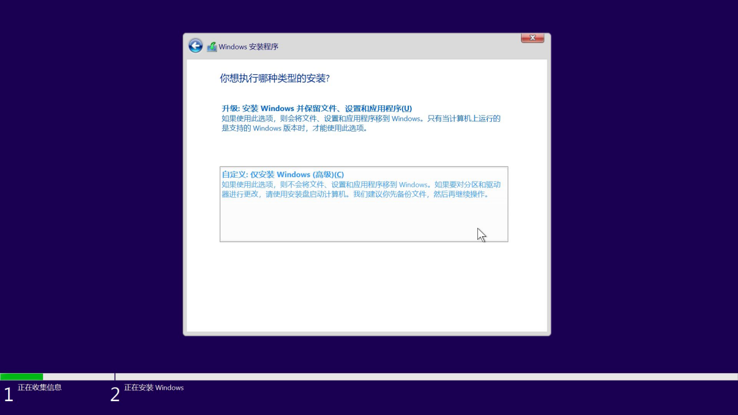

17.You can see that the disk list is blank. Click Load driver.
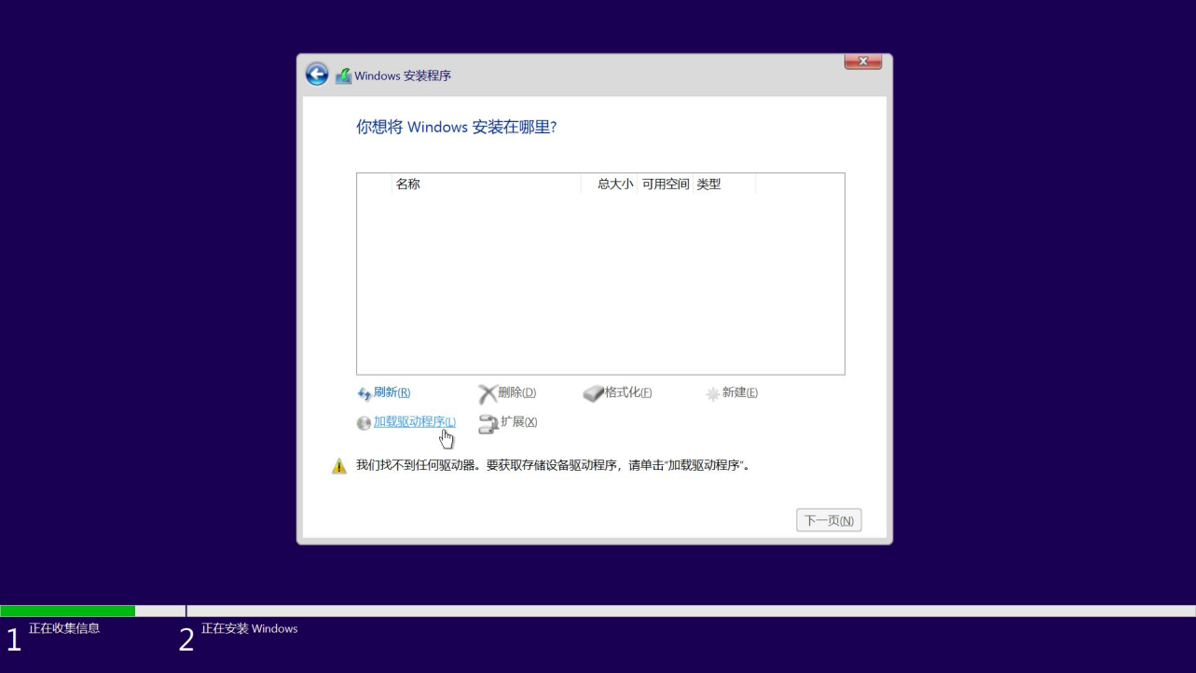

18.Click browse
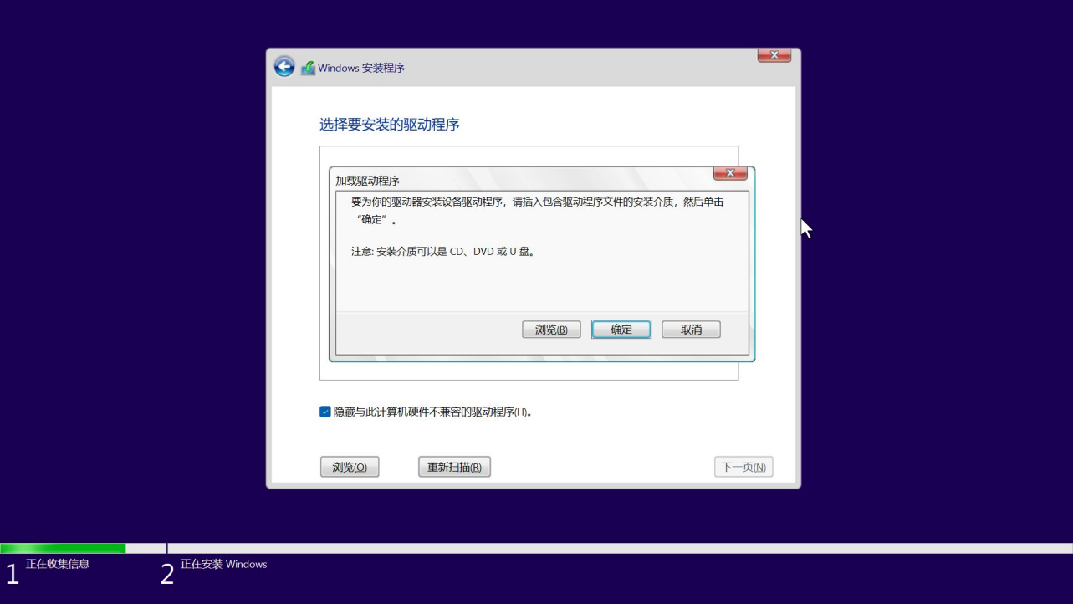

19.Select the path where the Windows RAID driver file is stored. Find the VMD directory and click OK.
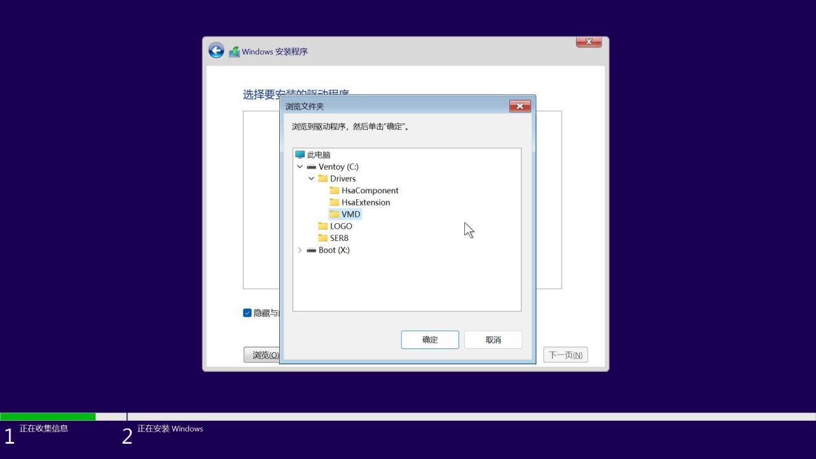

20.Uncheck Hide drivers that are incompatible with this computer. Multiple drivers appear in the list. Click Next to install automatically.
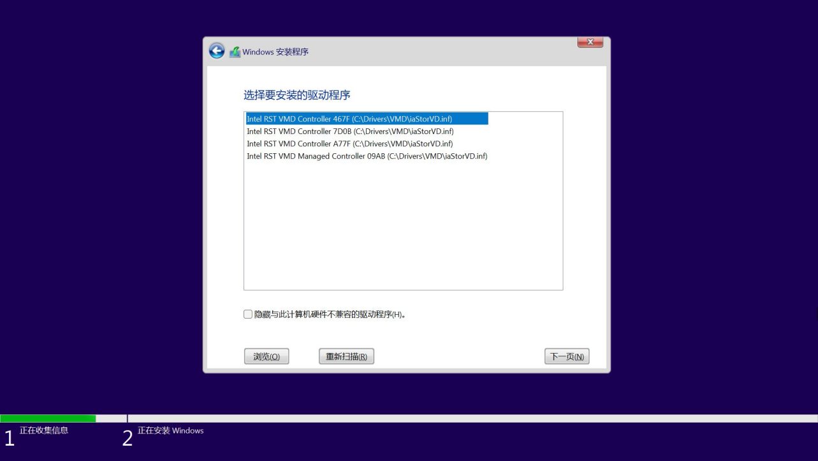
21.After the driver is installed, the hard drive is displayed normally. Click Next to start the normal process of installing the system.

22.Please wait patiently till the system installation is finished.
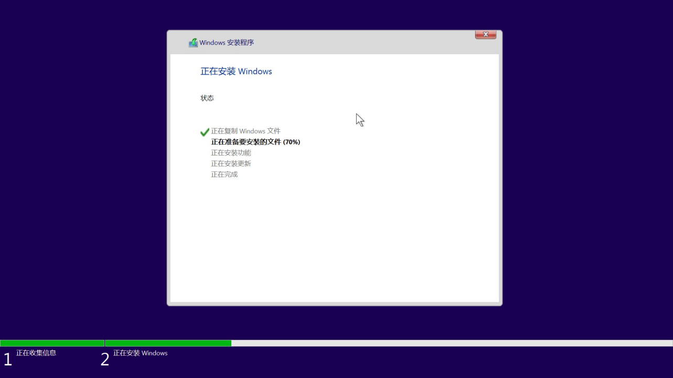

23.After the system is installed, it will restart automatically and enter the system initialization page. After simple configuration is completed, you can enter the desktop.
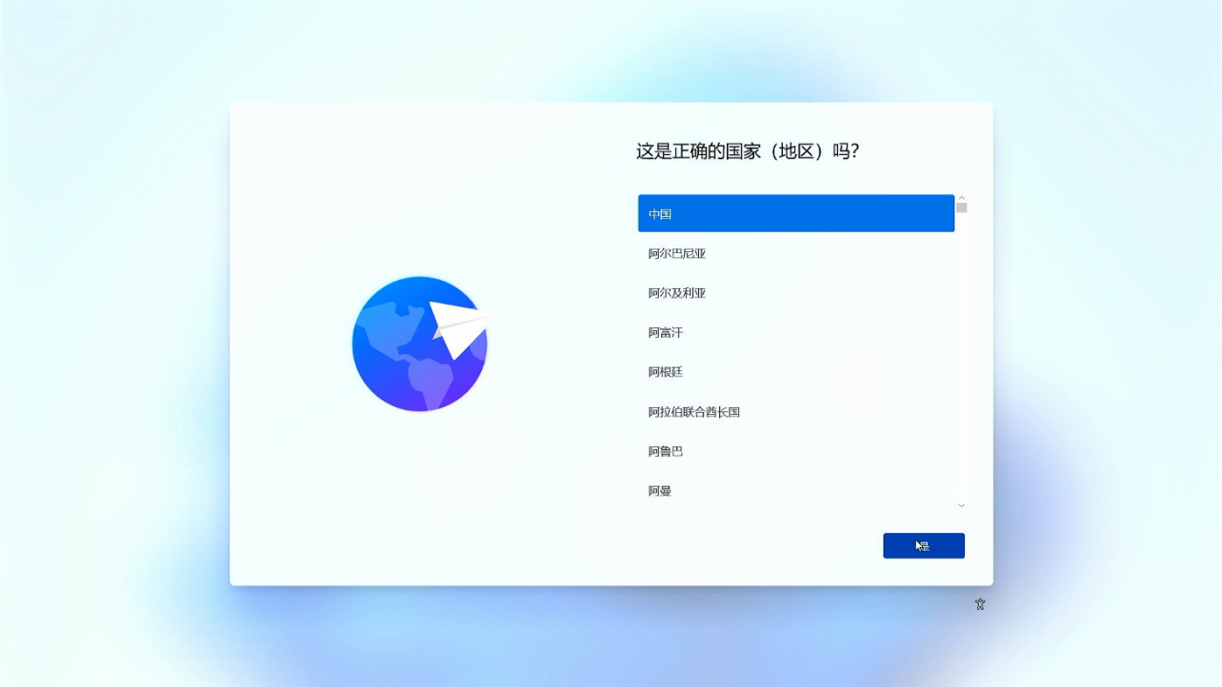

If it is required to log in to a Microsoft account through the Internet, you can press Shift + F10 to call out the CMD manager, type oobe.cmd to run. After automatic restart, there will be an option to skip the Internet connection. After skipping the Internet connection and entering the system, you can log in to the Microsoft account.
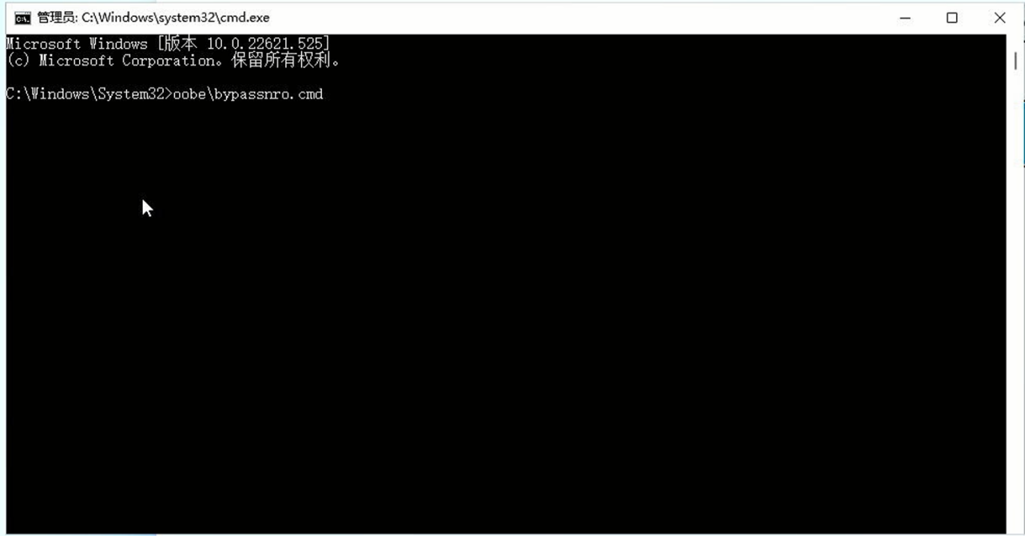
- Check the local disk space. You can see that the two hard disks have been merged into one disk, and the speed has been greatly improved.

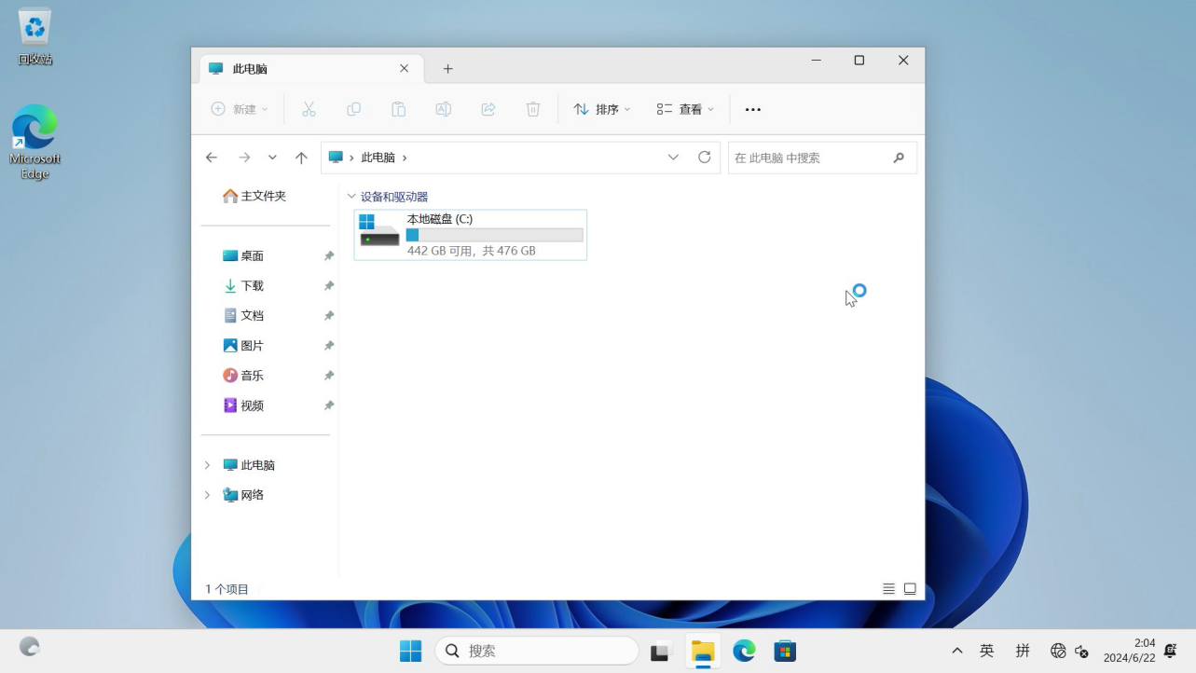
Notes: After the RAID array is set up, try not to update the BIOS or clear the CMOS. If these operations are performed, you need to set “Enable VMD controller” in Advanced-System Agent (SA) Configuration-VMD setup menu-Enable VMD controller to Enabled again in the BIOS.

