1. Use a screwdriver to remove the 4 bottom case screws.
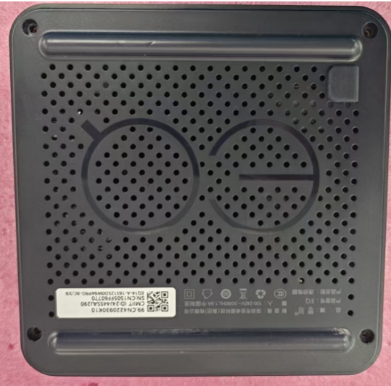

2.Use a screwdriver to remove screws of the power supply.
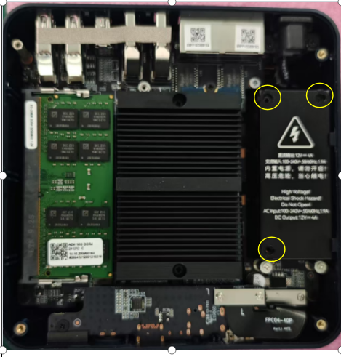

3.①Remove the power supply metal cover and open the power supply insulation sheet.
②Cut a notch of 8mm in length and 6mm in width from the power supply Mylar sheet as shown in the figure.
③Take the power supply silicone, split it into four equal parts along the center line, and attach them to the positions indicated in the figure.
Cut a notch of 8mm in length and 6mm in width from the power supply Mylar sheet
Split power supply silicone into four equal parts along the center line, and attach them to the positions indicated in the figure.
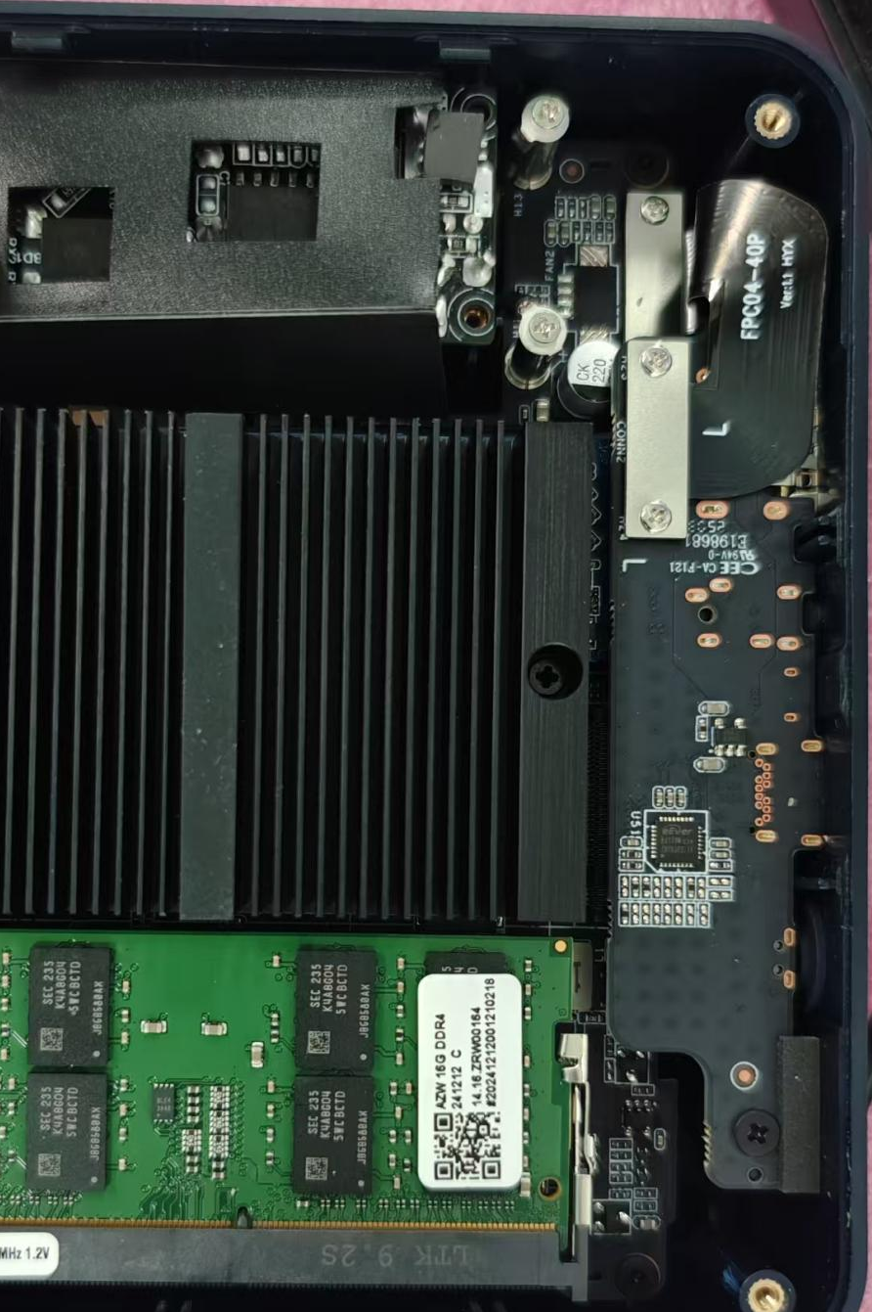

- Restore and reset part 01 (insulation sheet), part 02 (power supply cover), and part 03 (bottom case) one by one in their original positions.

