1，Please repeatedly press delete key as soon as you turn on the PC, go to BIOS. Please use arrow key to choose security option 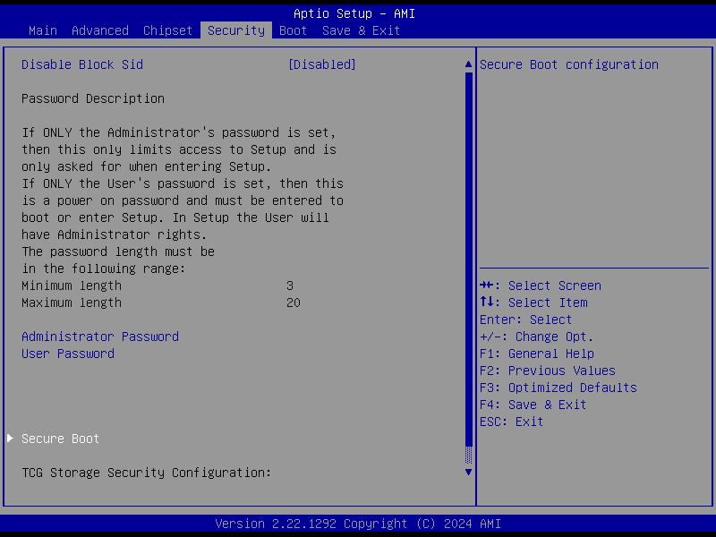

2，On the security page, please use up and down key too choose Secure boot, press enter to go to secure boot page. 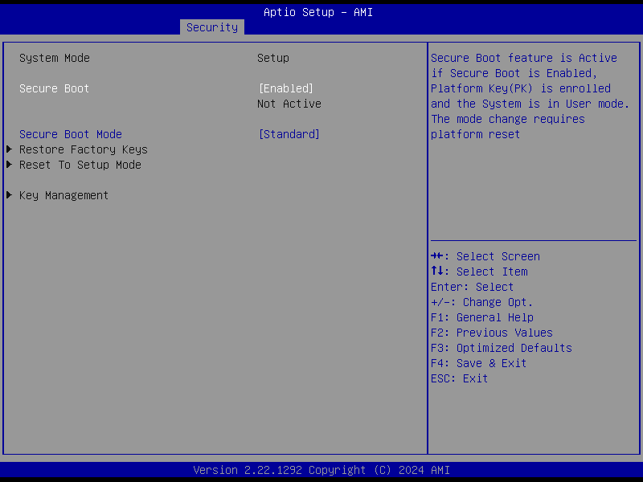

3, On the secure boot page, please set Secure boot to enabled,and please use up and down key to select Secure boot mode, and set it to custom. Then press F4 key to save and exit. If the secure boot is not active yet, please change the secure boot mode to standard and press F4 to save and exit.
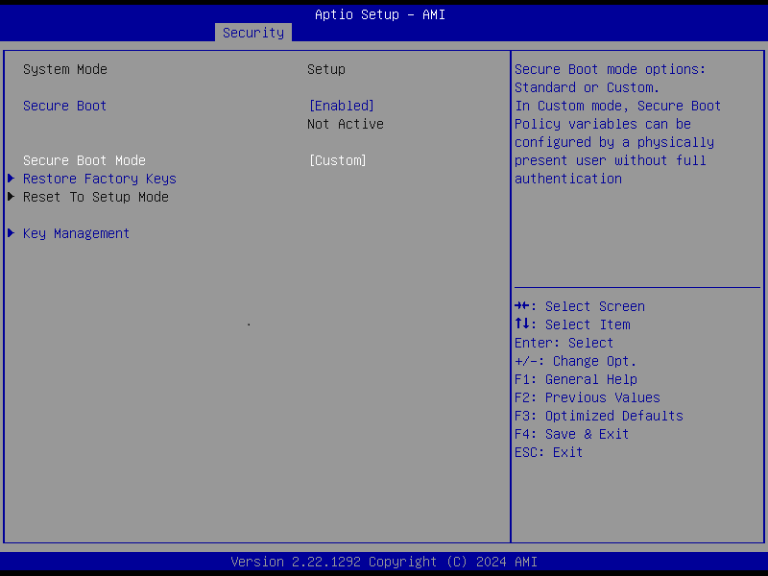
- Please use up and down key to choose Restore factory keys,and press enter, the window” Install factory defaults ” will pop up.
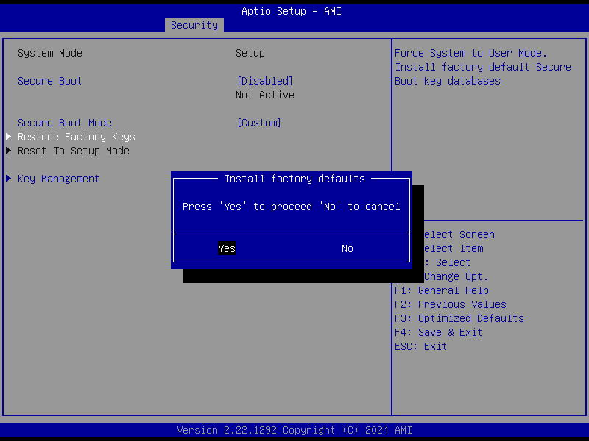
- Please choose Yes, and press enter,the window of “Reset Without Saving “ will pop up.
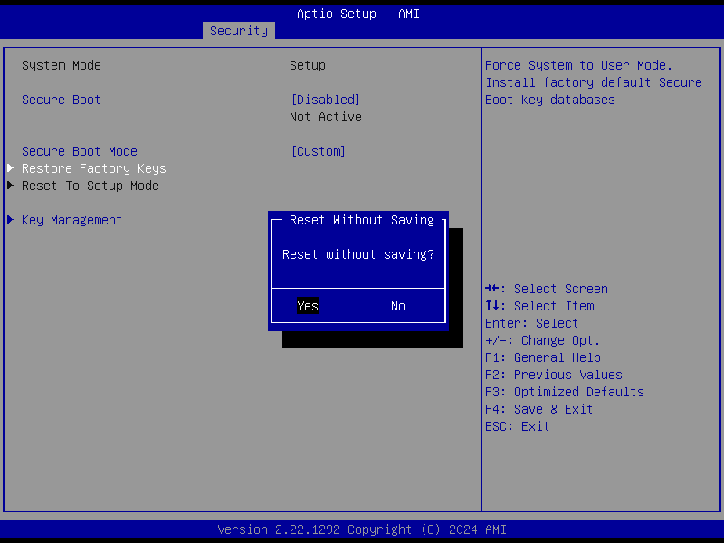

- Please choose Yes, press enter and the system will reboot.

7，When rebooting, please press delete key to go to the BIOS,and use left and right key to choose security screen, and use up and down key to choose Secure Boot option, press enter and go to Secure Boot page, you will see the secure boot is active.
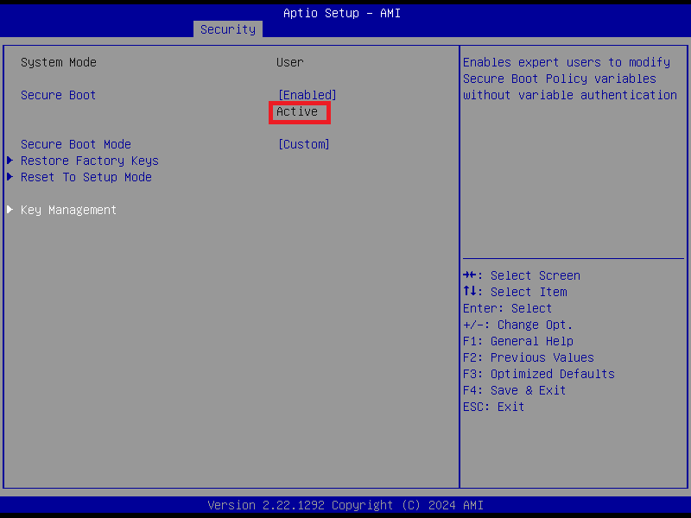
8，Please use up and down key to choose Key Management option, and press enter key go to Key Management page.
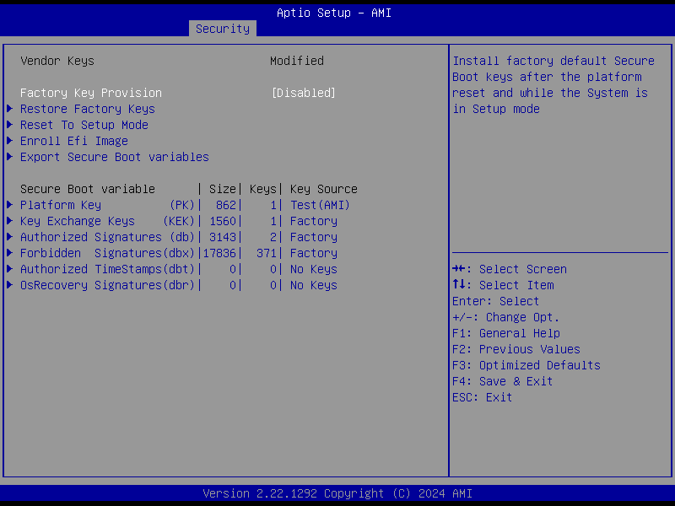
On the page, it shows that there is a Platform Key and a Key Exchange Key.

