Tutorial on Setting up RAID Disk Array for SER8/9

The SER8/9has two built-in NVme hard disk slots and supports the hard disk RAID function. Currently, the following RAID modes are supported:

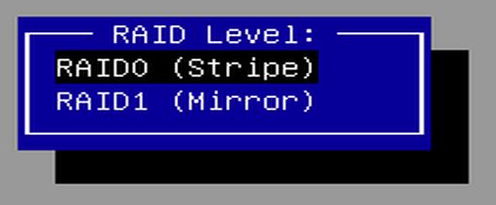
Volume: Combines multiple hard disks into one large hard disk, also known as JBOD (Just a Bunch Of Disks). It doesn't require the hard disk capacities to be the same, and the final available capacity is the sum of the capacities of each hard disk. RAIDable: Reserves the hard disk as a potential ability for future RAID. This means that the hard disk is designed to be combined with other hard disks to form a RAID array to provide higher performance, fault tolerance, or storage capacity. RAID 0: Distributes data evenly across multiple hard disks in a striped manner, thereby increasing the read and write speeds. The capacity of RAID 0 is the minimum hard disk capacity multiplied by the number of hard disks. RAID 1: Writes data to two hard disks simultaneously in a mirrored manner to ensure data integrity. Each hard disk contains a complete copy of the data, so when one of the hard disks fails, the other hard disk can still provide complete data.

If you need to set up the RAID mode, please follow the steps below:

Preparatory Work:

- Prepare an SER8/9 mini PC.
- Prepare two M.2 2280 solid-state drives (select hard disks with the same or different capacities according to the required RAID mode).
- Use the official Microsoft tool to create a Windows 11 system USB flash drive. The system USB flash drive provided as a gift cannot be used for installation via DOS. For the creation method, please refer to the [Windows 11 Official System Installation Tutorial].
- Download the RAID driver, decompress it, and then place it in the root directory of the Windows 11 system installation USB flash drive. Download address: https://url.bee-link.cn/kKWv

Note that creating a new RAID mode will delete all the current hard disk space and data. Please back up your data in advance and operate with caution.

Starting the Setup:

- Press the "delete" key after the boot-up and the Beelink logo appears to enter the BIOS setup page.
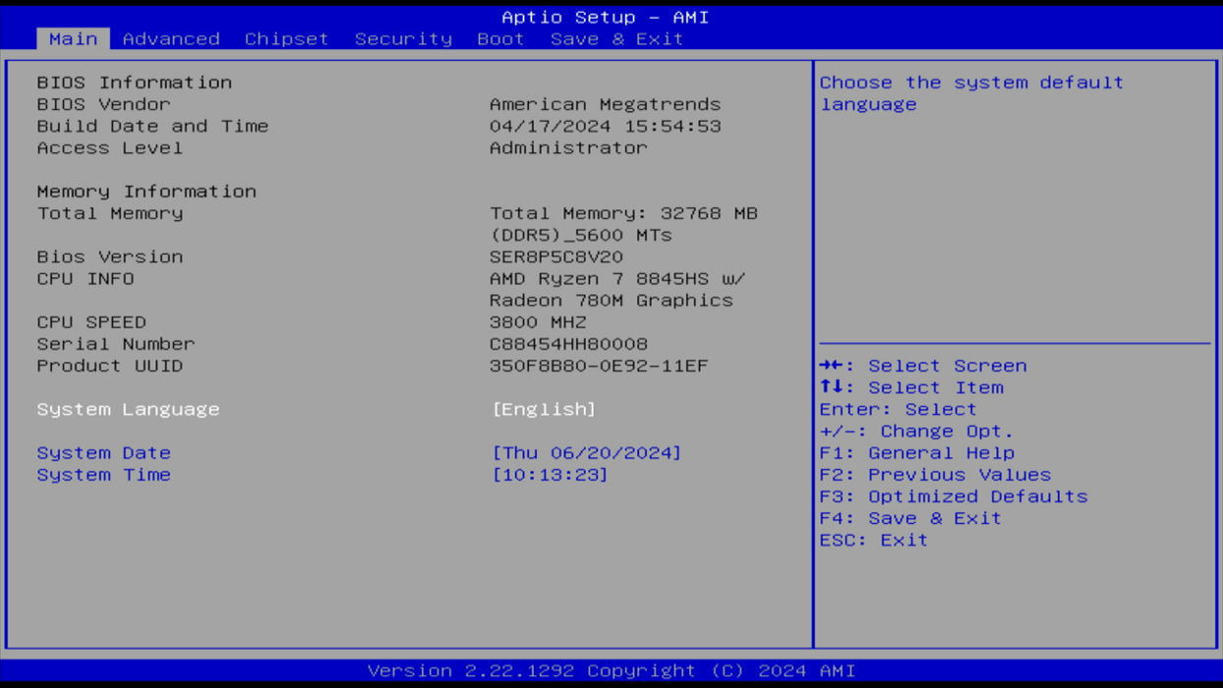

2.Select the second item "Advanced" in the menu bar, find the sub-menu "OEM Features Management", and press "Enter" to enter it.
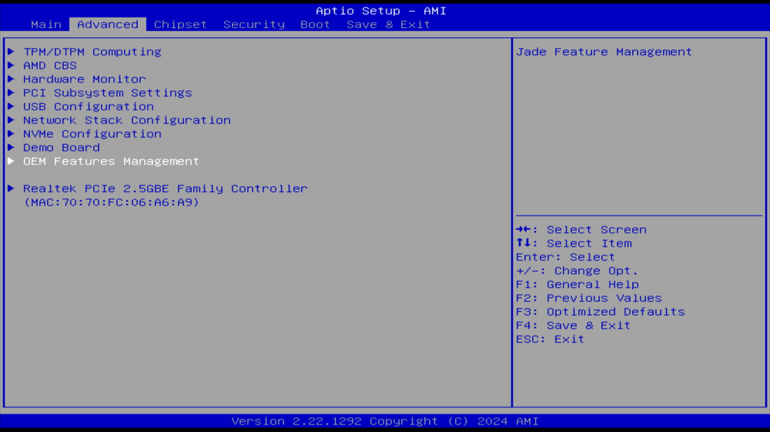

3.Select Nvme Raid Support, and set it to enabled.
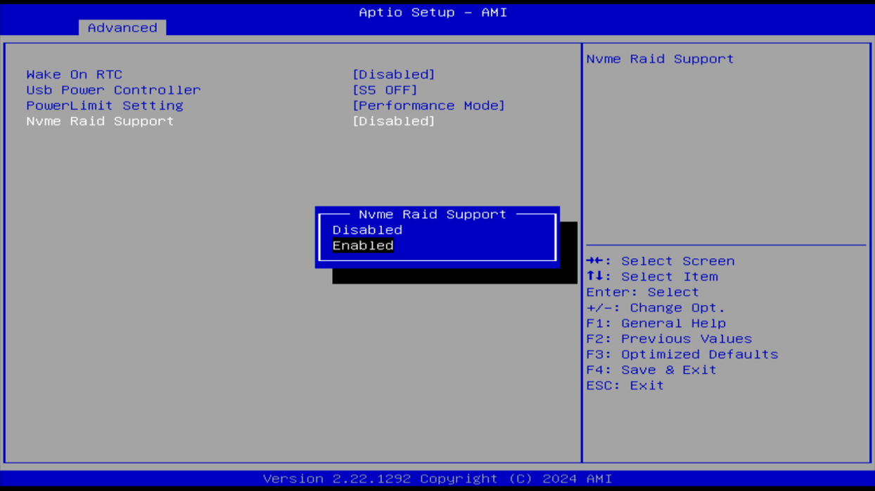

4.Press F4 to save and exit, then restart the PC.
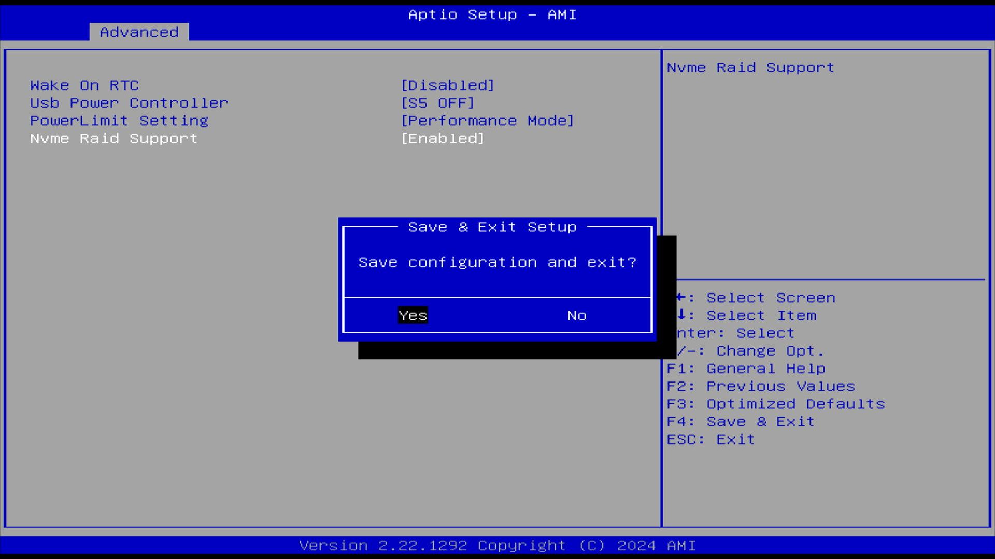

- Re-enter the BIOS menu, switch to the ["Advanced"] option, and you will see an additional ["RAIDXpert2 Configuration Utility"] menu. Press "Enter" to enter the setting.
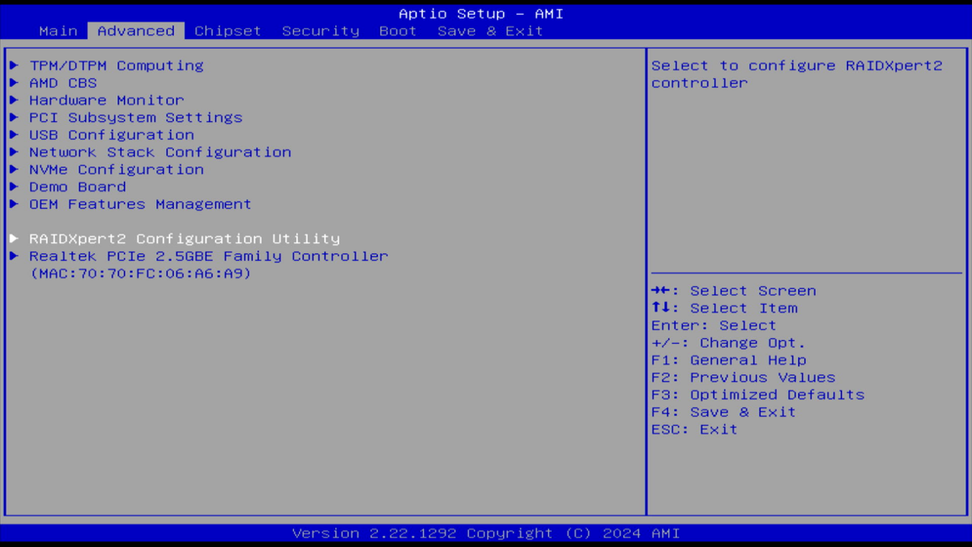
6.Click RAIDXpert2 Configuration Utility Continue to enter the ["Array Management"] menu.
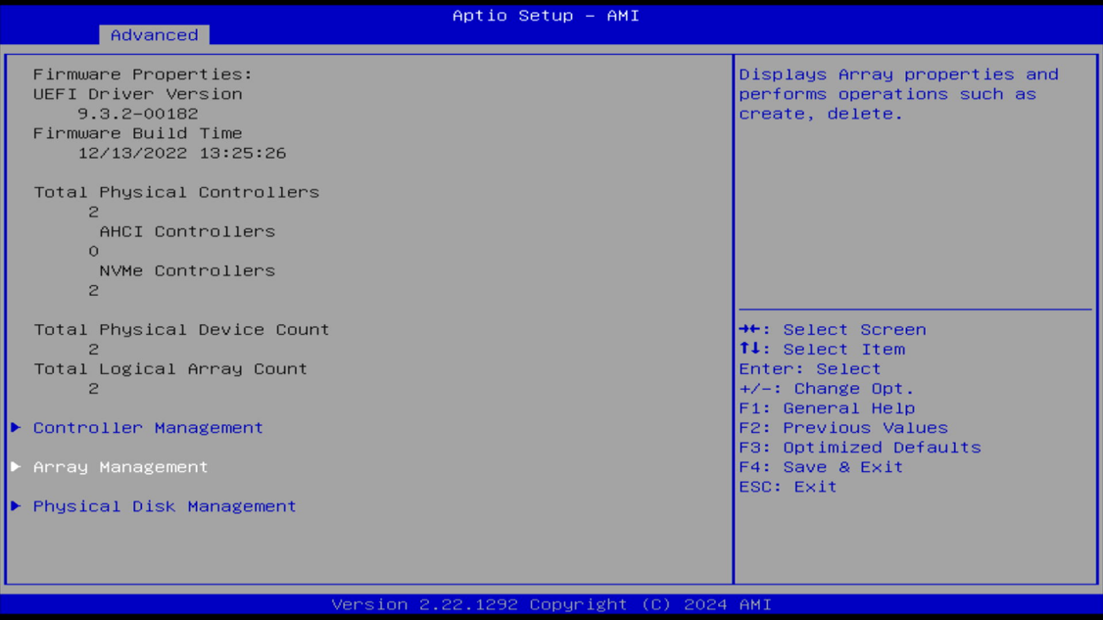
7.Choose "Delete Array" to delete the original data, the data in the SSD will be removed, please back up the data in advance.
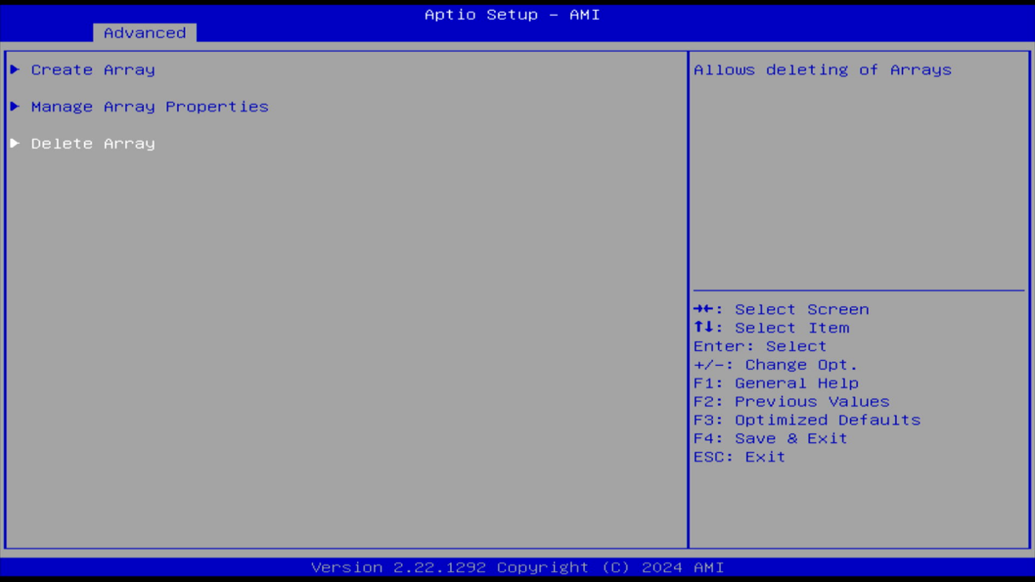
- First, select "Check All" to change the status of the two hard drives to "Enabled", and then select "Delete Array" to delete the data.
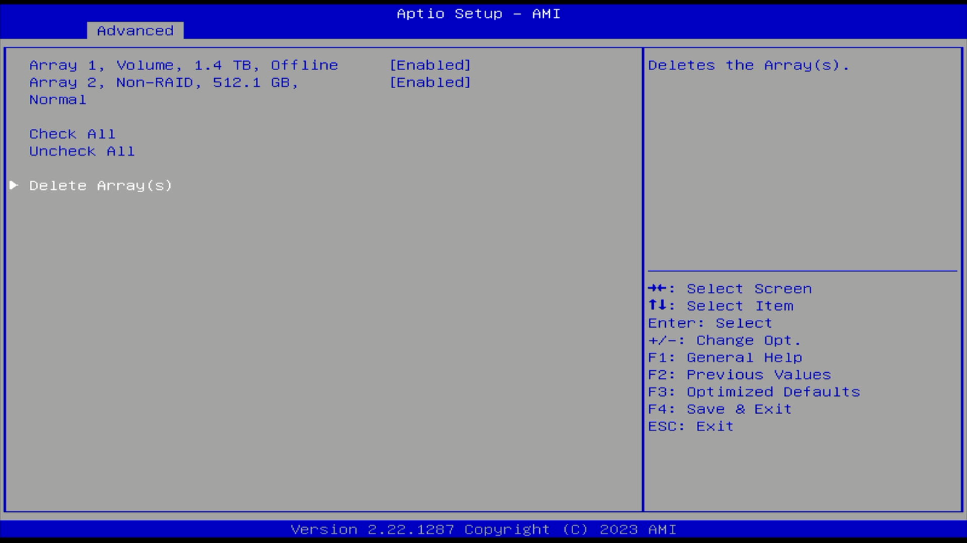
- Change the status of the Confirm option to Enabled, and select YES to confirm the deletion of data.
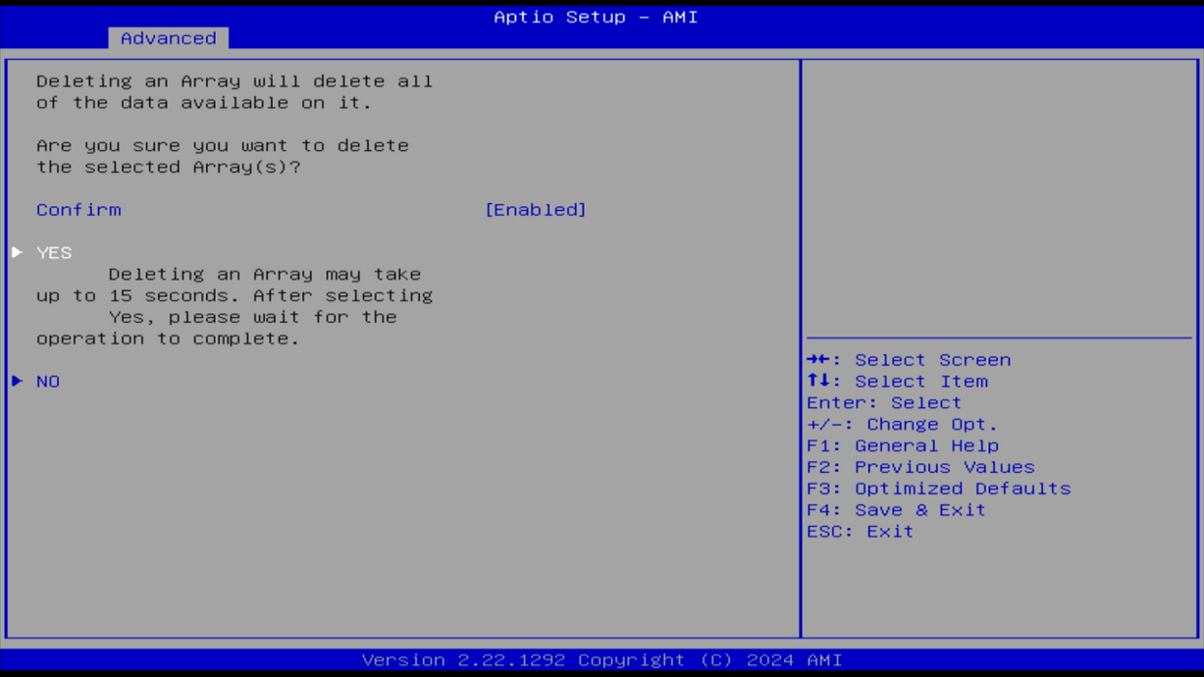

- If you have the following prompt,it indicates that the operation was successful.
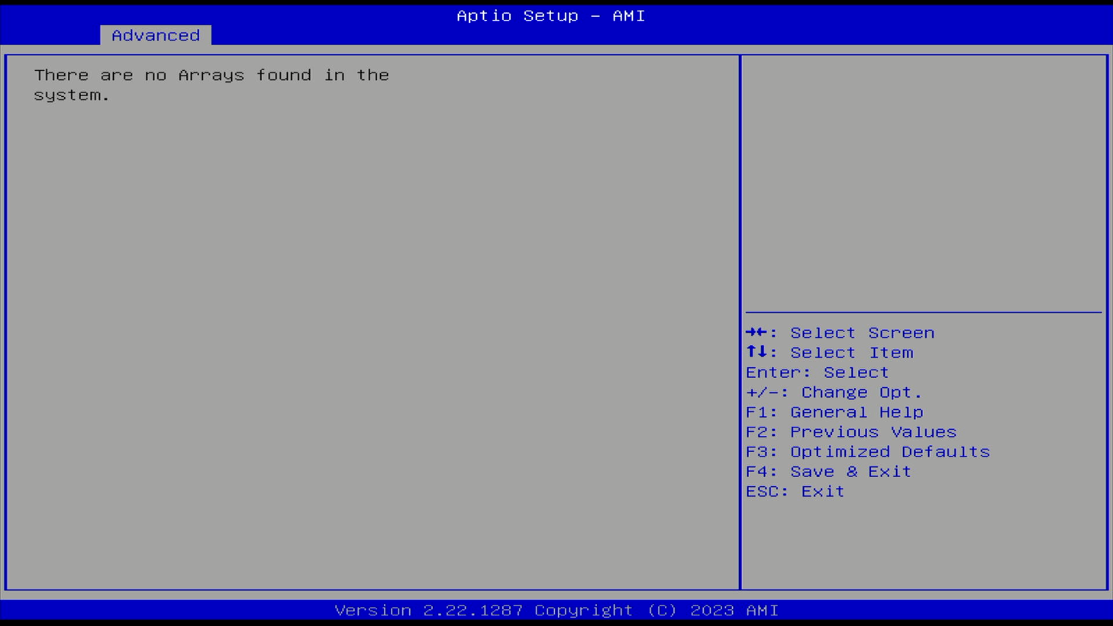
- Automatically return to the previous page. At this time, only "Create Array" (create an array) is available for selection. Enter to start creating a RAID array.
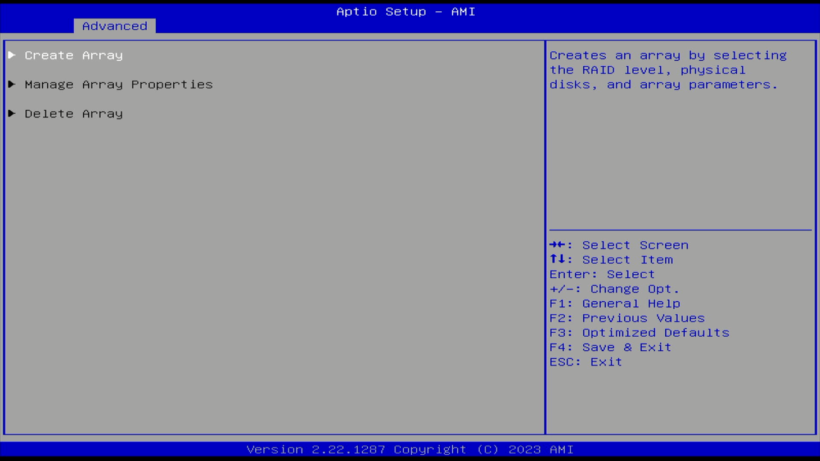
- Open "Select RAID Level", and you can see four RAID modes. Move the cursor to select the mode you want to set. Here, we'll demonstrate by selecting the RAID 0 mode.
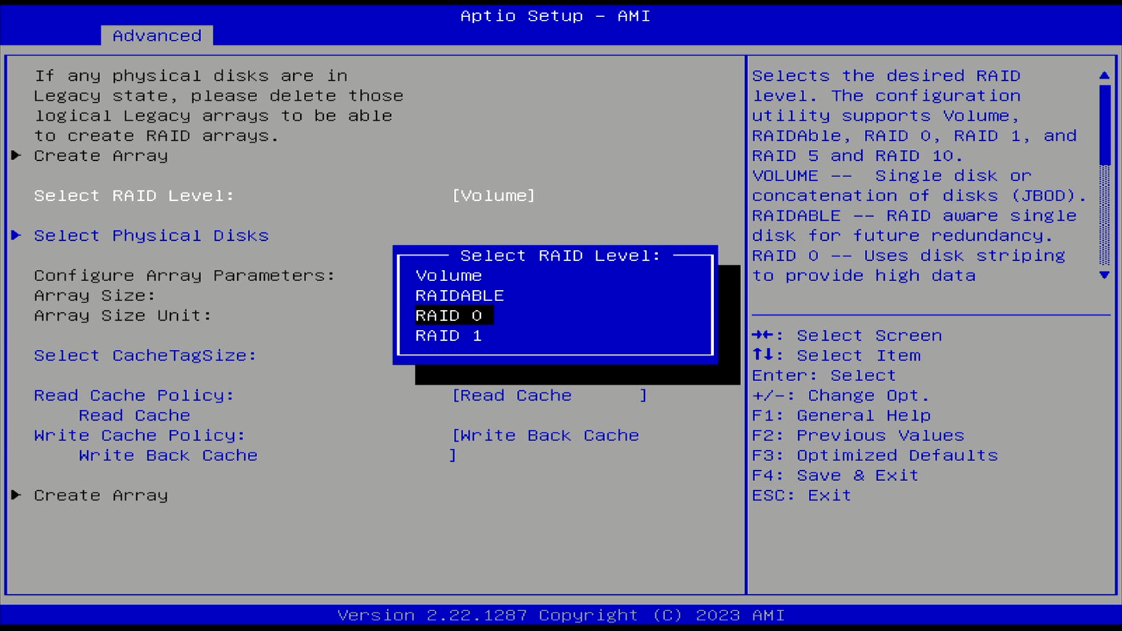
- After selecting the RAID mode, open "Select Physical Disks" to configure the hard drives.
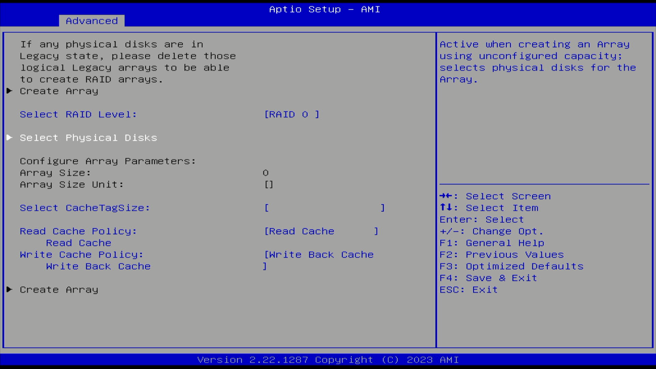
- Click "Check All" to change the status of the two hard drives that need to be set to RAID 0 mode to "Enabled", and then select "Apply Changes" to apply the modified settings.
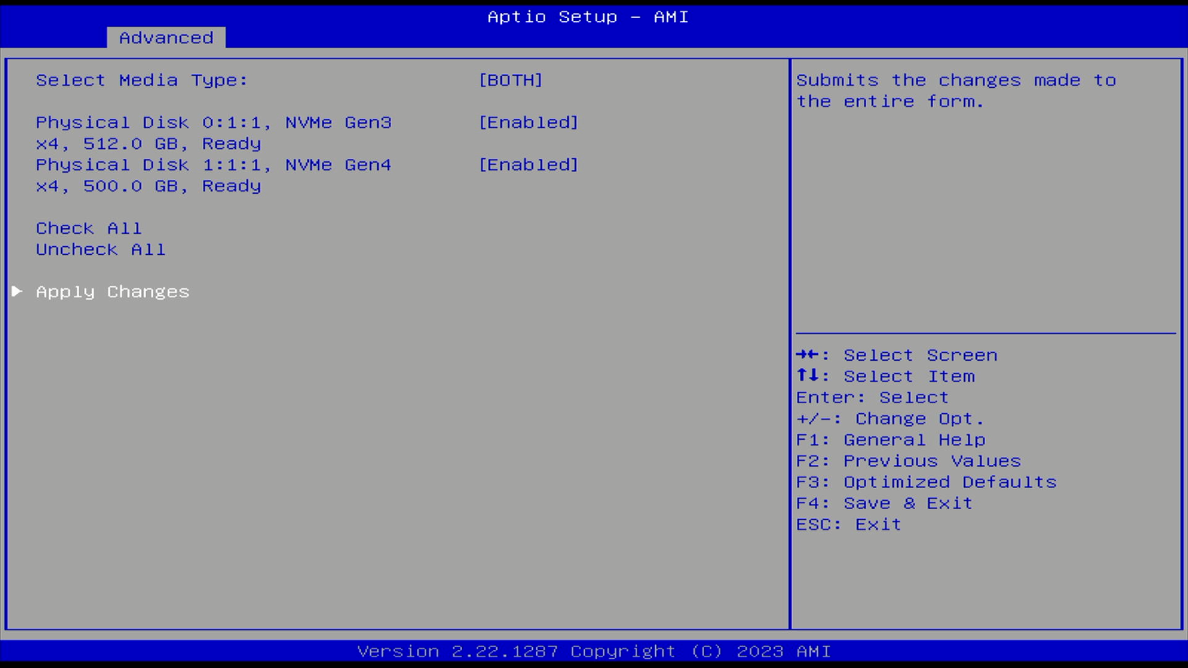
- After automatically returning to the previous level, the "Array Size" becomes twice the capacity of the smallest hard drive, indicating that the setup is successful. Then select "Create Array".
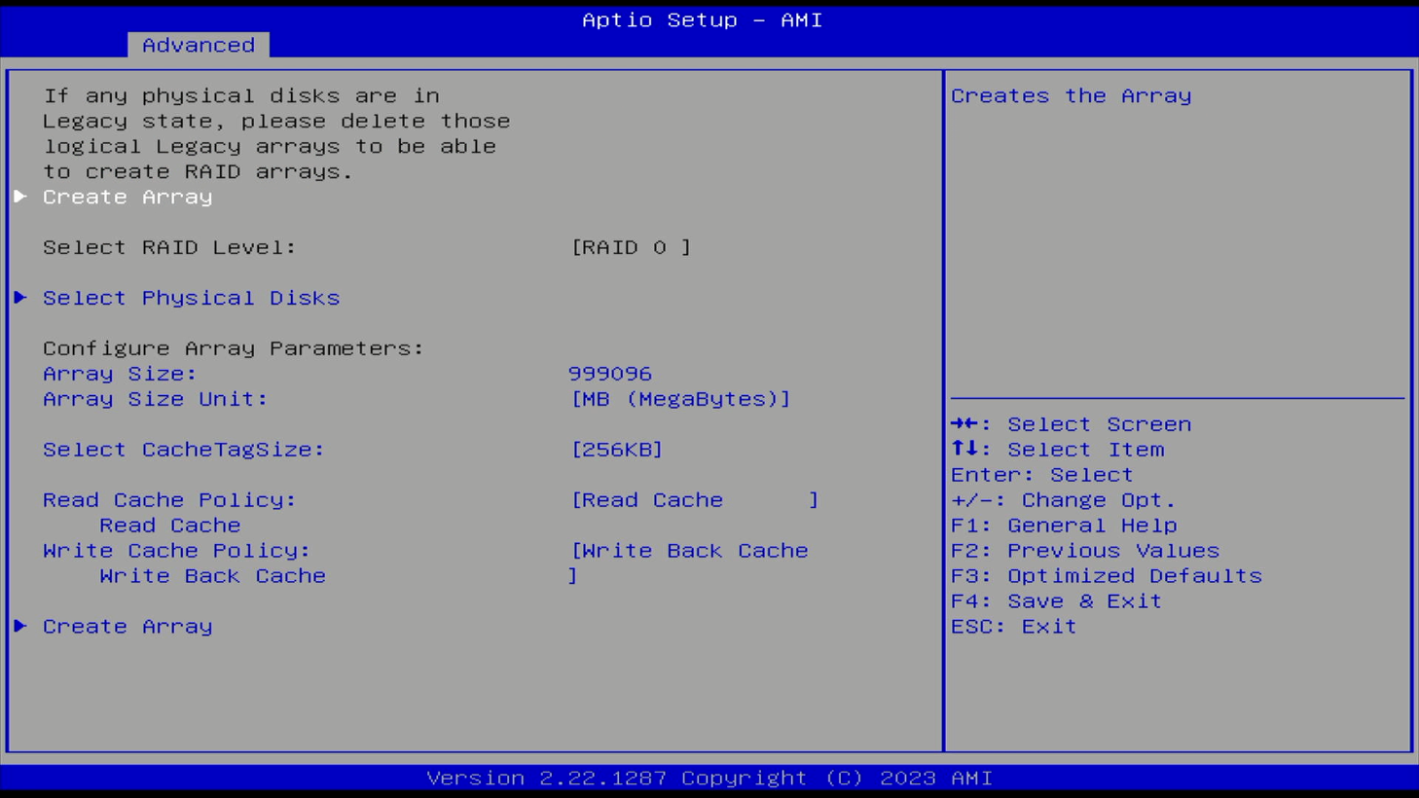
- After automatically returning to the previous level, insert the prepared USB flash drive with the Windows 11 system installation files, then press F4 to save the settings and restart the system.
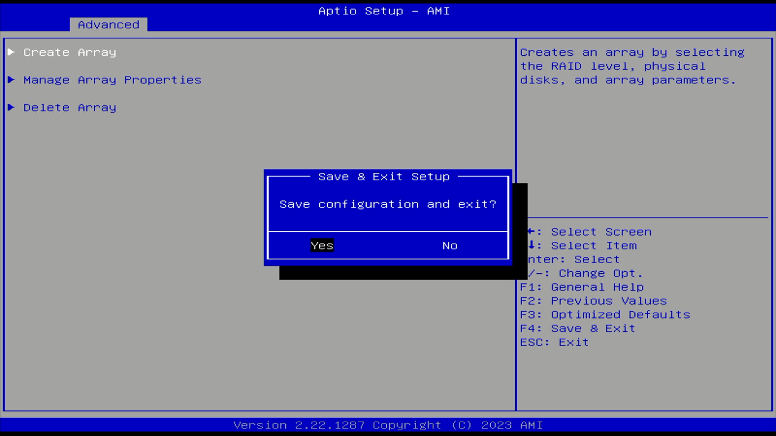
- Since the hard drive has been formatted, the computer will automatically enter the system installation page upon startup. Click "Next" to proceed with the system installation process.
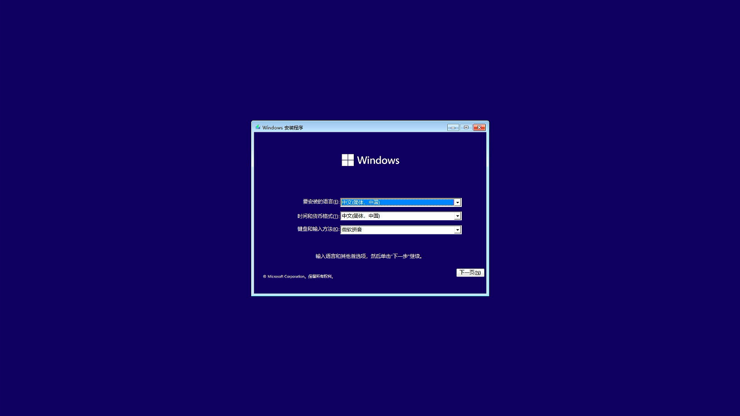
- Enter your Windows activation key. You can choose "I don't have a product key" to skip this option for now and activate the system later after entering it.
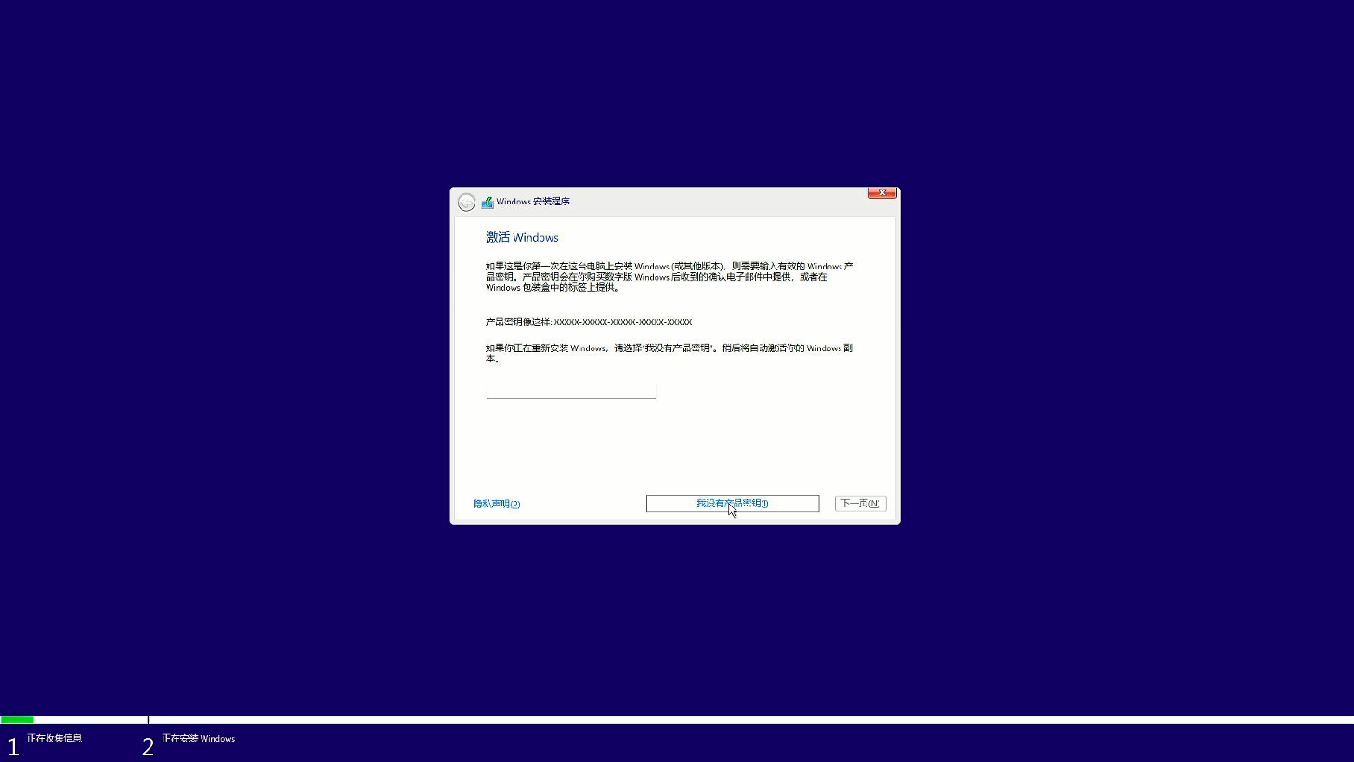
- Select the system version you want to install. Here, we recommend that you install Windows 11 Professional Edition, which has more available features.
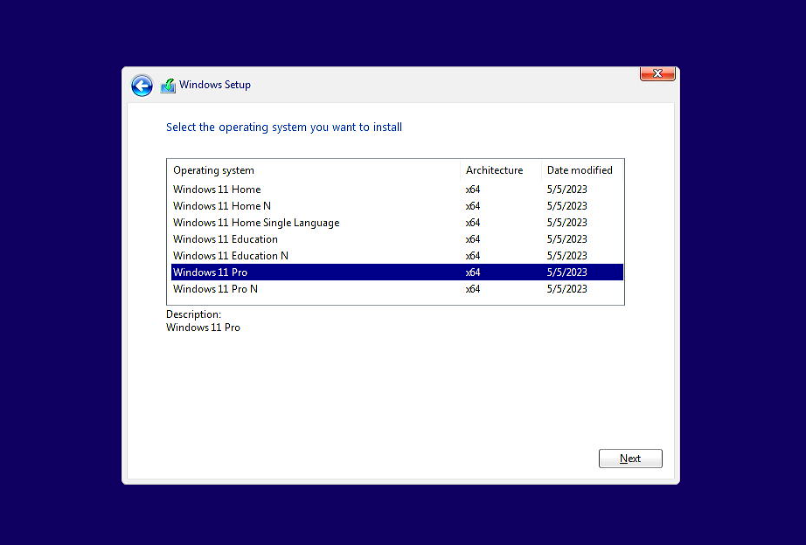
- Select "Custom: Install Windows only" to install a brand - new Windows system.
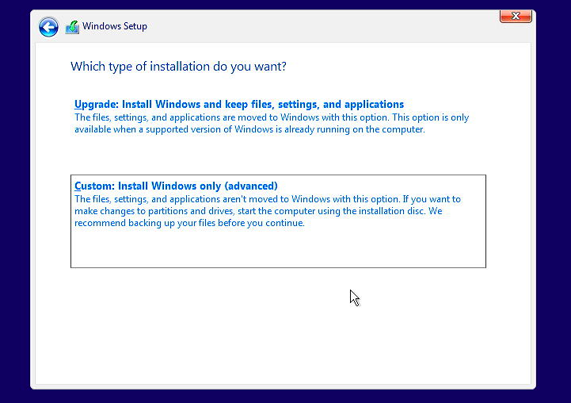

- You can see the two installed solid - state drives with approximately the same capacity. At this point, the merging process hasn't started yet. Click "Load driver".
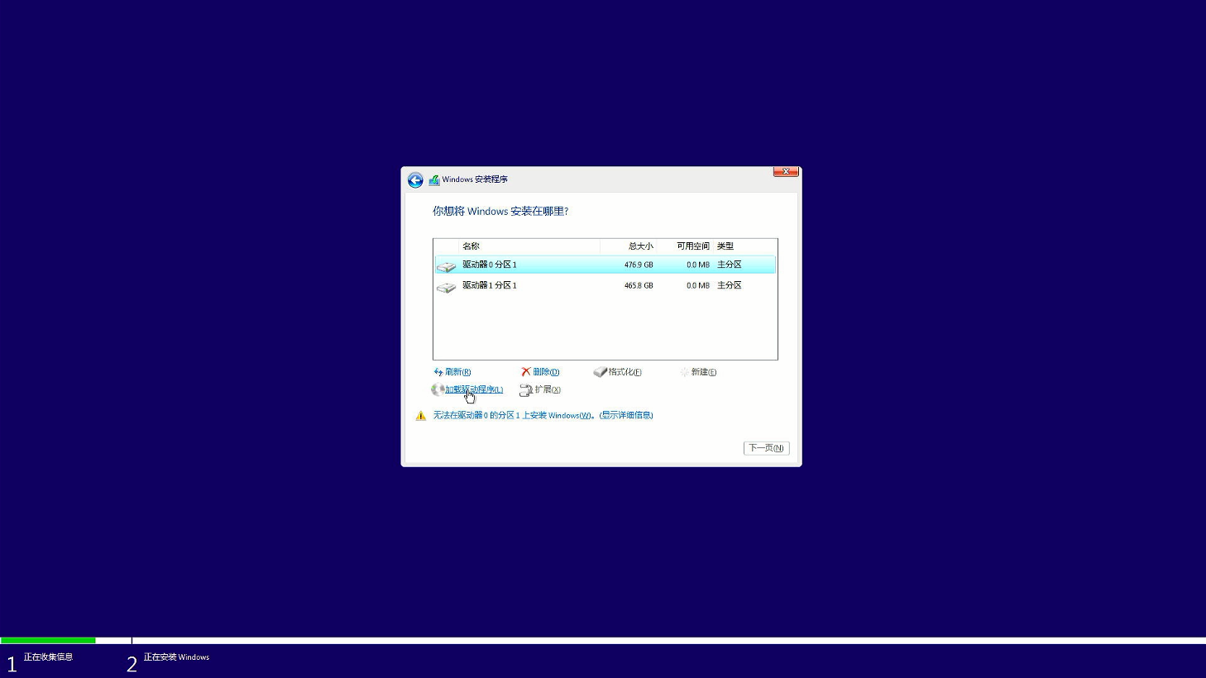
- Uncheck the option "Hide drivers that are not compatible with this computer's hardware", and then click "Browse".
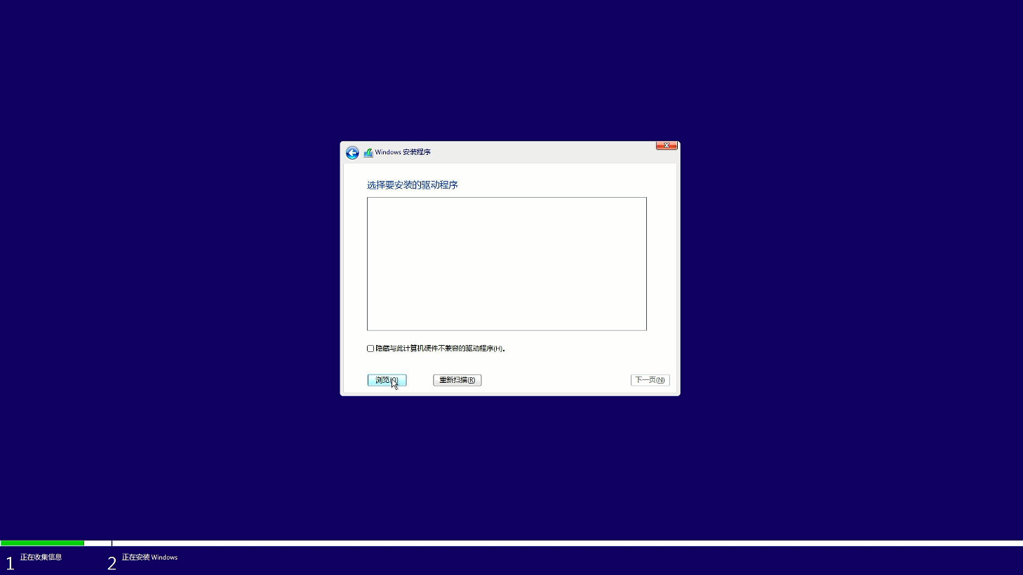
- Select the path where the Windows RAID driver files are stored, find the "rcbottom" directory, and click "OK".
*Note: You must install the Rcbottom driver first and then install the Rcraid file.*
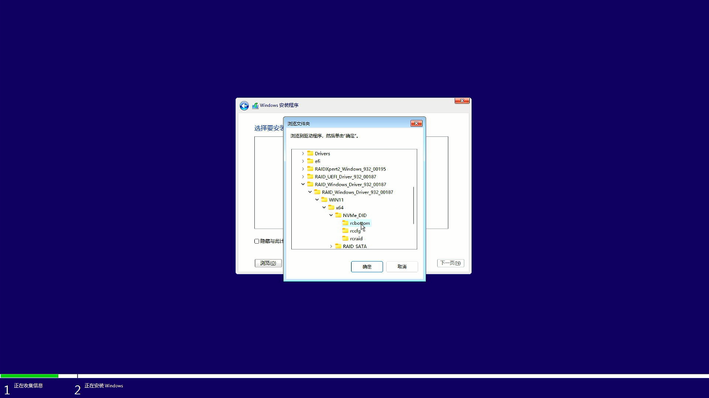

- Five drivers will appear in the list. There's no need to make a selection. Just click "Next" and they will be automatically installed.
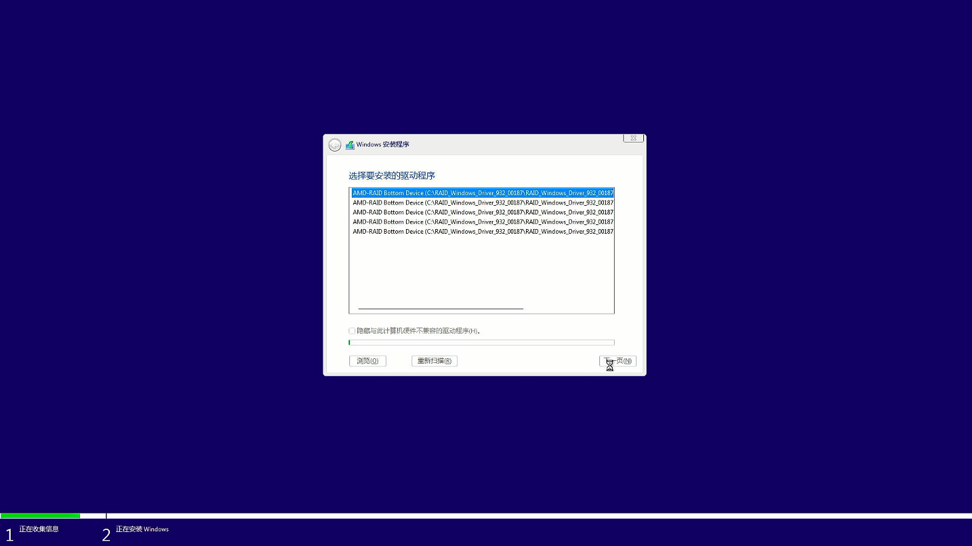
- After the installation is successful, none of the hard drives are shown in the list. Click "Load driver" again.
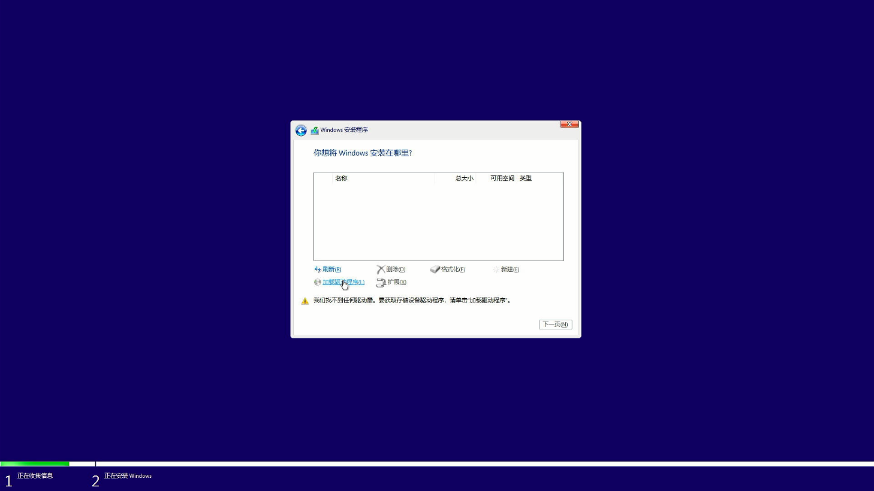

- Select the path where the Windows RAID driver files are stored, find the "Rcraid" directory, and then click "OK".
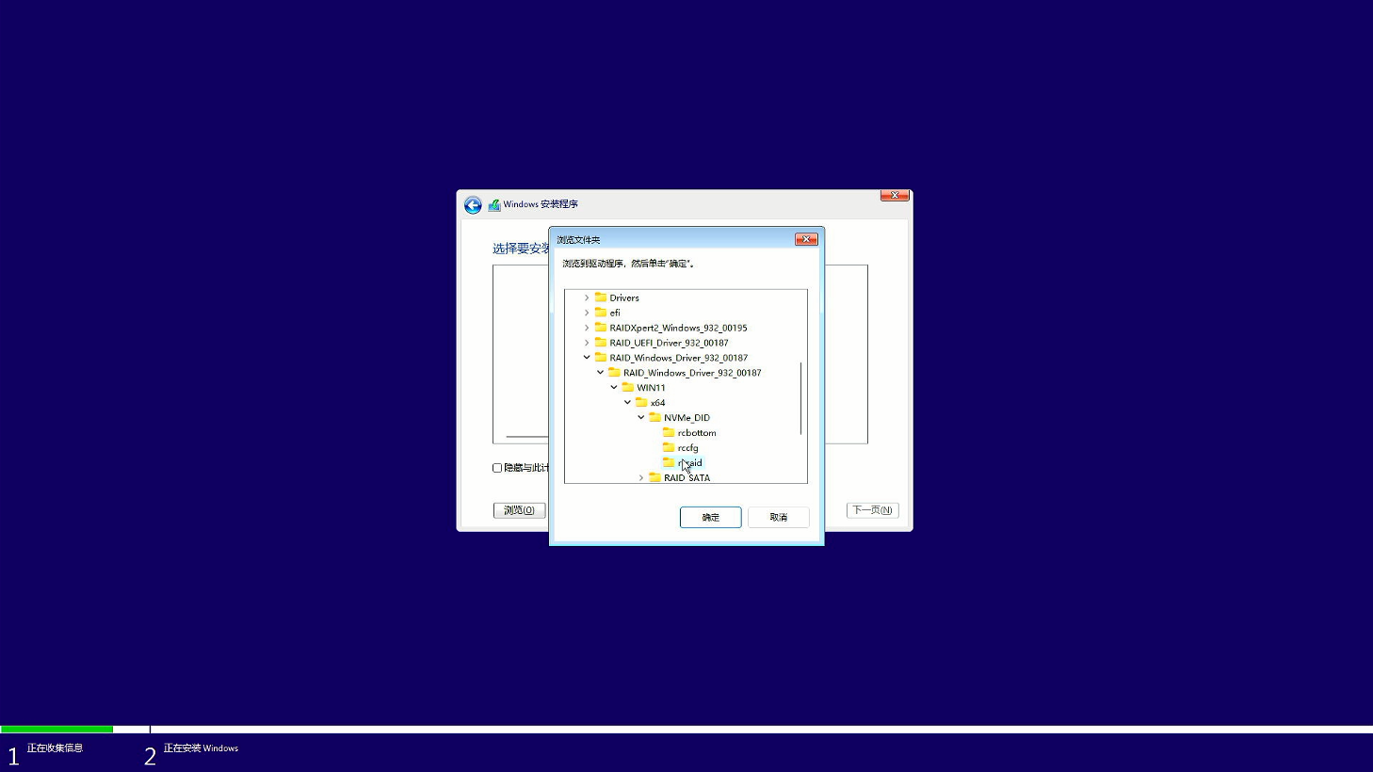
- After the driver installation is completed, the two hard drives have been merged into one storage space. Click "Next" to start installing the system following the normal process.
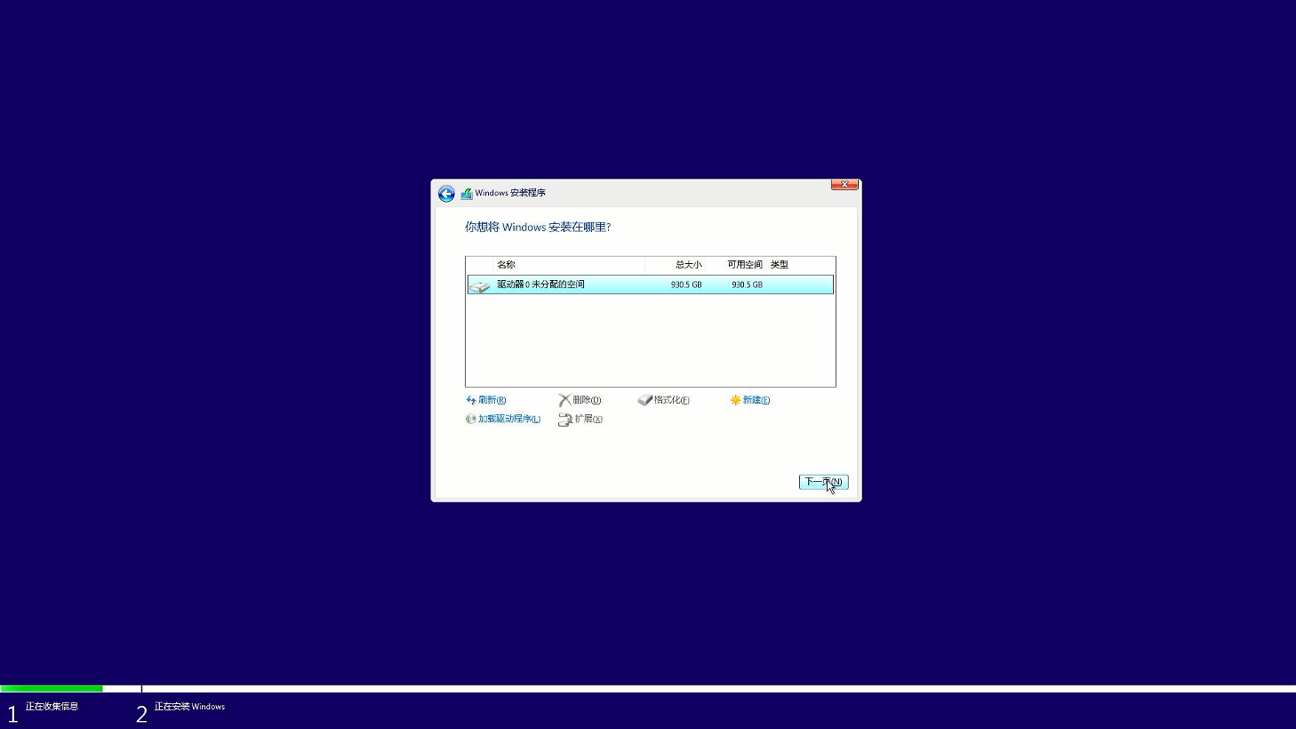

- Wait for the system installation to complete.
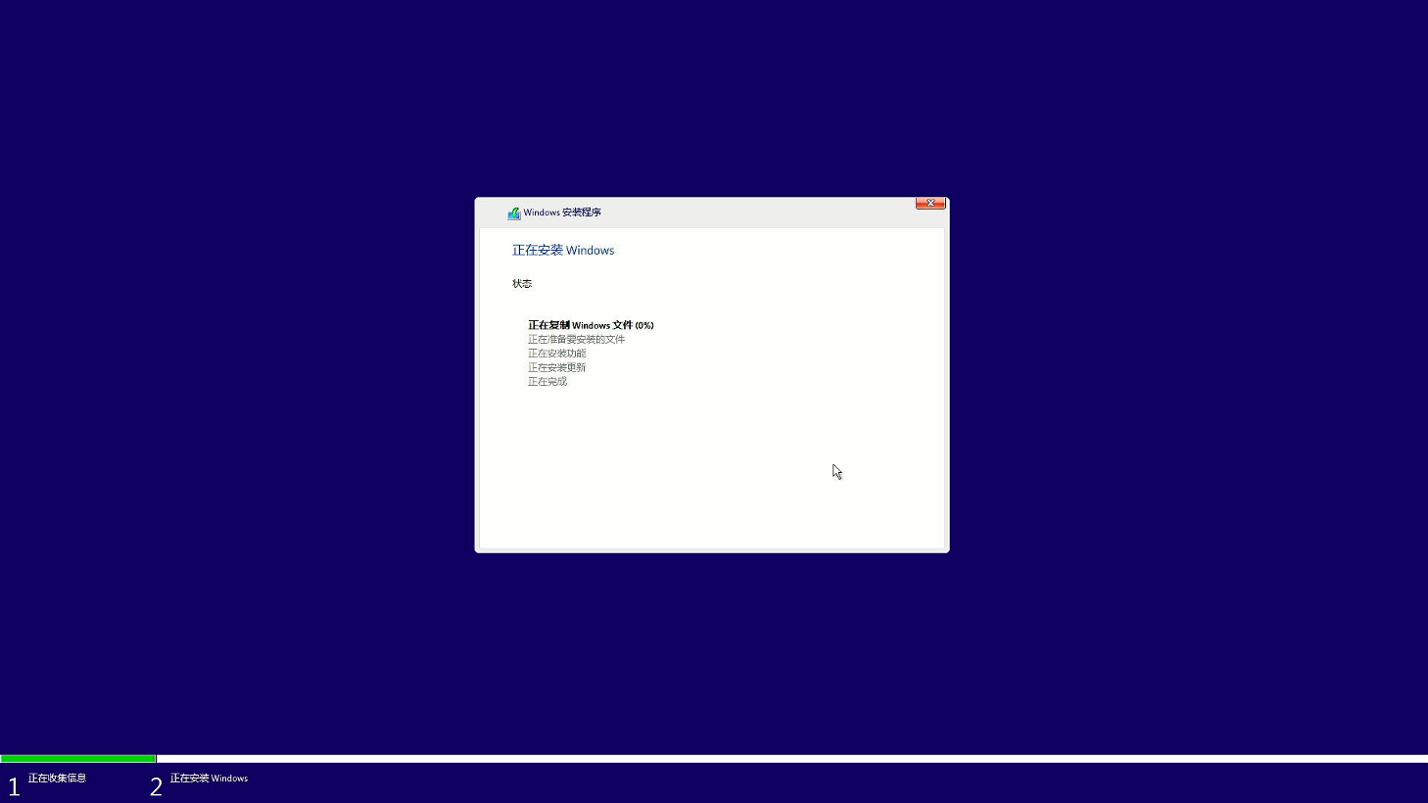

- After the system installation is completed, the computer will automatically restart and enter the system initialization page. You can enter the desktop after completing a simple configuration.
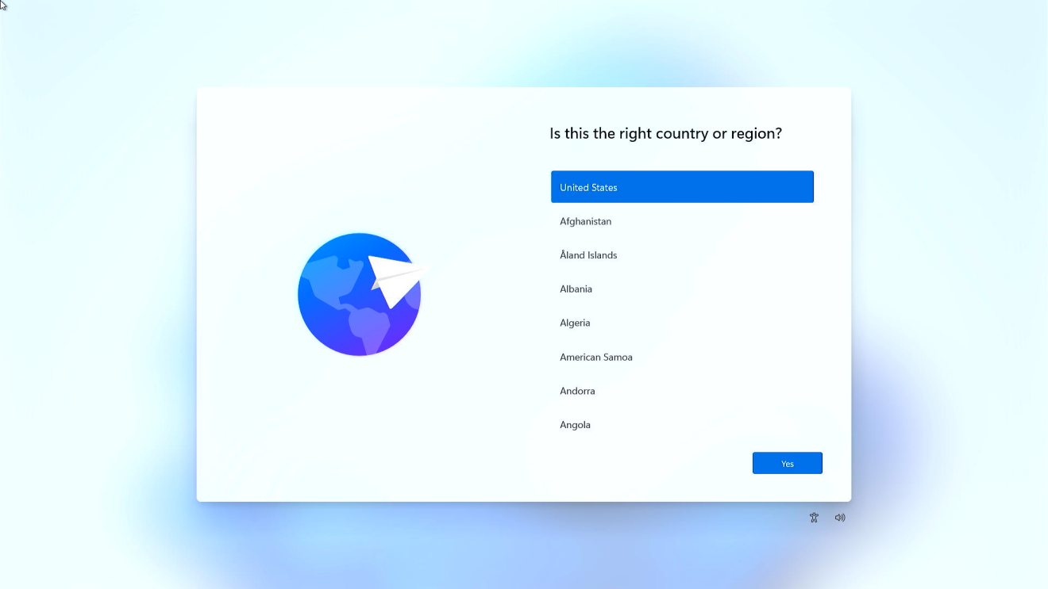
If you need to log in to a Microsoft account online, you can press Shift + F10 to bring up the CMD manager, enter "oobe\BypassNRO.cmd" and run it. After the computer restarts automatically, an option to skip the internet connection will appear. Skip the internet connection and log in to your Microsoft account after entering the system.
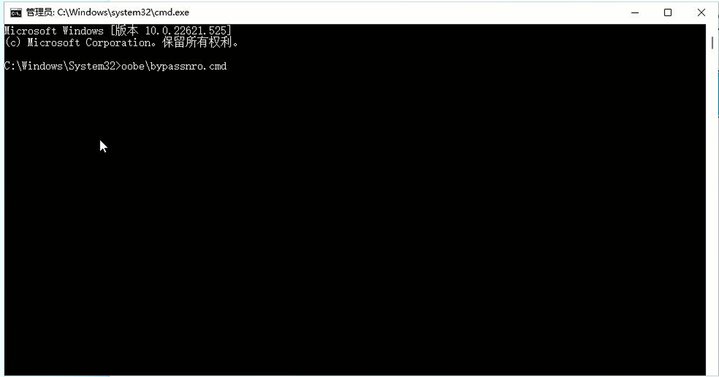
- Check the local disk space, and you'll find that the two 512GB hard drives have been merged into one disk. Use the AS SSD software to test the speed of this hard drive, and you'll see a significant improvement in speed.
**Note: Try not to update the BIOS or clear the CMOS after the RAID array is set up. If you perform these operations, you need to reset "Advanced—OEM Features Management--Nvme Raid Support" to "Enabled" in the BIOS again.**
