Truenas System Installation Tutorial

①What is Truenas?
TrueNAS is an enterprise-grade network storage solution built on open-source software, developed and maintained by iXsystems. Focused on data storage, sharing, backup, and virtualization support, it offers high reliability, flexibility, and ease of use, suitable for home users, small to medium enterprises, and even large data centers.

Core Features
Based on ZFS File System
• Supports data integrity checks (prevents silent data corruption), snapshots, clones, compression, deduplication (requires high memory), etc.
• Supports RAID configurations (e.g., RAID-Z, RAID-Z2, RAID-Z3) for flexible storage pool management.

Multi-Protocol Support
• File sharing: SMB/CIFS (Windows), NFS (Linux/Unix), AFP (macOS).
• Block storage: iSCSI (supports virtualization and database storage).
• Object storage: Compatible with S3 protocol (via MinIO plugins, etc.).

Data Protection and Recovery
• Scheduled snapshots: Can be created manually or automatically, supporting point-in-time recovery.
• Remote backup: Syncs to remote TrueNAS or other storage devices via ZFS replication.
• Cloud backup: Integrates with cloud storage like AWS S3 and Google Cloud.

Virtualization and Container Support
• Can serve as backend storage for virtualization platforms like VMware, KVM, Hyper-V.
• TrueNAS SCALE version supports Docker containers and Kubernetes (via built-in Apps feature).

Expandability and Plugins
• Supports functional expansion through plugins or virtual machines (Jail/Bhyve), such as Plex media servers, Nextcloud, etc.

②How to Install the Truenas System?
Preparation Tools:
• System USB drive: 1 USB drive ≥1GB. It is recommended to choose a branded USB drive (e.g., SanDisk) to avoid compatibility issues with non-branded ones.
• Data hard drive: At least 1 hard drive (for data storage, supporting a mix of new and old drives, unlimited capacity).

③ Download Truenas
1.Open the Truenas download page: https://www.truenas.com/truenas-community-edition/, click 【Download】 to jump to the download page.

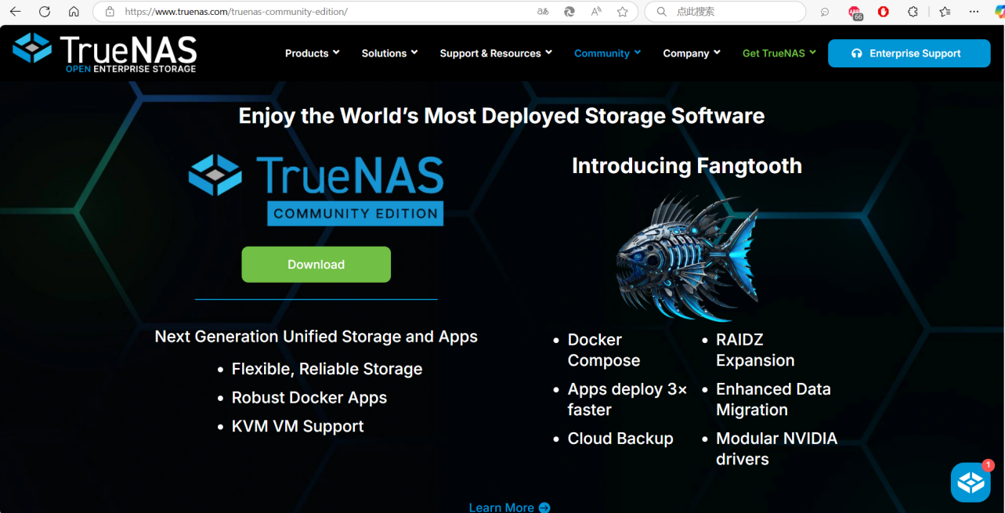
2.Click 【No Thank you, I have already signed up.】 below to skip login/registration.

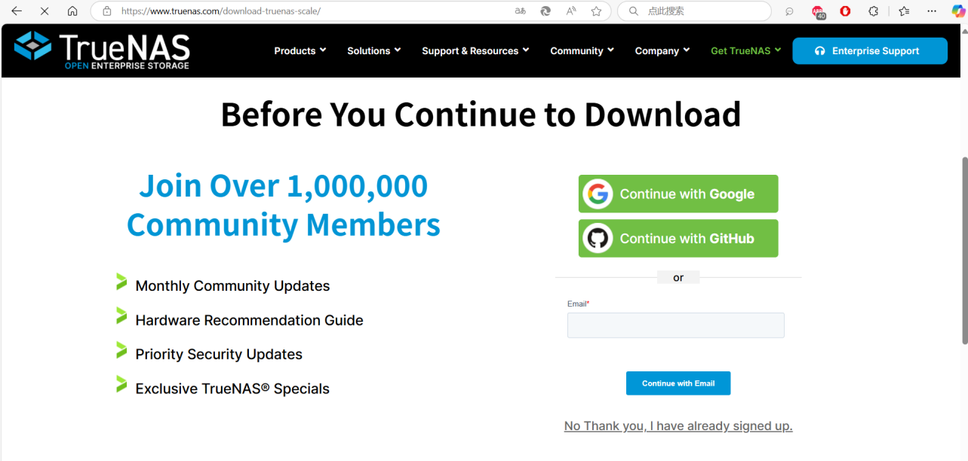
3.Click 【Download STABLE】 to start the download.

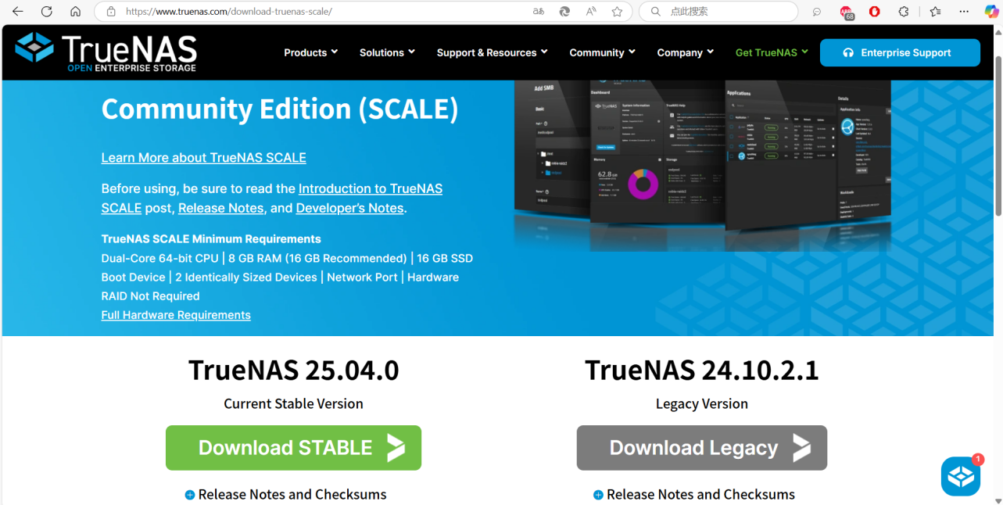

④Create a Bootable USB Drive：
1.This step requires using a disk writing tool on a computer to burn the image file to the USB drive for boot installation. The recommended tool is Rufus.
Download link: https://rufus.ie/zh/
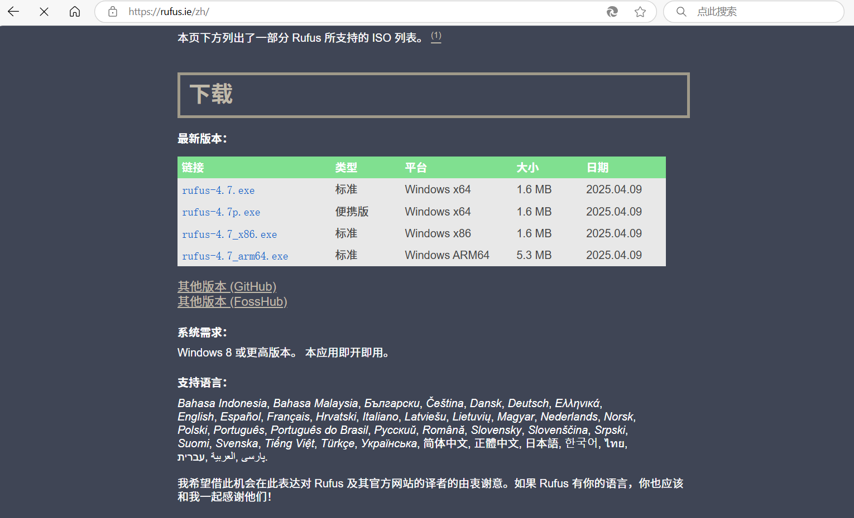

Double-click to open the Rufus tool, select the downloaded Truenas image, and click 【Start】 to begin writing.
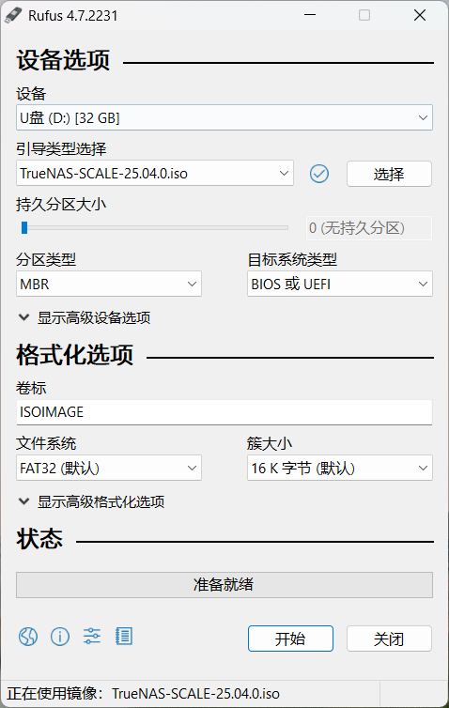
Recommended to use DD mode for writing.
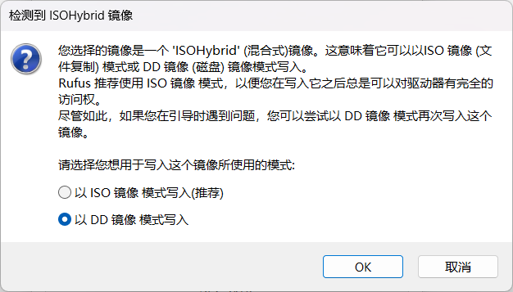

3.When the progress bar shows "Ready," the writing is complete, and the USB drive can be ejected.
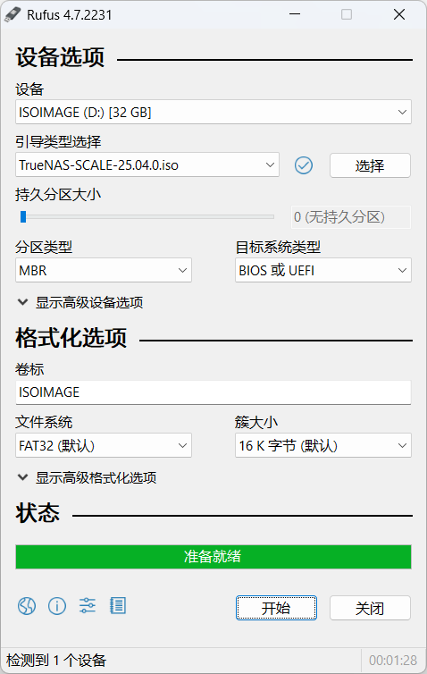
⑤ Device Preparation：
1.Connect the host to at least one hard drive for storage. It is recommended to use the built-in eMMC as the system disk to reduce occupation of extra hard drive slots. Connect the host to a network cable (wireless-only installation is not supported yet). Connect power, monitor, keyboard, mouse, and other devices.

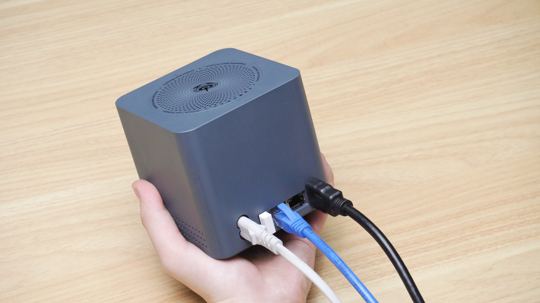
2.Select Boot Device
Insert the prepared bootable USB drive into the host's interface. Power on the host and quickly press the keyboard hotkey F7 during startup to enter the boot device selection interface.
Select the boot USB drive, press Enter, and enter the installation page.

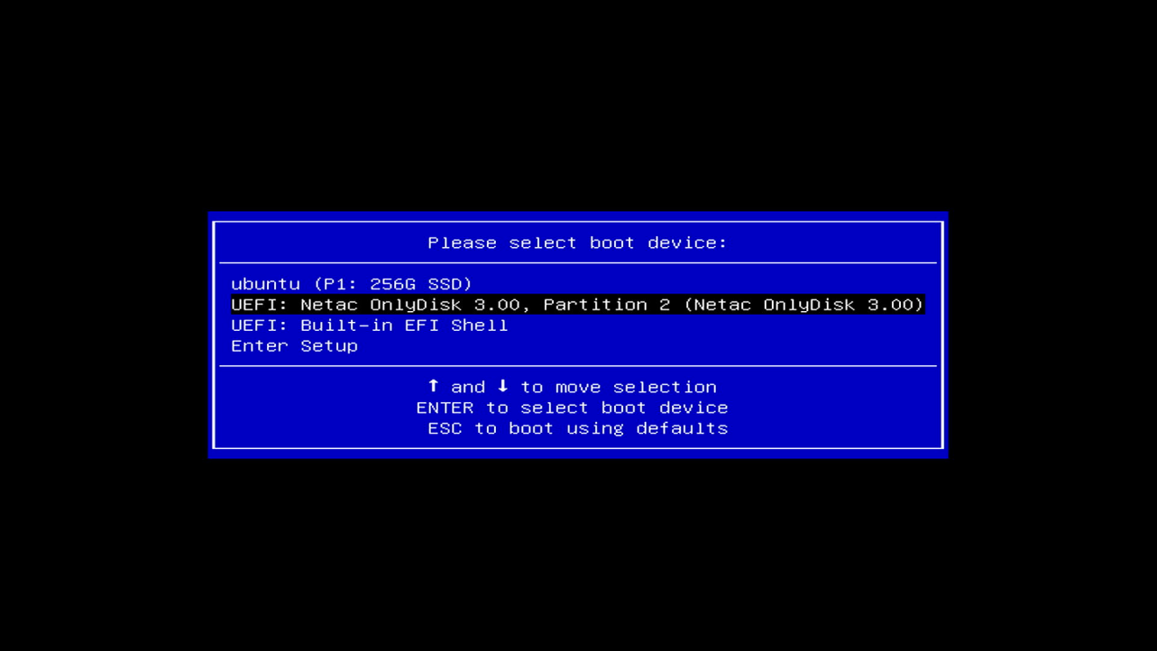
3.Select the first option and press "Enter" to enter the installation.

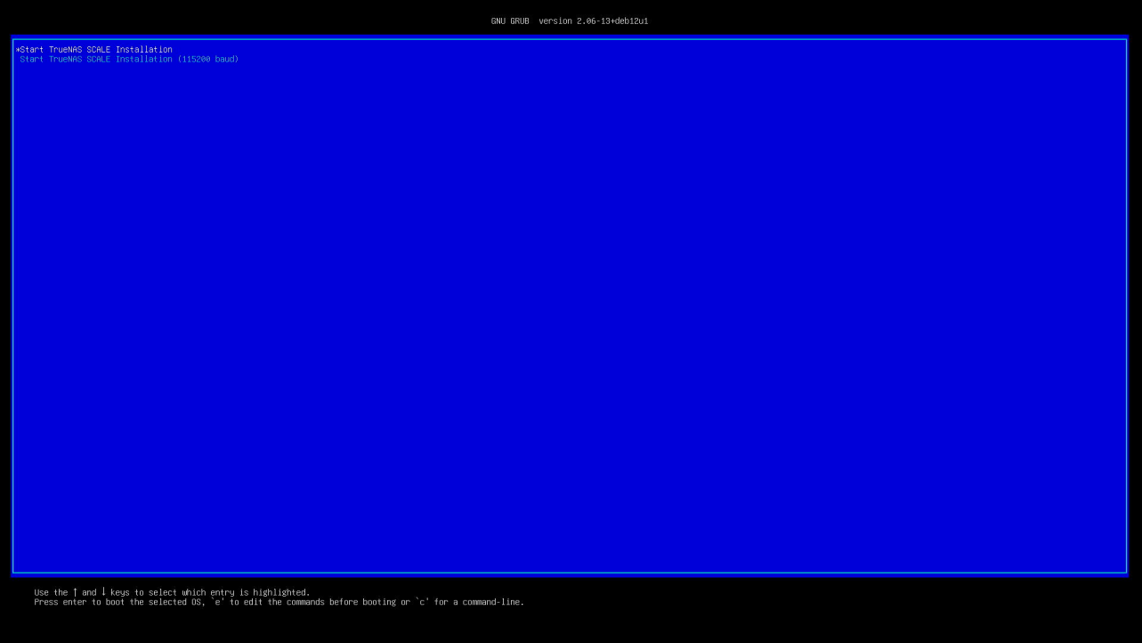

4.Select the first option: 【Install/Upgrade】.
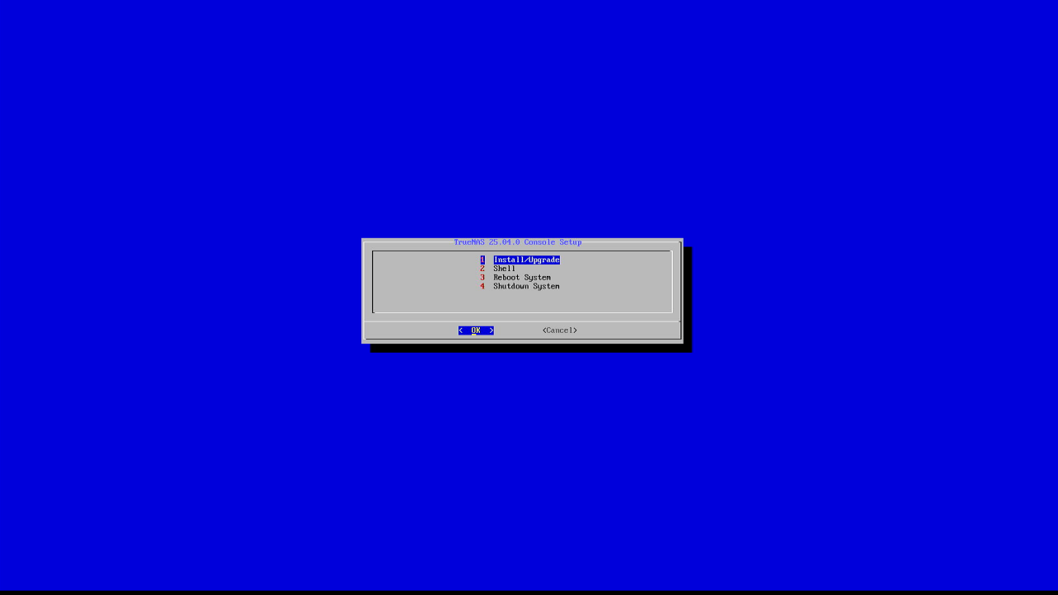
5.Use the spacebar to confirm the selected installation hard drive (here, choose the second disk), then click 【OK】.

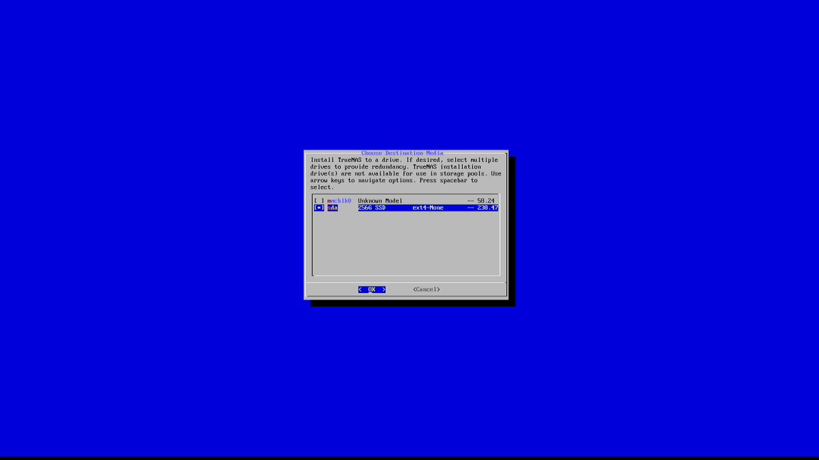
6.Click 【Yes】 to continue the installation.

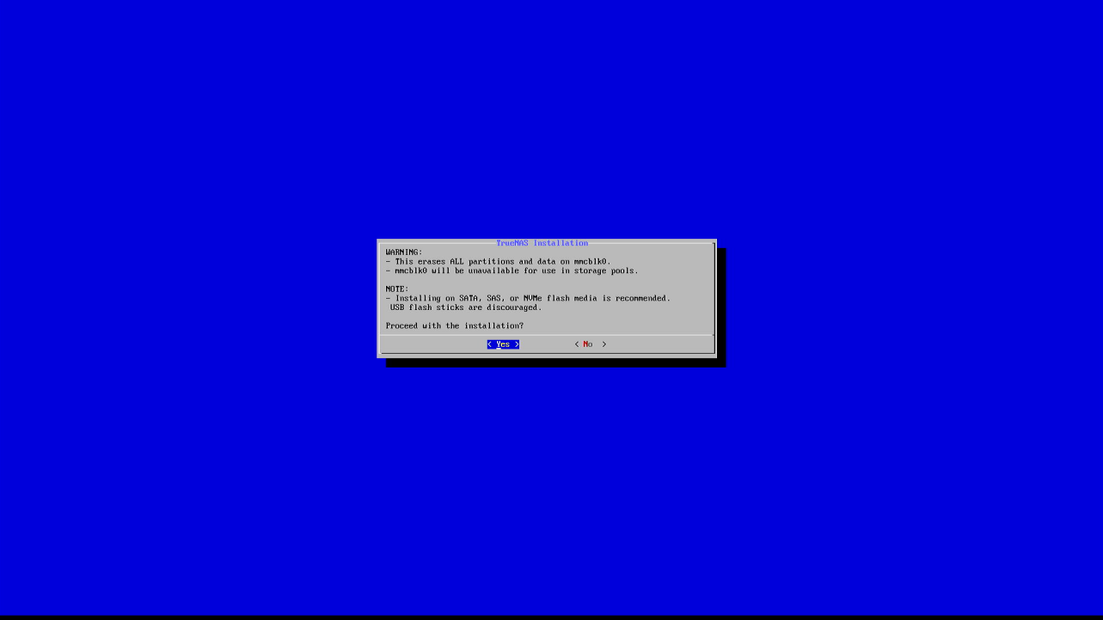
7.Select the first option to set the login password.

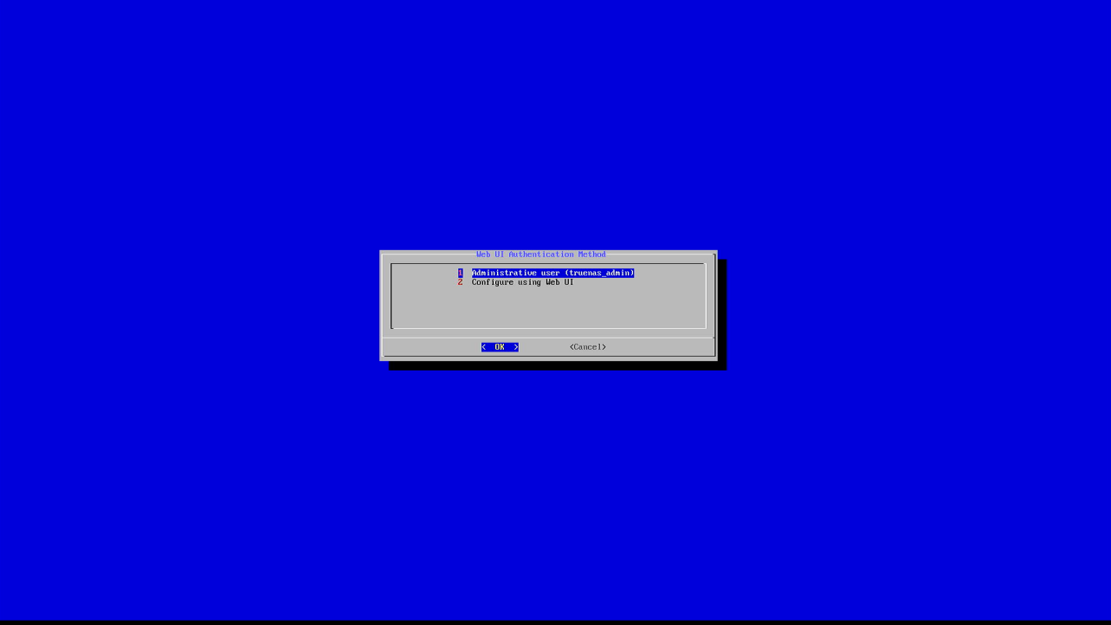
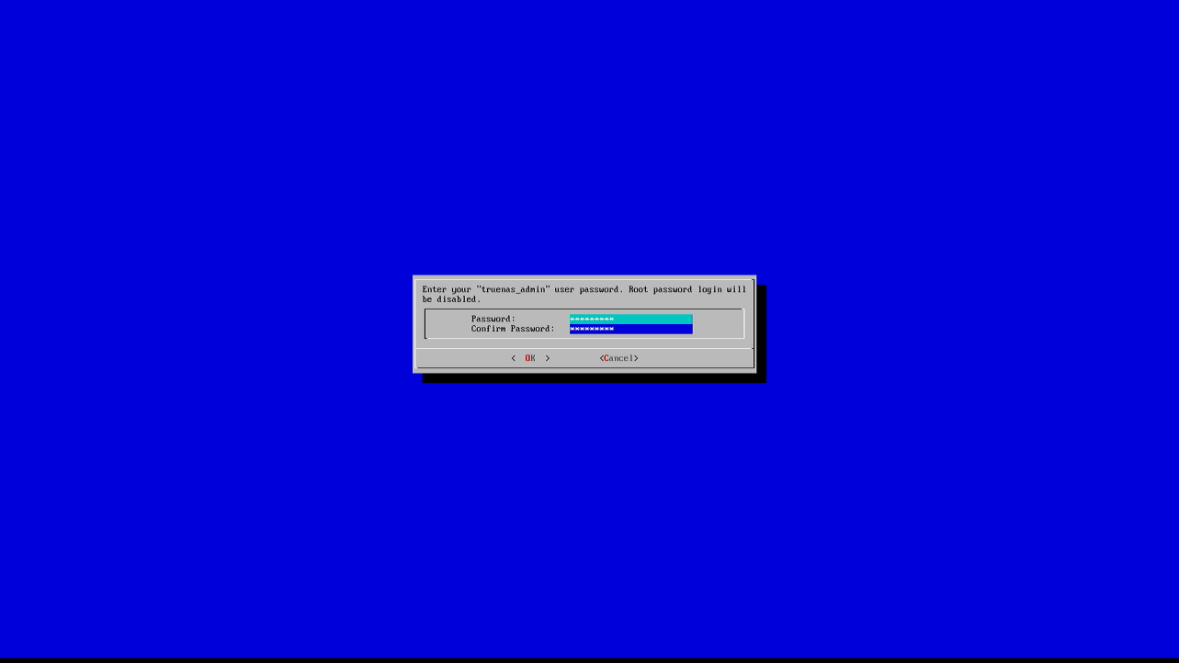

Wait patiently for the system to install.


9.After successful installation, remove the USB drive, click 【Ok】 to return to the menu.
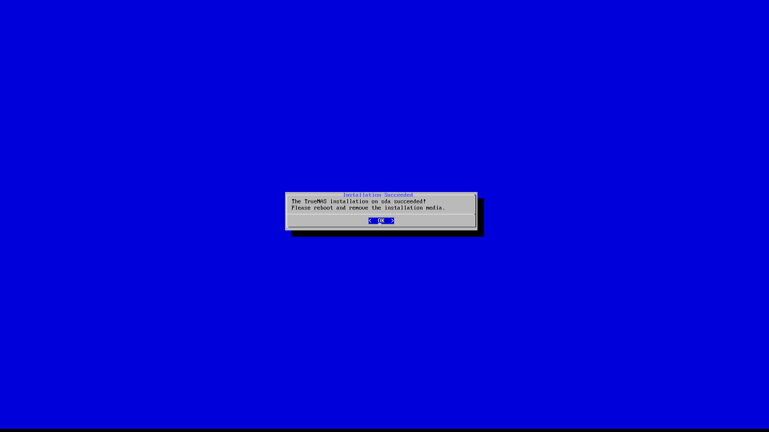

10.Click 【Reboot System】 to restart.
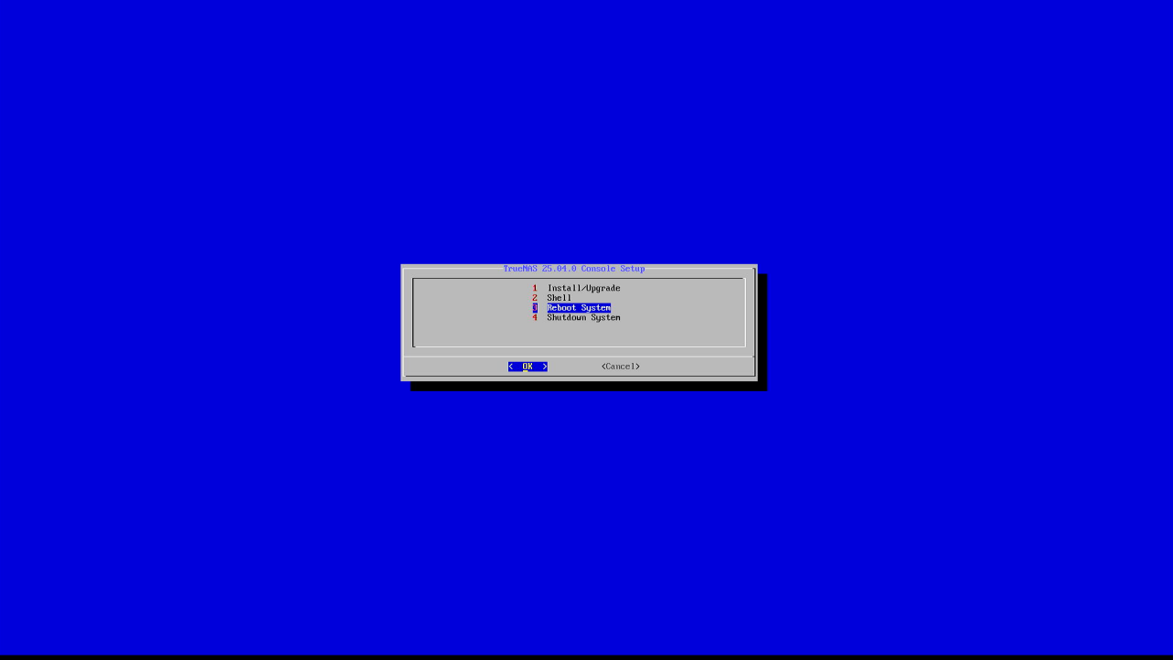

11.After startup, the default is DHCP mode, and the screen will display the automatically obtained IP address.
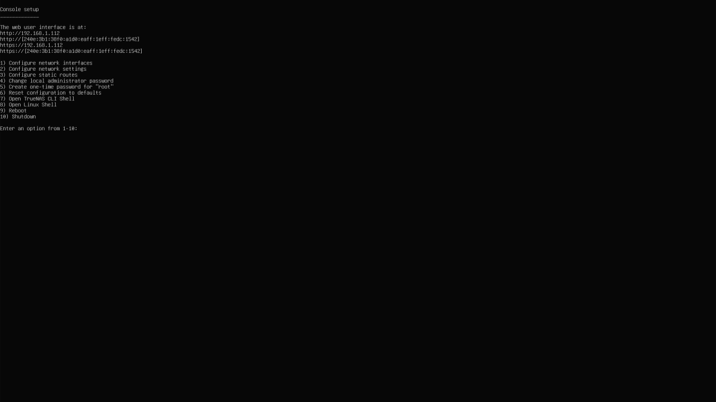

12.Use another computer to enter the device's IP address in a browser to access the Truenas management page.
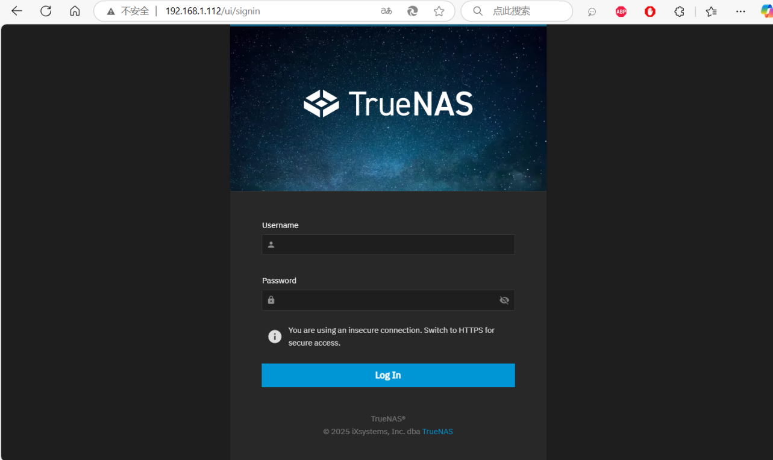

13.The default username is: truenas_admin, and the password is the one entered during installation. Log in with these credentials.
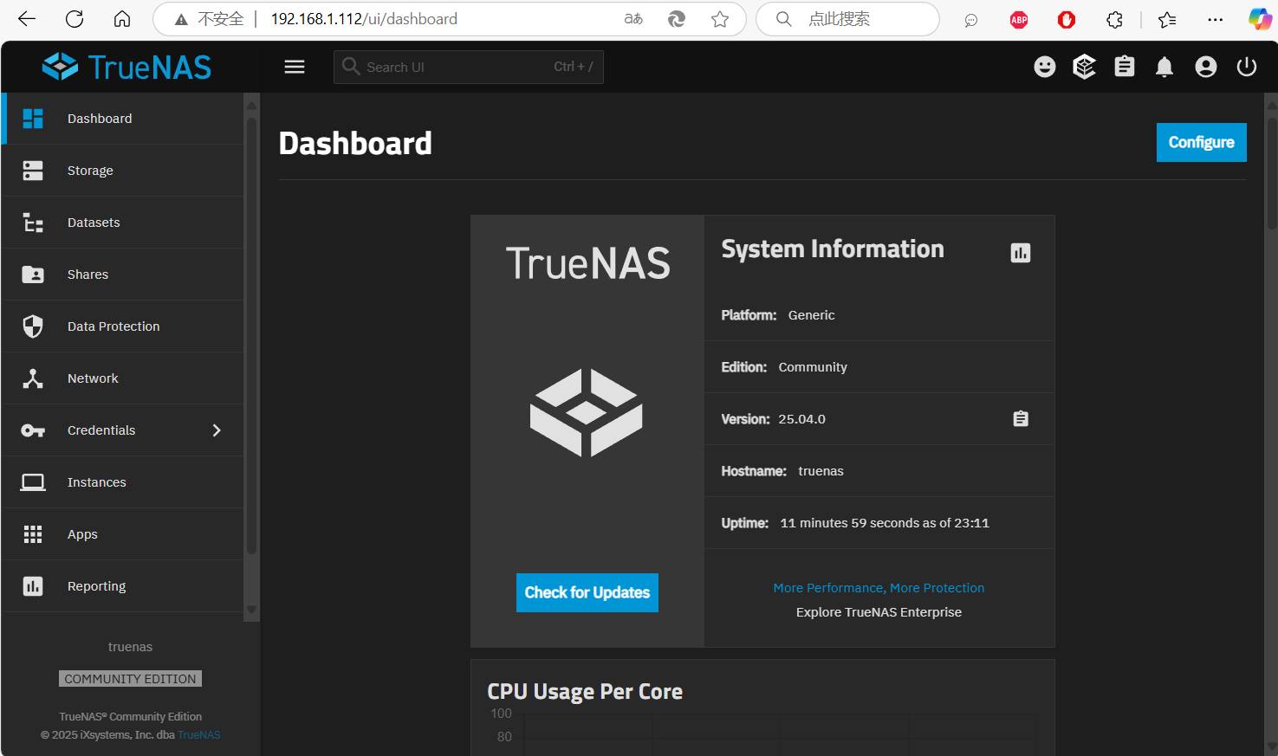

14.Click 【System】 → 【General Settings】 to configure.
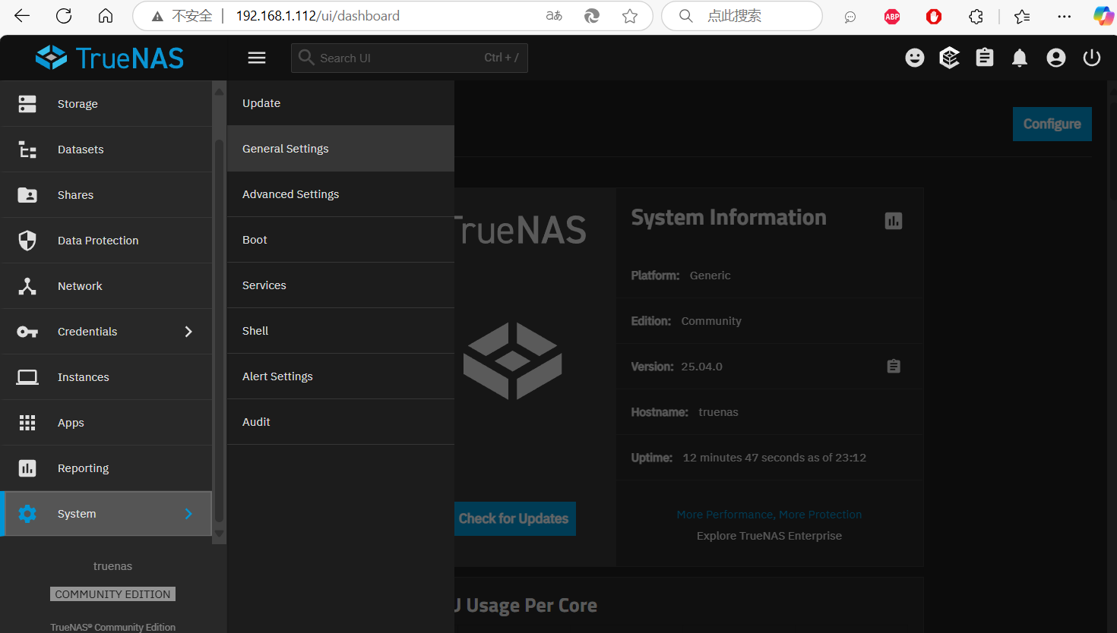

15.Adjust the language to English: First, go to 【Localization】 → 【Settings】.
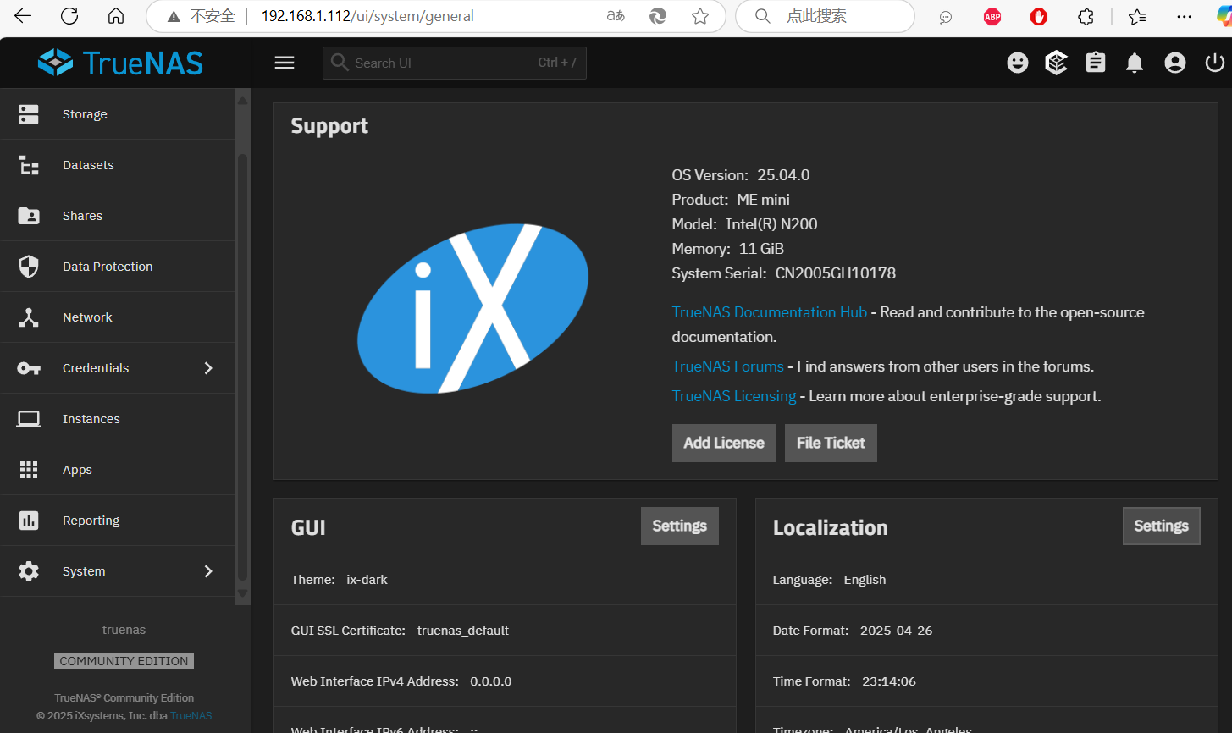

16.Select 【English】 in 【Language】 to switch to English.
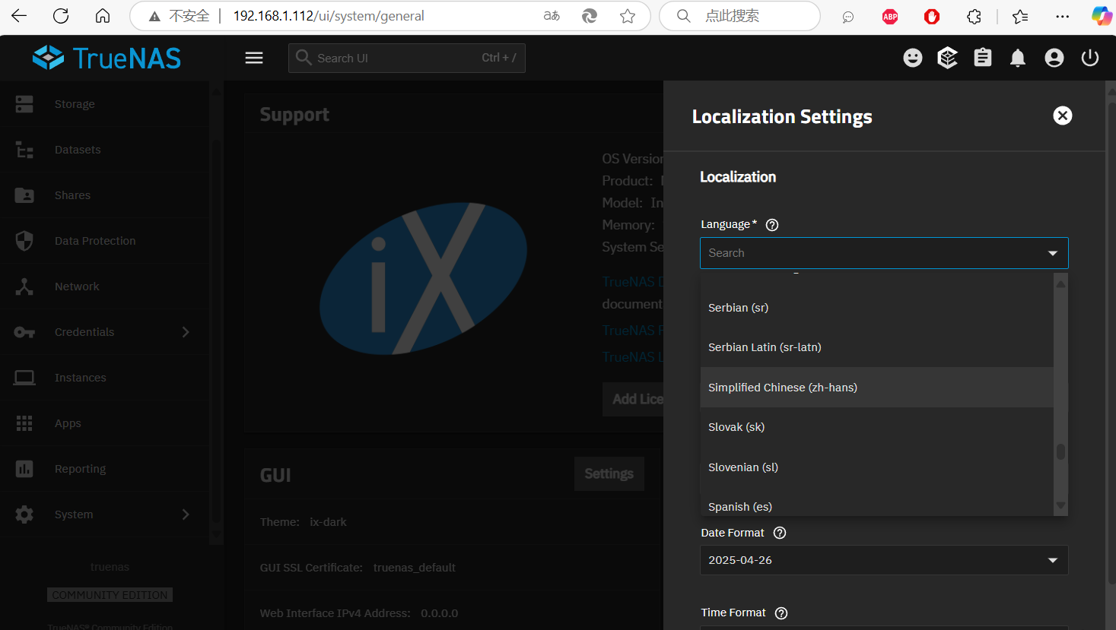

Adjust the timezone: Select 【your country】 in 【Timezone】, then click 【Save】 to save the settings.
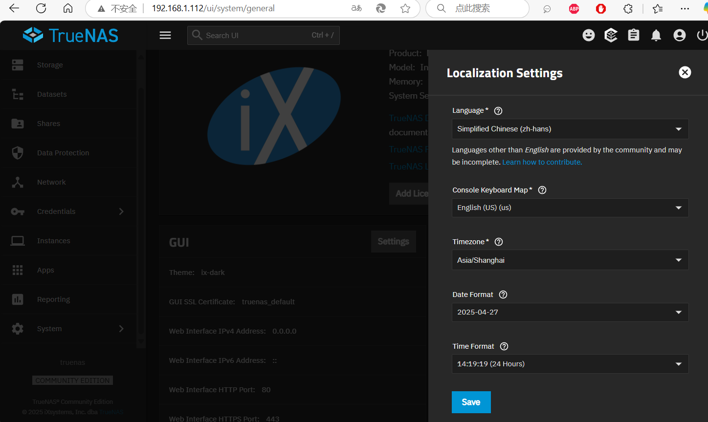

18.The entire system installation is complete, and it can be used normally .
