Tutorial for Installing Windows 10 on Mini PC
Prepare a USB flash drive with a capacity of over 16GB and insert it into a USB port on your PC.
Steps：
- First, open the official Microsoft website and navigate to the page of "Download Windows 10". Click on the "Download Now" button.
https://www.microsoft.com/en-us/software-download/windows10
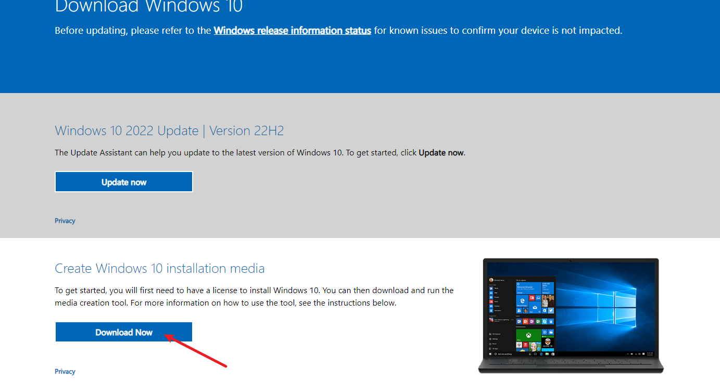
2. Double-click on the downloaded file to run the media creation tool and then choose "Accept".
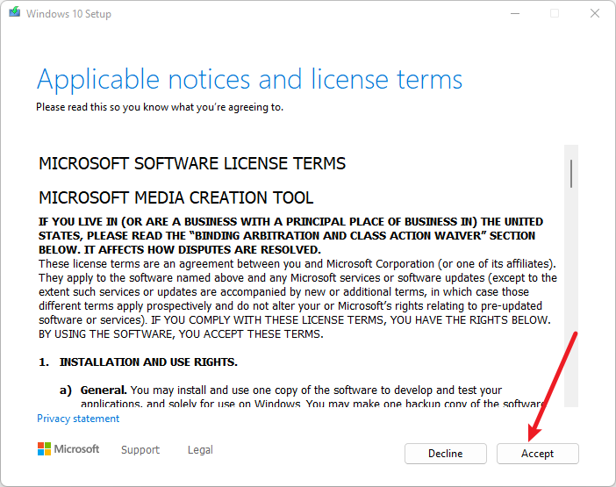
3. Select "Create installation media for another PC" and click "Next".
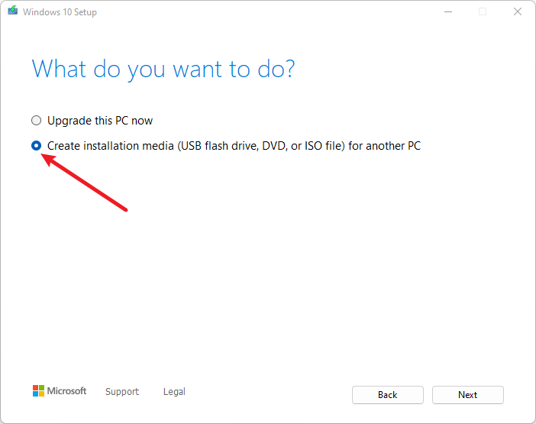
4. Select the language,edition and architecture you want to install of Windows 10 and then click "Next". If you are installing Windows on the current PC, just keep the "Use the recommended options for this PC" box checked and the tool will automatically download the correct version for your current PC. 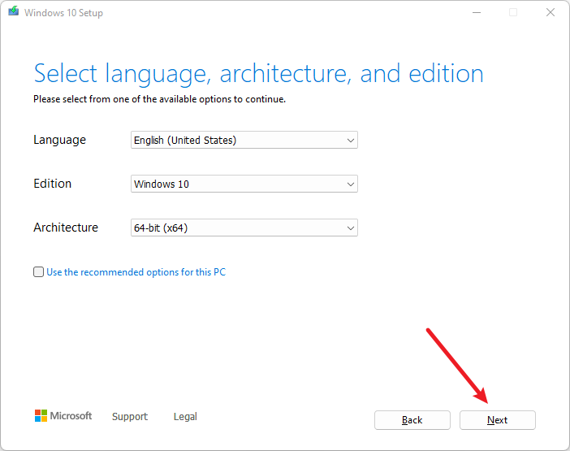
5. Choose "USB flash drive" and click "Next".
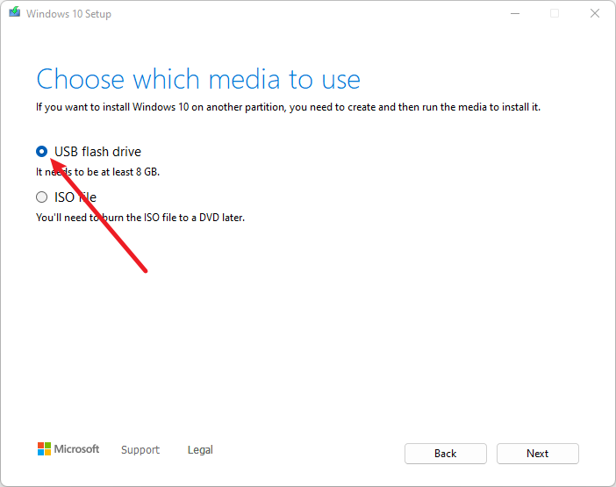
6. Select your USB flash drive and click "Next" to continue.
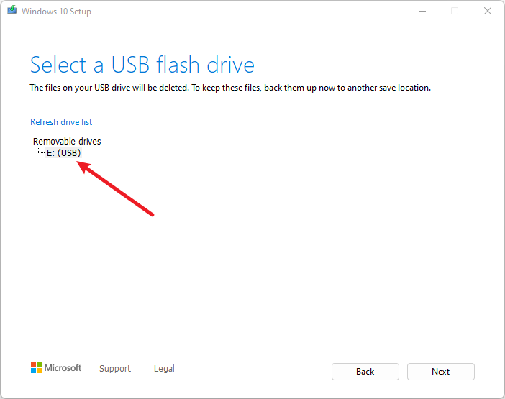
7. Wait patiently for the download to finish.
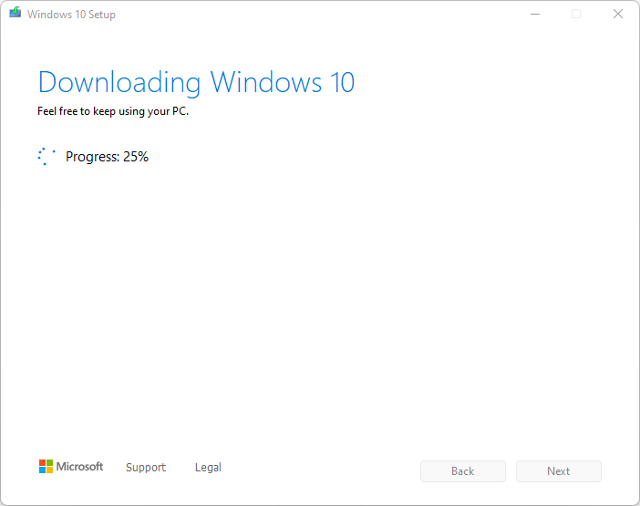
8. Once the download is completed, the installation media will automatically create Windows 10 media and write the image file to the USB flash drive.
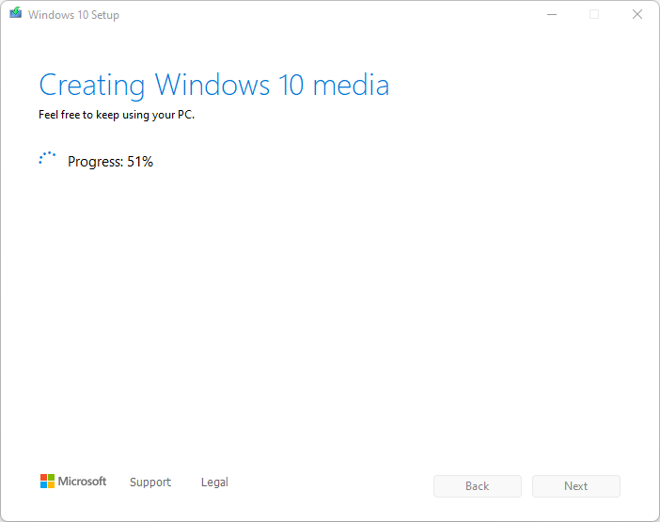
9. When the following prompt appears, it means that the windows 10 installation media has been successfully created. Click "Finish" to close the window.
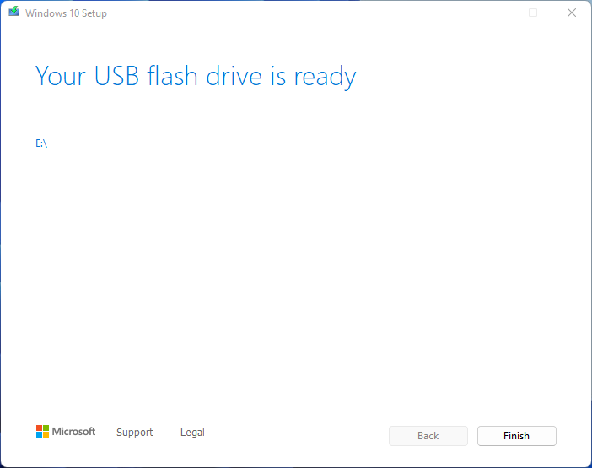
10. Insert the USB flash drive into the mini PC that you want to install Windows 10 on. Then press the power button to boot up the PC. When the logo appears on the screen, press the [F7] key repeatedly to enter boot menu.

11. Select your USB drive and press the Enter key.
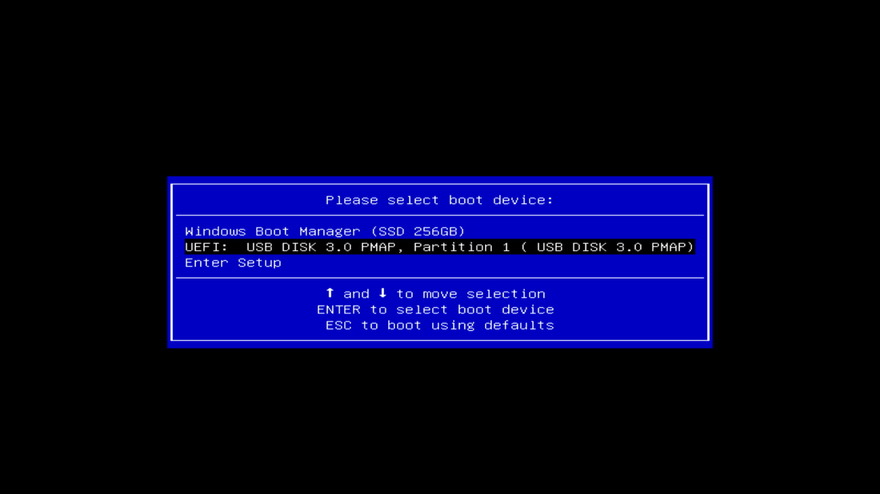
12. When you enter the installation interface, click "Next" and "Install now".
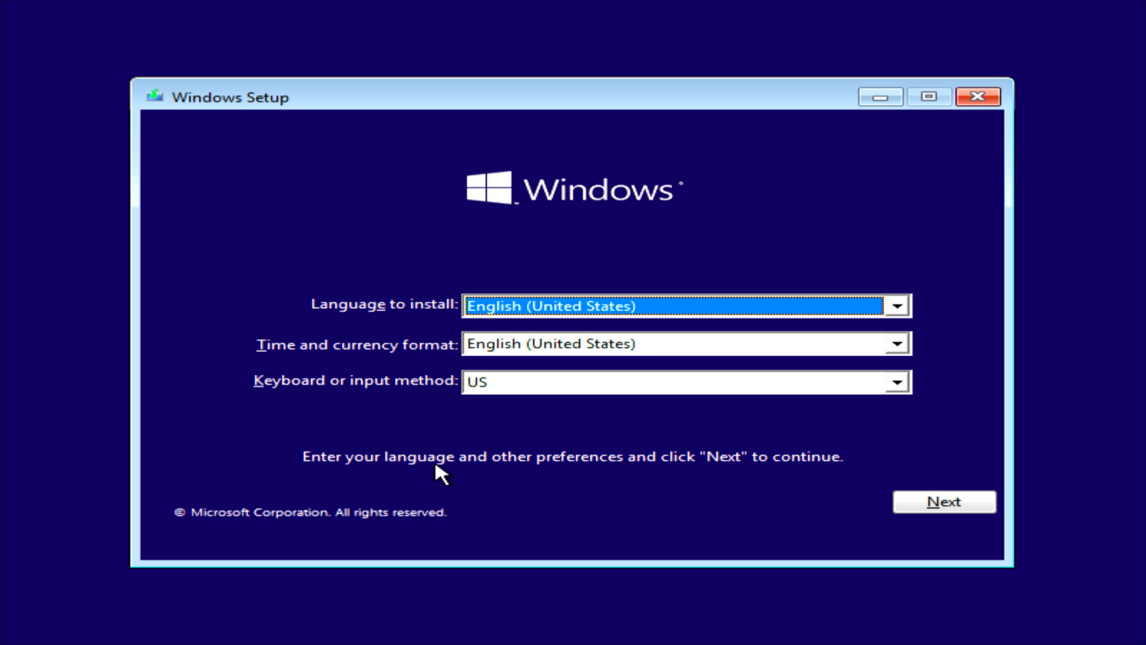
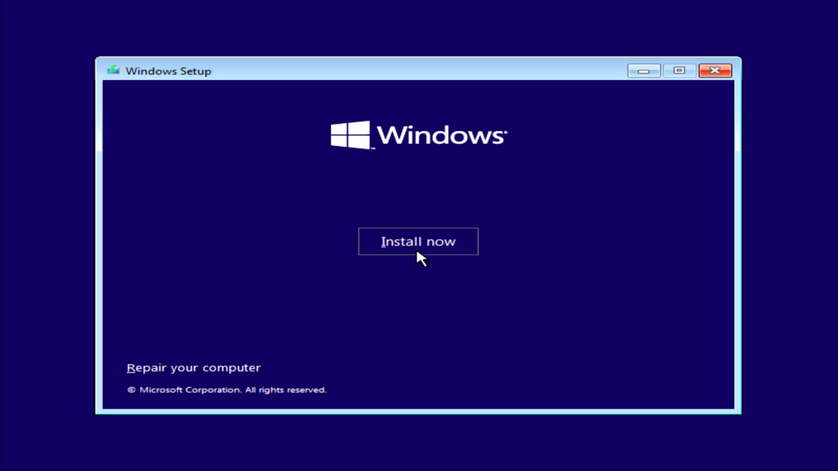
13. Select "I don't have a product key".
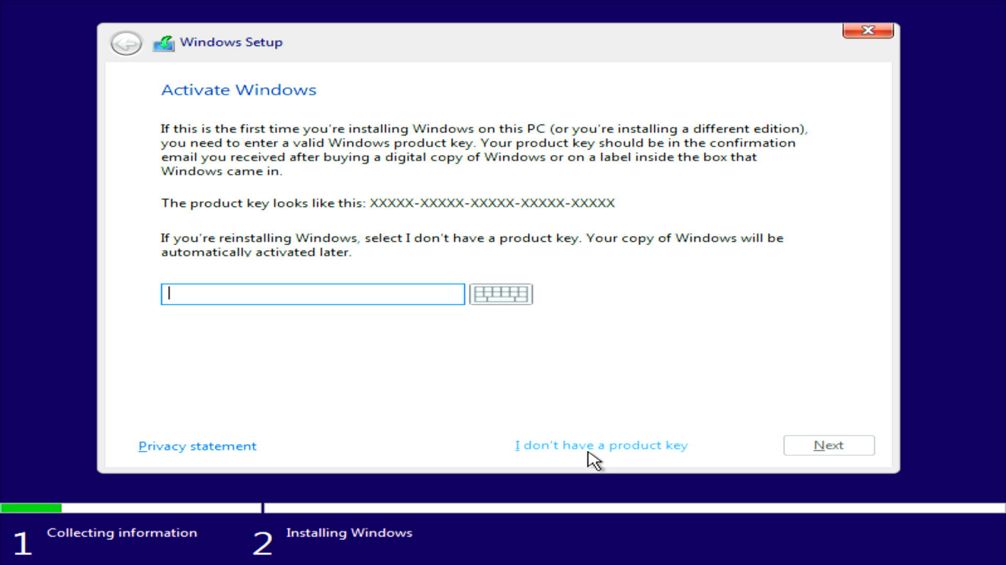
14. Select "Windows 10 Pro" and then click "Next".
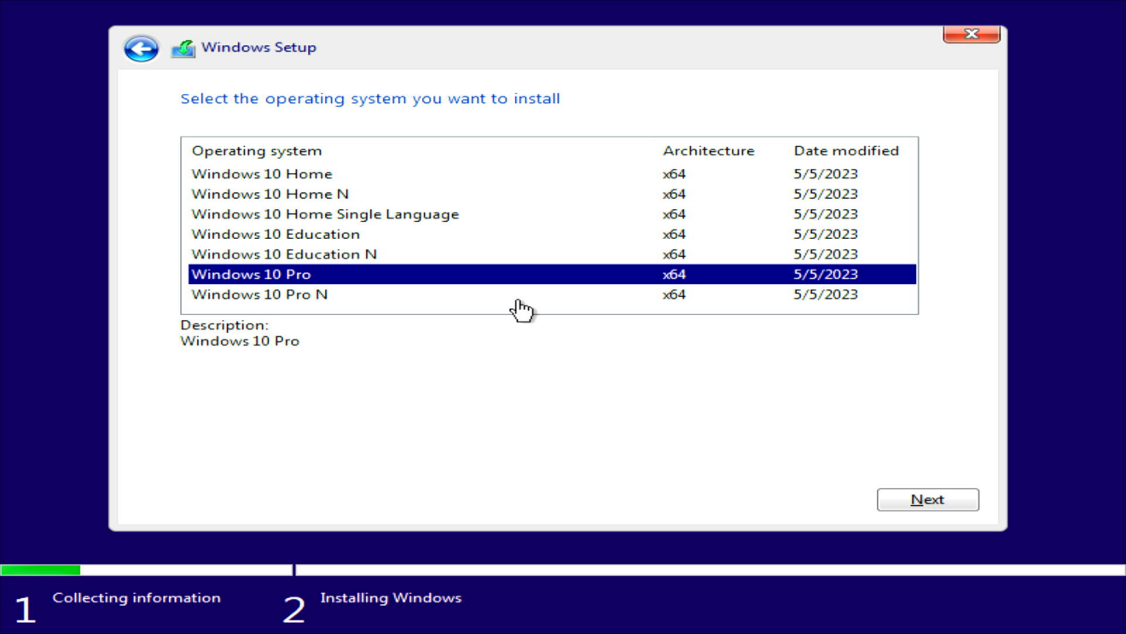
15. Check "I accept the license terms" and click "Next" .
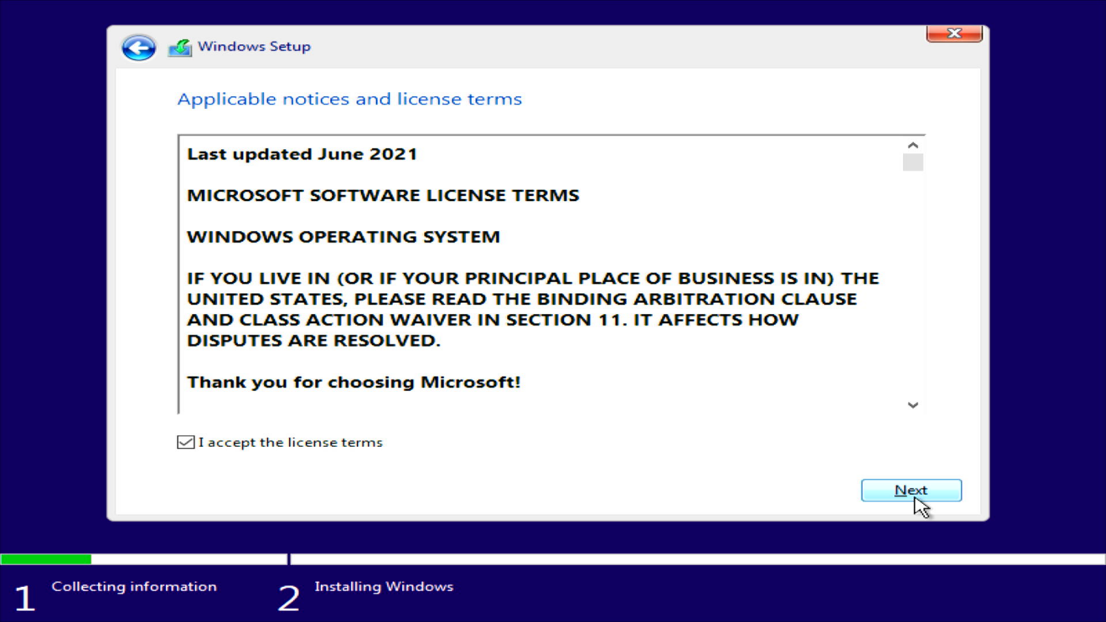
16. Select "Custom: Install Windows only (advanced)".
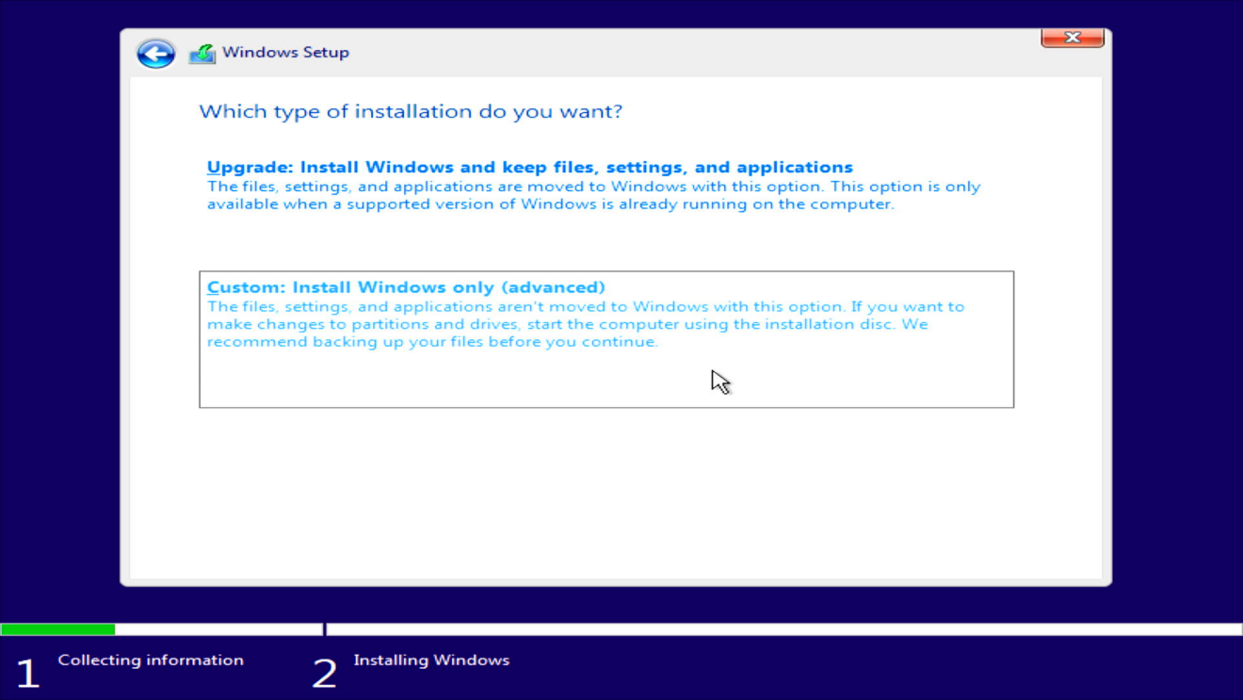
17. Select the disk you want Windows 10 installed on. If you are using a new drive with only one disk partition, simply select it and then click“Next”. If you are using an old drive with several partitions and you want Windows 10 to be your only operating system, we recommend that you delete the other partitions before clicking“Next”. Remember to back up your data beforehand to avoid any loss.
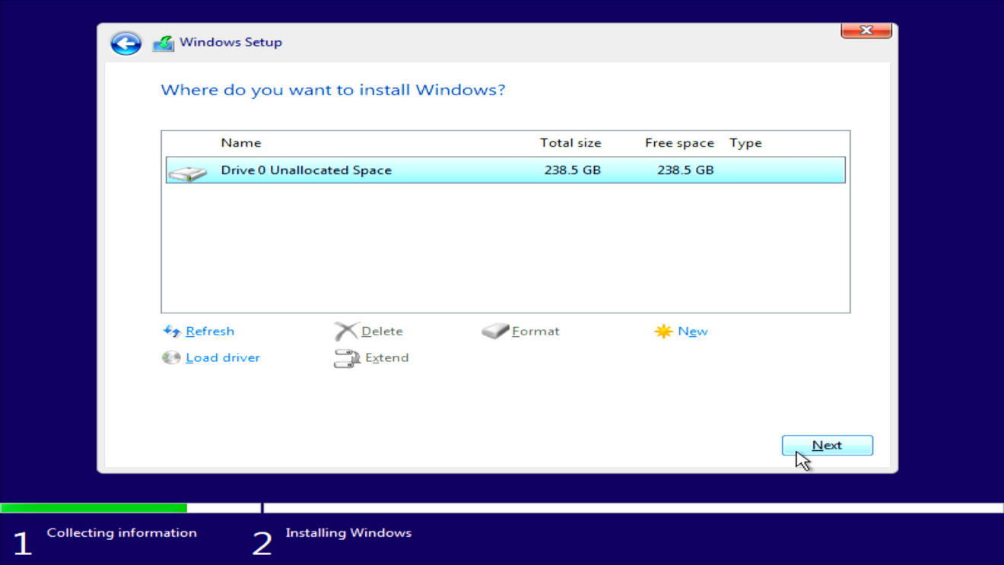
18. Wait patiently for the installation to finish. Once the installation is completed, the mini PC will automatically restart.
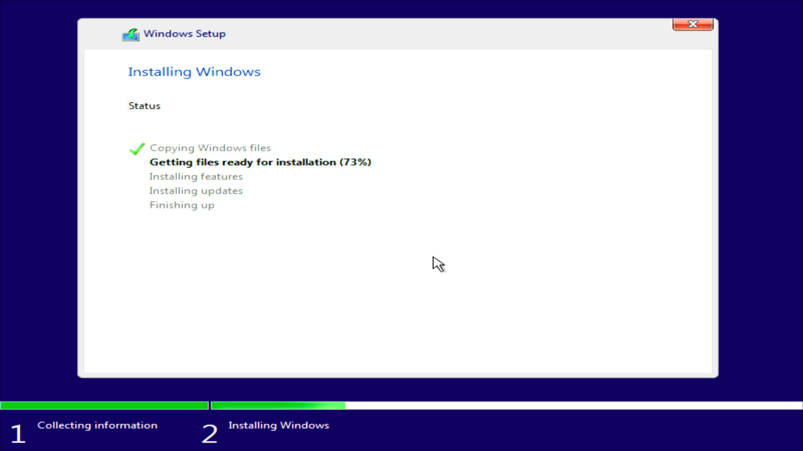
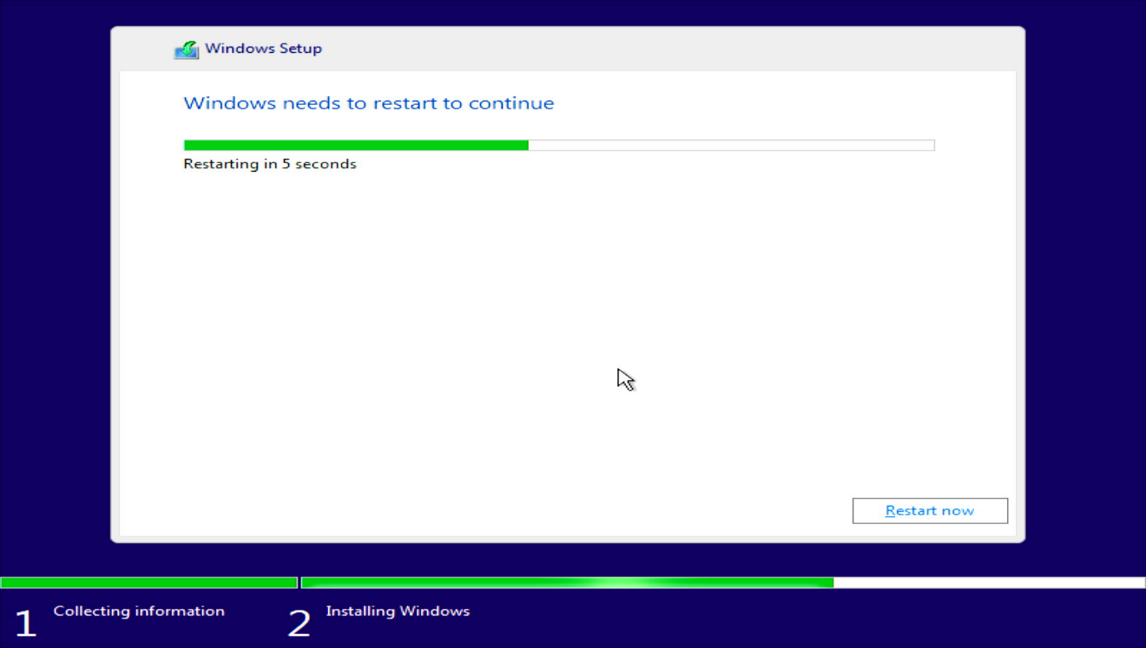
19. Next, you can configure the settings according to your needs.
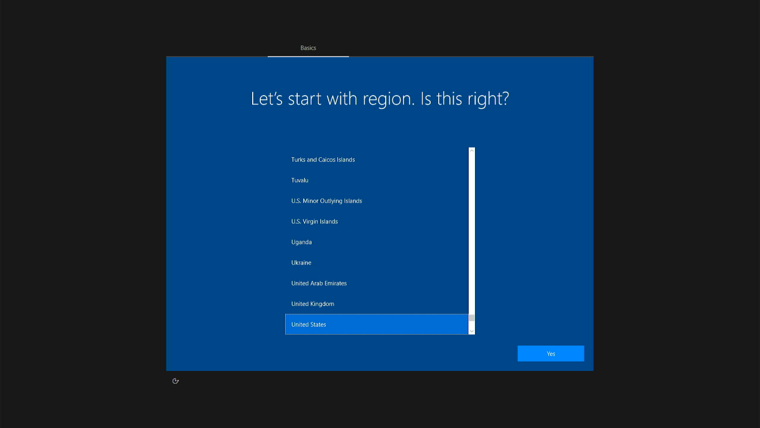
20. Attention: During the system configuration process, we do not recommend connecting to the internet. If connected, the system will update itself simultaneously, which may result in configuration lag. Please connect to the internet only after you enter the desktop. If this page does not appear, unplug the network cable and restart the mini PC.
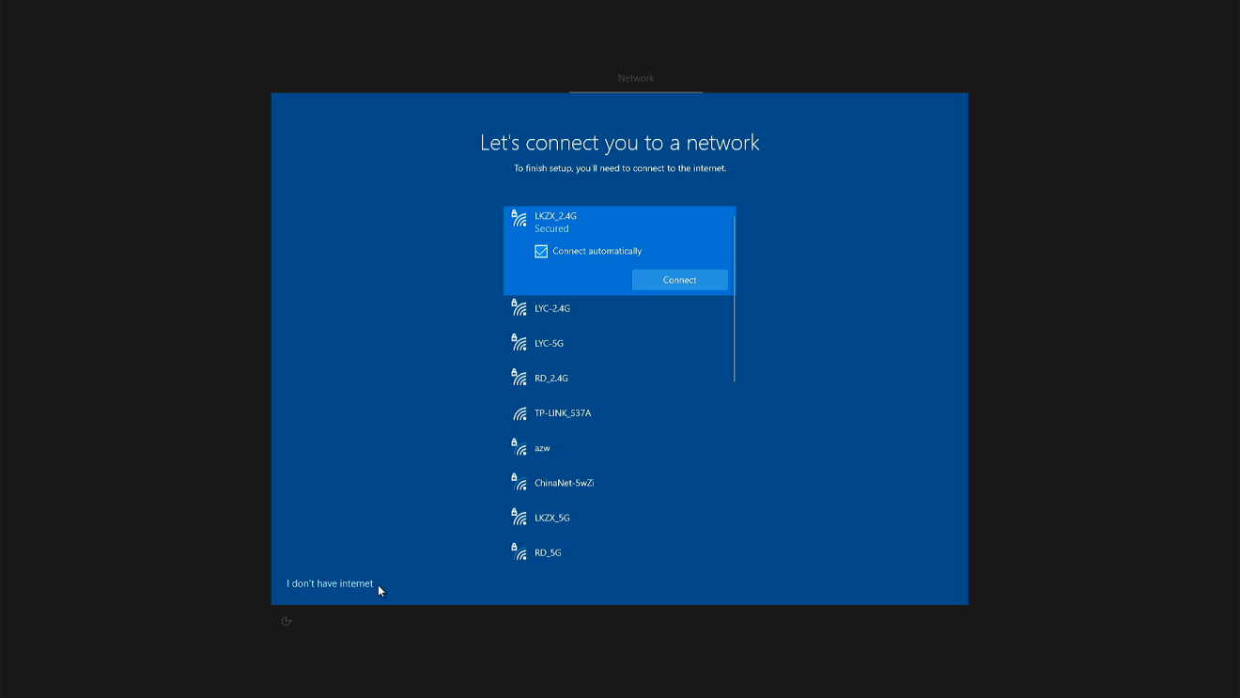
21. After the setup is completed, you can enter the desktop. The next step is driver installation.
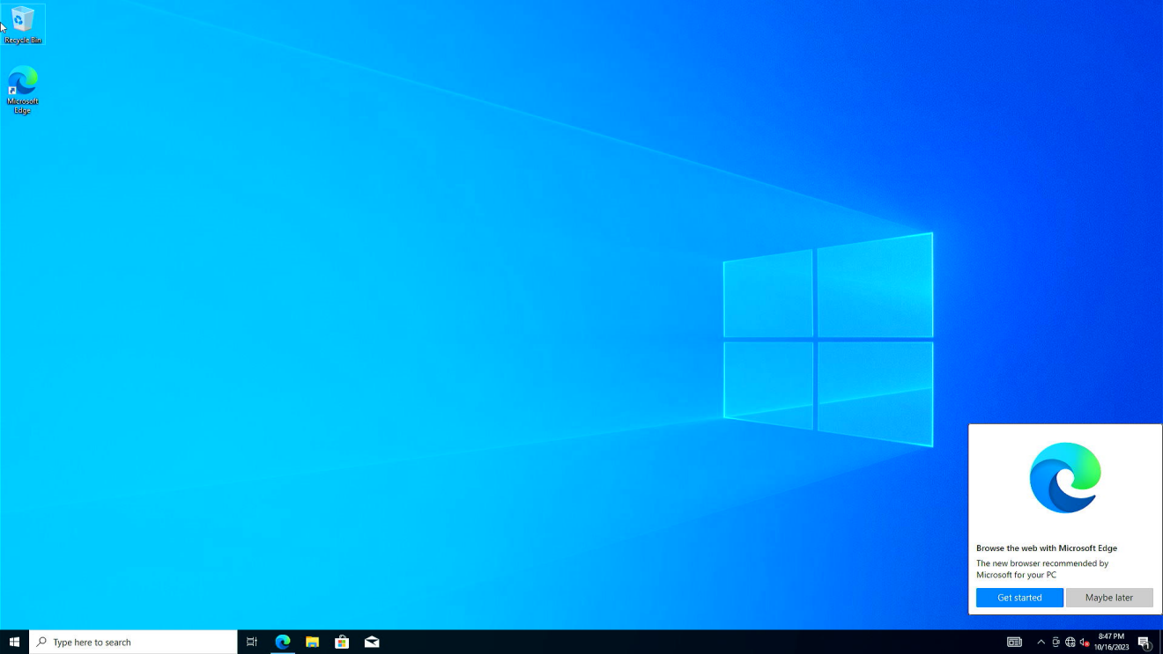
22. Go to the technical support page on official website, download the driver package file that matches your system, and extract it to the desktop.
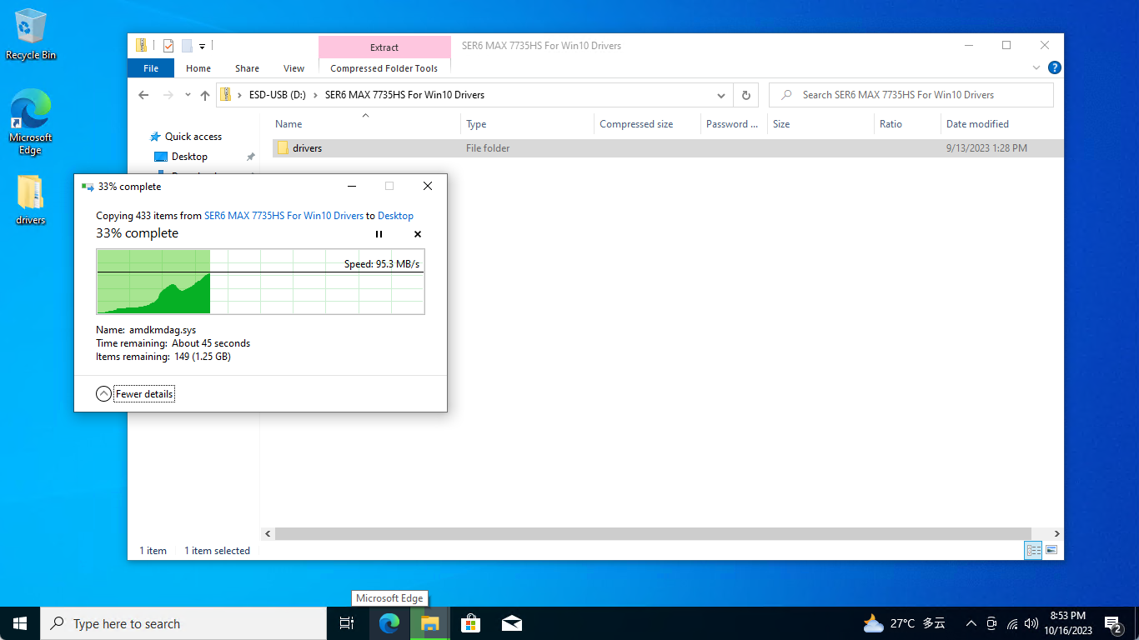
23. Search and open "Device Manager".
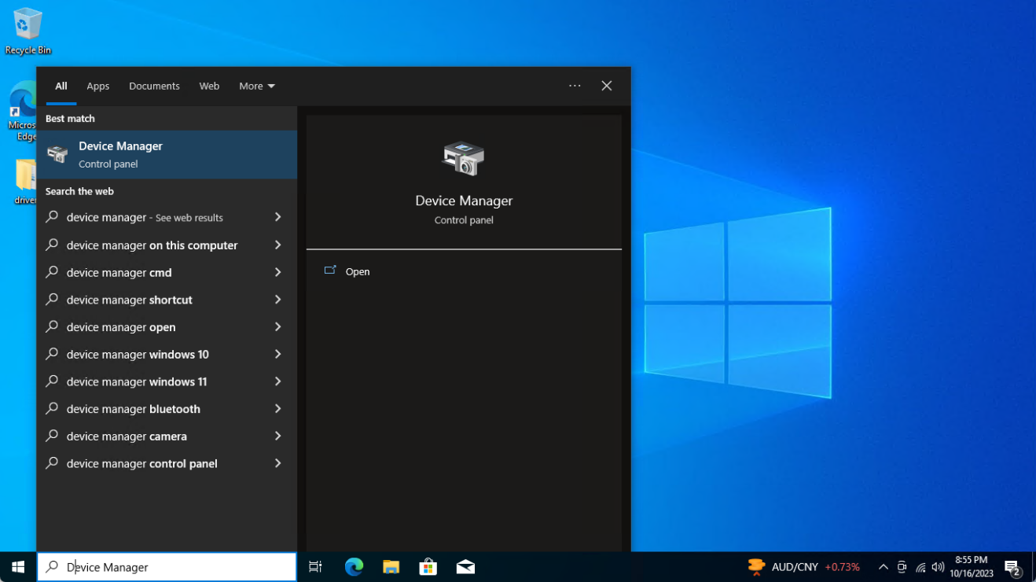
24. Once you find the device with yellow exclamation mark, right-click on it and select "Update driver".
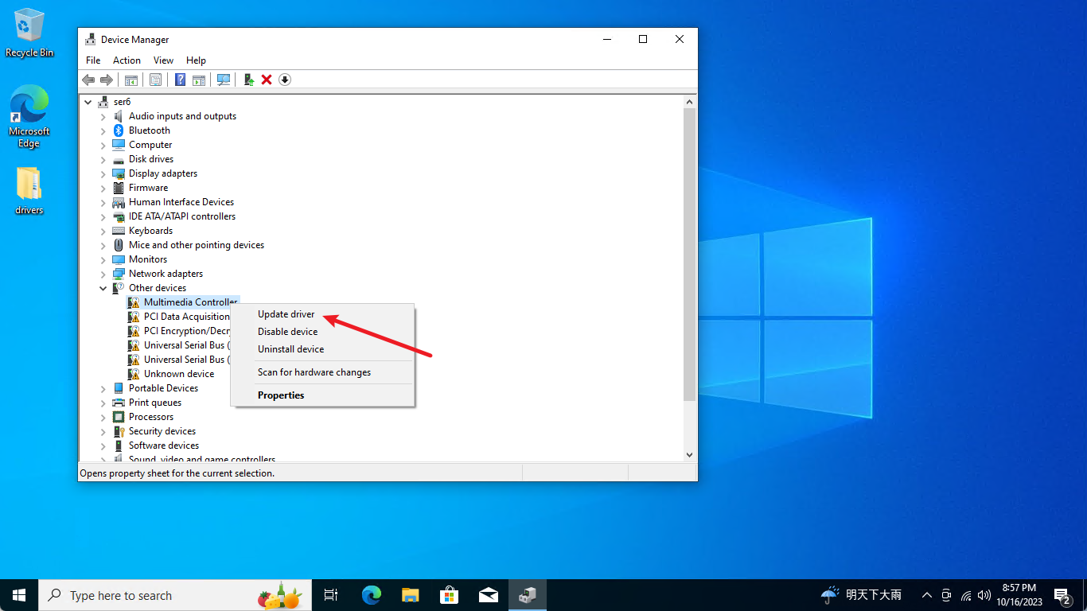
25. Click " Browse my computer for drivers".
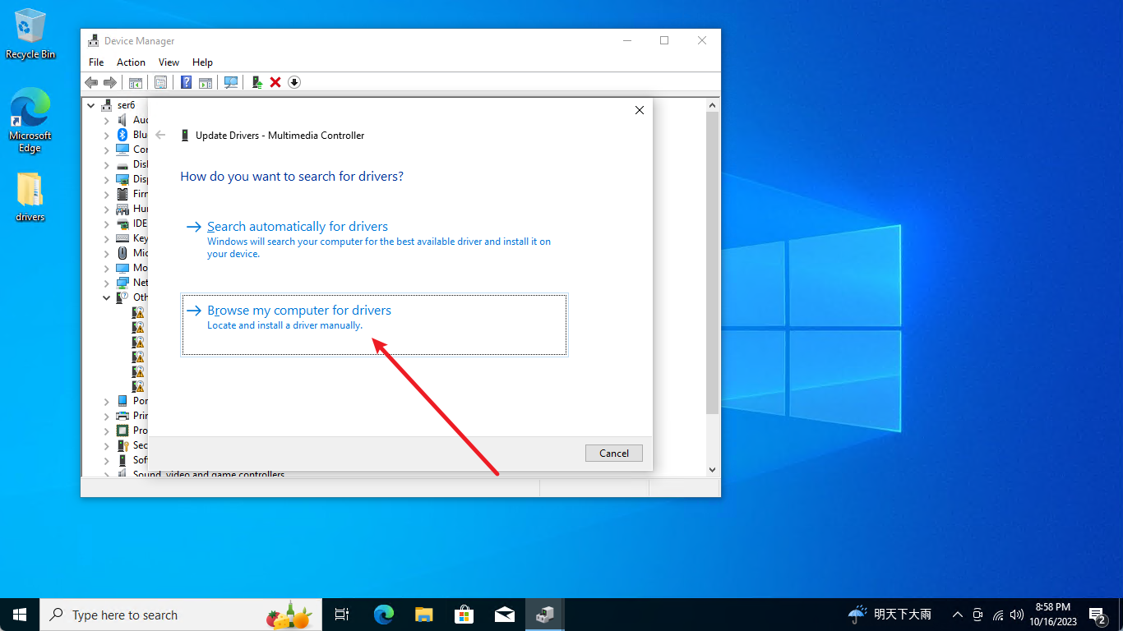
26. Select the driver folder that has already been extracted.
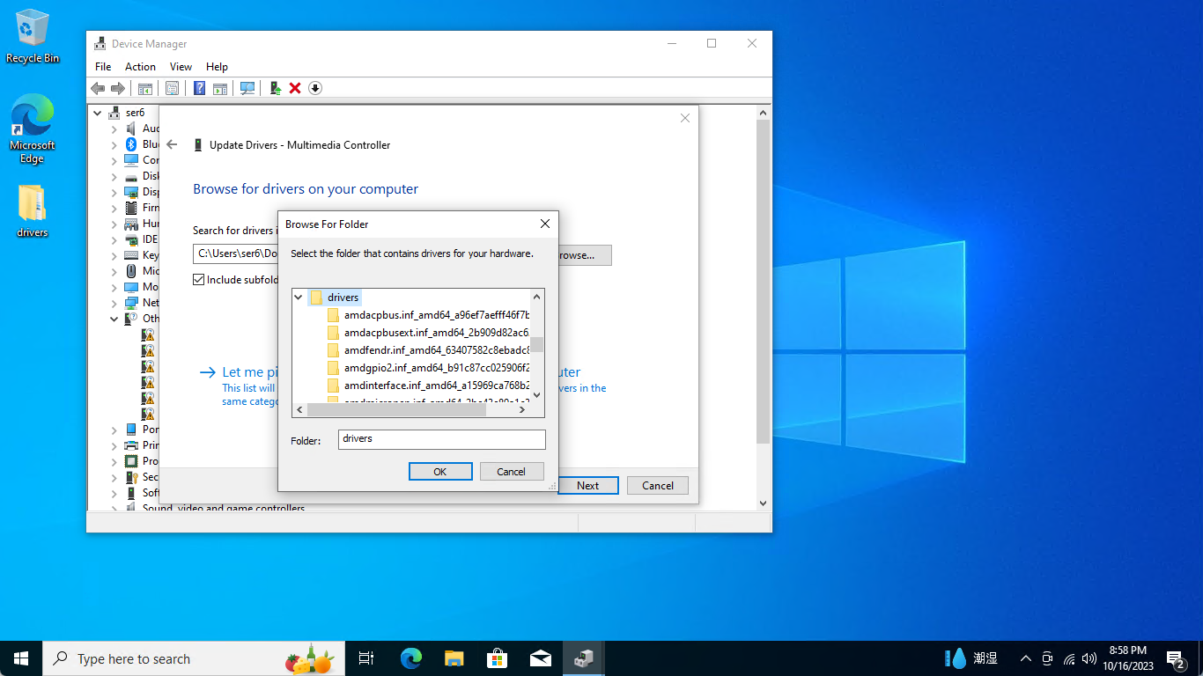
27. Click "Next" to proceed with driver installation.
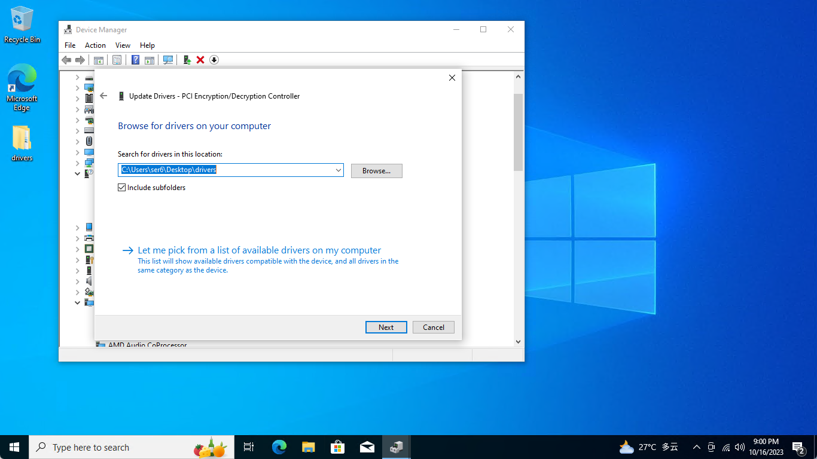
28. When the yellow exclamation mark disappears, the driver for the device has been successfully installed. Next, follow the same method to install drivers for other devices one by one.
29. After you finish installing drivers for the devices listed in “Other devices”, use the same method to install the driver for the graphics card.
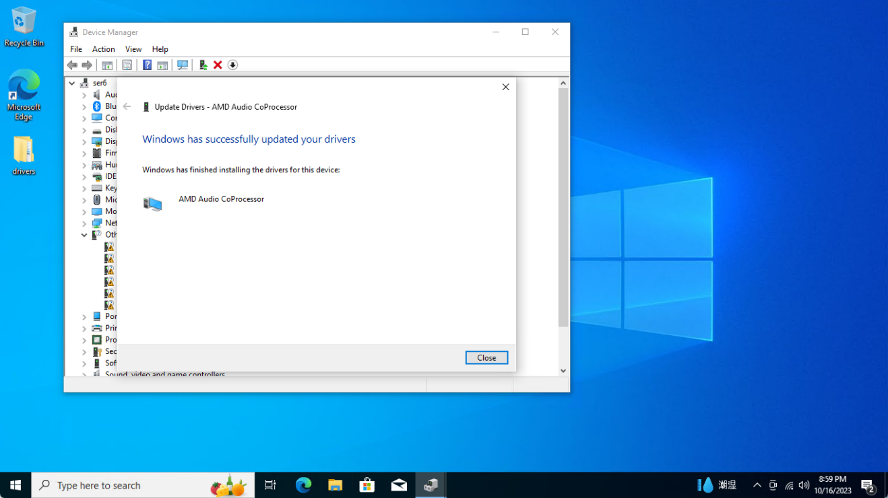
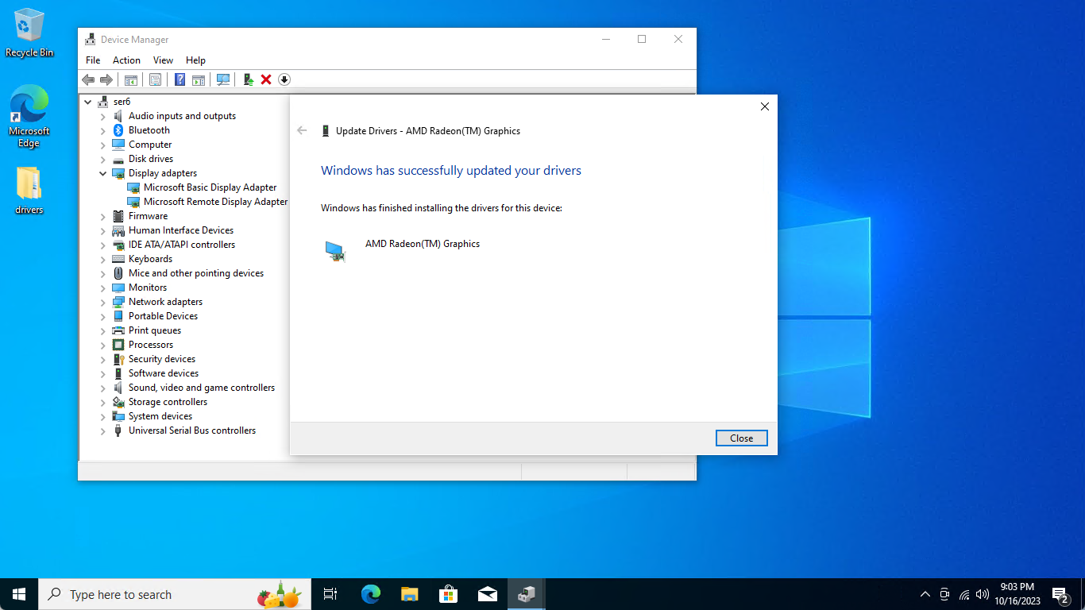
30. When all the drivers are installed, you can now enjoy using Windows 10 on your mini PC.
