Installation Guide for Ubuntu on Beelink Mini PC
一、Preparatory Work
Note: This article takes the installation of Ubuntu 23.04 as an example.
The preparatory work needs to be done on another system, and here we will perform the following operations on Windows 10.

1. Download Ubuntu image
Open the official website of Ubuntu: https://ubuntu.com/download/desktop
After entering the page, click the [Download] button on the right to start downloading the ISO system image file of Ubuntu.
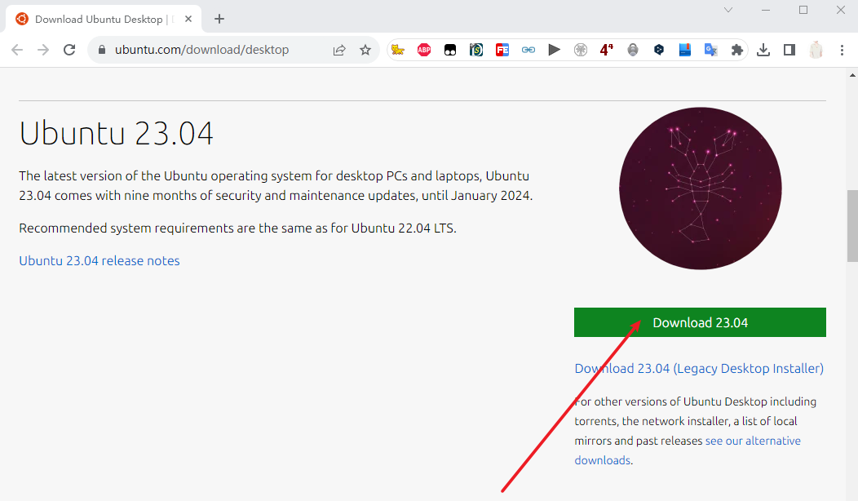

2.Creating a USB bootable drive
1) Download Rufuse writing tool and open it after the download is complete.
Download link: http://rufus.ie/zh
Lanzou Cloud: https://lanzoui.com/iFxVG0us3keb
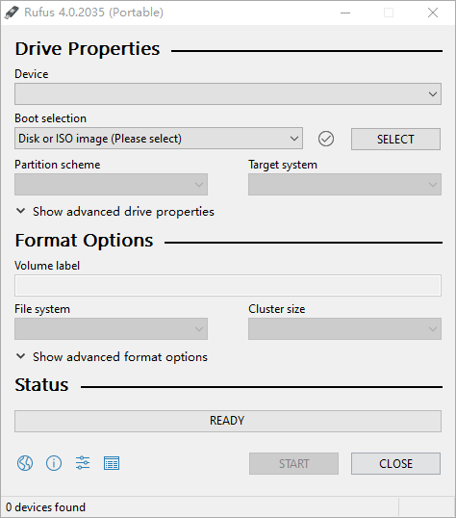

2) Insert the USB flash drive that will be used as a bootable disk. If there are any files on the USB drive, please make sure to back them up to prevent data loss. Once the USB drive is inserted, the capacity of the USB drive will be displayed in the device area.
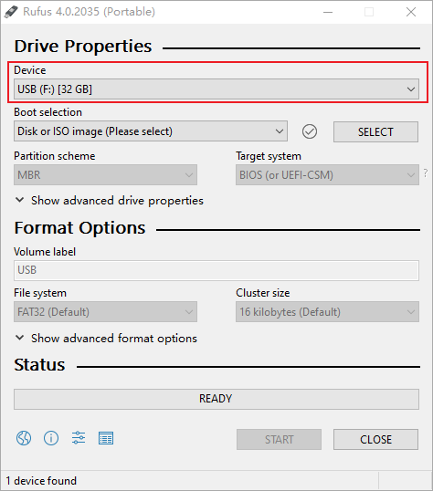

3) Click "Select" and then find the downloaded Ubuntu system image file, and click "Open".
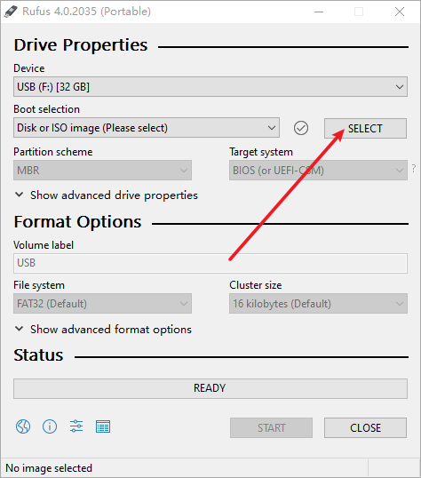

4)Click "Start" to write the Ubuntu system image to the USB drive.
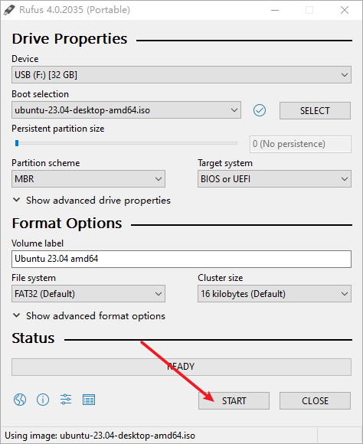

If the following prompt appears, select "Write in ISO image mode" and click [OK].
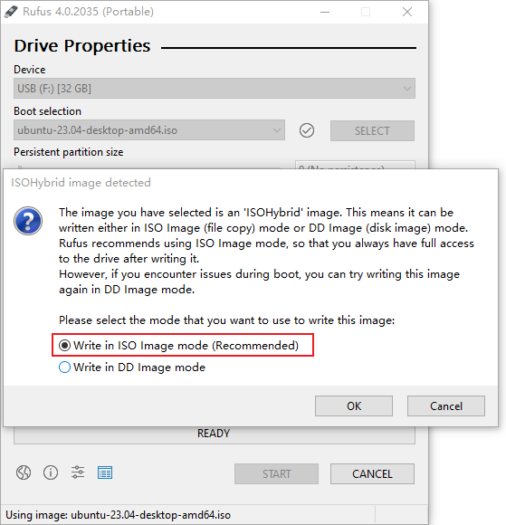

5) After the writing process completes, you can safely remove the USB flash drive.
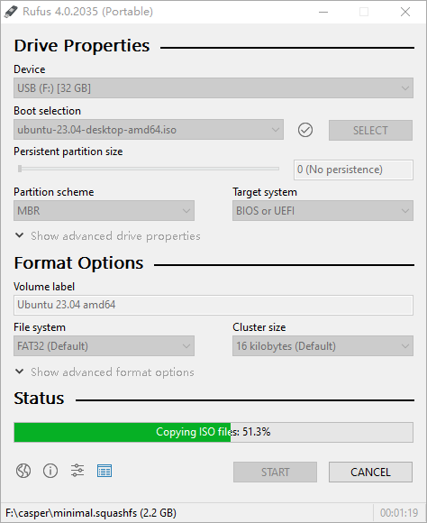

二、 Installing Ubuntu 23.04
1. Setting up the boot options
Shut down the Beelink SER7 7840HS mini PC, insert the bootable USB drive and then power on the machine. When the Beelink logo appears on the screen, press the [F7] key repeatedly to enter the boot menu.
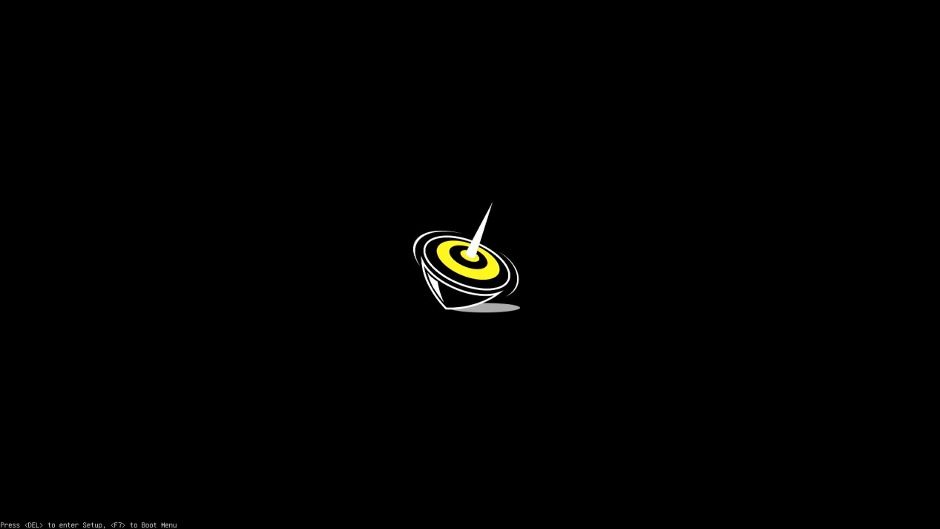

Select your USB drive as the boot device and press Enter.
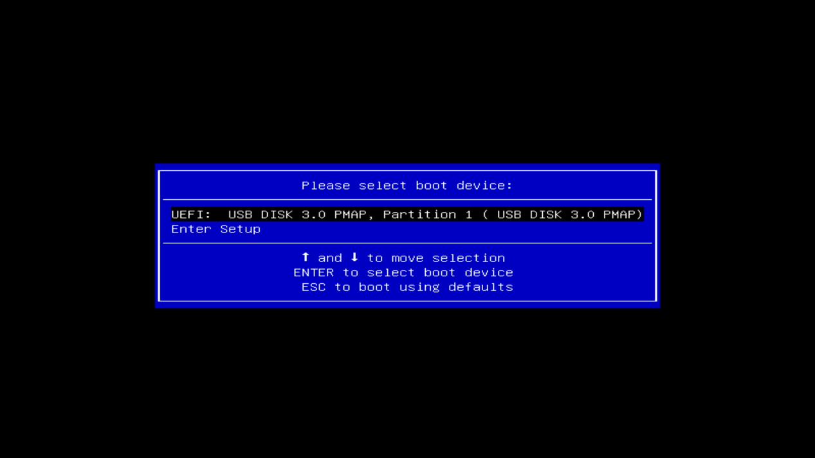

Select "Try or Install Ubuntu" and press Enter to continue with the installation.
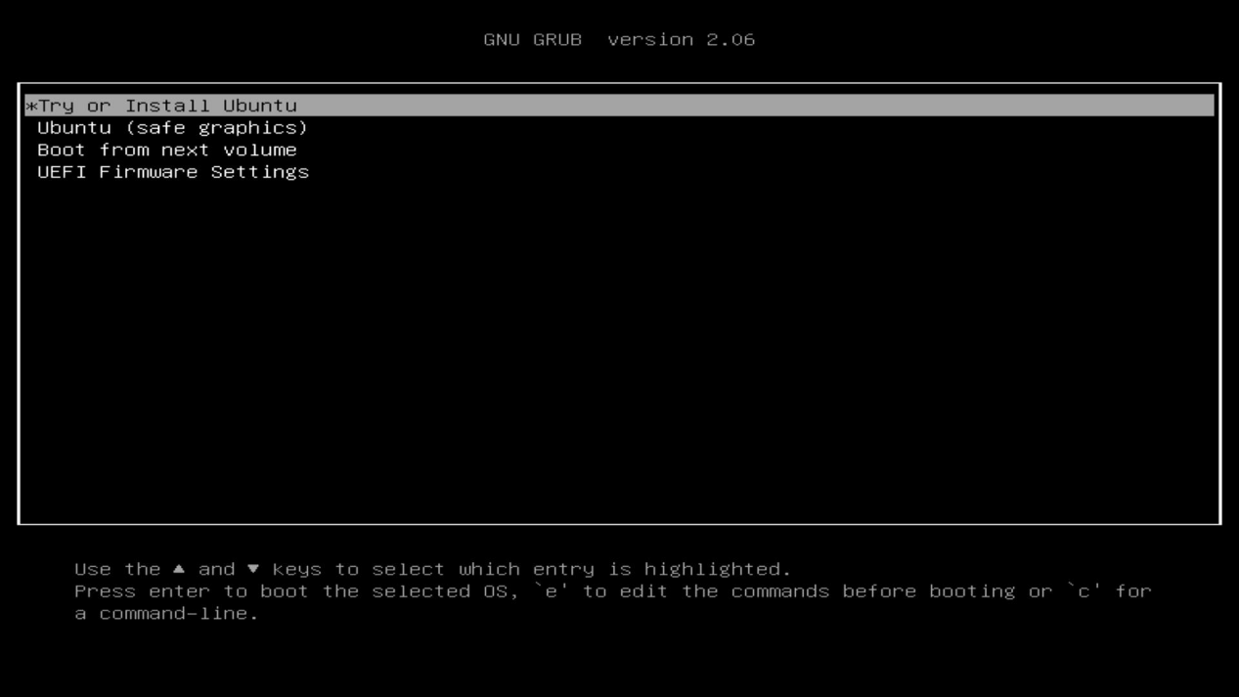
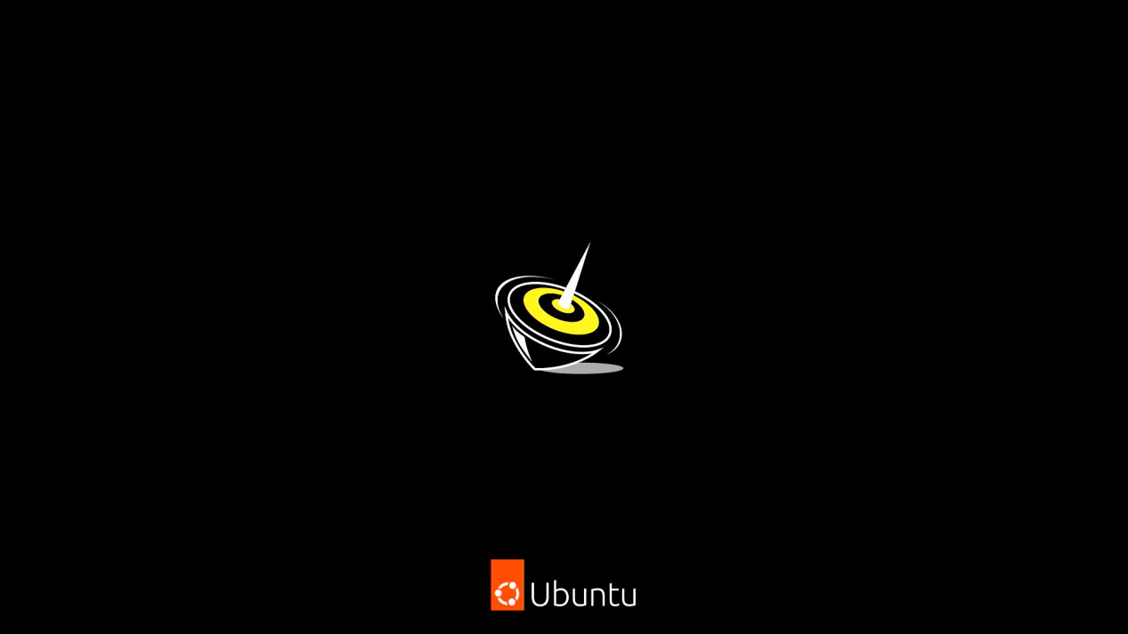

3. Formal Installation
1) Select Language
Select the language you prefer. Click "Next" to continue the installation.
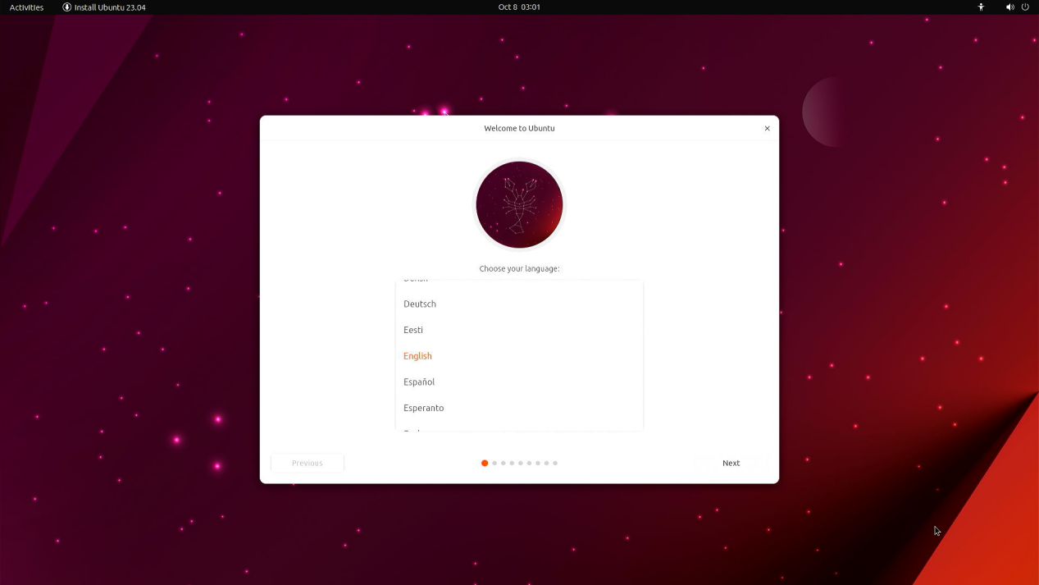

- Select "Install Ubuntu", and click "Next".
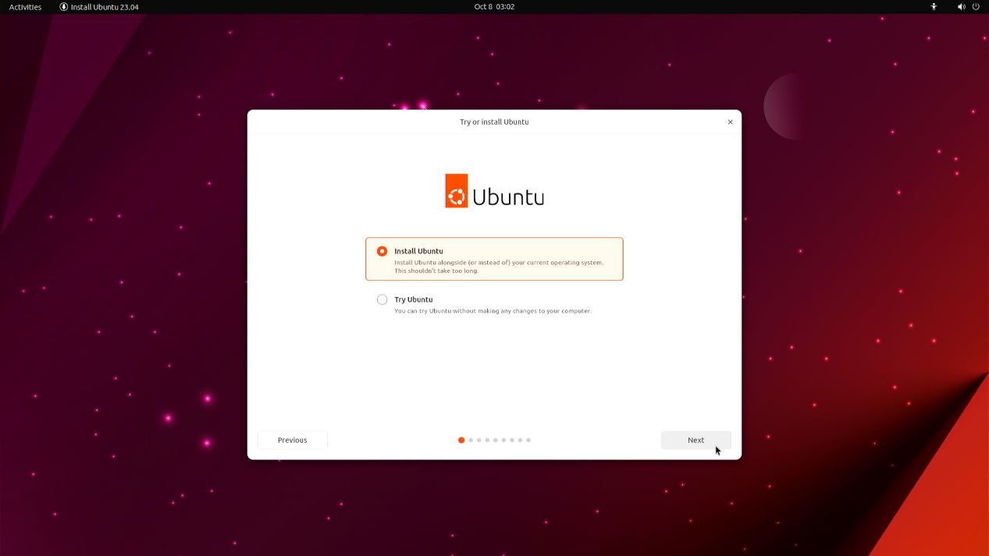

- You will be asked to select your keyboard layout. Once you’ve chosen one, click “Next”to continue.
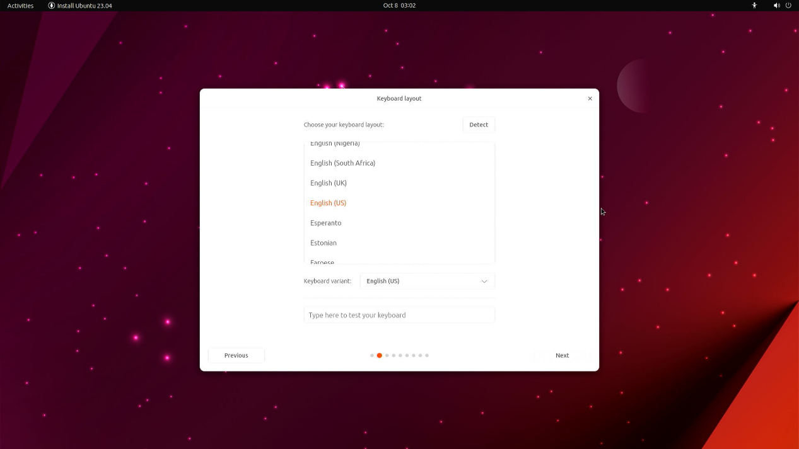

4) Network Connection
Select "I don't want to connect to the internet just now," and click "Next."
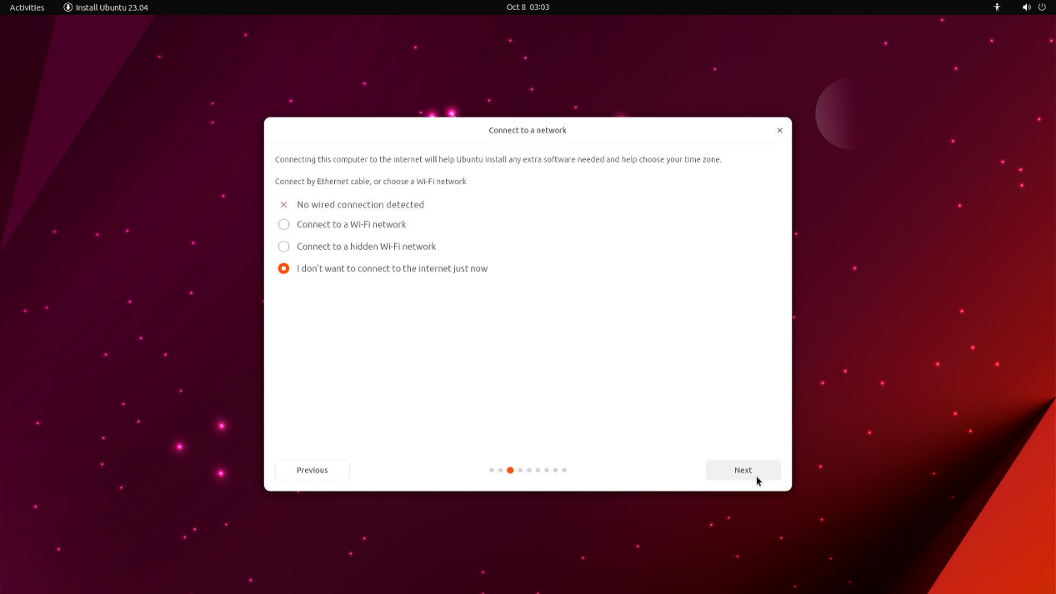

5) Update Options
You will be aksed to choose between the Normal installation and Minimal installation options. The minimal installation is useful for users with smaller hard drives or who don’t require as many pre-installed applications.
We recommend that you check the option "Install third-party software for graphics and Wi-Fi hardware", and click "Next" to continue.
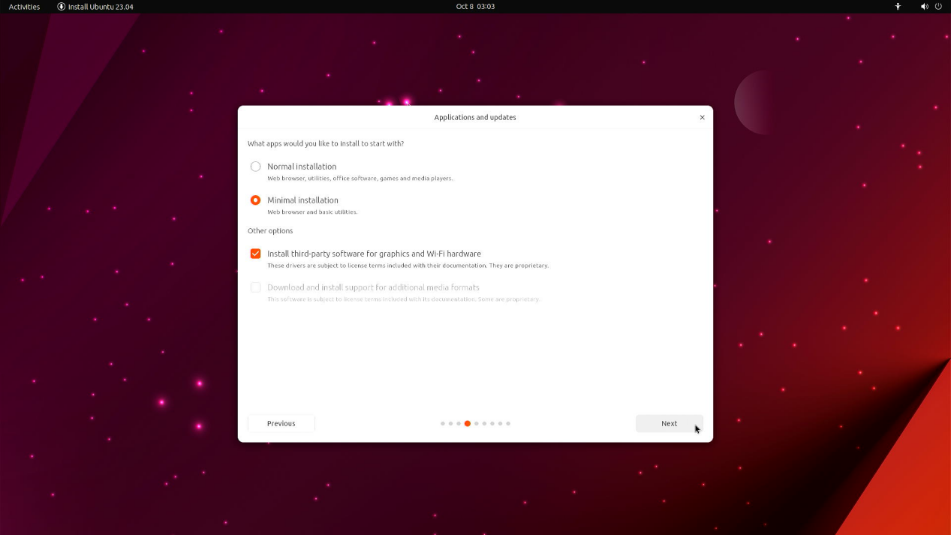

6) Select the type of installation
This screen allows you to configure your installation. If you would like Ubuntu to be the only operating system on your disk, select “Erase disk and install Ubuntu”. and click "Next" to continue.
If your SER7 mini PC currently has another operating system installed on the same disk, you can also choose to install Ubuntu alongside that OS rather than replacing it.
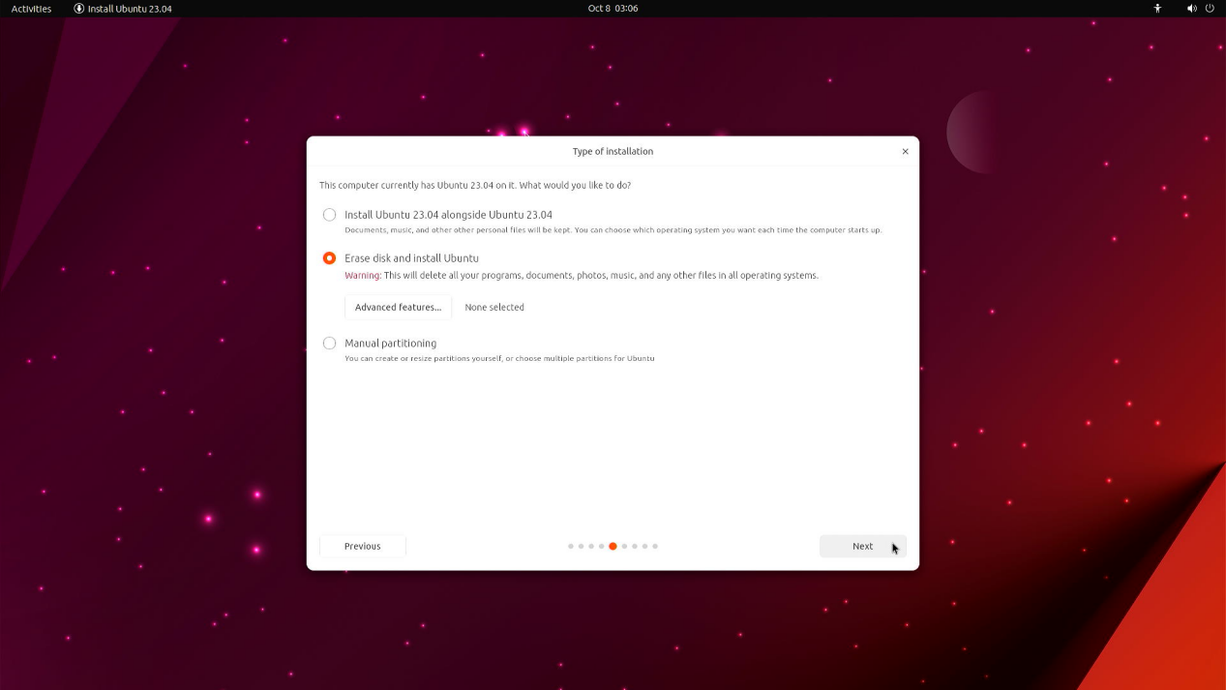

7) Installation Preparation
After confirming the partitions, click on "Install" to proceed.
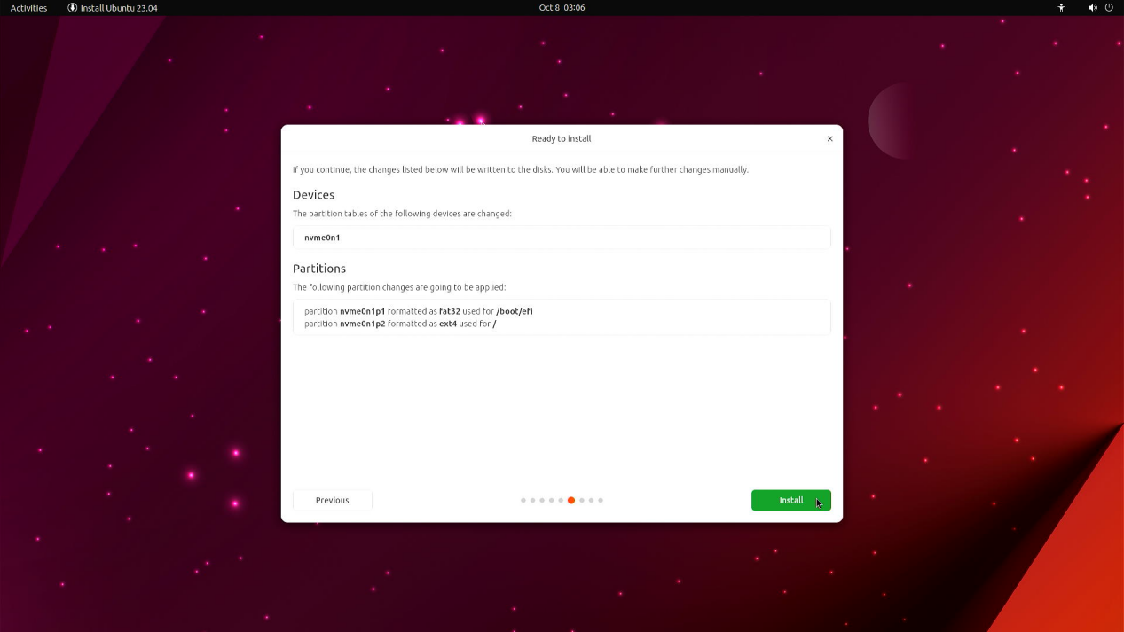

8) Select Time Zone
Select the location and time zone on the map, and click “Next”to continue.
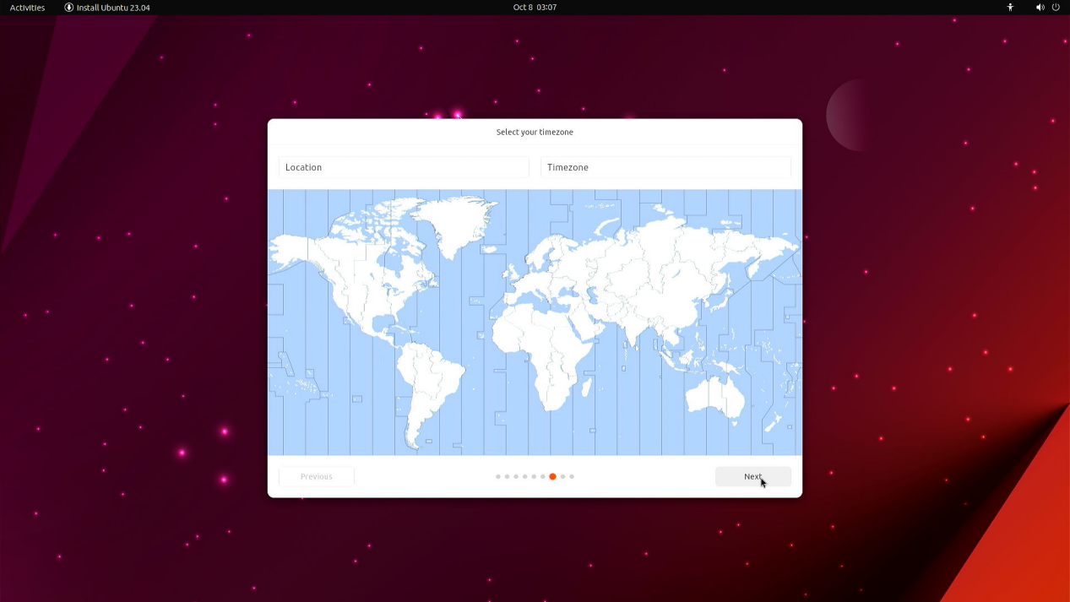

9) Create a username
After filling in your information, click "Next" to continue with the installation.
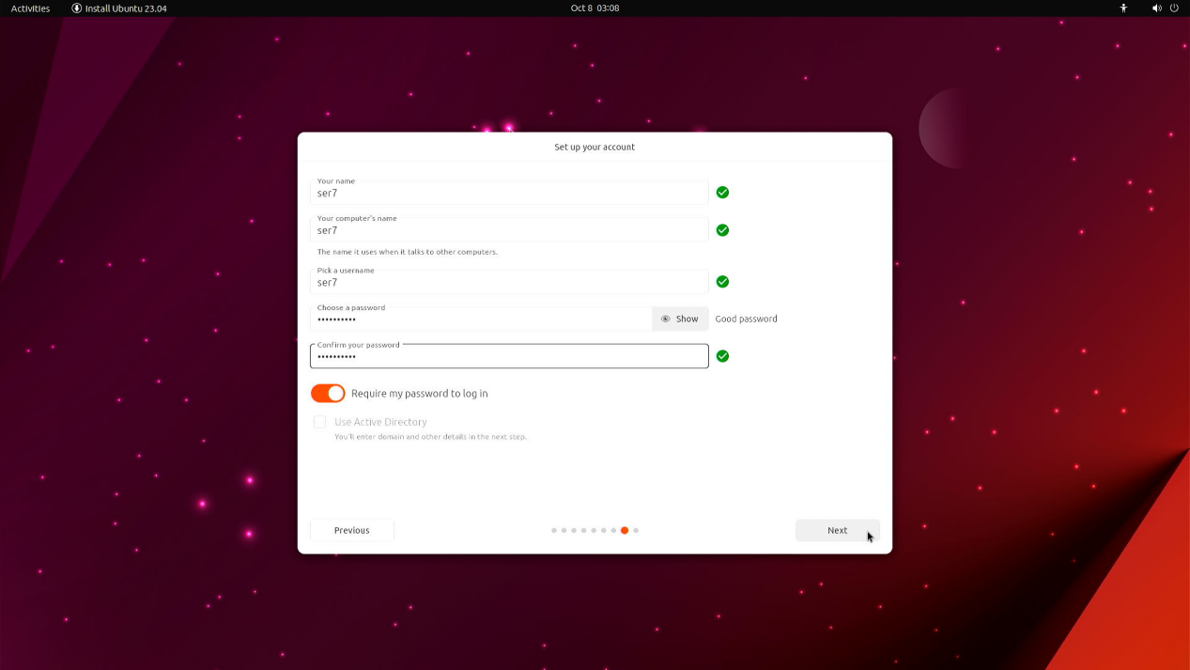

10) Theme selection
Select the theme based on your own preference, and then click "Next" to continue.
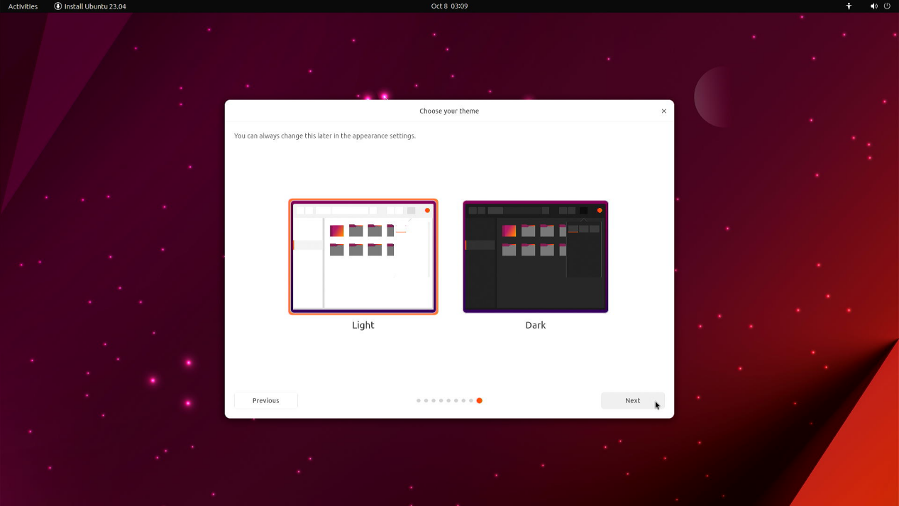

11) And then sit back and enjoy the slideshow as Ubuntu installs in the background! .
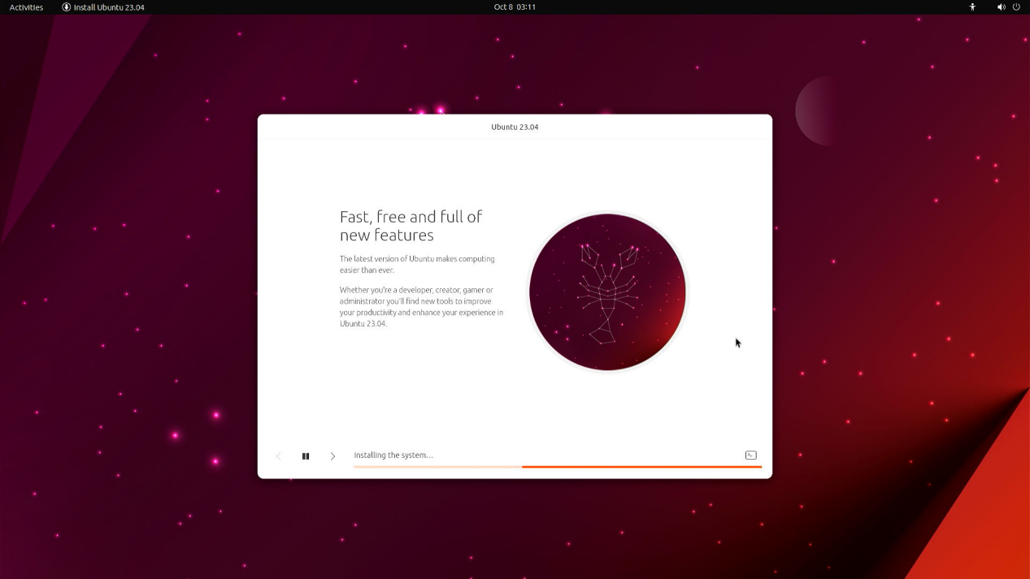

12) Installation completed
Once the installation has completed, you will be asked to restart your PC.
Click Restart Now.
When you restart, you will be asked to remove your USB flash drive from the device. Once you’ve done this, press ENTER.
After the system reboot, you will be able to enter the Ubuntu Desktop and start using the operating system.

