Download the file to your PC desktop:
https://url.bee-link.cn/B1XC
Step 1: Right click the file named “WriteOENSN” and open it as administrator.
Step2: After entering the interface, enter the serial number you need. Then tab
enter.
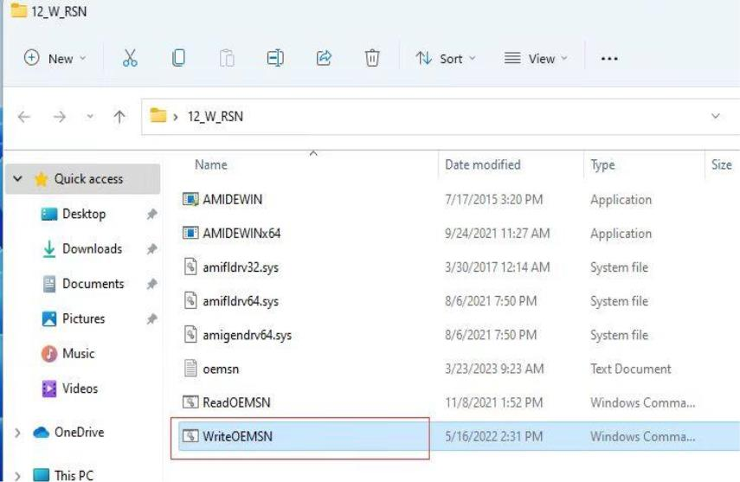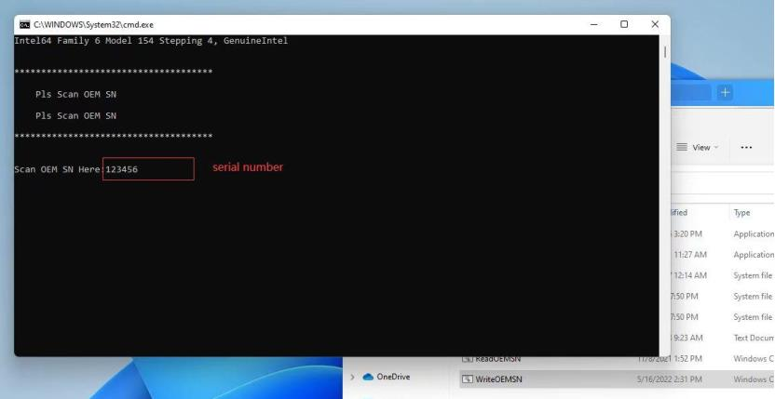
Step 3: After this interface appears, press any key to complete.
