EX Docking Station Manual

1. Docking Station Appearance ..........................................................................................1
2. Product Accessories 3
3. Product Specifications 5
4. Docking Station Installation Tutorial 6
5. SSD or Wifi Module Installation Tutorial 7
6. Graphic Driver Installation Tutorial 8
7. Video Output Switch Setting Tutorial 10
8.Both PC and EX Video Output Spontaneously BIOS Setting 12
9. Q&A 15

1. Docking Station Appearance
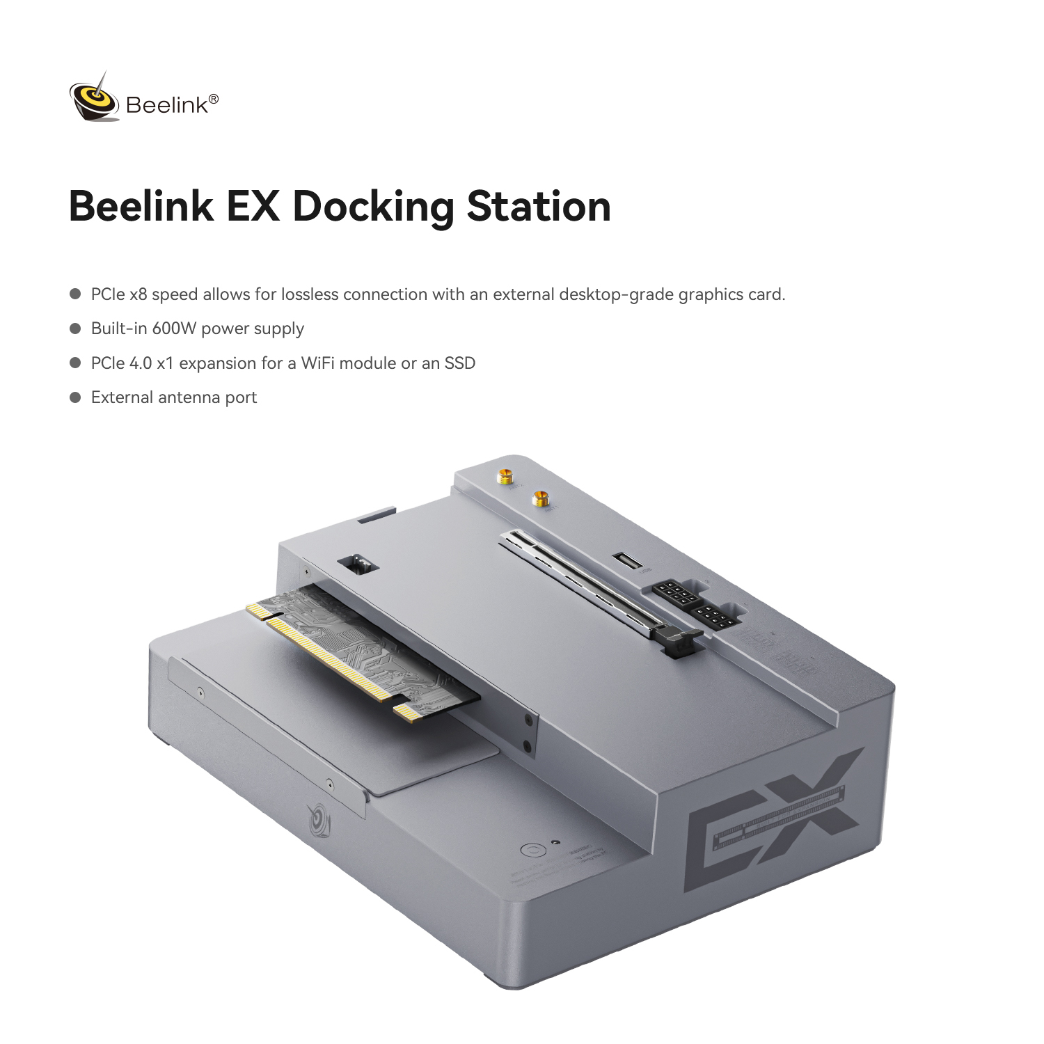

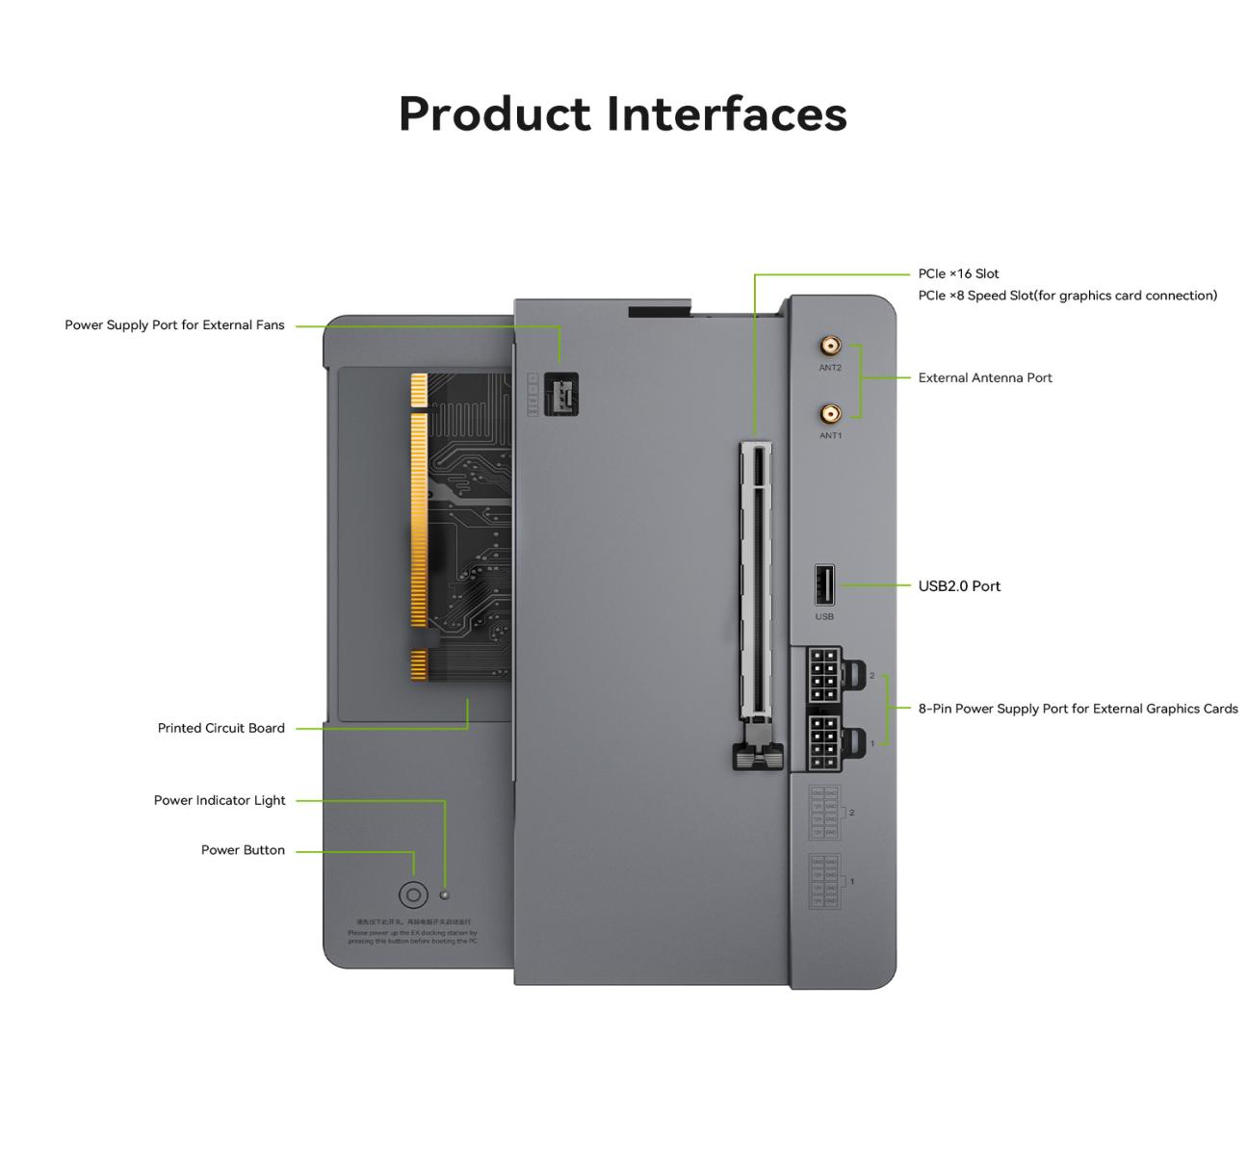
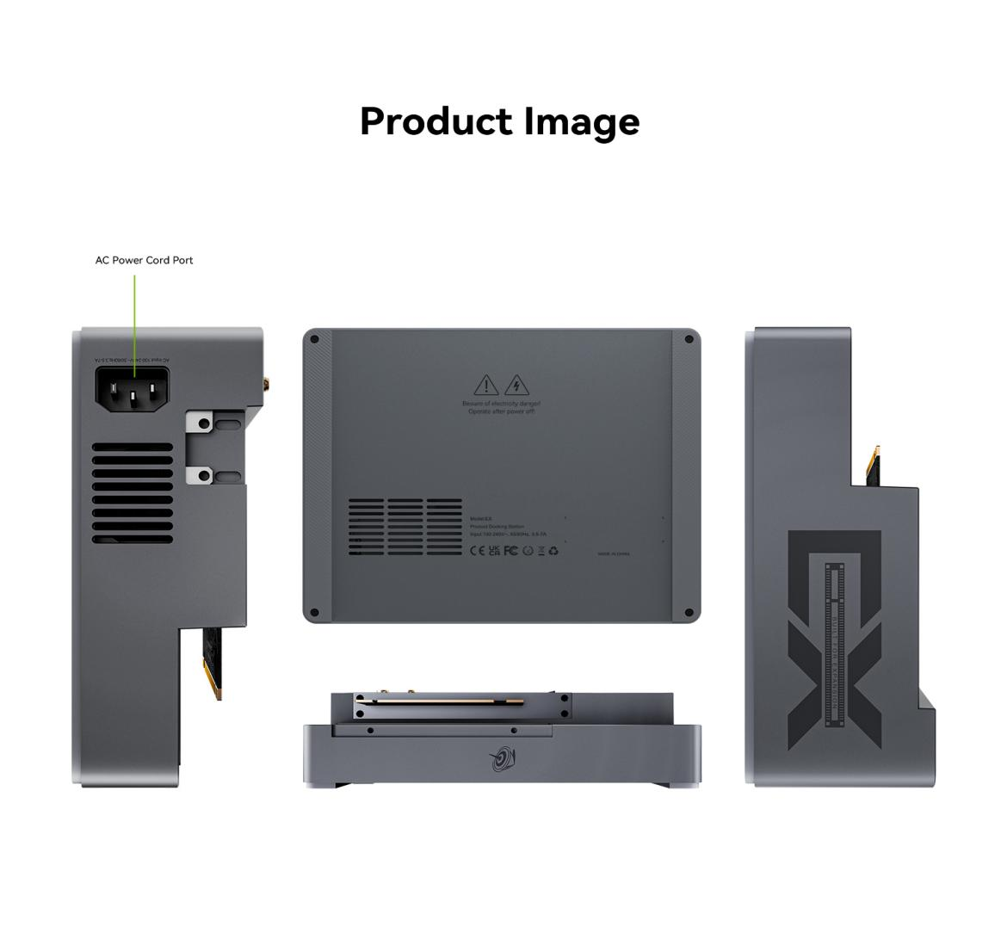

Product Accessories

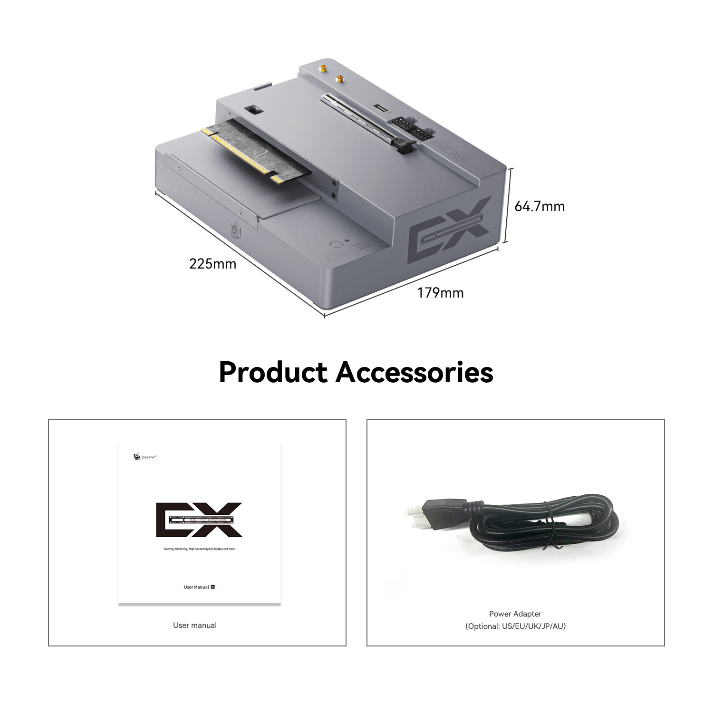
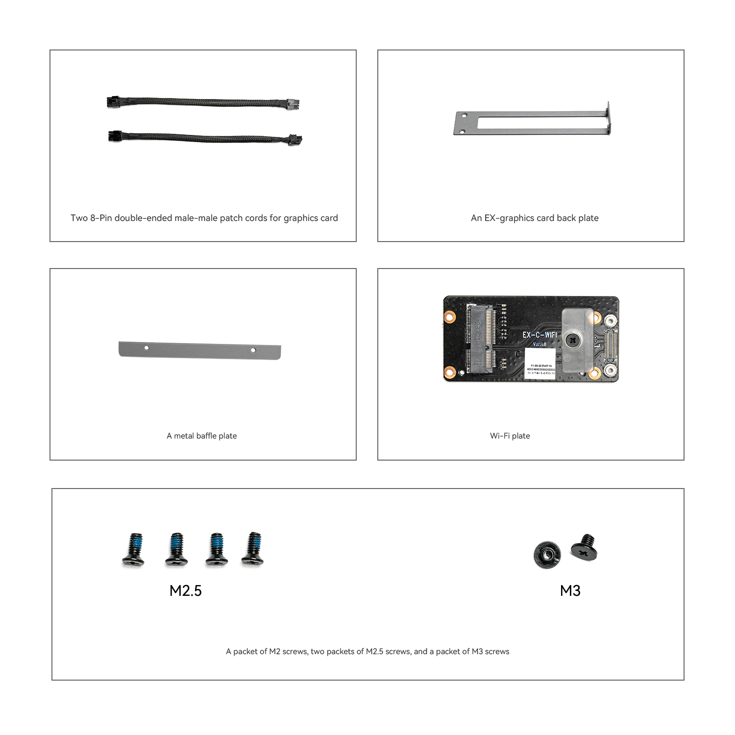

3. Product Specifications
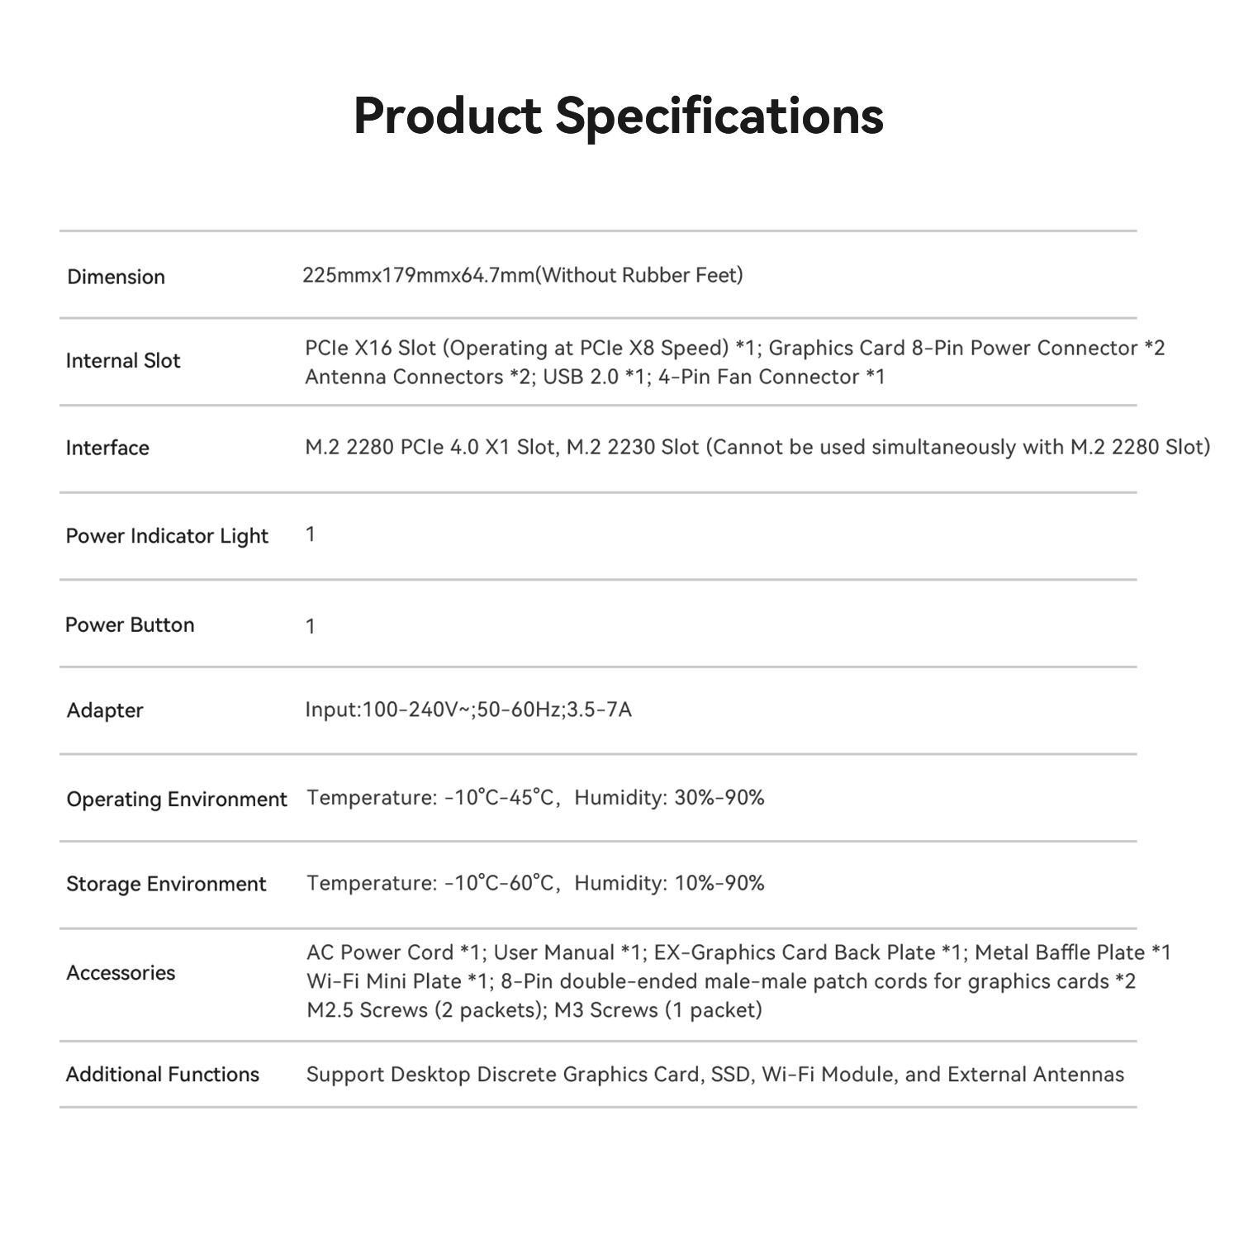

4. Docking Station Installation Tutorial
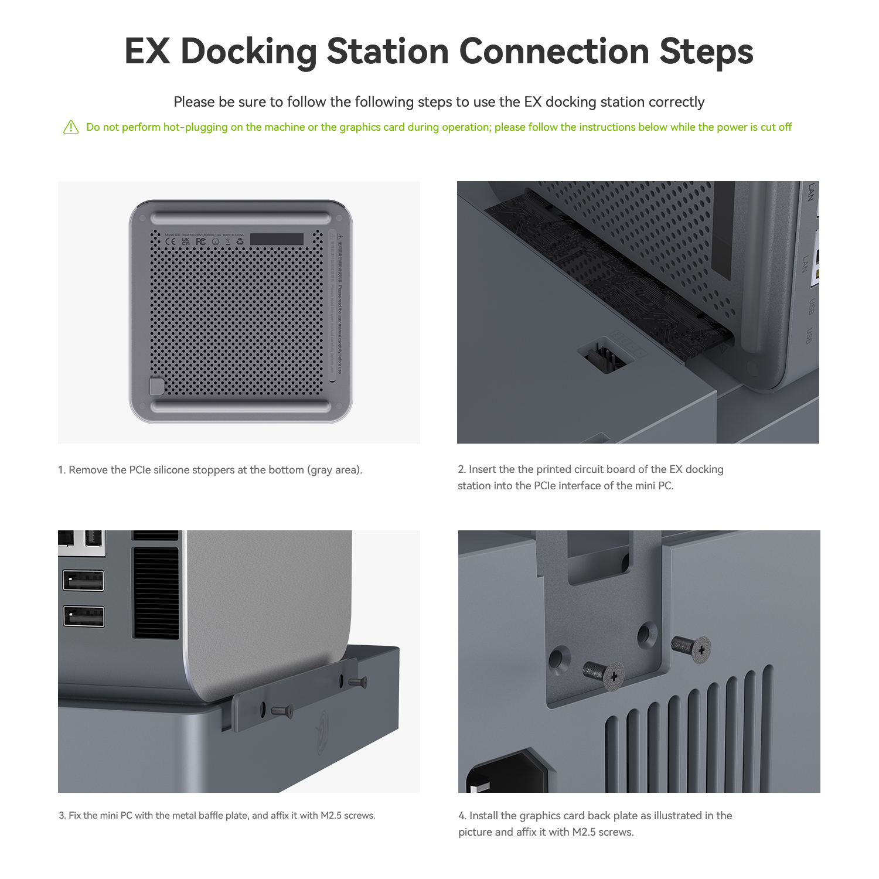

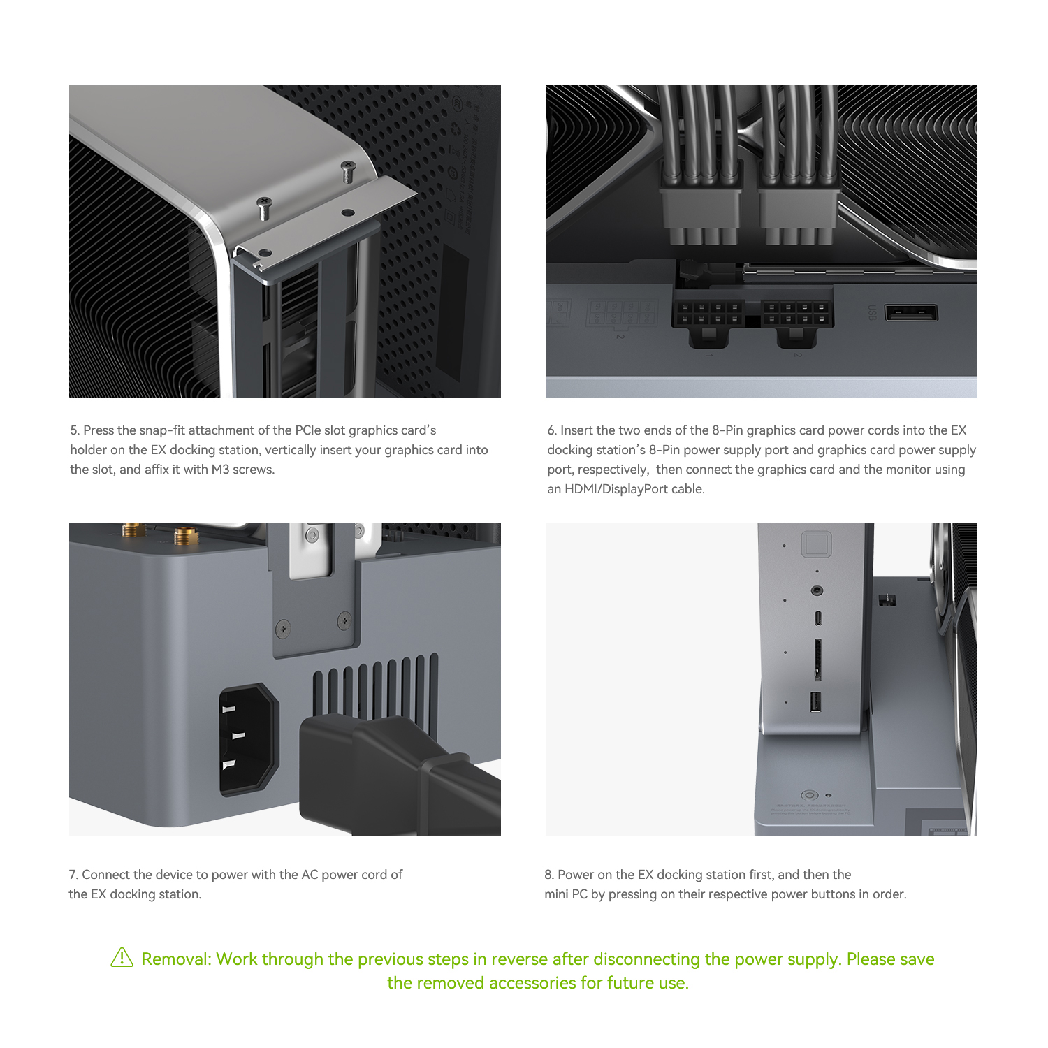

5. SSD or Wifi Module Installation Tutorial

[Installation Steps for M.2 2280 SSD]
Note: The following operations should be performed when the power is off. (For details of specific compatible models, please refer to the official statement)
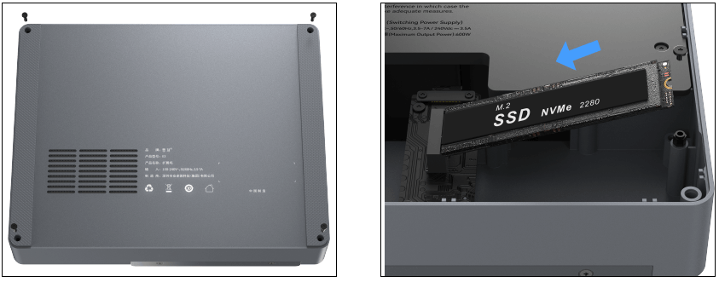
After removing the four screws on the bottom case and opening it:
1. Align the notch on the solid-state drive with the bayonet of the M.2 slot on the motherboard, and slide the solid-state drive in;
2. Press down on the other end, and then fix it with screws;
3. Fasten the four screws of the bottom case and cover the bottom case.

[Installation Steps for Wi-Fi Module]
Note: The following operations should be performed when the power is off.
(For details of specific compatible models, please refer to the official statement)

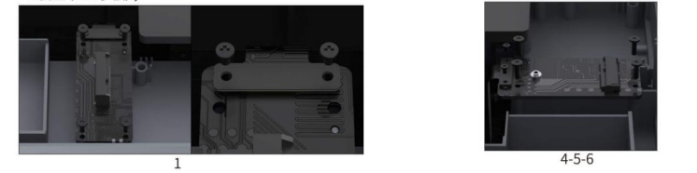

- Remove the four screws of the small board and the two screws of the FPC cable;
- Remove the FPC cable;
- Remove (the SSD small board);
- Install (the Wi-Fi small board);

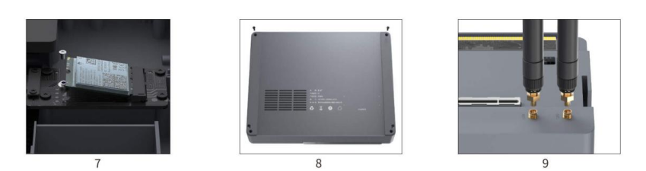

- Fasten the four screws of the small board;
- Install the FPC cable. Note that the FPC cable has a direction. The M end of the FPC cable corresponds to the motherboard, and the L end corresponds to the small board. Fasten the two FPC cable screws;
- Then install the Wi-Fi module and fasten it with screws;
- Cover the bottom case and fasten it with screws;
- Take out the two external antennas (purchased by yourself) (used only when installing the Wi-Fi module). As shown in the figure interface, and rotate and install it on the EX docking station.

6. Graphic Driver Installation Tutorial
After the PC and the docking station are installed completely, you can turn on the PC and go into the system, but then you need to install the graphic driver before you use the EX. Otherwise, you may encounter some issues ,like bad resolution or other unknown issues. So we suggest you install the graphic driver before you use it. You can install the corresponding driver based on your EX model and brand.
1) NVIDIA graphic driver installation tutorial
Please go to NVIDIA official website, and download the correct driver according to your EX model and serial number. https://www.nvidia.com/en-gb/drivers/
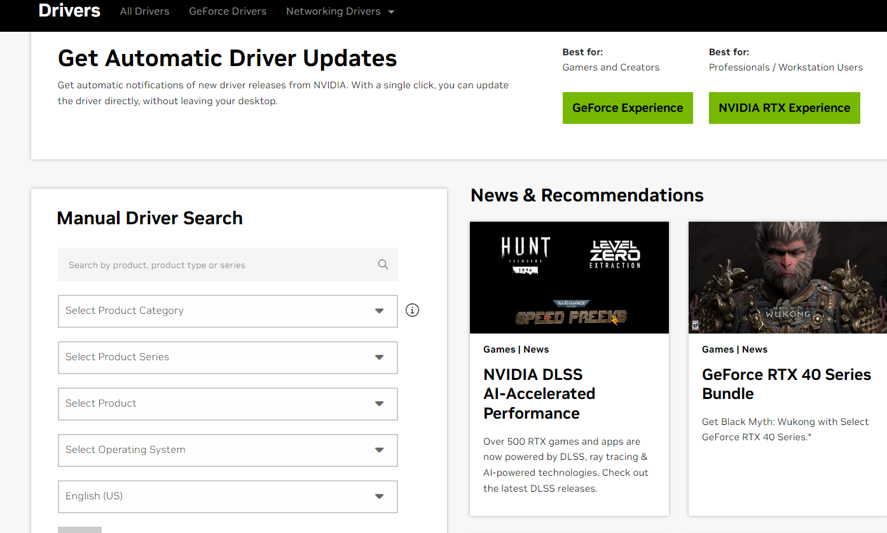

2) AMD Driver

https://www.amd.com/en/support/download/drivers.html
Please download the auto-detect program.
It will update some chipsets and video drivers automatically.
It will identify and install appropriate drivers for their AMD hardware. The program works
by scanning the users system to detect the installed AMD hardware components,
such as graphics cards or processors . It then compares the detected hardware information
with a database of AMD drivers and software versions.

3) Intel Driver
Please go to Intel website https://www.intel.com/content/www/us/en/download-center/home.html
Search for your graphic model and download the correct driver.

7. Video Output Switch Setting Tutorial
Under the default BIOS, the PC output video.
Initial state: Both the power of the PC and the power of the docking station are off.
Steps: Connect the monitor to the video output interface of the PC, and then press the power button of the PC to start it. There is no need to turn on the power of the docking station.

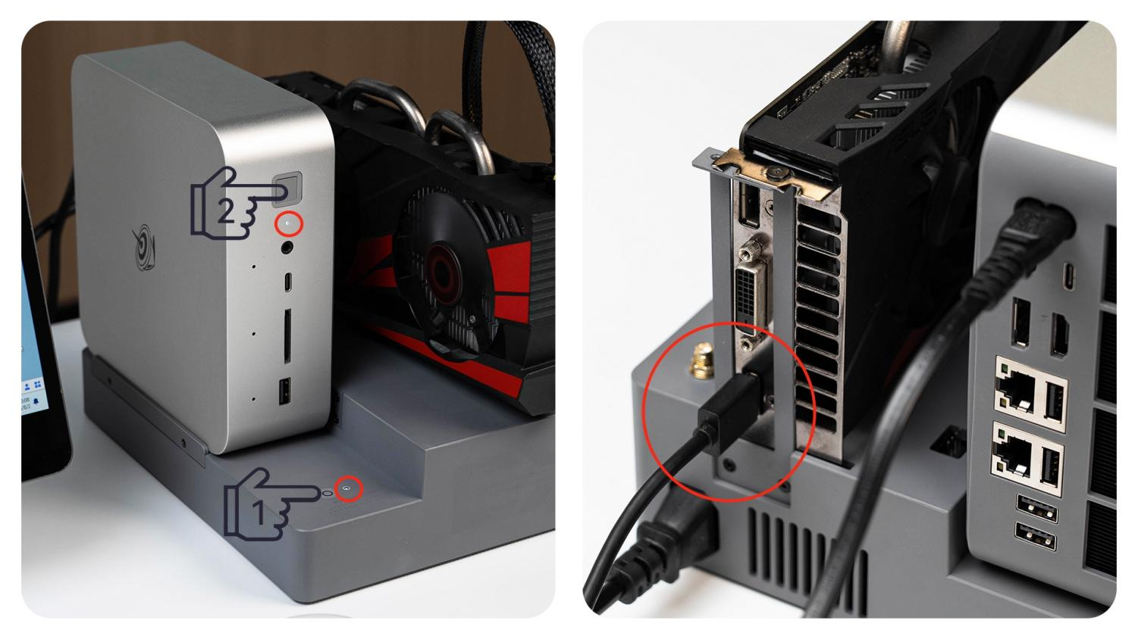

Initial state: Both the power of the PC and the power of the docking station are on.
Steps: If the graphics card docking station is not needed, first shut down the PC, then turn off the power of the graphics card docking station. Check whether the monitor is correctly connected to the PC, and finally restart the PC.

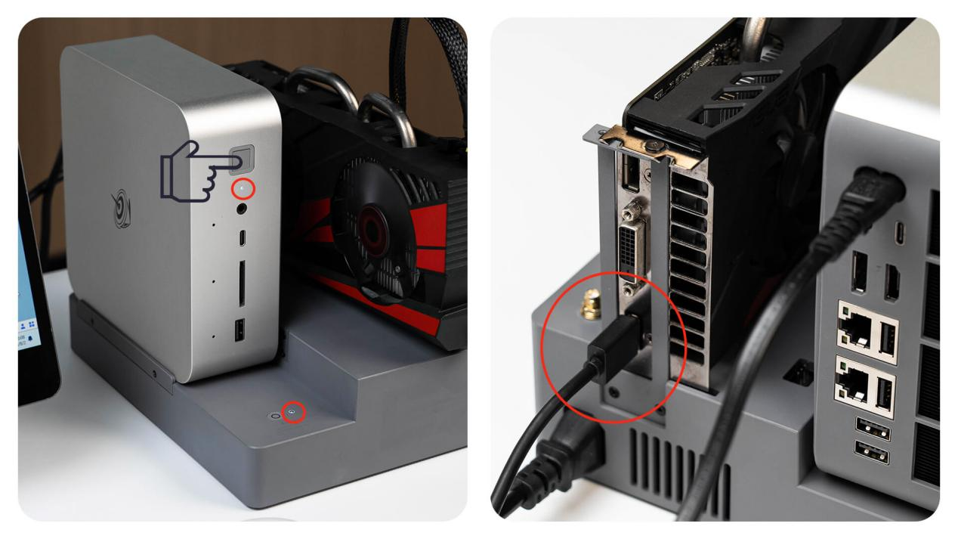

Under the default BIOS, the docking station output video.
Initial state: Both the power of the PC and the power of docking station are off.
Steps: Connect the monitor to the output interface of the graphics card. First, turn on the power of the docking station, and then press the power button of the PC to boot up. When shutting down: The PC needs to be shut down first, and then the power of the docking station is turned off.

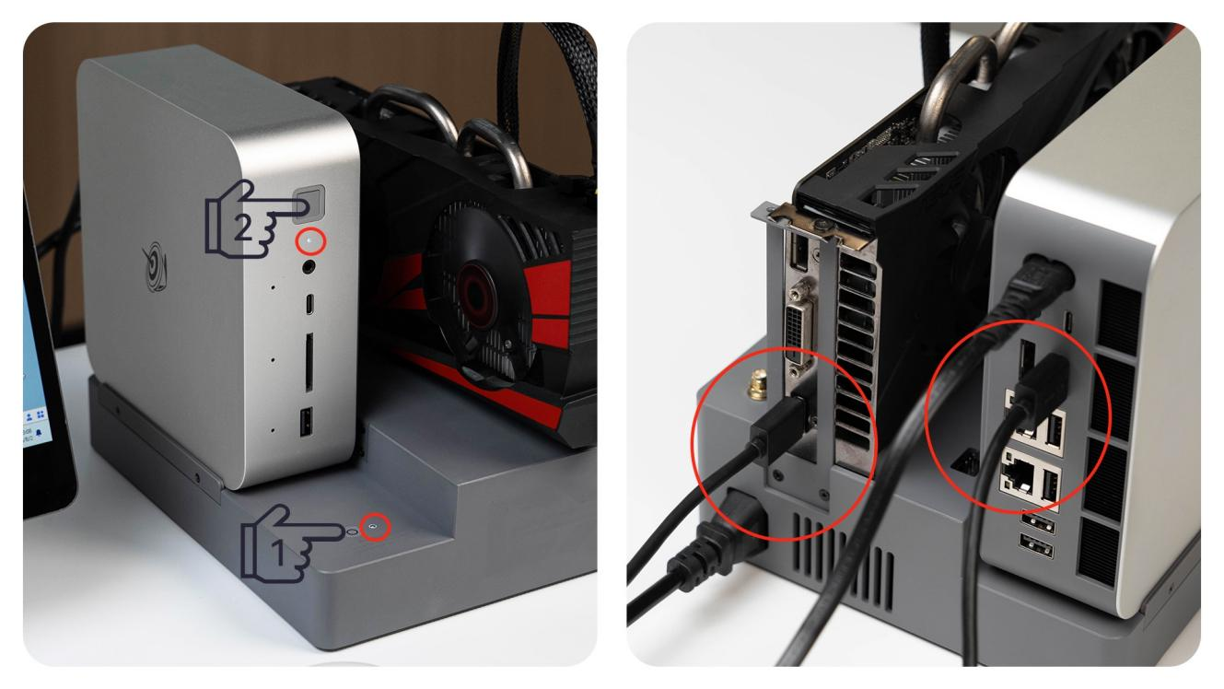

Initial state: The power of the PC is on and the power of the docking station is off.
Steps: Shut down the PC. After confirming that it is shut down, turn on the power of the docking station. Make sure the monitor is connected to the video output interface of the graphics card docking station. Press the power button of the PC to start the PC. The system will automatically detect and use the output of the graphics card docking station.

8.Both PC and EX Video Output Spontaneously BIOS Setting
Under default BIOS, the EX will take the priority to output the video,if you want to output video spontaneously for both PC and EX,you need to change the setting in the BIOS.

Please repeatedly press delete key as soon as you turn on the PC, go to BIOS.
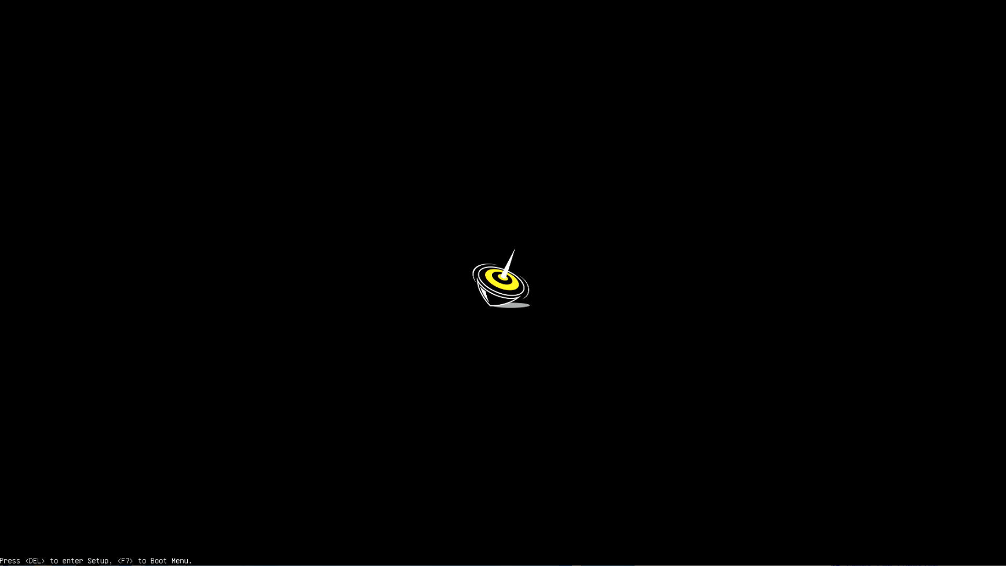

After going into the BIOS, use arrow key to navigate to Advanced menu,please choose System Agent（SA）Configuration
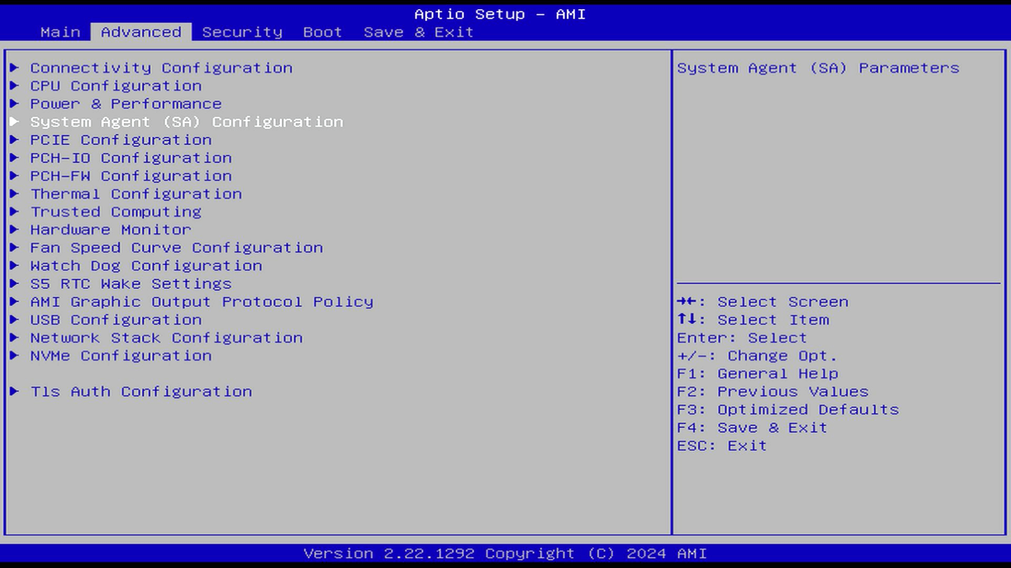

Please choose【Graphics Configuration】,please press enter.
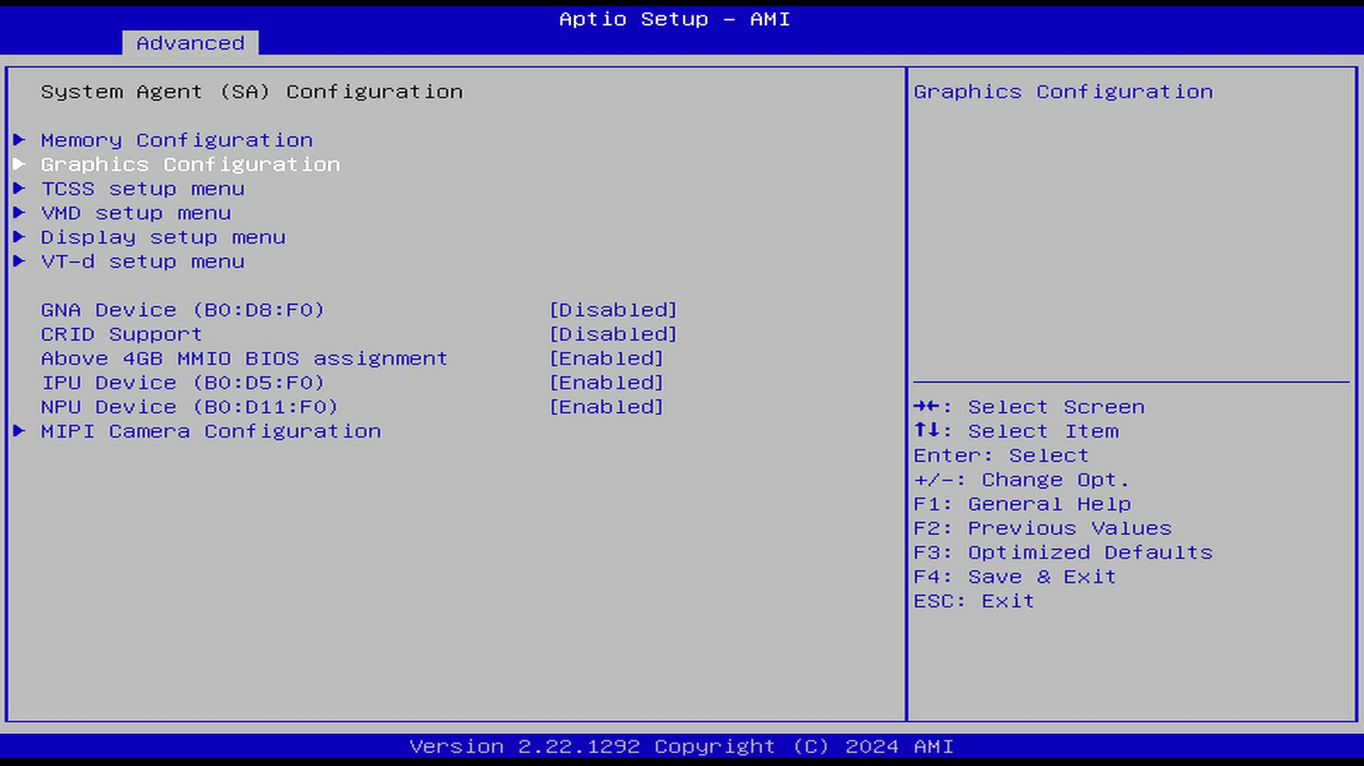

The default setting of【Primary Display】is【Auto】，the EX takes the priority to output the video.
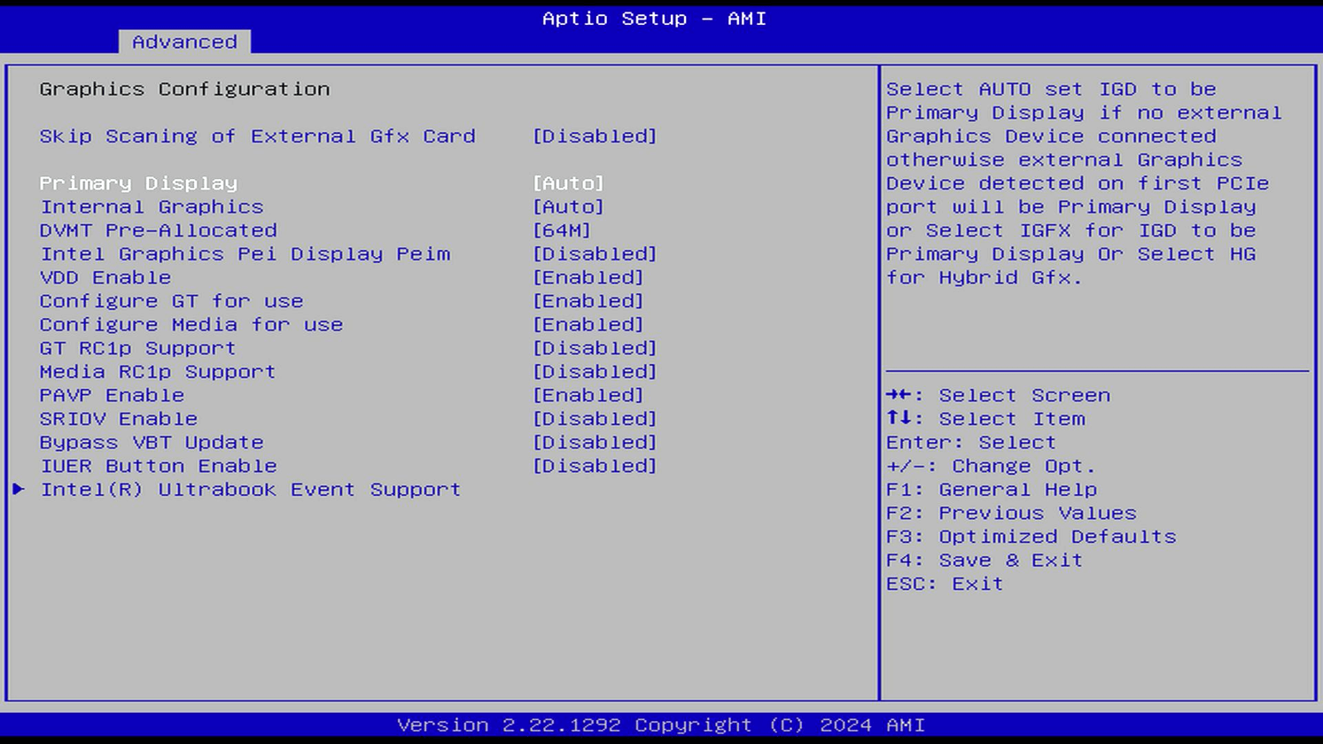

If you want to output video spontaneously for both PC and the EX, please change【Primary Display】to【IGFX】.
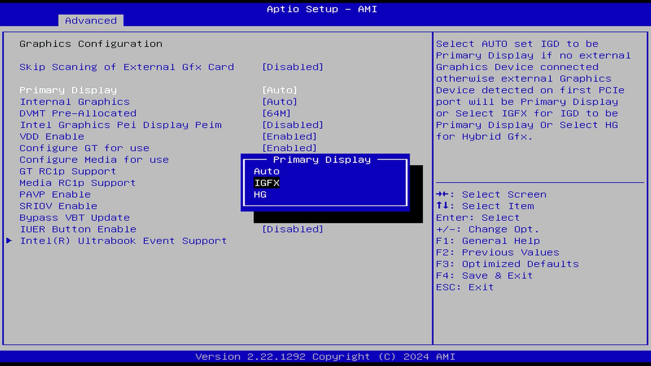

After setting is done, please press F4 to save and choose【Yes】to confirm , then exit.
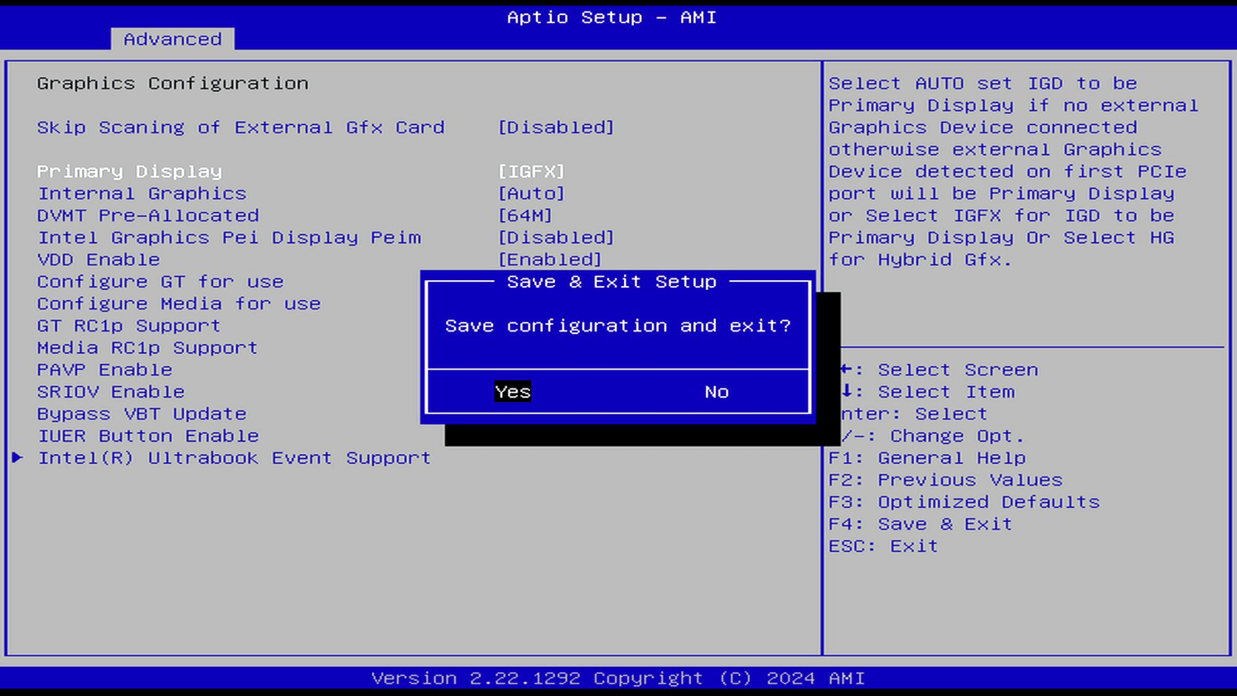

9. Q&A
FAQ：
- How does the EX graphics card docking station supply power to the graphics card?
The Beelink EX graphics card docking station has a built-in 600W independent power supply unit, which can directly power the graphics card without the need for users to externally connect a power supply.
- Why can't the power supply of the docking station be directly used to power the PC?
The PC and the expansion dock each have independent power supply capabilities and can be used separately or in combination. In scenarios with light graphics card loads such as daily office work and audio-visual entertainment, the host's built-in core display can be used, which is energy-saving and silent. For usage scenarios that require high-performance graphics cards, such as playing 3A games, video rendering, and local AI large model computing, a discrete graphics card can be used for stronger performance. The dual switch design of the host and the expansion dock ensures that users can switch the usage mode at any time and prolong the service life of the product.
- Can the graphics card docking station connect to other PCIE devices besides external graphics cards? Yes, the PCIE interface expanded by the graphics card dock is a standard interface and supports the connection of other PCIE devices, such as sound cards, capture cards, network cards, and expansion cards and other standard PCIE devices.
- Is there any loss when connecting external docking station devices through the 8X interface? Approximately how much? When using graphics cards with performance up to NVIDIA 4080, there is almost no loss and the performance of the graphics card can be fully exerted.
- Will connecting the graphics card docking station block the air intake at the bottom of the host and the sound output of the speaker?
In the design, there is a certain distance between the host and the graphics card, so it will not affect the normal functions of the air intake of the host and the speaker.
- What is the external transmission speed of the graphics card docking station?
The transmission speed of the graphics card dock is PCIE 4.0 x8, which can provide high-speed and stable transmission and almost has no performance loss for the external graphics card.
- Besides connecting the graphics card, what other functions does the docking station have? In addition to connecting the graphics card, the graphics card docking station also supports other expansion functions. It has a built-in 600W power supply and can support the expansion of M.2 hard drives or Wi-Fi network cards, but only one of the two can be chosen. In addition, it is also equipped with a USB interface.
- Can the EX graphics card docking station be used on other hosts?
No. The EX graphics card docking station is customized for specific brands and models of PC and is not compatible with other brands or other item models.

